Matrix Reference Guide

About This Guide
This guide is designed to be a general introduction into the concept of matrices. It covers what you can do with a matrix, the Matrix Designer Interface, and the various types of Matrices you will come across.
For more detailed information about a specific Matrix type see the relevant Matrix guide.

What You Should Already Know
You should be familiar with the concept of Elements, Types, Relationships, and Themes. See <How to define your Business Landscape>. You will also need to be familiar with Queries, see <How to Query the Business Landscape>.

MooD Terms Used in This Guide
Matrices are tables used to display information about Elements. Data Sheet Matrices use Queries to populate a basic table. Queries are used to gather sets of Elements, Relationships, and Events from the Business Landscape.

What is a Matrix
A Matrix is a table used to display information about elements in your Business Landscape. A Query determines what content will be included in the Matrix.
The cell content is highly configurable and is drawn from your repository. You can display a wide range of information such as Query results, related Elements, and string, number, and date values.
Each Matrix is owned by an Element which can later be used as a filter when searching through Matrices.

How to Create a Matrix
- Expand out the Matrix library in the Explorer bar
- Open the group the Matrix will go in - the default option is General Matrices
- Click "New" and select an Element to own the Matrix
- Select the type of Matrix you want to use in the Matrix Type popup and click "OK"
- Give the Matrix a name and a quick summary
- Complete the tasks in the Tasks section or refer to the specific Matrix guide for further information
For more information on how to create a specific Matrix see the relevant guide

How to Open a Matrix
- Expand out the Matrix library in the Explorer bar
- Open the group the Matrix is in - the default option is General Matrices
- Open the Matrix by
  - Double-clicking on the Matrix you want to open or
  - Right-clicking on the Matrix and selecting Open or
  - Clicking on the Matrix, then pressing Ctrl + O on your keyboard

What You Can Do with a Matrix
Matrices are a very powerful way to display Elements in your Business Landscape. They can be used to power a panel, to drive a Chart, and aggregate data. They can also be displayed in different ways on a Model.

Using a Matrix on a Model
Typically, when a Matrix is dropped onto a Model, the following dialogue box is shown, with two of the three options enabled:
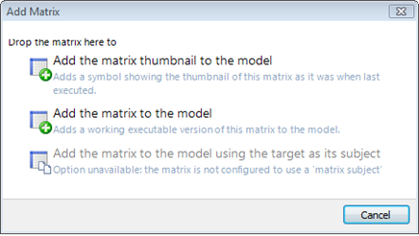
You can add a working version of the Matrix, or an image of the Matrix as it was when last executed. Any changes made to the working Matrix in the Matrix Designer will be reflected in the Matrix on the Model. All visual changes such as the cell background colour are styled within the Matrix Designer.
The third option, "Add the matrix to the model using the target as its subject", can be selected when the starting point of the Matrix's query is set to "the matrix subject".
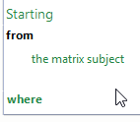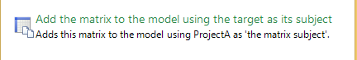
[Replace starting from with screencast]
When you place the Matrix on a Model, it takes the Model's Subject Element as its starting point. This means you can develop a Matrix for a particular purpose and then reuse it for many models.

Types of Matrix
There are 7 different types of Matrices:
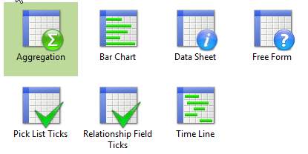

Datasheet Matrix
Datasheet Matrices are considered the simplest type of Matrix as they can only be used to display columns of existing information. For example, you could use:
Elements = Tasks | 1. Field values of the Elements | 2. Results of a Query against each row Element | 3. Sub-columns for the columns in the matrix
 | DSM shows number field values for each row Element in three columns.  Admin Resources, Dev Resources, Test Resources | A query against each row Element, which returns the child Elements of each row Element, populates a forth column called children.  -Children of each task = Goals | A sub-column to the Children column contains a number field for each Element in the Children Column.  -Priority of each child
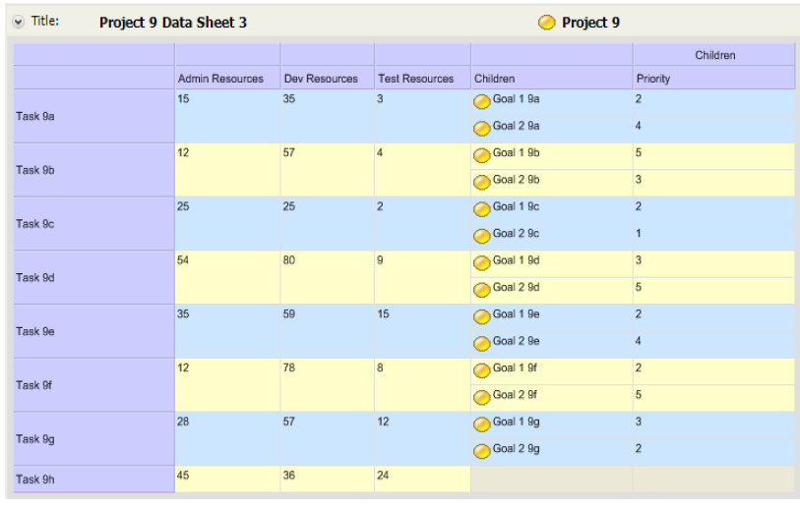 [replace image with up to date image]

Aggregation Matrix
Aggregation Matrices can perform calculations on Elements in multi-dimensional views and groupings. The total values produced from these views can be used to summarise, analyse, and compare data. For more information on Aggregation Matrices see <How to … Aggregation>
[image]

Bar Chart Matrix
Bar Chart Matrices display numeric information for Elements. Elements appear as rows, and the columns show a progression of values.
In this example, a Bar Chart Matrix shows the subject Element child Elements and shows the current values of a numeric field for each of the Elements – example from 2010 guide
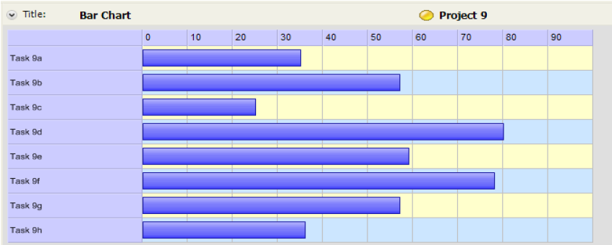
[replace image with up to date image]

Free Form Matrix
Free Form Matrices use multiple Queries to structure a Matrix in a less conventional way. Elements are used for both the row and column headings, whilst the cells show how they are related. Extra information can be included in the cells about either of the related Elements.
For example, the matrix shows Tasks performed by Software Development Team Members against Product Versions, using two relationships: Implemented by and Implemented in version. Additionally, the matrix shows the ID number of each Task that appears in a cell of the matrix
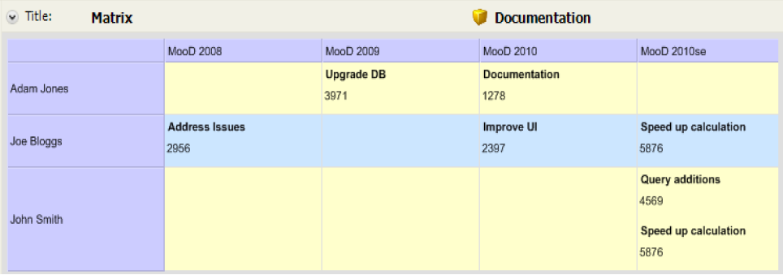
[replace image with updated version]

Pick List Ticks Matrix
Pick List Ticks Matrices display Pick List items for a list of Elements and ticks to represent which item is selected per Element. You can alternatively configure the Matrix to display icons instead of ticks.
For example, a matrix shows the subject Element child Elements with columns showing the pick list items configured for each Element. Elements = tasks, pick lists = Red, Amber, Green etc.
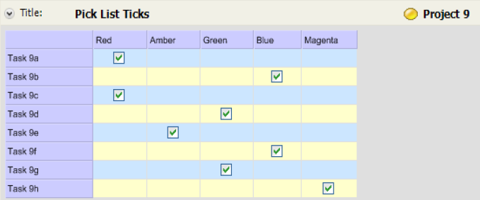
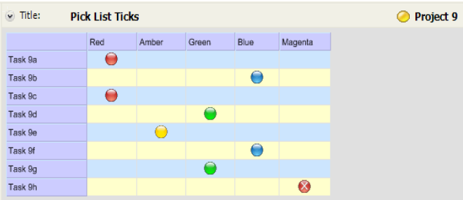
[replace images with updated version]

Relationship Field Ticks Matrix
Relationship Field Ticks Matrices display Elements on both the X and Y axes, and shows, by means of a Query, if they are related.
For example, matrix shows the subject Element child Elements and shows how pairs or Elements are related by a Relationship field.
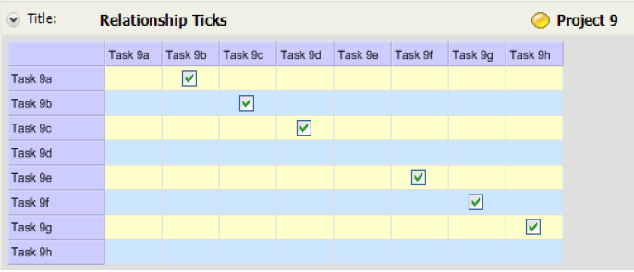
[replace images with updated version]

Timeline Matrix
Timeline Matrices display time related information for Elements. You can include bars between dates, milestones, dependency lines and date markers. You can also add a Datasheet type column to a Timeline Matrix.
For example, matrix shows subject Element child Elements with time line periods from start date to end date for each of the Elements
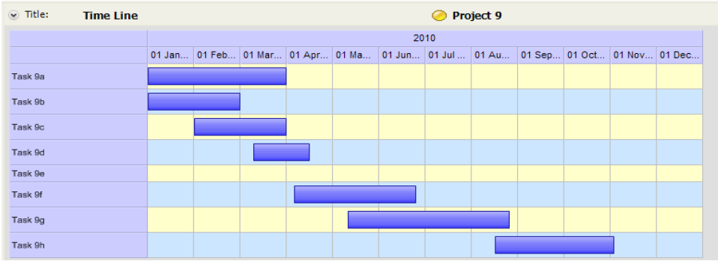
[replace images with updated version – include dependency lines and date markers]

Matrix Designer Interface
Opening a Matrix gives you access to the Matrix Designer. This workspace has several tabs which change depending on the type of Matrix and the starting point selected. The table shows which tabs each Matrix uses.
 |  | Matrix Type
 |  | Data Sheet | Aggregation | Bar Chart | Free Form | Pick List Ticks | Relationship Field Ticks | Timeline
Tab Name | General | Yes | Yes | Yes | Yes | Yes | Yes | Yes
 | Matrix | Yes | Yes | Yes | Yes | Yes | Yes | Yes
 | Designer |  | Yes
 | Row Query | Yes |  | Yes | Yes | Yes | Yes | Yes
 | Source Query |  | Yes
 | Column Query |  |  |  | Yes | Yes | Yes
 | Cell Query |  |  | Yes | Yes |  |  | Yes
 | Cell-Row Query |  |  | Yes | Yes |  |  | Yes
 | Cell-Column Query |  |  | Yes | Yes |  |  | Yes
 | Edit Columns | Yes | Yes | Yes |  |  |  | Yes
 | Variables | Yes | Yes | Yes | Yes | Yes | Yes | Yes

General Tab
The general tab contains a summary of the Matrix information alongside a list of steps required to create a useable Matrix. Clicking on the links sends you to the correct place to complete each task.
Edit Row Query | This option takes you to the Row Query tab, where you can construct and test a Query
(reset…) | This link lets you reset the row data source to a query chosen from a selection of basic queries listed in a Select Query dialogue box.  The selected query can be edited in the Row Query tab. If "Use a Dependency" was set, it is cleared.
Use a Dependency | This option lets you select a dependency from a Select Content dialogue box. Your selection will appear next to the highlighted "Use a Dependency" button.

Matrix Tab
The matrix tab has four subheadings; Matrix, Rows, Columns, and Cells. Each of these sections allow you to alter the general properties for that area.

Designer Tab
The Designer tab allows you to add dimensions and levels to an Aggregation Matrix. For more information on this tab and Aggregation Matrices see <How to… Aggregation Matrix>.

Query Tabs
The various Query tabs all use the standard Query Builder to create the Queries. For more information on Queries and the Query Builder see <How to Query the Business Landscape> and <Query Reference Guide>.

Row Query Tab
The Row Query tab is used to define a query that finds the rows for your Matrix.

Source Query Tab
The general functionality is the same as the Row Query tab except the Elements generated by the Source Query may not be the Elements in the row headers. For further information on the Source Query tab see <How to… Aggregation Matrix>.

Column Query Tab
The Column Query tab is used to define a query that finds the columns for your Matrix.

Cell Query Tab
The Cell Query tab is used to define a Query that finds Elements to populate the cells of a Matrix. Additional Queries are used to group the cells.

Cell-Row Query
The Cell-Row Query tab is used to define a Query that finds the rows for your Matrix. The Query Builder uses a fixed starting block to ensure the Query starts from a cell Element.

Cell-Column Query Tab
The Cell-Column Query tab is used to define a Query that finds the columns for your Matrix. The Query Builder uses a fixed starting block to ensure the Query starts from a cell Element.

Edit Columns Tab
This tab lets you select content that will appear as columns in your Matrix. The content can include Smart Columns, Pick Lists, memo fields, etc.

Variables Tab
If your Matrix is uses any variables in its Queries or columns, you can enter default variables in this tab.

