MooD 15
Repository Manager User Guide

Version 2

Document Number: MooD15RMG02

© MooD Enterprises Ltd., all rights reserved.

Notice of Copyright and Trademarks
MooD 15 Repository Manager User Guide Version 2 Build 86
® MooD, MooD Smarter Decisions, Performance Activation, Synchronization Activation Technology and Knowledge Map are registered trademarks of MooD Enterprises Ltd. in the United Kingdom and / or other countries.
Microsoft and Windows are trademarks of Microsoft Corporation in the USA and other countries.
Rights to all other referred trademarks or registered trademarks reside with their respective owners.
Aspects of the Enterprise Business Model, Model-Driven Data Aggregation and Business Solutions to Support Smarter Decisions are protected by International Patent and Patent Pending. These include the Meta-Architecture Framework, Panels Technologies, Auto- Explorer, Business Orchestration, the Activator mechanism, Process Driven System, Performance Activation, Model-Driven Enterprise Management, Dynamic Aggregation, Smart Columns, the Variant Mechanism, and other technologies and mechanisms implemented within MooD Business Architect and MooD Active Enterprise.
© MooD Enterprises Ltd., all rights reserved. No part of this document may be reproduced by any means, or transmitted, or translated into machine language without the written permission of the company.

2

Contents
Introduction 5
Technical support and resources 5
About repositories, servers and Repository Manager 6
Repositories 6
Servers 7
About schemas (brown (sepia) repository icons) 7
SQL Server permissions required by MooD 8
Starting Repository Manager 9
Importing older repositories when Repository Manager starts 10
Opening a repository in Business Architect 11
The File tab 13
Manage your licence 13
Manually start the Repository Manager service 16
View stored credentials 16
View log files 16
The Repositories tab 18
Renaming repositories (the display name only) 21
Advanced repository properties 22
Upgrading repositories 22
Upgrading to a new schema 23
Upgrading from an earlier (pre MooD 15) version of MooD 23
Backup a repository 23
Restoring a repository from a backup 24
Remove or delete a repository 24
Restoring a hidden (removed) repository 24
Publish a repository to the web 25
Validate a repository 25
3

Integrate a repository into another repository 25
Fix index fragmentation 25
Change the image used for a repository 25
Make a repository a blueprint 25
Using tags to filter the list of repositories 27
Creating a repository 31
Creating a repository on the default server 31
More ways to add a repository 32

The Servers tab 36
Adding a database server 38

4

Introduction
Enterprise architectures are held in database repositories. Repository Manager lets you create and manage repositories. You also use it to select and open repositories in Business Architect, and to upgrade repositories when a new schema is introduced.
This guide has these sections:
- About repositories, servers and Repository Manager (page 6) It also covers schemas.
- Starting Repository Manager (page 8)
- Opening a repository in Business Architect (page 11)
- The File tab (page 13)
This is Repository Manager’s administration point for licensing, version information, and its own maintenance.
- The Repositories tab (page 18)
The bulk of Repository Manager’s functionality is on this tab. It lists your repositories, and lets you manage them.
- The Servers tab (page 36)
Repositories exist on servers. This tab lists your available servers, and lets you hide repositories so that they don’t appear on the Repositories tab.

Technical support and resources
MooD 15 has a UK based technical support team. Repository Manager’s File tab has contact details. Other resources are available within the Support Area at www.moodinternational.com.

5

About repositories, servers and Repository Manager

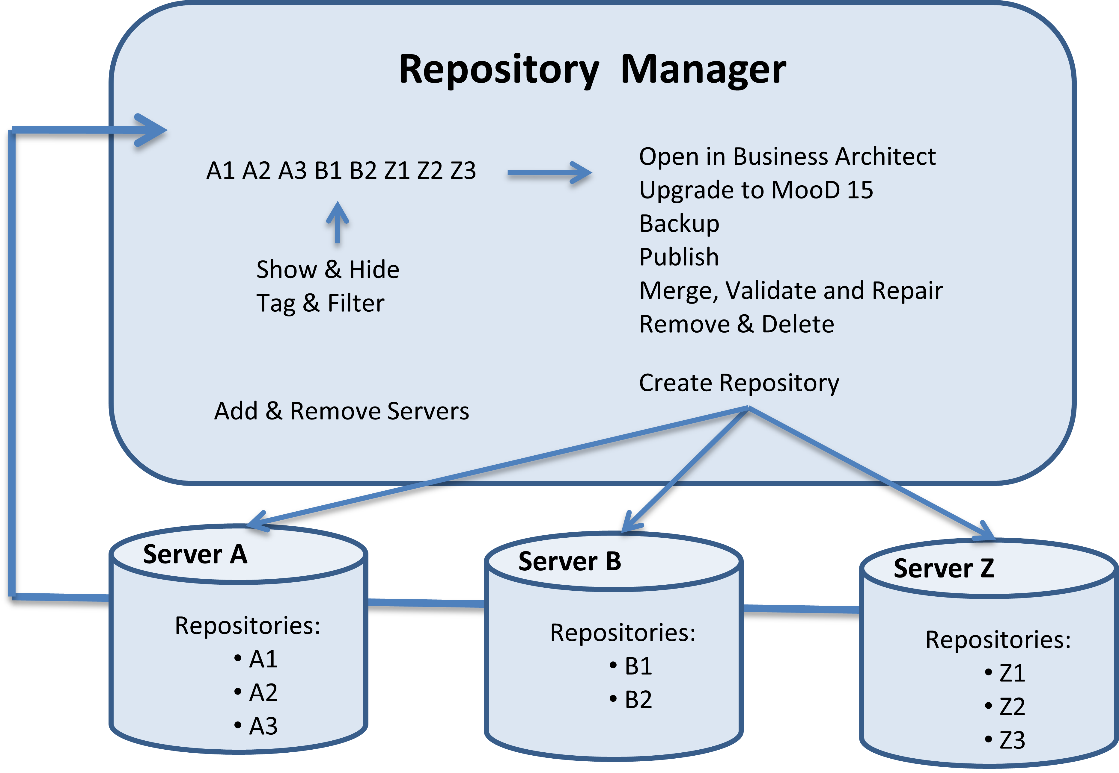

Figure 1. Diagram illustrating Repository Manager, repositories and servers

Repositories
A repository is the entity that holds your architecture. It is a database instance that collects together everything that makes up your architecture.
When you start MooD, it is Repository Manager that starts first. Repository Manager knows what servers you have, and lists the repositories on them. Use it to:
- Manage your MooD licence. If you need to install a licence, open Repository Manager as an administrator (right click and select Run as administrator).
- Open a repository in Business Architect.
- See repository details such as size and last modified time.
- Create, rename, remove (hide) or delete repositories.
- Upgrade repositories when you get a version of MooD with a new schema. If you install a new version and all your repositories appear brown (sepia), it is due to a change in schema. See About schemas (page 7) for more details.
- Publish repository content as a static website.
- Create backups (SQL Server only).
- Merge repositories by integrating one into another.

6

- Validate and repair the data within a repository. Validation is a recommended step prior to making a repository available on the web using Active Enterprise. Validation can also help resolve structural issues within a database.

Servers
Repositories exist on servers. In MooD, servers are database servers, not just physical servers.
You can have multiple servers, and each server can have multiple repositories on it. In Repository Manager, you have the concept of a default server. The simplest way to create a repository creates it on the default server.
Repository Manager’s Servers tab lets you manage what servers Repository Manager knows about, and which repositories on each server are shown on the Repositories tab.
Note: When you open Repository Manager for the very first time, it won’t know about any servers and, consequently, won’t list any repositories. If this is the case, see Adding a database server on page 38.

About schemas (brown (sepia) repository icons)
All builds of MooD and consequentially all MooD repositories have an underlying schema. This is the database structure it is built upon. The MooD schema changes less frequently that the MooD build. Builds introduce features and fixes on top of a schema. Hence, a schema can support several builds. The schema only changes when a new feature requires a change to the underlying database.
Repositories that do not match the schema of your current build appear in shades of brown (sepia) and cannot be opened in your version of MooD unless upgraded to the same schema.

Important:
- Before upgrading, take a backup and make sure the repository is not being used by other users.
- Once a repository has been upgraded to a new schema, you cannot open it in a version of MooD with an earlier schema.
To upgrade, highlight the repository and then select Upgrade (it is one of the few commands available to you).
Note: If you have a repository that appears brown and you are not given the Upgrade option, the repository is on a newer schema than your current installation. You will not be able to open this repository unless you get a newer version of MooD itself.
Mandating a Build
Business Architect includes a complementary feature called mandate. This lets you specify a specific MooD build (version of Business Architect) that the repository must be edited with. If you try and open a repository on a different build (but same schema), Business Architect warns you but will let you proceed. Mandating a build helps development teams ensure they always work on a set build of Business Architect. Mandating is optional and can be found (in Business Architect) under File > Manage Repository > Mandate a Build of Business Architect.

7

SQL Server permissions required by MooD
Repository Manager makes use of SQL Server users when creating and maintaining repositories in SQL Server. The SQL Server permissions required by MooD are:
- DBCreator to create repositories. This is a global SQL Server permission.
- dbo to reindex or upgrade repositories. This is a per database SQL Server permission.
- repname_role to manage data within the repository. This is a SQL Server role per database.
If you are using Windows Authentication, the user must have the necessary SQL Server permissions. Many support issues regarding repository maintenance are caused by the user not having the necessary SQL Server permissions to perform tasks. Your database administrator should be able to advise you about the permissions your username has.

8

Starting Repository Manager
Repository Manager is a Windows application. When it is installed, a desktop shortcut is created for it:
Double-click the icon to start Repository Manager.
If you are running for the first time and need to install a licence, right click and select Run as administrator. Use the File tab to install a licence (see page 13).
Note: If you do not have a desktop shortcut, use the Start menu to find and open the MooD 15 program.

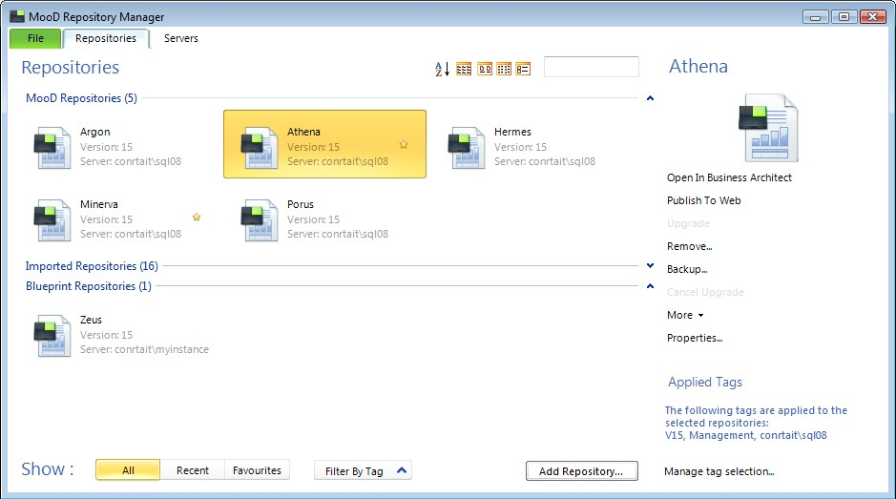
Repository Manager typically opens at its Repositories tab. This lists the repositories you can see.

Note: When you open Repository Manager for the very first time, it won’t know about any servers and, consequently, the Repositories tab won’t list any repositories. If this is the case, see Adding a database server on page 38.

If all your repository icons appear brown (sepia), the schema has changed. See About schemas on page 7 for details (you need to upgrade each repository to the new schema (this is irreversible)).

9

Importing older repositories when Repository Manager starts
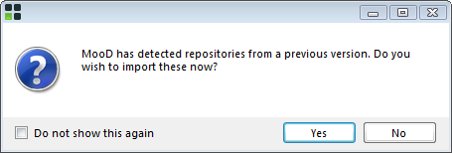
On starting, if Repository Manager detects older (pre MooD 15) repositories (including Access repositories), it displays this message:
If you import the detected repositories, they will appear in an Imported Repositories group on the Repositories tab. You can then upgrade imported repositories as required.
If you choose not to import repositories, Repository Manager will continue to offer the option on opening unless you select the check box disabling this. Even then, you can use the Connection and Access tabs on the expanded Add Repository dialog box to find, import, and upgrade older repositories. See More ways to add a repository on page 32 for details.

10

Opening a repository in Business Architect
Often you will only use Repository Manager to open a repository in Business Architect.

Task 1 To open a repository in Business Architect:
- On the Repositories tab, do one of the following:
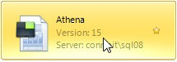
  - Double-click the repository.
  - Right-click the repository, and then click Open in Business Architect.
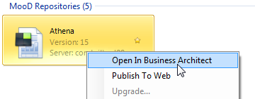
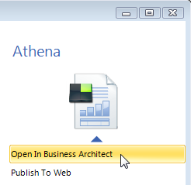
  - Click the repository (this selects it), and then, in the list of commands on the right hand side of the Repositories tab, click Open in Business Architect.

Note: If you need help on how to use the Repositories tab to find a repository, see The Repositories tab on page 18.

The Open dialog box is displayed.

11

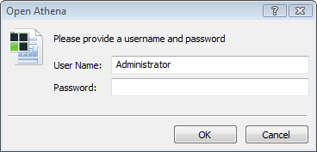
- Type your password, and then click OK.

Note: If you have not been given a password, try opening without a password before you contact your system administrator.

Business Architect will open the repository. You will see a progress message.

12

The File tab
The File tab is the administration point for MooD and Repository Manager. Use the File tab to:
  - Find information about your installation, and contact details for MooD International. For example, click About to see your node id.
  - Manage your licence.
  - Manually start the Repository Manager service.
  - View stored credentials.
  - View Repository Upgrade Manager.
  - View log files.
  - Exit Repository Manager.

Note: You cannot open a repository from the File tab. To do this, use the Repositories
tab.

Manage your licence
Your MooD licence can be:
  - A licence file supplied directly to you that you will use to license your installation. This is a fixed licence associated with your machine’s node id. To see the node id, click About.
  - Centrally held and administered by a licence server. In this case, Repository Manager connects to the server and requests a licence from the pool available. Such licences are checked out to you for a period of time, for example 24 hours, after which Repository Manager will request another. You can choose to check in a licence when Repository Manager closes.
Your system administrator will advise you of how your MooD software is licensed.
If you need to install a licence, open Repository Manager as an administrator (right click and

Run as administrator).
The Manage Licence button on the File tab opens the Manage Licence dialog box shown next:

13

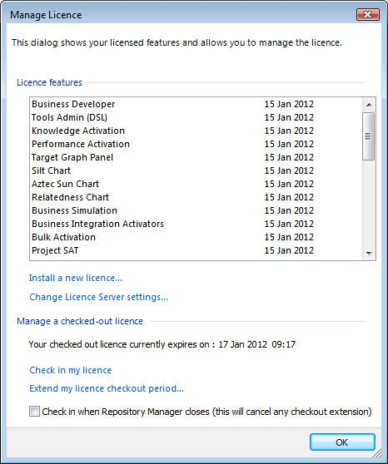
Here you can:
  - See what features are licensed.
  - Use the Install a new licence command to open the Install MooD Licence dialog box where you can select and install a MooD licence file.
  - Use the Change Licence Server settings command to check, and if necessary change, your licence server’s name and port number. This opens the Licence Server Settings dialog box shown next:

14

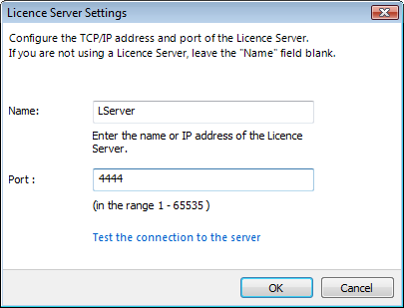

Note: To change the Name or Port settings, you must run as an Administrator. If
you aren’t, the dialog box will say so and instruct you how to run as Administrator.

  - Manage a licence that has been checked out (issued) from a licence server. The dialog box shows when the currently checked out licence will expire. You can:
    - Use the Check in my licence command to return the licence slot and make it available to others.
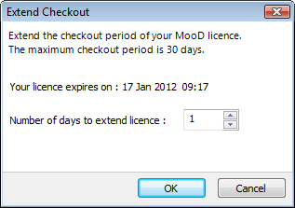
    - Use the Extend my licence checkout period command to add more days to the currently checked out licence. This opens the Extend Checkout dialog box shown next:
This is useful if you are going offline and will be unable to connect to the licence server to automatically renew an expired licence. The maximum extension is 30 days.
    - Select the Check in when Repository Manager closes (this will cancel any checkout extension) check box. This makes the licence available to others.

15

Manually start the Repository Manager service
Repository Manager runs a Windows service in the background. It should not require user intervention. However, some systems can be configured to prevent services starting automatically, or a system administrator might disable a running service for some reason. If the service is not running, you are liable to get messages saying that a connection has been actively refused, or find that the Repositories tab doesn’t list any repositories. If you encounter this, use the File tab to check that the service is running.
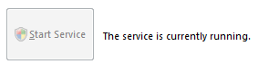
When the service is running normally, the File tab shows:
If the service is not running, use the Start Service button to start it manually.
If User Account Control (UAC) is enabled on your machine, you may be prompted to run the service as an Administrator. Allow this, and if there is a check box setting preventing modifications to your system, make sure it is cleared, that is, you must allow modifications.
If the service is running but then stops for some reason, a dialog box will inform you of this. It includes the option to restart the service.
Note: If the service is running but the Repositories tab shows no repositories, check that you are not filtering the list by too restrictive a set of tags. To see everything, on the Repositories tab, click All. If this isn’t the problem, use the Servers tab to ensure that the repositories on your servers are not all hidden (the Show and Hide buttons).

View stored credentials
Repository Manager stores users’ server authentication credentials, and clears them automatically when it closes (you can see them being used in the expanded Add Repository dialog box). To see what is currently stored, on the File tab, click View Stored Credentials. This displays the View Stored Credentials dialog box where you can manually clear credentials.

View log files
Repository Manager creates log files for any repositories it imports and upgrades. Use the View Log Files button on the File tab to view these log files in the lower part of the File tab, for example:

16

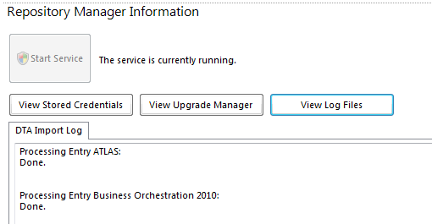

17

The Repositories tab
Use the Repositories tab to manage your repositories and open them in Business Architect.

Key points about using the Repositories tab:
  - Repositories are listed in groups: MooD Repositories, Blueprint Repositories and
Imported Repositories. You may not have the last two.

Note: If no repositories are listed, check that Repository Manager knows about at least one server. See The Servers tab on page 36 for details.

  - To the right of the list of repositories, there is a list of commands. These are valid commands for the currently selected repositories.
The name of the currently selected repository (if any) is shown above the list of commands. If more than one repository is selected, it states Multiple Selection.
The various commands are covered in the following sections:
    - Upgrading repositories (page 22)
This includes upgrading MooD 15 repositories to a newer schema, and upgrading pre MooD 15 repositories.
    - Backup a repository (page 23)
    - Remove or delete a repository (page 24)
    - Publish a repository to the web (page 25)
    - Validate a repository (page 25)
    - Integrate a repository into another repository (page 25)
    - Fix index fragmentation (page 25)
    - Change the image used for a repository (page 25)
    - Make a repository a blueprint (page 25)

18

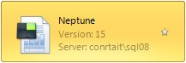
  - The selected repository has a coloured background:
    - If you see a brown (sepia) icon, it means that the repository is on a different schema and needs to be upgraded.
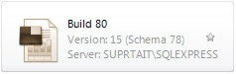
  - To select all of the repositories in a group, click the group name. For example, MooD Repositories. You can also use the Shift and Ctrl keys with the mouse to select multiple adjacent or non-adjacent repositories respectively.
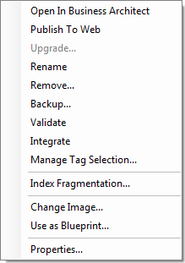
  - Right-click a repository to get its shortcut menu. In addition to commands that can be found on the Repositories tab itself, this menu includes a command to see the repository’s properties, the Rename command (F2 is the shortcut key for this), and another way to access and manage the tags associated with the repository.
The Renaming repositories (the display name only) section on page 21 and the Advanced repository properties section on page 22 include some information on the Properties dialog box.
  - Double-click a repository to open it in Business Architect. You can also open it using the list of commands, or the shortcut menu.
  - Click the star icon to toggle whether the repository is tagged as a favourite. A coloured star means it is. You can use the Favourites button to filter the repositories list accordingly. Both are shown here:

19

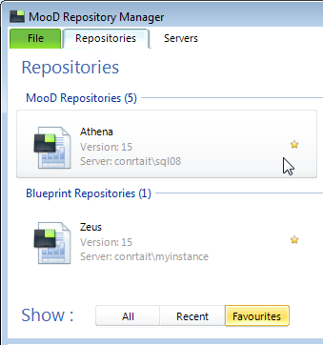
  - There are several features on the Repositories tab to help you find a repository:

o
Use these controls to sort alphabetically, switch between four views, and to filter by the starting character(s) of the repository name. (In this guide, the images show Tile view throughout (the third of the four views).)
    - The Show section. Use this to filter the list of repositories. Two standard filters are available: Recent (within 3 days), and Favourites. The All button removes any filters and shows you all visible repositories (note that some may still be marked on the Servers tab as hidden and not shown).
In addition, you can filter by tag. Tags are keywords that you apply to repositories. Some system tags are created and applied automatically, for example, MooD version and the server that each repository is located on, and you can add your own. For instance, you might want to create tags for each project.
If you click the Filter By Tag button to expand the Show section, you can select tags and filter the repositories list. Note that filtering by tag applies to what is currently shown (so if Favourites is selected, the filtering applies only to repositories marked as favourites). When the list is filtered, the Filter By Tag button changes to Tags Selected, and is coloured to match the currently selected tags, as shown here:

20

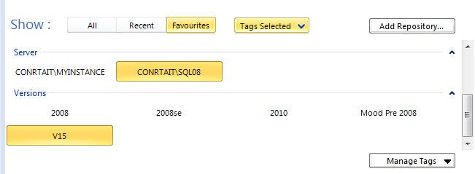
Click All to remove the tag filtering (and change the button back).
Use the Manage Tags button (revealed when the Show section is expanded) to create and manage your own tags.
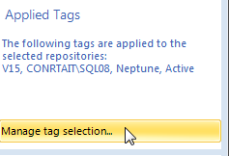
The Applied Tags section in Repository Manager’s lower right corner (shown in the following image) shows you the tags applied to the currently selected repositories. Use the Manage tag selection link to alter this set of tags.
See Using tags to filter the list of repositories on page 27 for more information.
  - There is also an Add Repository button. See Creating a repository on page 31 for details.

Renaming repositories (the display name only)
You can right-click a repository, and then click Rename (you can also use F2). This only changes the display name on the Repositories tab. It does not rename the underlying database or its name on the Servers tab. These remain set to the name given when the repository was created. The repository’s expanded Properties dialog box (also available on the shortcut menu) includes both the display name and the name on the server (shown ringed in the following image):

21

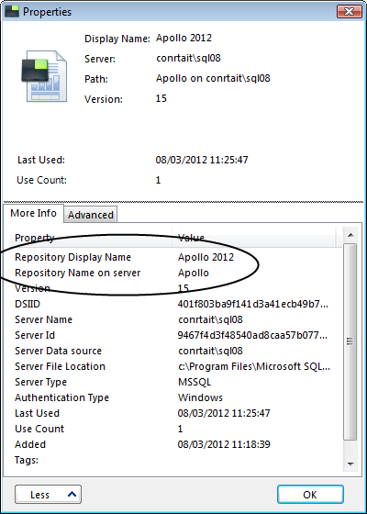

Advanced repository properties
A repository’s expanded Properties dialog box (shown in the previous image) includes an
Advanced tab. This includes the following settings:

Query Timeout
This is the length of time that a query has to start returning values. If queries are timing out, increasing this can help.

ODBC Parameters
Additional ODBC parameters can be added here.

Upgrading repositories
You are likely to perform two types of upgrade:
  - Upgrade MooD 15 repositories to a newer schema.
  - Upgrade pre MooD 15 repositories to MooD 15.

Both are covered below. Before you upgrade anything, ensure that you have a backup. Also make sure no one is using the repository.

22

Upgrading to a new schema
Repositories that don’t match the schema of your current MooD 15 build appear in brown (sepia) and cannot be opened unless upgraded. Once you upgrade a repository to a new schema, you cannot change it back.
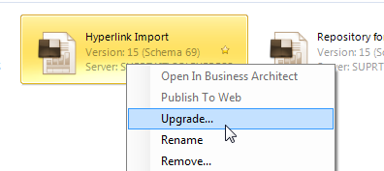
To upgrade, right-click the repository and select Upgrade.
See About schemas on page 7 for more information on schemas.

Upgrading from an earlier (pre MooD 15) version of MooD
When you upgrade repositories from earlier versions of MooD, it opens Repository Upgrade Manager. If you are upgrading multiple repositories, you can control their order in the upgrade queue.
To upgrade, right click the repository and select Upgrade.
If you want to upgrade a repository from a release earlier than MooD 2010, the following table tells you how.

Table 1. Pre MooD 2010 versions and how to upgrade them

MooD 2008SE
This is the same process as upgrading from MooD 2010. Use the Upgrade command, as described in the following task. Ensure that you have a backup of your original repository.
MooD 2008 and earlier
Use MooD 2010 to upgrade the repository to MooD 2010, and then use MooD 15 to upgrade the 2010 version to MooD 15. Ensure that you have a backup of your original repository.

Backup a repository
Use the Backup command on the Repositories tab to create a backup of a selected SQL Server repository. Backup files are Mssql backup files with a .bak file extension. You can easily restore SQL Server repositories from their backup file.
Note: The Backup command is currently restricted to SQL Server. Oracle backups must be made independently.

Task 2 To backup a repository:
- On the Repositories tab, select the repository you want to backup.

23

- In the list of commands, click Backup.
The Backup MooD Repository dialog box is displayed.
- In the Backup Destination box, type the path to the backup file, or click the Browse
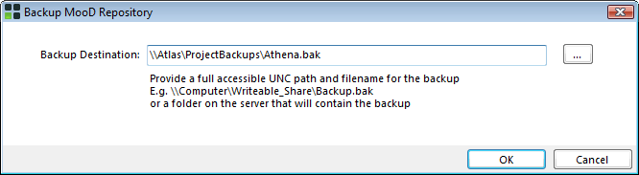
button to select a location. Include the filename and extension.
- Click OK.
The backup is created at the given location.

Restoring a repository from a backup
To restore from a backup file, on the Repositories tab, click the Add Repository button. Then click Click here to see more ways to add a repository to expand the Add Repository dialog box. Use the Backup mini tab to find and select the backup file you want to restore. See More ways to add a repository on page 32 for details on the expanded Add Repository dialog box.
Note: You can also drag a backup file (.bak) from Windows Explorer and drop it into a group on the Repositories tab. This displays the expanded Add Repository dialog box with the Backup mini tab already set. The .bak must be in a location that SQL Server has permission to access.

Remove or delete a repository
The Remove command on the Repositories tab lets you choose between removal and deletion. Removal only hides a repository so that it no longer appears on the Repositories tab. It does not affect the actual repository, and the repository can be reconnected later. Deletion deletes the actual repository. Deletion is irrevocable.

Restoring a hidden (removed) repository
To restore a hidden repository, do one of the following:
  - Use the Servers tab to look at hidden repositories, and then use the Show button to make it visible on the Repositories tab. See The Servers tab on page 36 for details. This is the simplest way, and it allows you to look for hidden repositories on different servers.
  - If the repository is on the default server, on the Repositories tab, click the Add Repository button. Then, click Click here to see more ways to add a repository to expand the Add Repository dialog box. Use the Connection mini tab to find and select the repository you want to restore. See More ways to add a repository on page 32 for details on the expanded Add Repository dialog box.

24

Publish a repository to the web
The Publish To Web command, on the Repositories tab, lets you statically publish repository content to your intranet or to the web. It prompts for authentication, and then opens MooD Web Publisher. This is a wizard that guides you through the process, letting you select what parts of the repository you want to publish. Web Publisher has its own help.

Validate a repository
The Validate command, listed in the More group on the Repositories tab, lets you validate, or validate and fix, issues in a repository. It prompts for authentication, and then opens MooD Repository Validator. This is a wizard that guides you through the process.

Active Enterprise
As part of the process to make a repository interactively available on the web, before you cache a repository in Business Integration Engine (BIE), you should validate it. (BIE is a component that, along with Active Publisher, serves up a web version of a repository, and manages communication.)

Integrate a repository into another repository
The Integrate command, listed in the More group on the Repositories tab, lets you compare two repositories, and, if required, merge one repository into another. It opens MooD Integrator and sets the selected repository as the source repository. This simple application lets you compare and merge all or selected repository elements from the source repository into a target repository. You set the target repository within MooD Integrator.
Note: You can also, on the Repositories tab, drag one repository (the source) and drop it onto another (the target). This opens MooD Integrator set accordingly.

Fix index fragmentation
Database indexes can become fragmented over time. This affects performance. The Index Fragmentation command, listed in the More group on the Repositories tab, lets you defragment SQL Server indexes and improve their performance. It opens the Fragmentation dialog box for the selected repository. Click its Defragment All button to fix the indexes.
Note: Oracle maintains its own indexes, and hence won’t benefit from defragmentation through Repository Manager.

Change the image used for a repository
The Change Image command, listed in the More group on the Repositories tab, lets you change the image used for a repository in Repository Manager. It opens the Change Picture dialog box. Use this to find the image file you want to use.

Make a repository a blueprint
A repository can be used as a blueprint for new repositories. The Use as Blueprint command, listed in the More group on the Repositories tab (or on a repository’s right-click shortcut

25

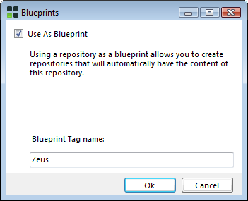
menu), lets you toggle whether a repository acts as a blueprint. It opens a dialog box confirming the addition or removal of blueprint status from the selected repository, and, when adding blueprint status, it lets you add a tag.
If you have blueprints, the Repositories tab will include a Blueprint Repositories group, as shown here:
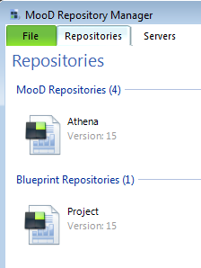
You create a repository from a blueprint using the expanded Add Repository dialog box’s
Blueprint tab:

26

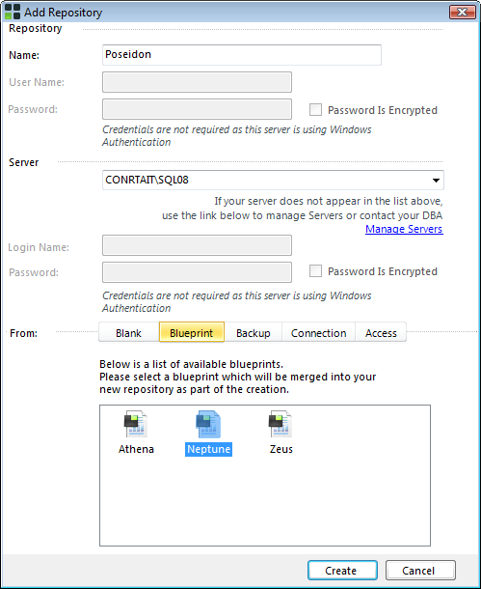
See Creating a repository on page 31 for general details, and More ways to add a repository on page 32 for information on the expanded Add Repository dialog box.

Using tags to filter the list of repositories
Tags are keywords that describe and classify repositories. Tags help you organize and find repositories as you can use them to filter what is shown on the Repositories tab. Some system tags are created and applied for you, including the MooD version number, and the server that each repository is located on. You can also add and apply your own tags. For example, you could tag repositories by project name.
In the Repositories tab’s Show section, if you click the Filter By Tag button:
The Show section expands to reveal your tags organized by group.

27

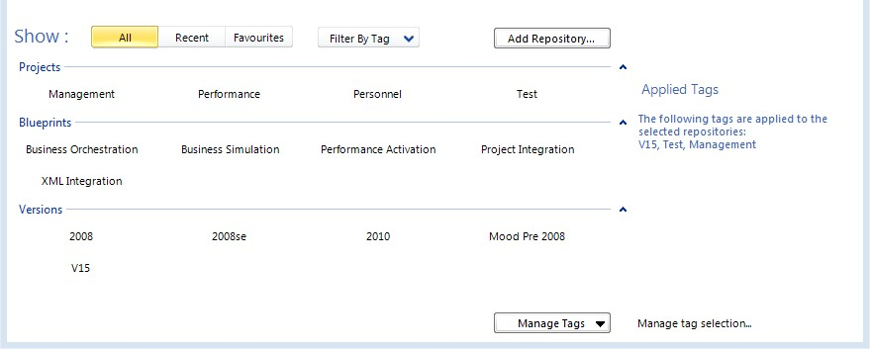

Note: If the list of repositories is currently filtered, the Filter By Tag button appears as
Tags Selected, and is coloured. It too expands the Show section and reveals what tags are selected. To remove any filtering, click the All button.

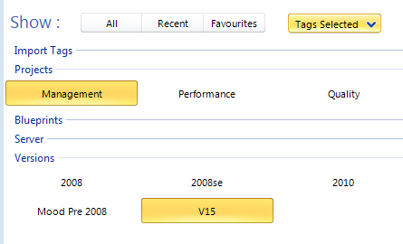
Click a tag to filter the list of repositories by that tag. The tag itself is highlighted to show that it is being applied, and the Manage Tags button changes to Tags Selected. For example:

Note: Tag filtering applies to what is currently shown. For example, if Favourites is selected, any tags that you select will filter the repositories marked as favourites.

You can filter by multiple tags:
  - Use the Shift key with the mouse to select adjacent tags.
  - Use the Ctrl key with the mouse to select non-adjacent tags.
  - Click the name of a tag group to select all the tags in that group.
When filtered by multiple tags, the repositories list only shows those repositories that have all
of the selected tags.
The Applied Tags section in Repository Manager’s lower right corner shows you what tags are applied to the currently selected repositories. For example:

28

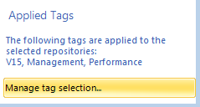
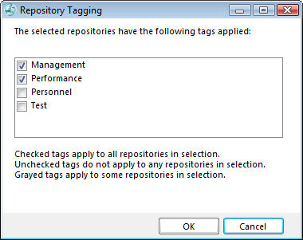
Use the Manage tag selection link to open the Repository Tagging dialog box.
Use this to add and remove tags for the selected repositories.

Note: The Repository Tagging dialog box only lets you apply manually added tags. The automatic tags, such as MooD version number, cannot be manually applied or removed.

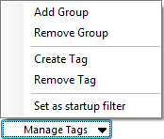
When the Show section is expanded, there is a Manage Tags button. This gives you the following menu:
The key points about these commands are:
  - When you create a tag, you must assign it to a group. Hence, before you use Create Tag, use Add Group to create any additional tag groups you require (although if you type an unknown name into the Tag Group field on the Create a Tag dialog box (shown in the following image) instead of selecting one from the drop-down list, Repository Manager will offer to create that group for you).

29

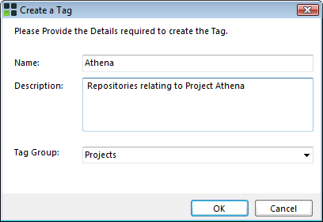
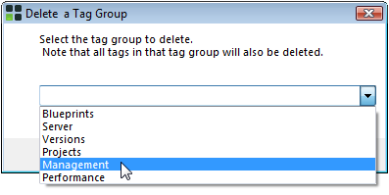
  - Remove Group opens the Delete a Tag Group dialog box. Use this to select a non system group and delete it and all of its tags.

Note: You can only delete groups that you have created. Although you can select one of the system groups (such as Blueprints), this will only delete the tags that you have added to that system group. The default system groups and their default tags cannot be deleted.

  - To remove a tag, select the tag you want to remove, and then click Remove Tag. You will be prompted for confirmation. Repository Manager will not let you remove system tags.
  - A startup filter can be applied each time Repository Manager starts. To set a filter, apply the tags you want, and then click Manage Tags to open the menu. Then click Set as startup filter.

30

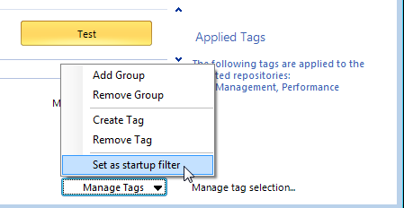
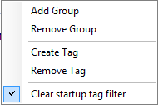
This sets the filter to the currently applied tags, and the command toggles to:
Only those repositories with all the tags in the startup filter will appear on the
Repositories tab.

Note: If you start Repository Manager and the Show section has a coloured Tags Selected button instead of an uncoloured Filter By Tag button, a startup filter is in effect.

Creating a repository
The Repositories tab has an Add Repository button. This displays the Add Repository dialog box, which can be used as presented to quickly create a basic repository on the default server, or expanded to offer more possibilities, including control over the server, and creating a repository from a blueprint or backup.

Creating a repository on the default server
The quickest way to create a repository is to use the Add Repository button on the Repositories tab to create it on the default server. The default server is set on the Servers tab (it is the server with the icon beside it).
Note: The Servers tab includes a Create Repository on this Server button. This behaves like Add Repository described in the following task, but lets you select any listed server beforehand.

Task 3 To create a repository on the default server:
- On the Repositories tab, click Add Repository.

31

The Add Repository dialog box is displayed. It will include a default name based on the date and time.
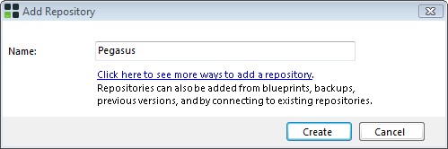
- If you want to alter the default name, in the Name box, type a name for the repository.
If you type an existing or invalid repository name, or include invalid characters in a name, it appears in red, the Create button is disabled, and an alert icon appears. Depending on the type of server you are creating the repository on, certain words and characters are invalid, and there may be a length restriction. A tooltip will explain the naming requirements for your server, or warn you that a repository of that name already exists. For example:
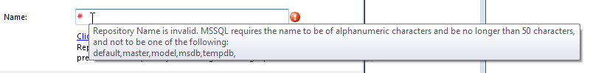

Note: If you get an error saying that the repository already exists, but you cannot see it listed on the Repositories tab, use the Servers tab to see if it is a hidden repository. See The Servers tab on page 36 for details.

- Click Create.
Repository Manager creates the repository.
To see the newly created repository, you may have to refresh the list of repositories. You can:
  - Move to another tab and then return to the Repositories tab. This refreshes the list, and preserves any filtering you have applied.
  - Click the All button. This refreshes the list, but removes any filtering you have.

More ways to add a repository
The Add Repository dialog box includes the link Click here to see more ways to add a repository. This expands the dialog box to show more options, as shown in the following image.

32

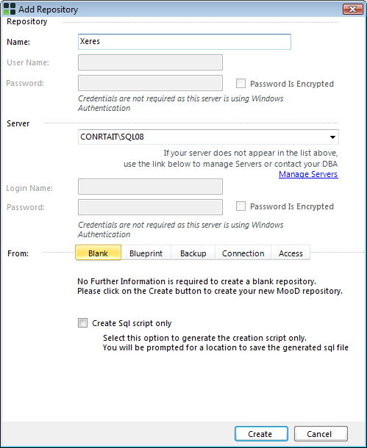
The following table includes the key points about the expanded Add Repository dialog box.

Table 2. The expanded Add Repository dialog box settings

Repository section
User Name and Password are only enabled when Windows Authentication is not being used. When enabled on SQL Server, they default to AUTHOR/AUTHOR (the MooD defaults), but you can change this. When enabled, the dialog box changes to guide you, as shown here:
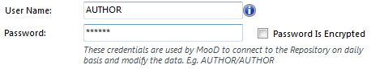
On Oracle, User Name is not required and is always disabled.

33

Server section
Specifies the database server that the repository will be created on. The drop-down list lets you select a server from a list of those already added. If the server you want has not been added yet, click the Manage Servers link to go to the Servers tab, and see Adding a database server on page 38 for details.
If the server uses SQL Authentication, the Login Name and Password fields are enabled. Again, the dialog box changes to guide you:
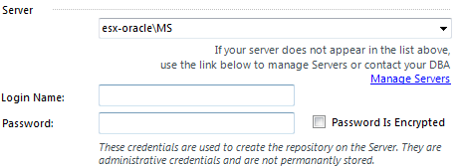
These are the security credentials for the database instance that the repository will be created in. Repository Manager can detect if they are cached on the server and auto complete them. Repository Manager only stores credentials for the time it is running. You can clear them during this time by means of the File tab. See View stored credentials on page 16 for details.
From tab sections
This section of the dialog box gives you different ways to add a repository. The visible (coloured) tab section is the one used. Click the tabs to choose between the following:
Blank | 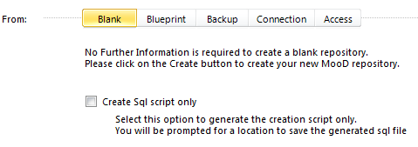  Use this to create a default repository on the selected server.  You can also create a SQL script only. This does not create a repository. It creates a script that you can subsequently use within your database management software to create a default repository. This devolves the actual creation of a repository to your database software.

34

Blueprint | 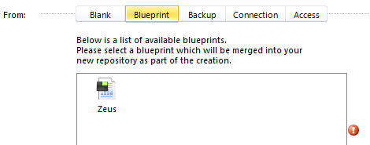  This creates a new repository based upon a blueprint repository (the alert icon stays until you select one of the listed blueprints).  Blueprints are listed in the Repositories tab’s Blueprint Repositories section, and if you right-click any repository on that tab, you can make it a blueprint.
Backup | 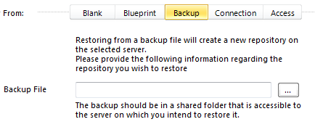  Create (restore) a repository from a SQL Server backup. You can use the Repositories tab to create backup files (.bak). See Backup a repository on page 23 for details.
Connection | 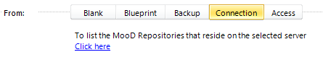  If you have existing repositories on a server, you can use this to add one to Repository Manager.
Access | 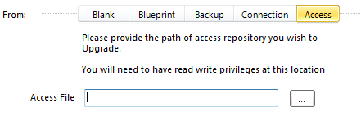  Access repositories were supported in earlier releases of MooD. This lets you upgrade Access repositories to be SQL Server repositories that you can work on in this version of MooD.

35

The Servers tab
Before Repository Manager can list available repositories on the Repositories tab, it must know what servers you have. The Servers tab lists the servers that you have repositories on. Once a server has been added, it is listed on the Servers tab until it is removed.
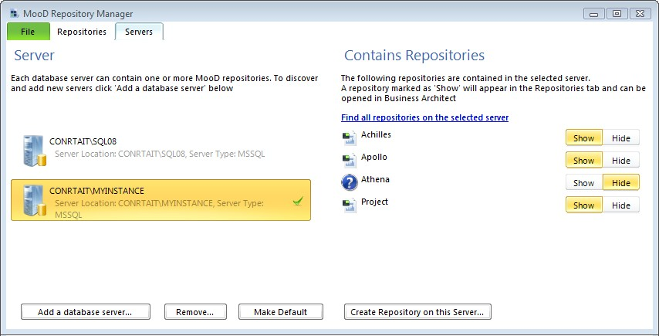

Note: When Repository Manager closes, it remembers what servers it knows about.
The only time you have to add a server is when you first install MooD, when you have a new server and want to add it, or when you want to add a previously removed server.
Key points about using this tab:
  - The Server side lists servers that have been added, and the Contains Repositories
side lists repositories held on the selected server.
See Adding a database server on page 38 for details on adding servers to Repository Manager.
  - The server with the icon beside it is the default server. When you use the Add Repository button on the Repositories tab, this is the server that the repository is created on (unless you expand the Add Repository dialog box and change it).
    - Use the Make Default button to make the selected server the default server.
  - Double-click a server to list the repositories on that server. (This is the same as the Find all repositories on the selected server link in the Contains Repositories side of the Servers tab.)
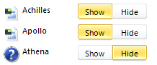
  - Each repository listed on the Contains Repositories side has Show and Hide buttons.

36

Use these to control what repositories appear on the Repositories tab (coloured means selected).
  - When you remove a server, you are only removing it from the Server list. This removes its repositories from the list of repositories that Repository Manager knows about (and can make available on the Repositories tab). The Remove button does not delete the actual server or the repositories on it. You can use the Add a database server button to add it again.
  - The Create Repository on this Server button behaves in the same way as the Add Repository button on the Repositories tab, but it creates the repository on the selected server. See Creating a repository on page 31 for details.
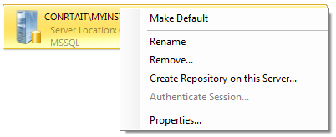
Right-click a server to get its shortcut menu:
This includes some of the commands available on the tab itself. The key points about the additional commands are:
  - The Rename command changes the display name only. It does not change the name of the actual server.
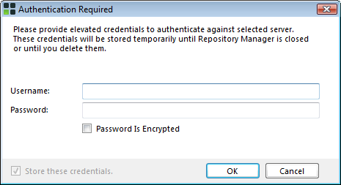
  - If the server does not use Windows Authentication to access the database instance, the Authenticate Session command will be enabled. This displays the Authentication Required dialog box shown here:
Use this to test the login credentials for the database instance on the server. These are the same as the Security credentials supplied when the server was added by means of the Add Server dialog box. See Adding a database server on page 38 for details.
  - Use the Properties command to display the Server Properties dialog box, for example:

37

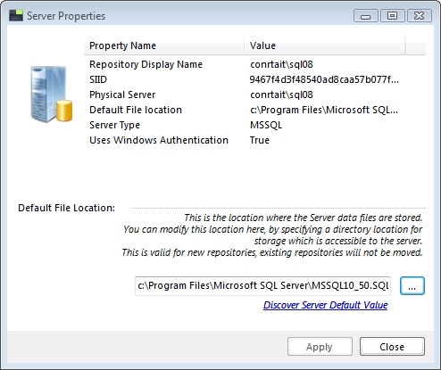
If the server does not use Windows Authentication, this dialog box includes an Encrypt Password command. Use this to encrypt the server’s authentication credentials, and get a password for that encryption copied to your clipboard. These can then be used on the expanded Add Repository dialog box in conjunction with the Password is Encrypted check box, or with the Authentication Required dialog box shown in the previous bullet point.

Adding a database server
Before Repository Manager can be used to manage repositories, it must know what servers to look for repositories on.
Servers are SQL Server or Oracle databases that have been set up to hold repositories. Your system administrator will know what servers you have.

Task 4 To add a database server:
- On the Servers tab, click Add a database server.
The Add Server dialog box is displayed.

38

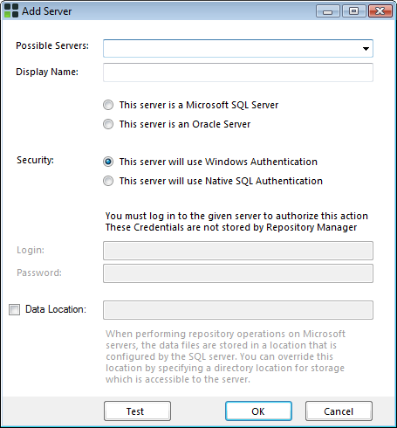
- Complete the Add Server dialog box. To help you:

Table 3. Add Server dialog box settings

Possible Servers | Type the server’s name in this box, or use the drop-down to select a server from a list of those available on the network.
Display Name | A display name for server. This is the name that will be used within Repository Manager. It defaults to the server’s name. However, you can change this to provide a more descriptive name. The server’s name on the network does not change.
Server Type | Set this to the type of database installed on the server. Choose between Microsoft SQL Server and Oracle.
Security  Including Login and Password | SQL Server or Oracle will be configured to use either Windows Authentication or SQL Authentication to determine if a user has permission to create or modify databases on the server. Your SQL Server or Oracle database administrator should advise you which.  If Security is set to SQL Authentication, use the Login and Password fields to supply login credentials for the database. Repository Manager will use this information to access the SQL Server or Oracle database software on the server. It is not the user name and password for a MooD repository.

39

 | If Security is set to Windows Authentication, the user’s Windows login credentials are used to authenticate their access to the database software. Hence, the Login and Password fields remain disabled.
Data Location | This depends on whether the server is Oracle or SQL Server:  - SQL Server. Use this optional setting to override the default data location selected by SQL Server. You must select an accessible location on the server.  - Oracle. You must set this to an accessible location on the server. If Server Type is set to Oracle, Data Location is selected by default, and the prompt changes to:  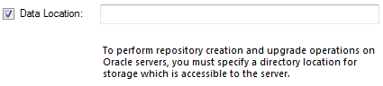  You can use the Servers Properties dialog box (on the Servers tab, right-click a server, and then click Properties) to change this location. (Any change applies to new repositories. The data for any existing repositories will not be moved.)
Test button | Use this to validate a server before attempting to add that server. This tests your login credentials.
- Click OK.
Repository Manager will add the server and, if successful, it will appear on the Servers
tab.
Once the server is listed, you can select it, and then use Find all repositories on the selected server to see what repositories it holds, and whether they are visible on the Repositories tab.

40

