MooD 15
Epochs – Configuration and Use
This document describes the role of epochs within MooD, and how they enable solutions to track performance measures over months, years or arbitrary periods.

Document Number: MooD15EPOCH57

© 2013 MooD Enterprises Ltd, all rights reserved.

Notice of Copyright and Trademarks
MooD 15 Epochs – Configuration and Use
® MooD, MooD Smarter Decisions, Performance Activation, Synchronization Activation Technology and Knowledge Map are registered trademarks of MooD Enterprises Ltd. in the United Kingdom and / or other countries.
Microsoft and Windows are trademarks of Microsoft Corporation in the USA and other countries.
Rights to all other referred trademarks or registered trademarks reside with their respective owners.
Aspects of the Enterprise Business Model, Model-Driven Data Aggregation and Business Solutions to Support Smarter Decisions are protected by International Patent and Patent Pending. These include the Meta-Architecture Framework, Panels Technologies, Auto- Explorer, Business Orchestration, the Activator mechanism, Process Driven System, Performance Activation, Model-Driven Enterprise Management, Dynamic Aggregation, Smart Columns, the Variant Mechanism, and other technologies and mechanisms implemented within MooD Business Architect and MooD Active Enterprise.
© MooD Enterprises Ltd., all rights reserved. No part of this document may be reproduced by any means, or transmitted, or translated into machine language without the written permission of the company.

2

Contents

About this guide 5
Introducing epochs 6
Epochs and measures (what epochs are for) 6
Calendar epochs and custom epochs – the Epochs library 7
The current epoch 8
Setting the current epoch 9
The Configure Epochs dialog box 9
A reminder of how to create a measure 11
Creating and applying epoch aware measures 12
Creating an epoch aware measure 12
About applying epoch aware measures to elements 12
Manually applying epoch aware measures in Business Architect 13
Using SAT to apply and update epoch aware measures 16
The Microsoft Excel Import synchronizer 17
The Create Measures synchronizer 19
The Copy Measures for Epochs synchronizer 20
Epoch functionality in MooD 21
Epochs in queries 21
Find blocks for epochs 21
Using an And Finally block to order epoch measure instances 22
Epochs in aggregations 23
Date Grouping levels in Aggregation matrices 24
Avoid And Finally order by blocks in queries used in aggregations 26
Controlling how epochs and epoch measures are named in aggregations 26
DATE TIME functions in Fact Builder 27
Epochs in charts, Info panels and matrices (excl. Aggregation) 28
Ordering 28
3
Naming 28
The Epoch Picker action panel 29
The Current Epoch session variable 30
FAQ 31
How do I get the last few months? 31
My epochs aren’t in chronological order on my chart? 31
How do I group by epoch in an Aggregation matrix? 32
How do I change the current epoch? 32
What does an epoch modifier do? 32
How do epoch modifiers work with custom epochs? 33
How can I get the current epoch in Active Enterprise 33

Tasks
Task 1 To manually apply a measure to an element 13

Tables

Table 1 Find blocks for epochs 21

Figures
Figure 1 How to create measures 11

4

About this guide
This guide has four main sections:
- Introducing epochs (page 6)
What epochs are, and their location and purpose in MooD.
- Creating and applying epoch aware measures (page 12)
How to create and apply epoch aware measures manually and by means of synchronizers.
- Epoch functionality in MooD (page 21)
Once you have epoch aware measures applied to elements, how to make use of them.
- FAQ (page 31)
Some frequently asked questions on epochs in MooD.

5

Introducing epochs
This section will help you understand epochs and their purpose. This material is useful to know before you start trying to use epochs. It is divided into the following sections:
- Epochs and measures (what epochs are for)
- Calendar epochs and custom epochs – the Epochs library in Business Architect’s Explorer Bar (page 7)
- The current epoch (page 8)
- The Configure Epochs dialog box (page 9)
- A reminder of how to create a measure (page 11)

Epochs and measures (what epochs are for)
Within Mood, an epoch is a period of time, for example, 2013, July 2013 or Phase 1. Epochs are used by measures and give you measure instances for epochs, for example:

Project.Cost.Dec 2012
- Project.Cost.Jan 2013
- Project.Cost.2012
- Project.Cost.Phase 1
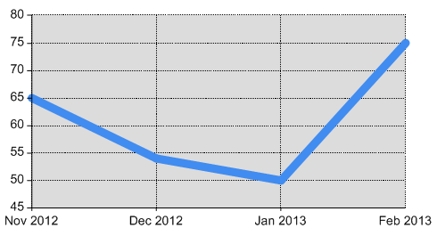
Each of these measure instances holds the measure’s value for that epoch. This allows you to measure and represent performance over time. For example, the following Line chart and Aggregation matrix both use the same measure instances:

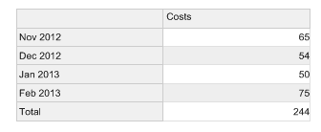
If a measure type is epoch aware, when you apply that measure to an element, you get to select the epochs that measure instances will be created for. You can choose between standard calendar epochs (months and years) and custom epochs.

6

Calendar epochs and custom epochs – the Epochs library
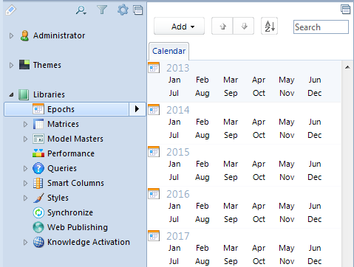
As shown in the next image, Business Architect’s Explorer Bar has an Epochs library that includes default calendar epochs, and any custom epochs that have been defined (by default, none are included).
By default, each repository includes a forty year span of month and year epochs (twenty years plus and minus today). These are the only epochs supplied as standard. You can use the Configure Epochs dialog box to control the span generated (see page 9 for details on this dialog box).
Epochs are elements. This means that a year epoch is the parent of its months, and all months are siblings of each other (the Find sibling epochs query construct relies on this, and if you have a month epoch, Find Parent will give you the year).
Note: Although there are no day, week or quarter epochs supplied as standard, if you are creating an Aggregation matrix, several Date Grouping levels are available, including, for example, Day of Week, Week Commencing and Quarter Name. See Date Grouping levels in Aggregation matrices on page 24 for details.

You can create custom epochs for specific periods of time or for abstract state changes. For example, project phases each lasting 10 weeks, or product maturity phases. Points to note about custom epochs:
- Custom epochs must belong to an epoch group. Hence, you must add at least one epoch group before you can add a custom epoch.
- To create a custom epoch, you simply add one, give it a meaningful name and, if required, set its start and end date. Custom epochs do not have to include dates. For example, you might have four project phases that are applicable to all projects.
- If you use custom epochs with an epoch modifier, the modifier relates to the order of the custom epochs within their group. You can move custom epochs within an epoch group.

7

The current epoch
MooD always has the concept of the current epoch. This defaults to the current month (you can change this), and it is widely available for use within Business Architect as <the current epoch>. It is the default working epoch and you can include it in queries.
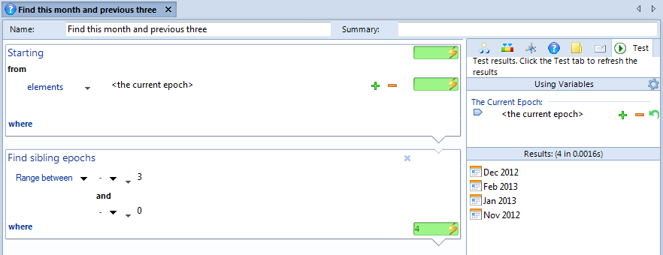
The following example illustrates the usefulness of this concept. In this query, <the current epoch> is used as a starting point to find the current month and the previous three.
Queries like this one are the basis for many controls that show rolling performance. For example, in this next image, this query is used within another query to return rolling measure instances (both the element and measure type can be pinned making this a widely reusable query construct).
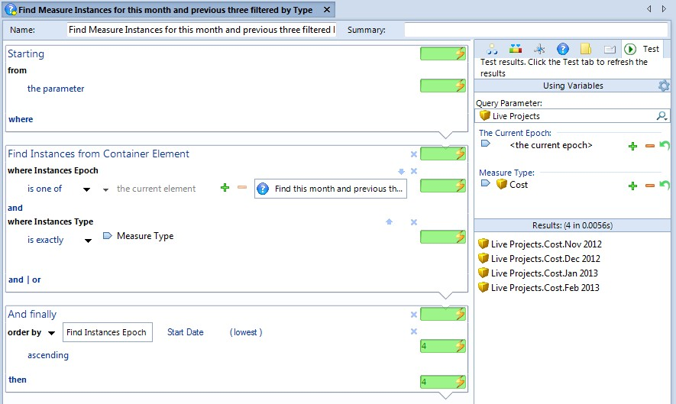

Note: The preceding examples use epoch related Find blocks, and an And Finally block to order the epoch measure instances. See Epochs in queries on page 21 for information on these and more.

8

Setting the current epoch
As mentioned, the current epoch typically defaults to the current month. However, you can control this:
- The Configure Epochs dialog box lets you set the current epoch from a query executed each time the repository is accessed. See the next section for details on this dialog box.
- In the top right corner of the Business Architect window, click Current Epoch. This lets you change the month that Business Architect is using as the current epoch.
- Many panels include The Current Epoch on their Inputs tab (on the flip side). You can pin this to an element or control. Typically, The Current Epoch field is accompanied by a plus or minus epoch modifier. This is plus or minus the epoch’s unit (months or years), or for custom epochs, relative to its position in its epoch group.
- There is a Current Epoch session variable that you can use in Active Enterprise solutions. Add the Session Variables action panel to a model to access this.

The Configure Epochs dialog box
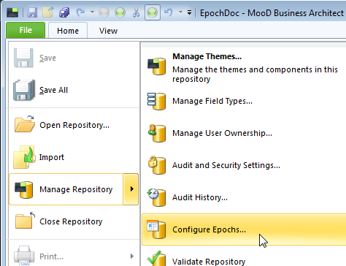
As shown in the next image, to display the Configure Epochs dialog box, in Business Architect, click File, point to Manage Repository, and then click Configure Epochs.
This next image shows the Configure Epochs dialog box.

9

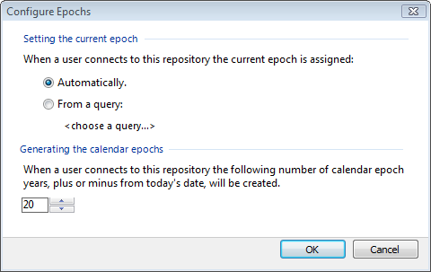
You can do two things:
- Specify a query that will set the current epoch. Automatically means set it to the current month (the default setting).
- Control the range of epochs that are created (and hence available) within the repository. By default, MooD creates calendar (month and year) epochs for 20 years either side of today’s date.
Note: If you delete epochs that are within this range, they will be recreated the next time the repository is accessed.

10

A reminder of how to create a measure
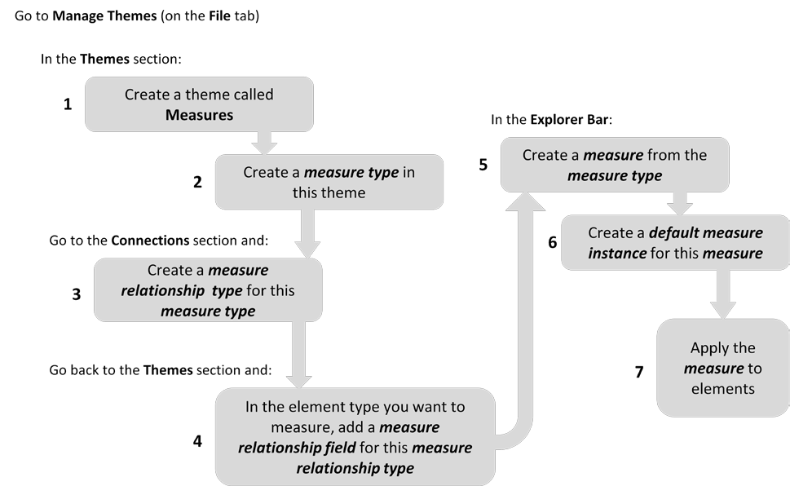
This following is taken from the MooD 15 Measures guide.

Figure 1. How to create measures
This process is applicable to all measures, however, the key stages for epoch aware measures are:
- Stage 2. This is where you must make the measure type epoch aware. By default, measure types are not epoch aware. See Creating an epoch aware measure on page 12 for full details on this stage.
- Stage 7. When you apply a measure to an element, you select the epochs that measure instances will be created for. See About applying epoch aware measures to elements on page 12 for full details on this.
The MooD 15 Measures guide is available for download (PDF) from the MooD International Support Portal.

11

Creating and applying epoch aware measures
Before you can make use of epoch measure instances in queries, aggregations and such like, you must create and apply epoch aware measures. You apply epoch aware measures to elements. This section covers this in the following sub sections:
  - Creating an epoch aware measure
  - About applying epoch aware measures to elements (page 12)
This gives you an overview of what’s possible and the processes involved. The remaining sections then go into detail.
  - Manually applying epoch aware measures in Business Architect (page 13)
  - Using SAT to apply and update epoch aware measures (page 16)

Creating an epoch aware measure

Important: You cannot change a non epoch aware measure type into an epoch aware one. You must always create a new epoch aware measure type.

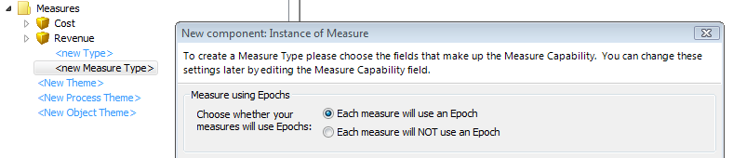
When you create a measure type, follow the standard process but ensure that the Each measure will use an Epoch setting is selected, as shown here:
See A reminder of how to create a measure on page 11 for an overview of this process or the
MooD 15 Measures guide (PDF) for full details.

About applying epoch aware measures to elements
Once you have epoch aware measures, you can apply them to elements. You can do this:
  - Manually in Business Architect by dropping the epoch aware measure into a valid measure relationship field. At this point you select what epochs you want measure instances created for.
    - Element inheritance is important here. When you add a measure to an element, you can choose to apply the measure to current and future descendant elements.
    - Regardless of which epochs you select, there is always the concept of the current epoch.
See Manually applying epoch aware measures in Business Architect on page 13 for an example task that illustrates this process and explains more of the detail.
  - With a degree of automation using SAT. You can use synchronizers to apply measure instances to elements. Specifically:

12

    - The Excel Import synchronizer has two layouts Epoch Grid and MooD Measure Instances specifically designed for different spreadsheet structures. These produce record descriptions that can be used with the Measure Instances target. This target is specifically designed for mapping to measure instances including epoch aware ones. There are also Month Epochs, Year Epochs and Custom Epochs targets available.
    - The Create Measures synchronizer creates measure instances on elements. This works with both epoch aware measures and standard measures. This was introduced in MooD 15 Build 57.
    - The Copy Measures for Epochs synchronizer lets you copy the existing measures from one epoch to another epoch, thereby creating the same measure instances in another epoch. Note that in MooD 15 Build 56 and earlier, this synchronizer was called Create Epoch Measures.
See Using SAT to apply and update epoch aware measures on page 16 for more information on these synchronizers.

Manually applying epoch aware measures in Business Architect
When you have an epoch aware measure type in the Explorer Bar you can apply it to elements that support a relationship to that measure type. This creates measure instances on that element. At this point, provided the measure type is epoch enabled, you choose which epochs you want to create measure instances for. The task that follows covers this and explains some of the key points. It assumes that you have epoch aware measures available to apply (see A reminder of how to create a measure on page 11 if you don’t have epoch aware measures in your repository).

Task 1 To manually apply a measure to an element:
- Using the Explorer Bar, find the element to be measured and open its element definition.
This element definition should include the measure relationship field for the measure type you want to apply.
- Drag the measure from the Explorer Bar and drop it into the measure relationship field.

13

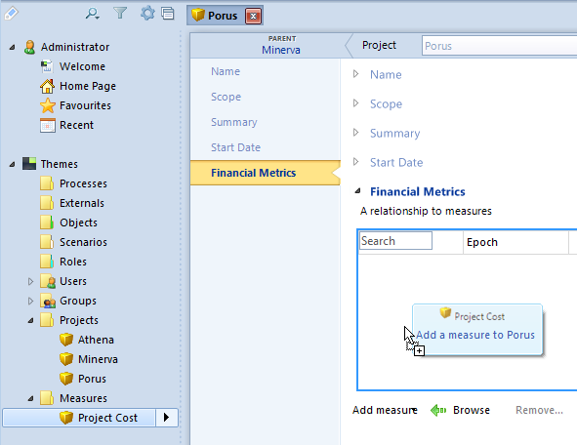
These first two steps are illustrated by the preceding image showing a Project Cost measure being applied to the Porus element. Financial Metrics is a measure relationship field on Project elements that allows the measure type that the Project Cost measure has been created from.
Note: Below any measure relationship field you can click Add measure to select from a list of measures, or Browse to filter the Explorer Bar by applicable measures.

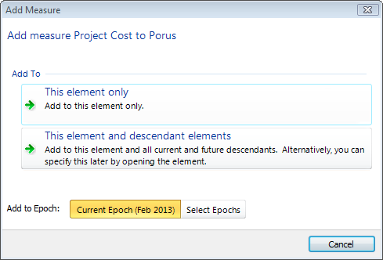
As soon as you apply a measure, you get the Add Measure dialog box shown here.

Note: If the dialog box doesn’t include Add to Epoch, you have applied a measure that is not epoch aware.

Key points about this dialog box are:
  - Under Add To, the two This element buttons do the action immediately. If you click either before you have selected your epochs, you will need to remove the

14

measure instance and then reapply the measure in order to select the epochs you require (i.e. get back to the Add Measure dialog box). To remove a measure instance, use the Remove command under the element’s measure relationship field.
o Although the second button gives an alternative, note that this alternative only affects future descendant elements not current descendants. The misleading text has been recorded as an issue. Step 5 includes more information on this.
  - The Add to Epoch section always defaults to Current Epoch.
- Click Select Epochs.
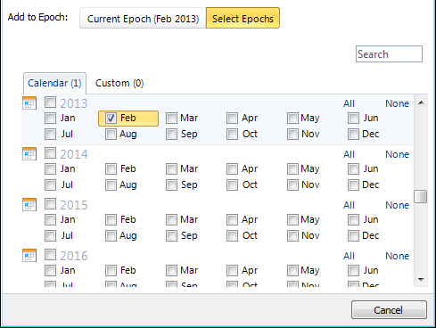
The Add Measures dialog box expands as shown here. Only the current epoch is selected.
- Select the epochs that you want to create measure instances for.
On the tab for each epoch group, the number in brackets denotes the number of epochs selected in that group.
- Do one of the following:
  - Click This element only to create measure instances on this element only.
  - Click This element and descendant elements to create measure instances on this element and on all of its descendants including future descendants.
Note: Although the button for This element and descendant elements states that you can specify this later by opening the element, this alternative is for future descendants only. It will not affect existing elements. To access this functionality you need to open the element and then open the measure instance. This gives you access to the Apply to new children setting shown here:

15

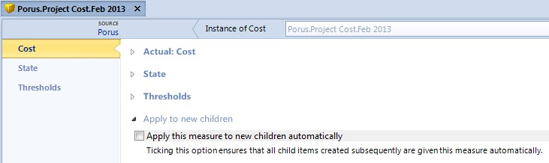

To automatically apply measure instances to a group of existing elements, you can use the Create Measures synchronizer. This would allow you to correct occasions where you have mistakenly selected This element only. See The Create Measures synchronizer on page 19 for details.
When you click either button, the measure instances are created for the selected epochs and applied to the affected elements (they will appear in the measure relationship field that you dragged the measure into in step 2).
If you clicked This element and descendant elements and there are lots of descendant elements, you’ll see a progress dialog box as the measure instances are created.

Using SAT to apply and update epoch aware measures
Synchronization Activation Technology (SAT) includes three synchronizers for use with epoch aware measures. These are:
  - The Microsoft Excel Import synchronizer
This includes layouts specifically designed for applying epoch aware measures.
  - The Create Measures synchronizer (Build 57 and later) (page 19)
This creates measure instances on elements. This works with both epoch aware and standard measures.
  - The Copy Measures for Epochs synchronizer (Build 57 and later) (page 20) This copies existing measure instances from one epoch to another.
Each is detailed in its own section below.
Important: MooD 15 Build 56 and below. Build 56 and earlier has a Create Epoch Measures synchronizer. This has the same functionality as the Copy Measures for Epochs synchronizer in Build 57 (the synchronizer was renamed).

The Create Measures synchronizer is new in Build 57. Its functionality was not available in Build 56 and below.

16

The Microsoft Excel Import synchronizer

Note: This is a summary of the epoch functionality available. The Microsoft Excel Import synchronizer guide (PDF) includes full details.

The Excel Import synchronizer includes two layouts specifically designed to apply epoch aware measures to elements. These are the Epoch Grid and MooD Measure Instances layouts. They are designed to be used with the Measure Instances target.
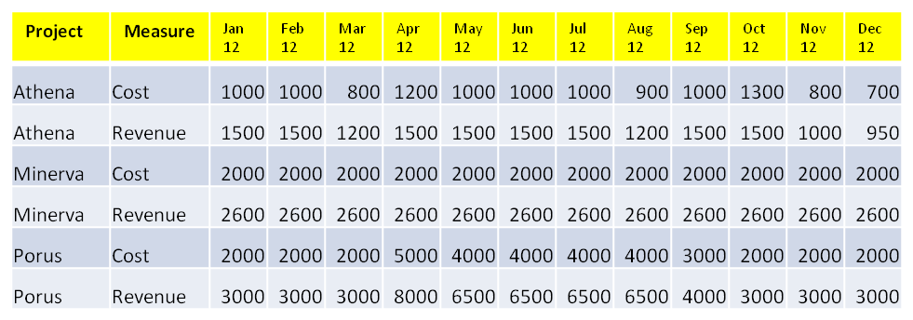
The Epoch Grid layout is suitable for spreadsheets like this:
To give mappings like this:
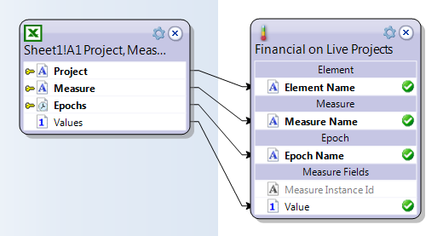
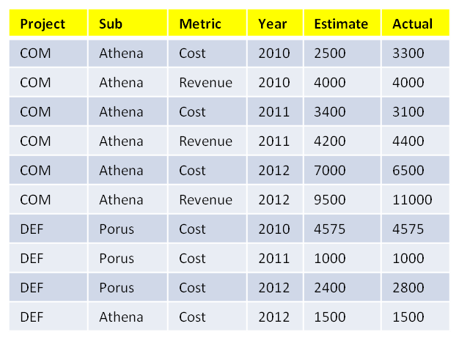
The MooD Measure Instances layout is suitable for spreadsheets like this:

17

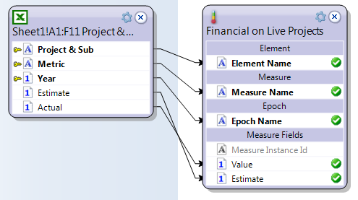
To give mappings like this:
Both mappings use the Measure Instances target.
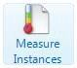
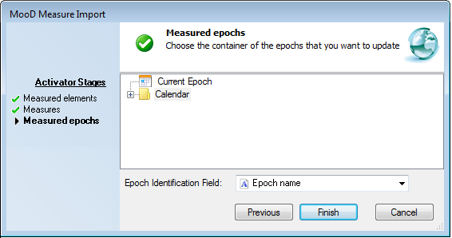
This target has its own wizard that gives you the target record description. The first stage lets you select the elements to target, the second stage lets you select the measure, and, provided this measure is epoch aware, the final stage lets you select the epochs. Here is an image of this final stage.
As shown in the following image, as well as the Measure Instances target, there are also
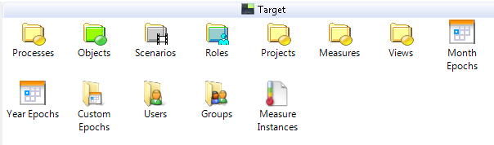
Month Epochs and Year Epochs targets available in Add tab’s Target side.
See the Microsoft Excel Import synchronizer guide (PDF) for full details on using these layouts and the Measure Instances target. It includes details on the wizard stages for both layouts.

18

The Create Measures synchronizer
This synchronizer was introduced in MooD 15 Build 57.
The repository synchronizer Create Measures creates measure instances on elements. It creates and applies measure instances with any default settings. You cannot use it to populate or update measure instances with specific, individual values.
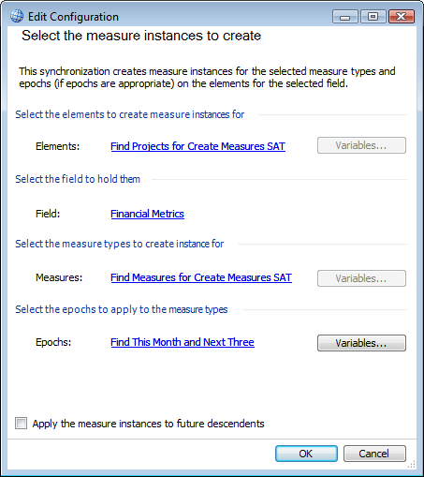
When you create a Create Measures synchronizer, you get a dialog box like the one shown next (completed with queries where allowed).
Key points:
  - The Elements, Measures and Epochs settings can come from queries.
  - The Epochs setting is only available when the Measures setting includes epoch aware measures. The synchronizer can handle both types of measure at the same time without issue.
  - The Apply the measures instances to future descendants check box applies to future descendants only. If you want to apply the measure instance to existing child elements, ensure that the Elements setting is a query that finds all those elements.

19

The Copy Measures for Epochs synchronizer
In MooD 15 Build 56 and earlier, this synchronizer was called Create Epoch Measures. Only the name changed in Build 57.
The repository synchronizer Copy Measures for Epochs copies the existing measures from one epoch to another epoch, thereby creating the same measure instances in another epoch.
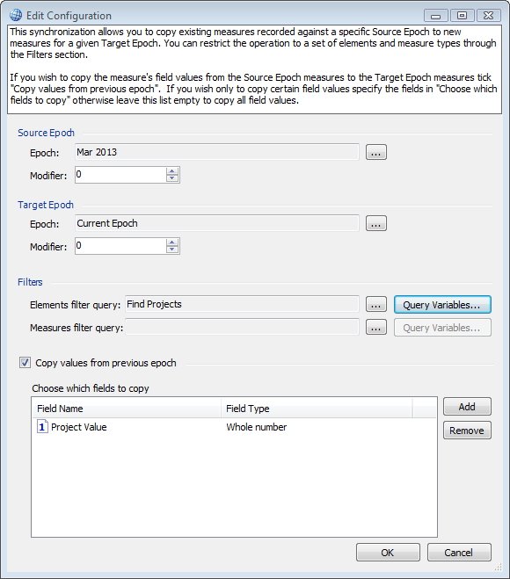
When you create a Copy Measures for Epochs synchronizer, you get a dialog box like the one shown next.
Key points:
  - Source Epoch and Target Epoch allow you to use modifiers.
  - Use the Filters group to restrict the scope of the copy to the elements and or measures returned by a query. For example, in the preceding image, the elements affected are returned by the Find Projects query.
  - When selected, the Copy values from previous epoch check box ensures that measure instance field values from the source epoch are also copied to the target epoch. When this check box is cleared, only the measure is applied in the target epoch (thereby creating measure instances with default settings).
    - You can restrict the scope of this by adding specific fields to the Choose which field to copy list. Leaving this list empty will copy all field values.

20

Epoch functionality in MooD
MooD has many constructs to help you utilize epoch aware measures. This section looks at what epoch functionality is available in these areas:
- Queries
- Aggregations (page 23)
- Charts, Info panels and matrices (excluding Aggregation) (page 28)
- The Epoch Picker action panel (page 29)
- The Current Epoch session variable (for Active Enterprise) (page 30)
There is a degree of crossover between these areas. For example, queries are used to create Aggregation matrices that then drive charts. A general understanding of what epoch related functionality is available in MooD should help you make the most of epoch aware measures.

Epochs in queries
The following sections cover key epoch functionality for queries:
- Find blocks for epochs
- Using an And Finally block to order epoch measure instances (page 22)

Find blocks for epochs
The following table gives reference material on Find blocks that let you use epochs and epoch aware measures in queries.

Table 1. Find blocks for epochs

Hierarchy tab
As epochs and epoch groups are elements in their own right, these hierarchy blocks are generally useful. For example, Find Parent on a month finds the year, while Find Children on a custom epoch group finds all the custom epochs within it.
Measures tab
Find Instances from Epoch | Taking an epoch, this finds measure instances for that epoch.
Find Instances Epoch | Taking a measure instance, this finds the epoch it belongs to.
There are corresponding where clauses for use as conditions within the various measures Find blocks. For example, within a Find Instances from Container Element measures block you can use a where Instance epoch condition to filter your results by epoch.
Tip. On the Measures tab, the measures icon beside a Find block indicates it finds measure instances. Remembering this can help you quickly differentiate between the different Find blocks.
Miscellaneous tab
Find sibling epochs | Taking an epoch, find other epochs at the same level in the element hierarchy. This is commonly used with a Range  between setting to find months either side of the month passed

21

to the block (as illustrated by the first example in The current epoch section on page 8).

Using an And Finally block to order epoch measure instances

Note: Do not use And Finally order by blocks in queries that will be used as aggregation starting points. The aggregation will not generate. Impose ordering within the Aggregation matrix, or at the point where you use the aggregation. See Avoid And Finally order by blocks in queries used in aggregations on page 26 for more details.

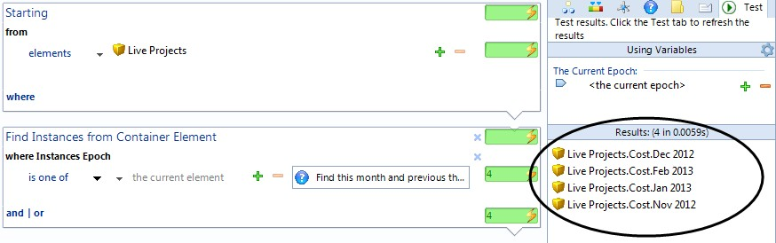
By default, measure instances are sorted alphabetically in query results. This includes epoch measure instances. For example, the following image shows some epoch measure instances returned in alphabetical order not date order (ringed).
You might expect these to be returned in date order. However, they are not. If you were to plot these results on a chart, they would appear in this alphabetical order. Fortunately, if date order is important to you, you can add an And finally block that sorts the measure instances into date order. This date order will then be available to any chart or Info panel driven from the query. Here is an example:
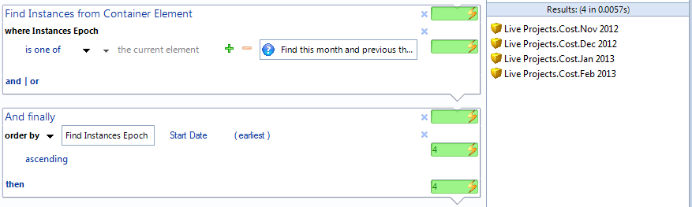
You can see that the results are now in date order. The measure instances are ordered by the start date of their epoch.
The following key points about this example should help you replicate it in your solution:
- The And finally block is an order by date field block.

22

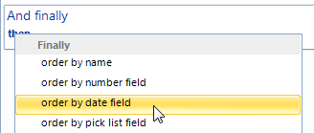
  - After adding the order by date field block, you need to click the down arrow next to
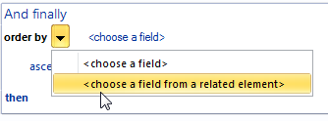
order by and then click <choose a field from a related element>.
This gives you a box where you can drop the Find Instances Epoch block (drag it from the Measures tab).
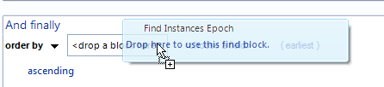
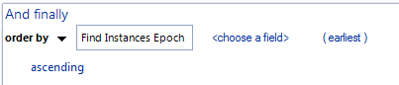
and once dropped:
  - Finally, click <choose a field> and then click Start Date. The clause defaults to
(earliest) ascending, but you can change this.

Epochs in aggregations
Levels, dimensions and source queries in Aggregation matrices and Smart Columns are built using MooD query constructs. Hence, the same blocks discussed in Find blocks for epochs on page 21 apply within aggregations. This section builds on this with the following sections on aggregation specific functionality related to epochs:
  - Date Grouping levels in Aggregation matrices
  - Avoid And Finally order by blocks in queries used in aggregations (page 26)
  - Controlling how epochs and epoch measures are named in aggregations (page 26)
  - DATE TIME functions in Fact Builder (page 27)

23

Date Grouping levels in Aggregation matrices
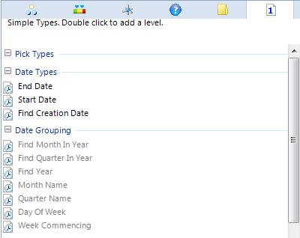
To allow you to add levels that group by epoch or date related criteria, there is an extra Simple Types tab of Find blocks available for Aggregation matrices (not Smart Columns). This includes the Date Type and Date Grouping categories shown here:
Unlike the other Find block tabs, the Simple Types tab does not have a Filter blocks setting. You can only add grouping levels that are logical to the data at that particular point in the Aggregation matrix. Hence, you always have to precede a Date Grouping level with a Date Types level that finds the dates that can then be grouped. This is illustrated by the following image.

24

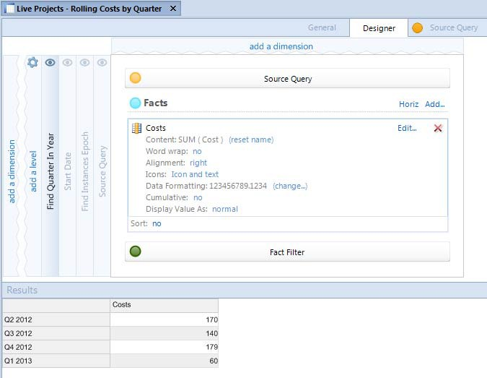
This example shows an Aggregation matrix where the source query finds the cost measure instances for the previous year, and then displays them summed by quarter. The measure instances returned by the source query are passed to a Find Instances Epoch level. The epochs returned by this then pass through a Start Date level. This produces the dates that the final level Find Quarter in Year can use. As this level is the only visible level, you get a table that shows costs by quarter.
The MooD 15 Aggregation Designer guide (PDF) includes more information on this example.

25

Avoid And Finally order by blocks in queries used in aggregations
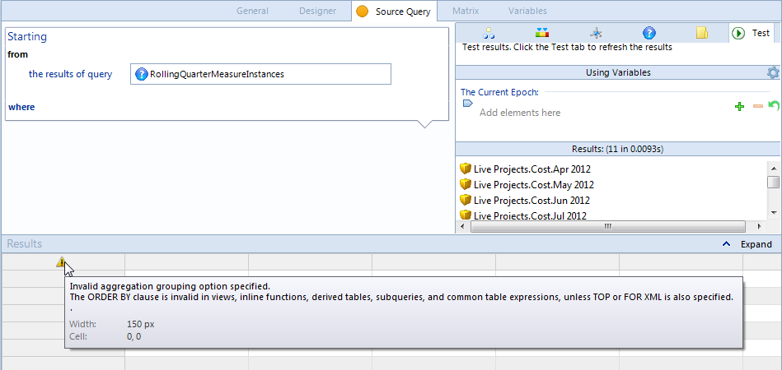
This image demonstrates an issue you might encounter. If you use an existing query as your source query and testing shows that it does return elements but the matrix will not generate, check that the query does not include an And Finally block that orders the results. If necessary, create a version of the query that doesn’t include the And Finally block, and impose the ordering in the Aggregation matrix or in the chart that uses the Aggregation matrix.
The warning icon for this problem includes a tooltip that mentions a problem with ORDER BY. This relates to the And Finally block in the query.

Controlling how epochs and epoch measures are named in aggregations
You can control the labels used for epochs and epoch measures. You specify these settings within Aggregation Designer.
Note: When an Aggregation matrix is used to drive a chart, the naming conventions set in the Aggregation matrix are the ones used. The chart’s naming conventions will not affect the epoch or epoch measure labels.

There are two ways to set the naming conventions used in labels. Which one you use depends on the type of level. The level’s where condition block guides you as follows:
  - If you see Using Naming Convention as shown in the next image, use the Names
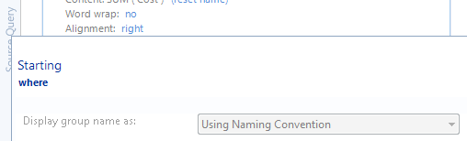
command on the ribbon (on the Home tab in the Design group).
  - Certain Date Grouping or Date Type levels give non standard groupings (for example quarters), that have dedicated format settings. If so, the button next to Display group name as will be enabled, as shown in the next image.

26

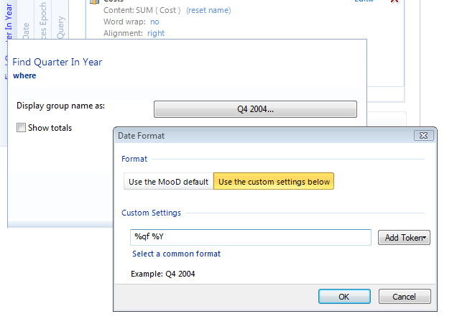
The button’s label shows you the current format. Click this to access the settings and make changes.
See Date Grouping levels in Aggregation matrices on page 24 for more details on this type of level.
Note: To access the level’s where condition block, on the Designer tab, click the level’s name within the aggregation’s design, as shown here:
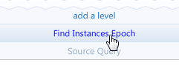
You must click the actual text.

DATE TIME functions in Fact Builder
Within Fact Builder, there is a DATE TIME category of functions that deal with epochs and dates within facts. Currently, this includes these functions:

DAYS IN MONTH
Use this to find the number of days in a month (epoch) that you can then use in a calculation. For example, you might have a fact that calculates the number of working hours available in the current month. For this you need the number of days in the current month as a number.

HOURS DIFF
This gives you the number of hours between two dates. Not purely epoch related, however epochs have Start Date and End Date fields so this could be used with these to give you the number of hours in an epoch.

27

The Facts and Fact Builder guide (PDF) includes more details on using functions within facts. These are only mentioned here to give you a more complete picture of what epoch related functionality is available within MooD.

Epochs in charts, Info panels and matrices (excl. Aggregation)
If you have epoch aware measures, you are likely to include them in charts, Info panels and matrices. Most issues with this relate to their order and naming.

Ordering
Key points:
  - If the content is found by a query, MooD treats the results like any other elements and sorts them alphabetically. Impose the date ordering you require in the query (standard query or matrix Row Query). See Using an And Finally block to order epoch measure instances on page 22 for more details and an example.
  - If the content is provided by an Aggregation matrix, make sure its visible level has the required ordering. In the Aggregation matrix, use Find Instance Epoch levels and or Date Grouping levels to do this. These are covered on pages 21 and 24 respectively.
  - If you set the panel’s Information Shown setting directly to epoch measure instances, then the chart or Info panel will plot them in date order.

Naming
Key points:
  - If the content is provided by an Aggregation matrix, set the naming conventions in the Aggregation Designer. See Controlling how epochs and epoch measures are named in aggregations on page 26.
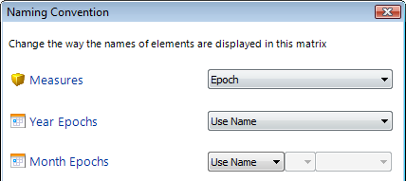
  - Elsewhere, use the standard Names command on the ribbon to access the Naming Convention dialog box. This has settings for measures and for epochs.
Note that if Measures is set to Epoch (as shown in the image), it can be easy to confuse what is actually being shown on an axis. If you aren’t getting the results you expect, check if your chart or action panel is showing epochs or measure instances.

28

The Epoch Picker action panel
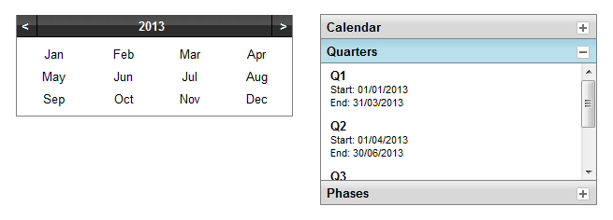
The Epoch Picker action panel is a control that you can include in Active Enterprise solutions so that users can select the epoch used by the solution. The following image shows two epoch pickers.
The first control is a default epoch picker. It is a simple calendar that defaults to the current year and lets the user select months. If you don’t configure the epoch picker, this is what you get.
The second control shows an epoch picker that has been configured to allow the user to select from custom epoch groups (Quarters and Phases) as well as the standard Calendar group.
The configuration of this action panel is straightforward and divided between content configuration on the panel’s flip side, and visual configuration on the ribbon. Here are the key points.
  - On the panel’s flip side:
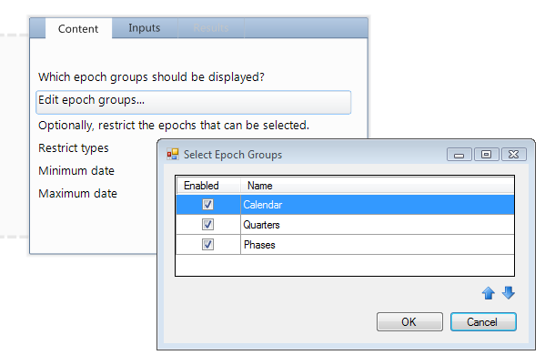
    - On the Content tab, Edit epoch groups lets you control the groups that the user can select an epoch from. For example, here is the setting for the second example:
Use the arrows to change the group order in the control.
If required, the remaining options on the Content tab give you additional control over the epochs available for selection in the epoch picker.

29

    - On the Input tab, use Value to set a starting point for the epoch picker. If unset, the current epoch is used.
  - On the ribbon, select Show As Popup to display an icon instead of the whole epoch picker control. Clicking the icon makes the epoch picker appear. With this setting, you can use Value (on the Input tab) to display the initial setting. With Value set, the control appears like this:
And, when you click the icon:
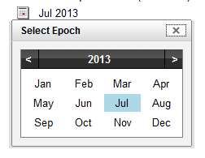
As shown in the image, the popup includes a Close button. This returns the selected (coloured) epoch.

The Current Epoch session variable
To access the current epoch in Active Enterprise, include the Session Variables action panel in your models. This exposes a session variable called The Current Epoch on the panel’s Inputs tab.

30

FAQ
Here are some frequently asked questions:
  - How do I get the last few months?
  - My epochs aren’t in chronological order on my chart?
  - How do I group by epoch in an Aggregation matrix?
  - How do I change the current epoch?
  - What does an epoch modifier do?
  - How do epoch modifiers work with custom epochs?
  - How can I get the current epoch in Active Enterprise?
If you would like to suggest additions to this FAQ list, please send them to MooD International Support for consideration.

How do I get the last few months?
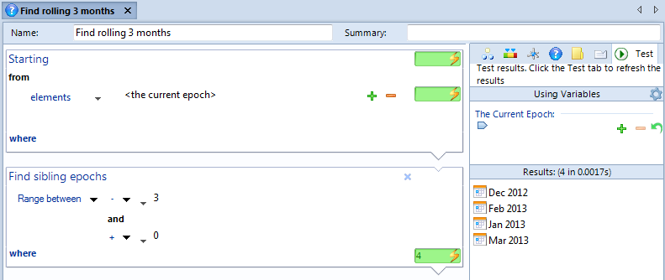
In a query that starts from the current epoch, use the Find sibling epochs block with, for example, a -3 to + 0 range (always do ranges from minus to positive (positive to minus will not work)). For example:
The next answer shows a query like this being used within another query to give you measure instances for the current month and the previous three on a rolling basis.

My epochs aren’t in chronological order on my chart?
Your chart is likely to be showing measure instances not epochs. In the query that drives your chart, use an And Finally block to order the measure instances by their epoch. For example:

31

Note: Do not use And Finally blocks in queries that will drive Aggregation matrices.

How do I group by epoch in an Aggregation matrix?
Use the Date Type and Date Grouping Find blocks. These are on the Simple Types tab (the last tab of Find blocks in an Aggregation matrix). See Date Grouping levels in Aggregation matrices on page 24 for an example.

How do I change the current epoch?
In Business Architect’s top right corner, click Current Epoch. Here you can change the current epoch.
You can also use the Configure Epochs dialog box to use a query to set the current epoch each time a repository is accessed. See The Configure Epochs dialog box on page 9 for details.
If you need to change the current epoch within a query, starting from the current epoch, use the
Find sibling epochs block to find another month, or the Find parent block to find the year. Elsewhere, you will find epoch modifiers. For example, in synchronizers, the Properties tab includes the Epoch plus or minus modifier.
In Active Enterprise, the Session Variables action panel includes a session variable for the current epoch.

What does an epoch modifier do?
It lets you execute something against another epoch. The starting epoch is represented by zero. The modifier is a number plus or minus this point. It is always in the same unit as the epoch. For example, if the epoch is a year, it is a number of years. As the default epoch is the current month, typically it is a number of months plus or minus the current month.

32

How do epoch modifiers work with custom epochs?
The modifier is in relation to the order of custom epochs in their custom epoch group.

How can I get the current epoch in Active Enterprise
Include the Session Variables action panel in your models. This exposes a session variable called The Current Epoch on the panel’s Inputs tab.

33

