MooD 15 General Chart
This guide covers how to implement the General chart. This is the most flexible chart in MooD.

Document Number: MooD15GCUG47

© MooD Enterprises Ltd., all rights reserved.

Notice of Copyright and Trademarks
MooD 15 General Chart
® MooD, MooD Smarter Decisions, Performance Activation, Synchronization Activation Technology and Knowledge Map are registered trademarks of MooD Enterprises Ltd. in the United Kingdom and / or other countries.
Microsoft and Windows are trademarks of Microsoft Corporation in the USA and other countries.
Rights to all other referred trademarks or registered trademarks reside with their respective owners.
Aspects of the Enterprise Business Model, Model-Driven Data Aggregation and Business Solutions to Support Smarter Decisions are protected by International Patent and Patent Pending. These include the Meta-Architecture Framework, Panels Technologies, Auto- Explorer, Business Orchestration, the Activator mechanism, Process Driven System, Performance Activation, Model-Driven Enterprise Management, Dynamic Aggregation, Smart Columns, the Variant Mechanism, and other technologies and mechanisms implemented within MooD Business Architect and MooD Active Enterprise.
© MooD Enterprises Ltd., all rights reserved. No part of this document may be reproduced by any means, or transmitted, or translated into machine language without the written permission of the company.

2

Contents

Introduction 5
Technical support and resources 5
About the General chart 6
Adding a General chart to a model 7
Configuring General charts 12
Configuring a General chart’s behaviour 12
Configuring a General chart’s layout 14
General chart features 17
Chart titles 17
Chart type 18
Axes 19
Secondary axes 22
Plotting a data series against a secondary Y axis (different scales) 22
Grid lines 23
Data series 23
Data series labels 24
Data series order and colour 24
Legends 25
Manually creating a legend table 26
Data point labels 28
The Show Labels setting 29
Manually creating data point labels 29
3D charts 30
Multiple chart areas 31
Crossing points 32
Historical charts 33
Using Aggregation matrices with General charts 33
3
Reference 36
The General chart’s panel 36
The Content tab 37
The Inputs tab 39
The Results tab 39
The Style, Settings and Web tabs (on the ribbon) 40
The Chart Layout Settings dialog box 42
The Chart Area Collection Editor 43
The Axis Collection Editor 43
The Legend Collection Editor 44
The Legend Cell Column Collection Editor 44
The Series Collection Editor 44
The Title Collection Editor 45
Chart template XML 46
Keywords 47
Examples 48
Tables
Table 1 Keywords 47
Table 2 Keyword formatting 48

Tasks
Task 1 To add a General chart to a model 7

Task 2 To configure chart wide settings using the flip side: 12
Task 3 To set a chart’s web behaviour by means of the ribbon: 13
Task 4 To set a chart’s data point labels by means of the ribbon: 13
Task 5 To configure a General chart’s layout 14

4

Introduction
This guide is for MooD Business Architect users who want to include General charts in models. The General chart is highly configurable, for example, although by default it is a simple column chart, it can be converted to many other chart types including a pie chart. Also data series can use different but compatible chart types within the same chart area, for example, one series plotted by columns another by a line. The General chart can also be made to appear 3D.
This user guide contains the following sections:
- About the General chart (page 6)
A brief introduction to the General chart and what you can achieve using it.
- Adding a General chart to a model (page 7)
Covers adding a General chart and associating it with the elements it will illustrate.
- Configuring General charts (page 12)
Simple configuration is available on the chart’s flip side and directly on the ribbon. This includes common layout features, and the chart’s relationship with its model. At a deeper level, the General chart’s layout is highly configurable using the Chart Layout Settings dialog box that you access from the ribbon. This section outlines both.
- Features (page 17)
This section covers key features in detail and gives instruction on how to implement them in Business Architect.
- Reference (page 36)
Reference material on the General chart’s flip side, the ribbon, and the Chart Layout Settings dialog box and its various Collection Editors. This material is useful if you need to quickly find out about a dialog or setting.
- Keywords (page 47)
Reference material on the keywords you can use in data point labels and legends. Keywords are replaced at display time with their current value. Examples are included.

Technical support and resources
MooD 15 is backed by a dedicated UK based technical support team. Contact details can be found on Repository Manager’s File tab.

5

About the General chart
The General chart is highly configurable. It is a simple column chart by default. However, by changing the Chart Type property, you can change it into many other formats. For example, all of the charts below are variants of the same chart (the last one uses different data). The Chart Type setting is only one of the things you can configure. Throughout this guide you’ll see examples of the features you can configure including secondary axis, data series, titles, legends and 3D (the last chart below demonstrates several features used together). This highly configurable nature is what makes the General chart one of the most useful charts in MooD.
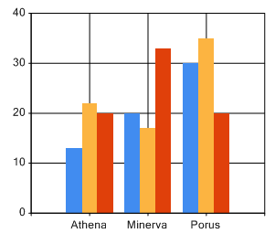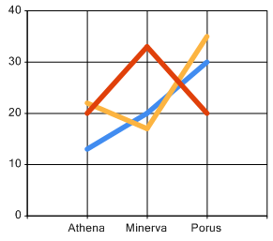
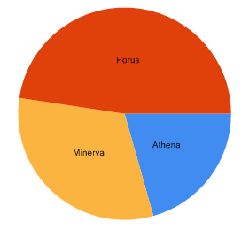
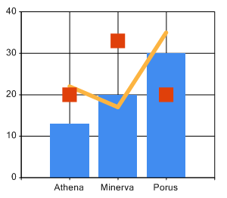
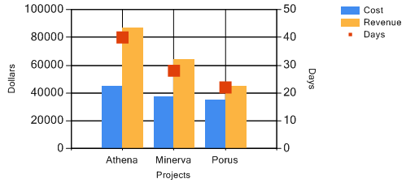

The list of General chart features on page 17 gives an overview of key configuration possibilities.

6

Adding a General chart to a model
Adding a General chart is similar to adding any other panel. You place it onto a model, and then use its flip side and the ribbon to configure it.

Task 1 To add a General chart to a model:
- Open the model that you want to add the chart to.
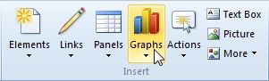
- On the Home tab, in the Insert group, click Graphs.
A gallery opens.
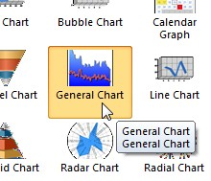
- In the gallery, in the Graphs section, click General Chart.
As you move cursor over the model, Business Architect shows you that a General chart will be created.
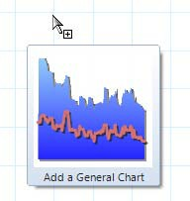
- Click to add the General chart to the model. A General chart is added on its flip side.

7

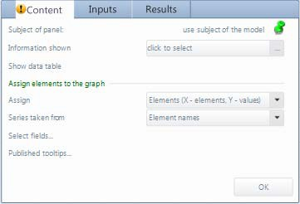
By default, the panel (chart) is pinned to the model’s subject element.
- If you want to use a different subject element, pin the panel to that element. The subject element must be on the same model as the chart.
- Next to Information shown, click click to select.
A Select Content dialog box for the subject element is displayed.
- Select the content from the subject element that will be the basis for the chart. For example:
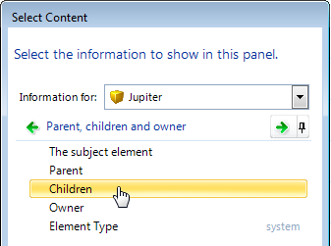
As soon as you click something in the Select Content dialog box, it selects it and closes the dialog. On the Content tab, the Information shown setting shows the selected content, and the icon indicates that the Select fields property is the remaining property that must be set to create a working chart.

Setting Information shown to a query
If you set Information shown to a query, an Edit this query link is added to the
Content tab, and the Inputs tab will include fields for any query variables required.
The Results tab lists the elements that will be included in the chart, as shown next:

8

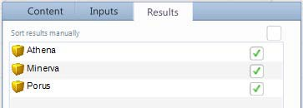

Manually adding elements
This task described here lets Business Architect automatically add the elements associated with the selected content. However, you can add elements manually. On the Select Content dialog box, click I want to add elements manually.
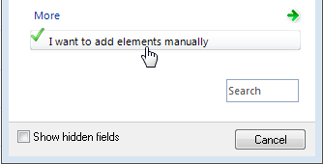
When this is selected, the Content tab changes to include an Add and remove elements from this panel link. This displays the Results tab with an Add an element button on it. See The Results tab on page 39 for details on manually adding the elements for your chart.
- If required, use the Assign drop-down to change the chart’s format. The choices are:
  - Elements. This is the default. The X axis plots elements and the Y axis plots field values. This type of chart can plot multiple data series against the elements on the X axis.
  - Pivot. The X axis plots fields and the Y axis plots the values of those fields. In this type of chart, the data series are items on the X axis.
  - Historical. For elements configured to store historical values (a change history), this type of chart plots dates/times on the X axis and field values on the Y axis. When selected, a Configure settings link is added immediately below. Use this to set the date range for the historical data. See Historical charts on page 33 for more details.
  - Scatter. Both the X and Y axis plot values. The density and location of plotted points can indicate the relationship (or lack thereof) between two items.
  - Aggregation. Content from an Aggregation matrix. This is set automatically when Information shown is set to an Aggregation matrix. See Using Aggregation matrices with General charts on page 33 for details.
The remaining steps assume you are adding the default Elements format.
- Click Select fields.
The Select Content dialog box is displayed.

9

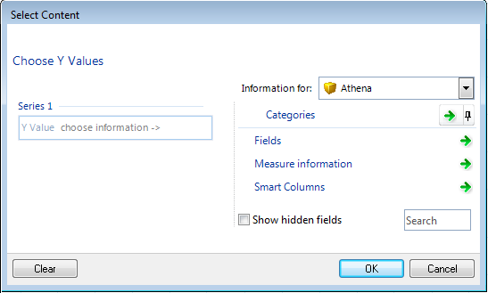
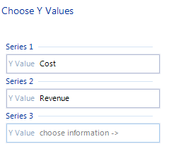
- Use the Select Content dialog box to search for and select the content you want to use as data series in the chart.
As you choose content for a series, a new empty series field is added.
- When you have added the data series required, click OK to close the Select Content
dialog box.
You can return and edit the selected fields or add additional data series at any time.
- On the Content tab, click OK.
The panel flips to display the General chart on the model.

10

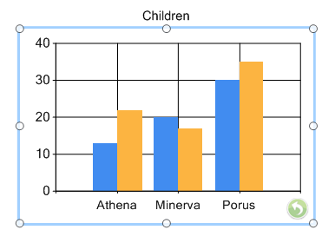
At any time you can configure it further. See Configuring General charts next for details and options.
Note: If you flip the general chart and no data is displayed on the model, it is usually because there are unset variables on the chart’s Inputs tab. Even if your chart is driven by session variables, if you want to configure it further, you need to set inputs so that you can see and verify the results of your changes.

11

Configuring General charts
You configure General charts at two levels:
- Accepting the chart’s current layout, configure its association with the model and how it generally behaves and appears within Business Architect and Active Enterprise.
Use the chart’s flip side and the ribbon to do this. See Configuring a General chart’s behaviour next for details.
- Change the underlying nature and layout of the chart itself. This is at a much finer level of detail.
Use the Chart Layout Settings dialog box to do this. You access this from the ribbon. From this dialog box you can shape the General chart in many ways, for instance, change the chart type, add secondary axis, and remove the background grid. See Configuring a General chart’s layout on page 14 for details.
Together, the ribbon, the chart’s flip side, and the Chart Layout Settings dialog box give you access to all available configuration options.
Note: Creating a General chart, including defining the elements it charts, is covered in
Adding a General chart to a model on page 7.

Configuring a General chart’s behaviour
The General chart’s flip side includes three tabs that let you set chart wide features, and the ribbon lets you control data point labels (the Style tab in the Panel tab group) and the chart’s behaviour on Active Enterprise (the Web tab). These settings affect the chart in its current layout.

Task 2 To configure chart wide settings using the flip side:
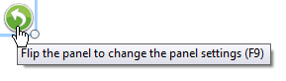
- Flip the General chart’s panel. Press F9 or click:
The panel flips to show three settings tabs. It opens at the last tab used.
- Use the tabs to configure the chart.
The tabs and the configuration options they offer are:
  - Content (see page 37 for reference material) Defines the chart’s starting point and its basic format.
  - Inputs (page 39)
Use this to configure refresh features on Active Enterprise. If the chart is based on a query that takes a variable, the Inputs tab will include fields for those variables.
Note: Additional Active Enterprise settings appear on the ribbon (the Web
tab). See the next task for details.
  - Results (page 39)
Use this to change the sequence of elements on the X axis, or to exclude individual

12

elements. If, on the Content tab, Information shown is set to Elements, you also manually add the elements here.
- Click OK when you have finished configuring the chart.
The panel flips back to show the General chart in its new configuration.

Task 3 To set a chart’s web behaviour by means of the ribbon:
- On the model, click the chart.
This selects the chart, and means that the settings on the Web tab relate to it.
- Click the Web tab.
- In the Element Behaviour group:
  - Allow Navigation makes the chart interactive when viewed in Active Enterprise.
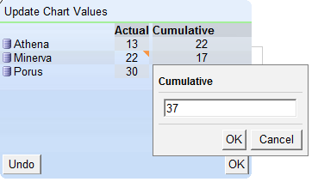
  - Allow Editing. If selected, you can flip the chart in Active Enterprise and edit its values. For example:
The triangle icon within a cell indicates that that value has been changed but not saved. When you flip the chart back, it will update to reflect the updated values.
  - Allow Scrolling and Fixed Headers do not apply to General charts.

Task 4 To set a chart’s data point labels by means of the ribbon:
- On the model, click the chart.
This selects the chart, and adds the Panel tab group to the ribbon.
- Click the Style tab.
- In the Points Labels group, click Show Labels.
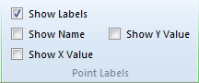
By default, Y axis values are added. The remaining Show settings are enabled to allow you to modify this.
- Select one or more of the following to include in the data point label:
  - Show Name includes the element’s name.

13

    - Show X Value includes the X axis value. This is only relevant for charts that plot values along the X axis. If the chart plots elements, this will insert 0.
    - Show Y Value includes or excludes the item’s Y axis value. The chart updates itself as you select options.
Note: You can also manually configure data point labels. This give you more control, and lets you include keywords. See Manually creating data point labels on page 29.

Configuring a General chart’s layout
The General chart is highly configurable, and the Chart Layout Settings dialog box gives you access to additional dialog boxes that you can use to change or add to the default layout. This includes the chart type, the appearance of each data series, axis settings, titles, labels and legends.

Template XML
Chart layout settings that change the defaults are stored and applied as XML. When a General chart is selected, you can use the Template XML command on the ribbon (the Style tab) to look at this XML. This is a quick way to see what defaults, if any, have been changed. You can also edit this XML, and a quick way to restore a chart to its default formatting is to delete the XML. In both cases, you must exercise caution. See Chart template XML on page 45 for details.

Task 5 To configure a General chart’s layout:
- On the model, click the chart.
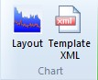
This selects the chart, and adds the Style tab to the ribbon.
- On the Style tab, in the Chart group, click Layout. The Chart Layout Settings dialog box is displayed.

14

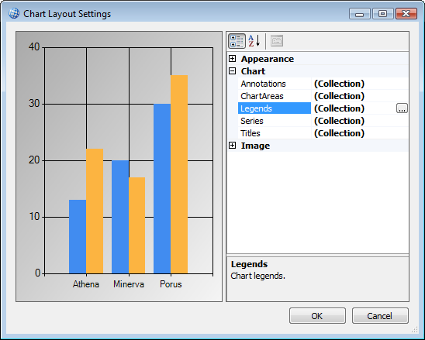
The key features of this dialog box are:
  - Property settings are grouped by default and sorted alphabetically within groups. You can use the AZ sort button to remove the groupings and list all settings alphabetically.
  - Collection indicates that you can have more than one of these items. When you click one, a (…) button appears. Use this to open the Collection Editor for that type of item.
  - The preview updates as you change the chart.

Note: As a general rule when configuring any chart, you should regularly confirm that the model shows what you want, and not rely entirely on the preview. Some functionality that is previewed is not supported in the actual model. Where possible, this is noted in this guide.

- Configure the chart’s layout as required. The most common layout tasks are:
  - Add titles. Use Titles in the Chart group to open the Titles Collection Editor. See
Chart titles on page 17 for more details.
  - Change the chart from the default Column chart to another type, for instance a Pie chart. Use Series in the Chart group to open the Series Collection Editor. Then set the Chart Type property for each series. See Chart type on page 18 for more details.
  - Configure the X and Y axis or add secondary axes. Use Chart Areas to open the
Chart Areas Collection Editor. Then, with the required chart area selected, in the

15

Axes group, use Axes to open the Axis Collection Editor for that chart area. See
Axes on page 19 and Secondary axes (page 22) for more details.
  - Remove the default grid lines. You do this with the MajorGrid settings in the Axis Collection Editor. See Grid lines on page 23 for more details.
  - Change the data series labels that appear on an axis. These default to the element’s name, but you can use the Custom Label Collection Editor to change them. See Data series labels on page 24 for details.
  - Change the colour or order of data series. Use Series to open the Series Collection Editor. See Data series order and colour on page 24 for details.
Important: Do not attempt to add data series in the Series Collection Editor.
Any data series added there will not appear in your model. The Add button, whilst appearing to work, does not. You must use the chart’s Content tab to add data series. See Data series on page 23 for more details.
  - Add default legends or manually create a legend table. Use Legends to open the Legends Collection Editor. Then click the Add button to add a default legend table. See Legends on page 25 for more details.
  - Manually create data point labels. If the Show Labels setting on the ribbon is not sufficient, use Series to open the Series Collection Editor. Then, with the required series selected, set the Label property. See Data point labels on page 28 for details and Keywords (page 47) for a list of keywords that you can use in this setting. Each time a chart is displayed or refreshed, keywords are updated to show their current value in the repository.
  - Make the chart 3D. Use Chart Areas to open the Chart Areas Collection Editor. Then, in the 3D group, set the Enable3D property to True. See 3D charts on page 30 for more details.
See The Chart Layout Settings dialog box on page 42 for reference material on each layout possibility, or click on the individual links above to be taken to reference material on that particular feature. See General chart features on page 17 for a complete list of possibilities covered in this guide.
- Click OK when you have finished configuring the layout. You return to the chart’s flip side.
- Click OK to flip the panel and see the General chart’s updated layout within the model.

16

General chart features
This section covers aspects of the General chart in depth. It covers:
- Chart titles
- Chart type (page 18)
- Axes (page 19)
- Secondary axes (page 22)
  - Plotting a data series against a secondary Y axis (page 22)
- Grid lines (page 23)
- Data series (page 23)
  - Data series labels (page 24)
  - Data series order and colour (page 24)
- Legends (page 25)
  - Manually creating a legend table (page 26)
- Data point labels (page 28)
  - The Show Labels setting (page 29)
  - Manually creating data point labels (page 29)
- 3D charts (page 30)
- Multiple chart areas (page 31)
- Crossing points (page 32)
- Historical charts (page 33)
- Using Aggregation matrices with General charts (page 33)

Chart titles
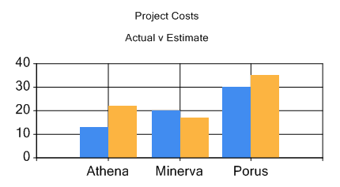
The default General chart does not include any titles. You can add one or more titles, for example, the following chart has two titles:
To do this, go to the Title Collection Editor:

Chart Layout Settings dialog box > Title Collection Editor
Then click the Add button to add the titles you require. For each title, the key properties are:

17

- (Text) in the Appearance group. This is the text that will appear when (Visible) is set to
True. These are bracketed so that they appear first in the list of title properties.

Note: You cannot use keywords in titles. They can only be used in manually created data point labels and data series legends.

- The Docking group of properties lets you position each title.
As you add and configure titles, the preview in the Chart Layout Settings dialog box updates to show a representation of how they will appear in the chart on the model. As a general rule when configuring any chart, you should confirm that the model shows what you want and not rely entirely on the preview.

Chart type
The Chart Type property sets the chart’s basic style, Column, Bar, Line, Pie etc. By default, the general chart is a Column chart.
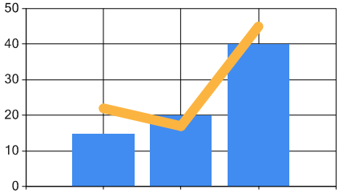
A General chart can plot multiple data series. Each data series can be a different but compatible chart type; for example, one series could be the default Column type, while a second series could be plotted as a Line. Here is such a chart:
Because of this, the Chart Type property is found in the Series Collection Editor.

Note: Data series are plotted in order and overlap accordingly. You can see this in the preceding image. The Column chart of the first data series is behind the Line chart of the second series.

To set the Chart Type property, go to the Series Collection Editor: Chart Layout Settings dialog box > Series Collection Editor
Then, with the required series selected, set the Chart Type property in the Chart group of series properties to the required style.
Key points about setting Chart Type are:
- You must set each series listed in the Series Collection Editor to the same Chart Type, or to compatible Chart Types. Compatible types are types that can be plotted against the same X and Y axis. Hence, Bar charts and Column charts are incompatible.
Note: In the Series Collection Editor, you may get an error dialog saying that you have selected incompatible Chart Types. In some cases you can

18

ignore this; for example, if you decide to change all the series from Bar to Column, you’ll get the error message until the last series has been changed to Column and the incompatibility removed. However, if you leave the Series Collection Editor and your chart is not rendered, you must check each of your Chart Type settings.
- The drop-down list of Chart Types is extensive. You should use trial and error to establish the best for your purposes. When doing this, it can be helpful to experiment with a single series chart.
- Most but not all of the Chart Types listed in the drop-down are supported. You should test your selection in your model to ensure it is supported before you spend time developing it further.
Note: The appearance of the selected Chart Type in the preview area of the Chart Layout Settings dialog box does not guarantee that the chart will appear correctly in a model.
Making the line in a Line Chart thicker
The Line Chart Type property is often used to plot one or more data series as a line. The line’s thickness defaults to 1. To change this, in the Series Collection Editor for that series, in the Appearance group of properties, set the BorderWidth property.
Note: If you want to change the line’s default colour, use the Color property in the same group. This is covered in more detail in the Data series order and colour section on page 24.

Axes
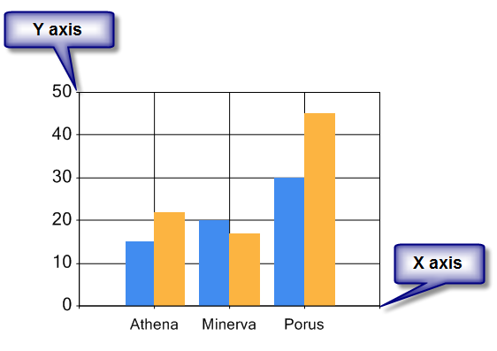
The default General chart has one X axis and one Y axis. Typically, the X axis appears horizontally along the bottom of the chart area, and the Y axis appears vertically on the chart area’s left border.

19

Note: An exception to this is the bar chart. By default, its axes are rotated 90 degrees. Pie and doughnut charts don’t use axes. See Chart type on page 18 for details on changing the General chart from its default column layout.
Y axes always plot values. Typically, X axes plot category data, such as elements, fields or date ranges, but can also be used to plot values, as in Scatter charts.
Axes present lots of configuration possibilities. To configure axes, go to the Axis Collection Editor:

Chart Layout Settings dialog box > Chart Area Collection Editor > Axis Collection Editor
Within the Axis Collection Editor, you can configure each axis independently. For example:
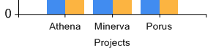
- Use the Title group of axis properties to add and format a title. For example, in the following, the title Projects is centred:

Note: You cannot use keywords in titles. They can only be used in manually created data point labels and data series legends.

Changes to the title font are not transferred to the chart. The font, including its size, is fixed.

See Data series labels on page 24 for information on changing the labels used for the actual elements on an axis.
- In the Labels group, use the Angle setting (in the LabelStyle subgroup) to alter the orientation of labels along an axis, for example, this is the effect of setting Angle to 90:
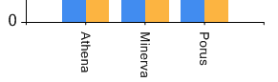
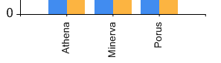
Setting Angle to -90 writes the text the other way:
- Add secondary axes. See Secondary axes on page 22 for details.
  - You can plot a data series against a secondary Y axis. See Plotting a data series against a secondary Y axis on page 22 for details.
- Remove or modify the chart’s grid lines. See Grid lines on page 23 for details.
- Use the Scale group of axis properties to manually control the scale used on each axis. By default, these cater for the displayed information (the data series), but you can manually set them if required. Within the Scale group:

20

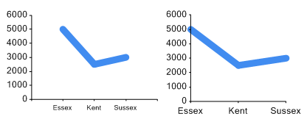
  - Set the IsMarginVisible property to False to remove the space padding either side of the data series on the X axis. For example, the next image shows the same chart, but the second chart has its X axis IsMarginVisible property set to False.
  - Use the Crossing setting to move the primary X axis to a point on the Y axis. See Crossing points on page 32 for details.
  - Use the IsReversed setting to reverse the origin of the chart from the bottom left corner to the bottom right corner, for example:
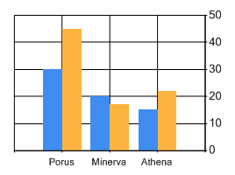
- Use the ScaleBreakStyle group of axis properties to help cater for charts that plot large differences between the high and low values. When enabled, this changes the scale used on the Y value axis at a certain point. By default, this point is automatically calculated based on the data being plotted, but you can control this. The chart adds a ragged line to draw attention to the change in scale as shown in the following image. Again, you can change this if necessary.
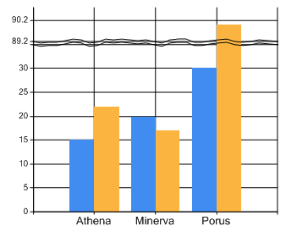

21

Secondary axes
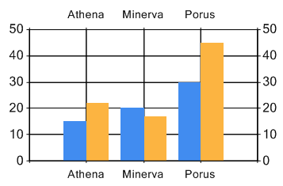
Charts can have secondary axes. By default, the secondary X axis appears at the top of the chart, and the secondary Y axis appears on the chart’s right border, for example:
To enable secondary axes, go to the Axis Collection Editor:

Chart Layout Settings dialog box > Chart Area Collection Editor > Axis Collection Editor
By default, the Axis Collection Editor includes disabled secondary axes. To enable either, in its Misc group of axis properties, set Enabled to True.
By default, secondary axes have the same axis properties as their primary counterparts. You can configure them independently as required.

Plotting a data series against a secondary Y axis (different scales)
A secondary Y axis can plot a different data series from the primary Y axis. For example, in the following, the Days data series is plotted against the secondary Y axis. Because of this, the scale has automatically become appropriate for that data series. If Days were plotted against the primary Y axis, it would barely register on the chart, and having two axes allows you to put sensible labels on them.
The axis that a data series is plotted against is a property of the data series. Hence, you need to go to the Series Collection Editor:

Chart Layout Settings dialog box > Series Collection Editor
Select the data series, and then, in the Axis group of properties, set YAxisType to Secondary.

22

Some of the best uses of the General chart come from mixing the various features to get exactly what you want. The preceding image also demonstrates these other features:
- The Days data series is displayed using the Bubble chart type (the other two data series are set to Column). See Chart type on page 18 for details.
- A legend has been added. See Legends on page 25 for details.
- Titles have been added against the axes. This can be particularly helpful when the axes use different scales. See Axes on page 19 for details (the Title properties).

Grid lines
By default, the General chart is shown on a grid. The grid’s interval and tick mark settings are automatically determined by the data series being plotted.
You can alter or remove these grid lines. To do this, go to the Axis Collection Editor:

Chart Layout Settings dialog box > Chart Area Collection Editor > Axis Collection Editor
You can:
- Remove the grid completely. In the MajorGrid axis properties group, set Enabled to
False for each axis.

Note: The tick marks at which grid lines (whether shown or not) transect the axis are independent of the grid lines. To remove these, in the MajorTickMark axis properties group, set Enabled to False.

- Use the Interval group of properties to alter the interval between grid lines.

Note: The General chart’s default grid is known in the Axis Collection Editor as the MajorGrid. Charts also have a MinorGrid that appears within the MajorGrid. By default, this is disabled, but the same general formatting principles apply.

Data series
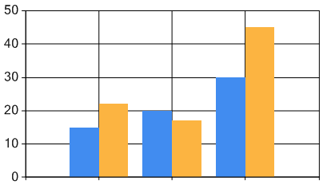
A data series is a piece of information plotted on a chart for each element on the X axis. Charts can include more than one data series, for example, estimated costs and actual costs could be two series that appear in a chart like the following:
When you add a General chart to a model, you specify each data series in the Select Content
dialog box (step 10 in the set of instructions starting on page 10). You can return to this dialog

23

box and add any further data series required. To access this, click the Select Fields link on the
Content tab (on the chart’s flip side).
Important: Do not attempt to add data series in the Series Collection Editor. Any data series added there will not appear in your model. The Add button, whilst appearing to work, does not. You must use the chart’s Content tab to add data series.

Data series labels
By default, data series are labelled by name on their axis. To change these without renaming the actual elements, go to the Custom Label Collection Editor:

Chart Layout Settings dialog box > Chart Area Collection Editor >Axis Collection Editor > Custom Label Collection Editor
Then, in the Appearance group of custom label properties, set Text to the required label. You may also need to adjust the To Position property to set the label’s location.

Data series order and colour
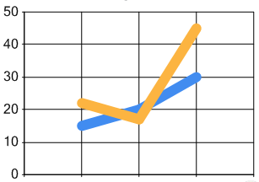
Data series are plotted in order. This means that, depending on Chart Type, the second data series can overlap the first data series and so on. The chart shown next illustrates this. It is the same chart shown in the preceding image, but its Chart Type is set to Line for both data series.
You can change the order of data series. To do this, go to the Series Collection Editor: Chart Layout Settings dialog box > Series Collection Editor
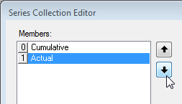
Then use the Up and Down buttons to change the order.
When you flip the chart back, it will show the data series in their new order, as shown next. This is the previous chart with its data series order reversed.

24

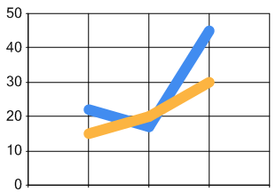
As can be seen in the two chart images above, the default colours are also applied in order. You can manually set the colours for each data series. Use the Color series property in the Appearance group. Manually set properties are preserved when a data series is moved.
Note: If you want to change the order of elements on the X axis, use the Results tab to manually sort the chart’s elements.
Tip – Colour transparency
In the Chart Layout Settings dialog box and its various Collection Editors, you can set colours. The Color setting can be manually entered as four comma separated numbers. The first number sets the colour’s opacity. This is a number between 0 (transparent) and 255 (solid colour). The final three numbers are Red, Green, Blue values again in the range 0 to 255.
Hence, setting a colour to 100, 255, 255, 0 gives yellow with some transparency while 255,
255, 255, 0 give a solid yellow.

Legends
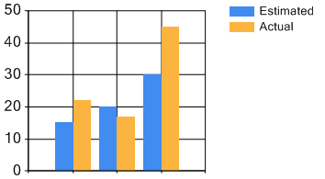
Legends identify each data series plotted on a chart. When switched on, legends, by default, appear to the top right of the chart and reduce the chart area, for example:

Note: As illustrated above, the default legend is a two column table listing each symbol and data series in the chart. This section covers this basic format. However, you can modify the format and content of this table, for example, to include a column showing the percentage of the total a data series represents. See Manually creating a legend table on page 26 for details on this more advanced configuration.

25

The RightToLeft property in the Appearance group of properties in the Chart Layout Settings dialog box does not alter the default legend order in the model. The dialog box preview is incorrect. The setting has no actual effect. If you wanted to change the order, you should manually create the column order. Again, see Manually creating a legend table (page 26) for guidance.
To add a legend, go to the Legend Collection Editor:

Chart Layout Settings dialog box > Legend Collection Editor
Then, click the Add button.

Note: The text used for each legend (Estimated and Actual in the preceding image) is a property of each data series. To change this, in the Series Collection Editor, set the LegendText property (in the Legend group).

In the Legend Collection Editor:
- Use Title to add a text title to the text box that holds the legend. As noted above, the text used in the legend is a property of each data series.
- To control the amount of chart area that is available to the legend, set
MaximumAutoSize in the Docking group of legend properties to a percentage.
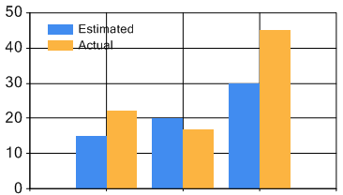
- To locate the legend within the chart area, in the Docking group of legend properties, set DockedToChartArea to Default and IsDockedInsideChartArea to True. You can then use other Docking properties to control its position within the chart area. This increases the available chart area. For example, the following shows the same chart as before, but with the legend displayed within the chart area.

Note: If you do this, to minimize the possibility of your legend obscuring the chart’s content, you can set BackColor to Transparent (in the Appearance group of legend properties). You might also want to remove the default grid lines. See Grid lines on page 23 for details.

Manually creating a legend table
The default legend uses a two column table and no titles. This can be seen in the images above. You can manually configure more complex legends. For example, the following shows a legend with a three column table. The third column uses the #AVG keyword to show the

26

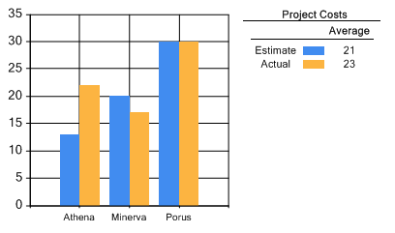
average of the Y values in that series. Each time a chart is displayed or refreshed, keywords are updated to show their current value in the repository. The legend table also includes titles.
To configure a legend like this, you need to:
- Use the Legend Collection Editor to add a legend. This adds a default legend that you then configure into the required format.
- In the Legend Collection Editor, in the CellColumns group, select the CellColumns
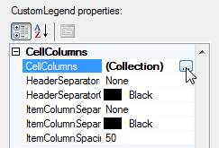
legend property, and then click the (…) button as shown here:
This opens the Legend Cell Column Collection Editor. It will have no members. The next image shows it with the three columns used in the example.
- Use the Legend Cell Column Collection Editor to add each of the columns you want in the table. The important cell properties for each column are:
  - The ColumnType property in the Series Items group. This can be set to Text or SeriesSymbol. In the example, the first and third columns are set to Text, while the second column is set to SeriesSymbol.
  - The Text property also in the Series Items group. This can be text, or more likely, a keyword. In the example, the first column uses #LEGENDTEXT to get the name of the data series (from the LegendText property in the Series Collection Editor). The third column sets this to the #AVG keyword to include the average value for that series (#AVG{N2} would restrict this to 2 decimal places). See Keywords on page 47 for a list of keywords and formatting options.
  - If you want to add a title to a column, use the HeaderText property in the
Header group. In the example, this is set to Average for the third column.
The image here shows the third column being configured.

27

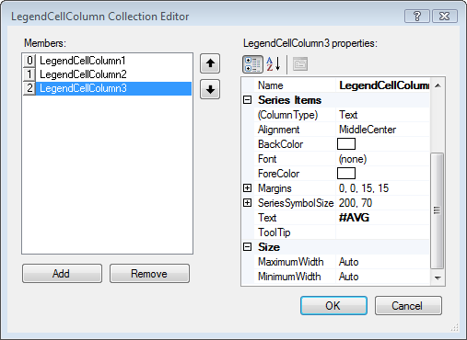
Once you have added and configured the required columns, click OK to return to the

Legend Collection Editor.
- Back in the Legend Collection Editor, add any other formatting properties required. In the example, Title and TitleSeparator in the Title group are set, as is HeaderSeparator in the CellColumns group.
The above outlines the process you need to follow to create a legend manually. You can design as complex or as simple a legend as required. The Legend and Legend Cell Column Collection Editors include many configuration and formatting settings not covered here.

Data point labels
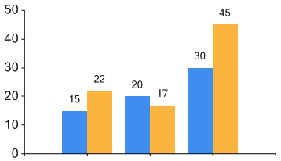
You can have labels on each data point, as shown below.
You can implement data point labels in two ways:
- Select the chart on the model, and then, on the ribbon, on the Style tab, in the Point Labels group, select Show Labels. Then select the format you want. This is the

28

simplest way. It offers minimal configurability. See The Show Labels setting next for details.
- Use the Label series properties in the Series Collection Editor to manually configure how the labels appear for each data series. This allows you to use keywords that are replaced at display time with their current value. See Manually creating data point labels on page 29 for details.
Note: You cannot use a combination of these methods. If Show Labels is selected on the ribbon, any manual data point label configuration is ignored.

The Show Labels setting
When Show Labels is selected on the ribbon, Y values are shown by default, and you can configure the data point label by selecting any combination of:
- Show Name. The item’s name. For example, the element’s name if the X axis shows elements.
- Show X Value. The X axis value. This is only relevant for charts that plot values along the X axis. If the chart plots elements, this will insert 0.
- Show Y Value. Include or exclude the Y axis value.

Manually creating data point labels
To manually configure data point labels, ensure that Show Labels on the ribbon is not selected, and then go to the Series Collection Editor:

Chart Layout Settings dialog box > Series Collection Editor
Then, with the required series selected, set the Label setting in the Label group of series properties to the required text. You can combine text and keywords. Keywords will be replaced by their current value. For example, #VAL adds the Y value, and #PERCENT gives its value as a percentage of the total Y series. See Keywords on page 47 for a list of keywords and additional examples.
The Label and Label Appearance groups of series properties give you additional formatting options, for example, colours used.
You do not have to add labels to every data series.

Note: Although you can access a Data Point Collection Editor from the Series Collection Editor, it is not functional. Any changes you make in the Data Point Collection Editor will not appear in your model, regardless of whether they appear in the preview shown on the Chart Layout Settings dialog box.

29

3D charts
By default, the General chart is 2-dimensional. To make it 3-dimensional, go to the Chart Area Collection Editor:

Chart Layout Settings dialog box > Chart Area Collection Editor
Then, in the 3D group of chart area properties, set Enable3D to True.
You can then use the Chart Area Collection Editor to configure other properties in the 3D
group. For example, use:
- Inclination to rotate the chart around the X axis. By default, this is set to 30. Valid values are -90 to 90. Negative values rotate clockwise.
- Rotation to rotate the chart around the Y axis. By default, this is set to 30. Valid values are -180 to 180. Negative values rotate counter clockwise.
- IsClustered to cluster the data series into a single plain on the X axis. For example, the first image shows a 3D chart with IsClustered set to True, while the second shows it set to False (the default).
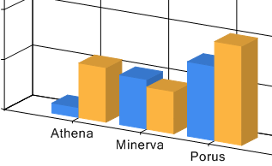
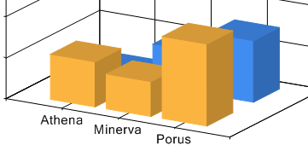

30

Multiple chart areas
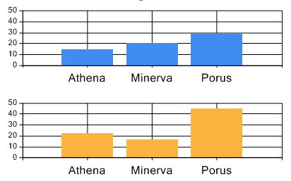
By default, the General chart uses a single chart area. However, it can have multiple chart areas. For example, you can add a single General chart that includes a chart area for each data series:
To create additional chart areas, go to the Chart Area Collection Editor: Chart Layout Settings dialog box > Chart Area Collection Editor
Then, click the Add button to add a new chart area. You can then configure it as required. Once you have additional chart areas, you can add data series to them. To do this, go to the

Series Collection Editor:
Chart Layout Settings dialog box > Series Collection Editor
Then, with the required series selected, set the ChartArea property in the Chart group of series properties to the required area. There is a drop-down list of available areas.
Note: If you use this feature with the intention that your users can quickly compare like information, note that the default settings scale the Y axis according to its content. You may want to manually set the Y axis in each chart area to the same maximum scale. For example, by default, the preceding chart would look like the next image:
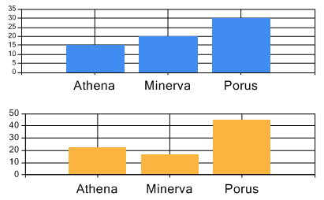
A cursory glance at the columns alone could give the wrong impression as the size of the chart area remains the same. See Axes on page 19 for more information on setting the Y axis scale.

31

Crossing points
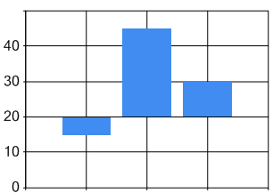
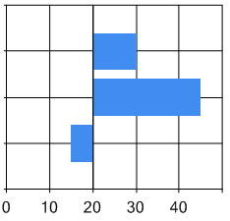
An axis crossing point lets you move the primary X axis to a point on the Y axis. Values that exceed the crossing point are plotted above the crossing point (in Column charts) or to the right (in Bar charts). Values that don’t reach the crossing point are plotted below or to the left of the threshold. The images below show Column and Bar charts with the crossing point set to 20 on the Y (value) axis. The first item, at 15, falls short of the crossing point and is therefore plotted in the opposite direction to the other items whose values exceed 20.
Crossing points can be useful in charts where you want to quickly convey where items have exceeded, or fell short of, some threshold or target, for example, project costs per month against a budget.
To move the X axis to a crossing point, go to the Axis Collection Editor:

Chart Layout Settings dialog box > Chart Area Collection Editor > Axis Collection Editor
Then, with the primary Y axis selected, use the Crossing axis property in the Scale group to set the crossing point to a point on the Y axis. The primary X axis will be located at that point.
Note: When Crossing is set, the axis labels and cross marks move with the axis. To move them back to the edge of the chart area, for the axis concerned (that is, not the axis that you set the Crossing property for), set the IsMarksNextToAxis setting in the Appearance group to False. You may also want to set the LineWidth setting (also in the Appearance group) to zero to remove the line that appears at the crossing point.

For clarity this section has covered moving the primary X axis. However, all axes can have crossing points.

32

Historical charts
Element fields can be configured to store their historical values (a change history). The Assign
setting on a General chart’s Content tab can be set to Historical. This lets you plot this history. When you set Assign to Historical, a Configure settings link is added to the Content tab.
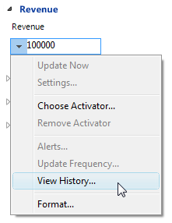Use this to configure what is shown, and the date range to use.
To record historical values for a field
Open an element, click the down arrow next to a value, and then click View History. This displays the View History dialog box where you can configure this.

Using Aggregation matrices with General charts
You can use General charts to display information from Aggregation matrices. To do this, on the General chart’s flip side, set Information shown to an Aggregation matrix. When you do this, the Assign setting automatically sets itself to Aggregation. You then have to decide whether the chart’s data series are taken from the Aggregation matrix rows or columns. This is the Series taken from setting. It defaults to Rows.
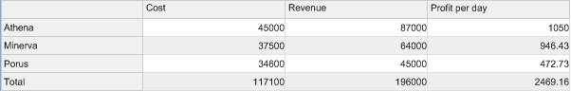
As the content and structure of Aggregation matrices can vary greatly, you will need to experiment with your General chart’s settings and configuration to get the best representation of your data. For example, as an illustration, consider a chart based on the following Aggregation matrix:
This has:
- Elements as rows (Athena, Minerva, and Porus)
- Facts as columns (Cost, Revenue, and Profit per day) On a General chart, you get:

33

Series taken from set to Rows: | Series taken from set to Columns:
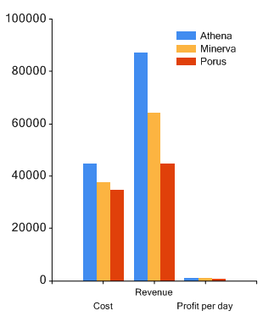
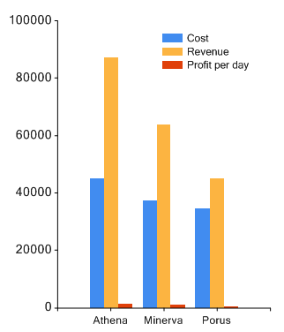
A legend has been added to these examples to show you what the data series are. In the first chart, they are the elements. In the second, they are the facts.
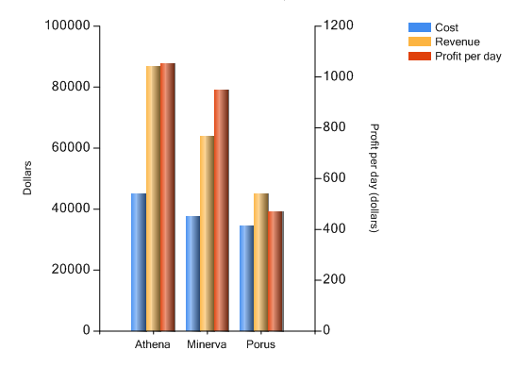
These charts also illustrate another consideration you might have when choosing a format, that is, the scale. In both charts, Profit per day is miniscule compared to Cost and Revenue, and barely registers on either chart. One solution is to use a secondary Y axis. However, this solution is only viable for the second chart. This is because secondary axes plot data series, and only the second chart has Profit per day as a data series. Doing this, you could get a chart like the following:

34

See Plotting a data series against a secondary Y axis (different scales) on page 22 for instructions on doing this.
The preceding image also demonstrates these other features:
- Grid lines have been removed. See Grid lines on page 23 for details.
- A legend has been added. See Legends on page 25 for details.
- Titles have been added against the axis. This can be particularly helpful when the axes use different scales. See Axes on page 19 for details (the Title properties).
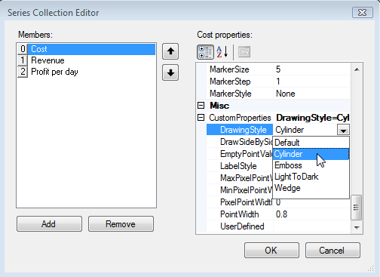
- The column appearance has been set to Cylinder, as shown in the image next.
This is an example of one of the many settings available within the Chart Layout Settings dialog box that you might want to experiment with.

35

Reference
This section provides reference material on:
- The General chart’s panel. The chart’s flip side has three settings tabs.

Content
  - Inputs
  - Results
- The Style and Web tabs on the ribbon.
- The Chart Layout Settings dialog box available from the ribbon. Use this to more closely configure the chart itself. It includes a representation of how a chart is likely to appear on the model.
Note: As a general rule when configuring any chart, you should regularly confirm that the model shows what you want and not rely entirely on the preview. Some functionality that is previewed is not supported on the actual model.

Configuring layout can involve Collection Editor dialog boxes which, in turn, can lead to others (shown nested). The following are covered:

Chart Area Collection Editor
    - Axis Collection Editor
  - Legend Collection Editor
    - Legend Cell Column Collection Editor
  - Series Collection Editor
  - Title Collection Editor

Note: Collection indicates that you can have more than one of these items. When you click the item, a More button appears (the … button). Use this to open the Collection Editor.
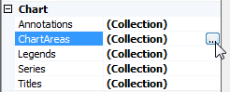

Only the widely used Collection Editors are covered in this guide.

The General chart’s panel
When you flip a General chart, it has three settings tabs:

Content
- Inputs
- Results

36

The Content tab
Use this to set the chart’s starting point and initial layout.

Content
Subject of panel | Drag the pin to the subject element that the chart will get its content from. Once pinned to an element, this property shows its name. To unpin the chart, drag the pin onto white space. When unpinned, the subject element is the model’s element. This is also the default.
Information shown | Specifies what content from the subject element will be included in the chart. This opens a Select Content dialog box for the subject element. Use this to select the required content.  Once set to content that includes a number of elements, the Results tab lists the individual elements that will appear in your chart. You can use this tab to remove elements and change their sequence, for example, to ensure that certain elements appear side by side. If the selected content makes the Results tab irrelevant, it displays a message saying so. For example, the Results tab won’t show anything when Information shown is set to an Aggregation matrix.  The Select Content dialog box includes a setting I want to add elements manually. If selected, Information shown is set to Elements and an Add and remove elements from this panel link is added.  If you set Information shown to a query or Aggregation matrix, an Edit this link is added, and the Inputs tab will include fields for any variables required.
Show data table | Use this to see a table of the data that will be used in the chart. This helps you select the correct content.
Data Filter – May not appear
Select a filter | If you have this section on your tab, you have an optional component that allows you to use SQL to filter the input to a chart. This advanced usage is not documented here. For most users, using a query to filter the content, or the Results tab to exclude content, will be sufficient.
Assign elements to the graph
Assign | Use this to set the chart’s basic column layout. This defines what is plotted against each axis. Choose from:  - Elements. The X axis plots elements and the Y axis plots field values. This type of chart can plot multiple data series against the elements on the X axis.  - Pivot. The X axis plots fields and the Y axis plots the values of those fields. In this type of chart, the data series are items on the X axis.  - Historical. For elements configured to store historical values (a  change history), this type of chart plots dates/times on the X axis and field values on the Y axis. When selected, a Configure

37

settings link is added immediately below. Use this to set the date range for the historical data. See Historical charts on page 33 for more details.
- Scatter. Both the X and Y axis plot values. The density and location of plotted points can indicate the relationship (or lack thereof) between two items.
- Aggregation. Plots content from an Aggregation matrix. If Information shown is set to an Aggregation matrix, this is selected automatically. See Using Aggregation matrices with the General chart on page 33 for more details.

Note: Once the basic chart is defined, you can use the Chart Layout Settings dialog box to customize this starting layout. This can be minor changes, or a fundamental reworking.
Series taken from | When Information shown is set to an Aggregation matrix, use this to specify what is used as data series in the chart.  When this field appears and you are not using an Aggregation matrix, the setting relates to the name of the series. The default is Element names. If you set this to Column values, when you click Select fields, the Select Content dialog box lets you set a name for each data series.
Select fields... | Opens the Select Content dialog box. Use this to set the data series that will be plotted on the chart. This is content from the subject element. For example, if your chart shows projects, this could be the fields that hold project costs such as estimated cost and actual cost. These fields would then appear as data series on the chart.  The Select Content dialog box will vary slightly depending on the Assign and Series taken from settings. For example, if Assign is set to Scatter, the Select Content dialog box lets you set the source for the X and Y values in each series.
Publishing — Active Enterprise only
Published tooltips... | Use this to enable and format data point tooltips when displayed in Active Enterprise. For example:  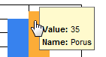  This opens the Published Tooltips dialog box, shown next:

38

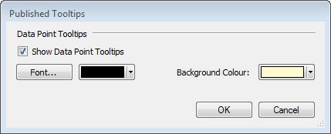

The Inputs tab
Use this to configure refresh options in Active Enterprise.

Inputs
Refresh when the pinned Action Panel is clicked | If pinned to a button, only refresh the chart when that button is used. Any input value changes are not applied to the chart until the button is used. You can only pin this to a button.
Refresh when the page loads | By default, this is always set and can only be unset when you have a pinned Refresh button. When unset, the page will not refresh on load, and is only refreshed when the Refresh button is clicked.
Refresh when any input changes | By default, this is always set and can only be unset when you have a pinned Refresh button. When unset, the page will not refresh when an input to the chart changes, and is only refreshed when the Refresh button is clicked.
Note: If your chart is based something that takes a variable, the Inputs tab will include additional Variable fields.

The Results tab
Use this to manually control the elements that appear on the chart’s X axis, and their sequence. This tab’s appearance depends on whether elements are manually or automatically added (the Information shown setting on the Content tab). If automatically added content means that the Results tab is irrelevant, the tab displays a message saying so.

Results
Sort results manually | If selected, the elements have been manually sorted. You can drag elements and change their position within the sequence. This is their order on the chart’s X axis.  If you clear Sort Results Manually, the original sort order is restored.
Add an element | Use this to manually add elements. This is only available when  Information shown on the Content tab is set to Elements.

39

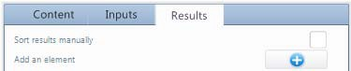
Click the Plus button to get a list of elements. You can only add elements one by one.
Result list | This area lists the elements that will be included in the chart. Its appearance depends on how the elements were added:  - Elements added automatically appear with checkboxes next to them:  - Manually added elements have a Delete button:  If you clear or delete an element, it won’t be shown in the chart. Delete  only removes the element from the list.  You can drag elements up and down the list. This changes their position on the chart’s X axis. To reset the sequence, clear the Sort Results Manually checkbox.

The Style, Settings and Web tabs (on the ribbon)
Specific General chart settings appear on the ribbon, under Panel, on the Style and Settings
tabs, and for Active Enterprise, on the Web tab.

Style
Chart group
Layout | Use this to open the Chart Layout Settings dialog box.
Template XML | Use this to open the Configure Chart XML dialog box. See Chart template XML on page 45 for details.
Point Labels group
Show Labels | Select this to add data point labels. Y values are shown by default, but you can use the remaining three settings to alter this.

40

Show Name | Includes the item’s name. For example, the element’s name if the X axis plots elements.
Show X Value | Includes the X axis value. This is only relevant for charts that plot values along the X axis. If the chart plots elements, this will insert 0.
Show Y Value | Include or exclude the Y axis value.
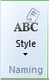
The Settings tab contains a single command called Style:
Use the top half of this button to display the Naming Conventions dialog box. Use the bottom half to also display this dialog box, or to turn the display of element names on and off.
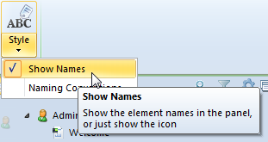

Web
Element Behaviour group
Allow Navigation | Makes the General chart interactive when viewed in Active Enterprise.
Allow Editing | If selected, users can flip the chart in Active Enterprise and edit its values. For example:  The triangle icon within a cell indicates that that value has been changed but not saved. When the chart is flipped back, it updates to reflect the updated values.
Allow Scrolling and Fixed Headers | Do not apply to the General chart.

41

The Chart Layout Settings dialog box
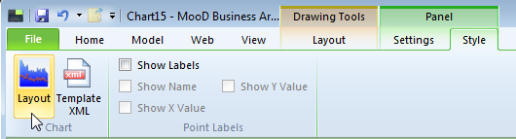
Opened from the Layout command on the ribbon:
Use this to manually configure the appearance of the selected General chart. This dialog box lets you access a series of Collection Editors that allow you to configure the appearance of specific chart components, such as titles and legends.

Note: The Chart Layout Settings dialog box is highly detailed. Only significant or problematic properties and settings are included in the reference material below.
Chart Layout
This area shows a preview of how your chart is likely to appear on your model. As you configure the chart this preview updates itself (when you click out of a setting field).
As a general rule when configuring any chart, you should regularly confirm that the model shows what you want, and not rely entirely on the preview. Some functionality that is previewed is not supported on the actual model. Where possible, this is noted.
Appearance
This collection of settings affects the appearance of the chart as a whole.
Cursor | Not implemented. Regardless of this setting, the default cursor is used.
RightToLeft | Not implemented. To change the order of items in a legend, you need to manually create the legend table. See Manually creating a legend table on page 26 for details.
Text | Not implemented. If you want to change the chart’s titles or legends, use the Collection settings listed under Chart. Anything you enter in this Text field is not saved.
Chart
This group lists Collection Editors. Collection indicates that you can have more than one of these items. When you click the item, a ... button appears as shown below. Use this to open the Collection Editor.

42

Annotations | Opens the Annotation Collection Editor. This dialog box is not functional and annotations are not relevant to General charts in MooD.
ChartAreas | Opens the Chart Area Collection Editor from which you can open the  Axis Collection Editor.
Legends | Opens the Legend Collection Editor from which you can open the  Legend Cell Column Collection Editor.
Series | Opens the Series Collection Editor.
Titles | Opens the Title Collection Editor.

The Chart Area Collection Editor
Opened from the Chart Areas link in the Chart group on the Chart Layout Settings dialog box, use this to configure the chart area. This is the area within which the chart is plotted. By default, charts have a single chart area. However, you can have multiple chart areas.
Each area can be individually configured using the Chart Area Collection Editor. Chart area properties can be listed alphabetically or by group (the default). If a property has been set manually, its setting appears in a bold font.
Note: To quickly see if a chart has manual settings, use the Template XML command on the ribbon (the Style tab). Manual settings are stored as XML.

Use the Chart Area Collection Editor to:
- Make charts appear 3-dimensional. See 3D charts on page 30 for details.
- Create multiple chart areas, each plotting one or more data series. See Multiple chart areas on page 31 for details.
- Access the Axis Collection Editor. Each chart area has its own set of axes.

The Axis Collection Editor
Opened from the Axes link in the Axes group in the Chart Area Collection Editor, use this to configure the X and Y axes for the selected chart area. See Axes on page 19 for general details.
Each axis can be individually configured using the Axis Collection Editor. Axis properties can be listed alphabetically or by group (the default). If a property has been set manually, its setting appears in a bold font.
Note: To quickly see if a chart has manual settings, use the Template XML command on the ribbon (the Style tab). Manual settings are stored as XML.

Use the Axis Collection Editor to:
- Add and format an axis title. See Axes on page 19 for details.
- Access the Custom Label Collection Editor (click CustomLabels in the Labels group of properties) and set the labels used for the elements on that axis. See Data series labels on page 24 for details.
- Add secondary axis. See Secondary axes on page 22 for details.

43

- Remove or alter the background grid. Use the MajorGrid and MajorTickMark axis properties. See Grid lines on page 23 for more details.
- Create charts that use a crossing point. See Crossing points on page 32 for details.
- Manually control the axis scale overriding the default settings which are designed to automatically accommodate the data series being plotted. See Axes on page 19 for details. This section also includes details on the IsMarginVisible, IsReversed and ScaleBreakStyle properties. Respectively, use these to remove the space padding on the X axis, reverse a chart’s axis, and to cater for data with large value differentials.

The Legend Collection Editor
Opened from the Legends link in the Chart group on the Chart Layout Settings dialog box, use this to add a legend table to a chart. By default, a General chart does not show legends. In charts with multiple data series, legends show which colour represents which data series.
Legends properties can be listed alphabetically or by group (the default). If a property has been set manually, its setting appears in a bold font.
Note: To quickly see if a chart has manual settings, use the Template XML command on the ribbon (the Style tab). Manual settings are stored as XML.

Use the Legend Collection Editor to:
- Add a default legend table, and then format it by, for example, adding a title and positioning it within the chart area itself. See Legends on page 25 for details.
- Create your own legend table. The default legend table has two columns. You can create your own legend table, for example, one with three columns where the third column uses a keyword to show the percentage of the total that a data series represents. See Manually creating a legend table on page 26 for details.

The Legend Cell Column Collection Editor
Opened from the CellColumns link in the CellColumns group in the Legend Collection Editor, use this to manually configure a legend by adding each of the columns you want to appear in the legend table. See Manually creating a legend table on page 26 for specific instructions and Legends (page 25) for more general details.

The Series Collection Editor
Opened from the Series link in the Chart group on the Chart Layout Settings dialog box, use this to configure each data series that appears in the chart. A data series is a piece of information plotted in the chart, for example, you could have one data series for estimated costs, and one data series for actual costs. Each data series has data points (Y values or columns) plotted against the elements on the X axis. See Data series on page 23 for an example.
Important: Do not attempt to add data series in the Series Collection Editor. Any data series added there will not appear in your model. The Add button, whilst appearing to work, does not. To add data series, you must use the Select Fields link on the chart’s Content tab.

44

You can have any number of data series, and each series can be individually configured using the Series Collection Editor. Series properties can be listed alphabetically or by group (the default). If a property has been set manually, its setting appears in a bold font.
Note: To quickly see if a chart has manual settings, use the Template XML command on the ribbon (the Style tab). Manual settings are stored as XML.

Use the Series Collection Editor to:
- Set the chart type, for example, change from the default Column chart to a Pie chart. ChartType is a property of each series, and charts can mix compatible types such as Column and Line. See Chart type on page 18 for details.
- Change the order of data series. See Data series order and colour on page 24 for details.
- Plot a data series against a secondary Y axis. Use the YAxisType series property in the Axis group. See Plotting a data series against a secondary Y axis on page 22 for details.
- If you have more than one chart area, assign data series to another area. Use the ChartArea series property in the Chart group. See Multiple chart areas on page 31 for more details.
Important: Although you can access a Data Point Collection Editor from the Series Collection Editor, it is not functional. If you want to control data point labels, use the Show Labels command on the ribbon (the Style tab), or manually create them. See Data point labels on page 28 for details.

The Title Collection Editor
Opened from the Titles link in the Chart group on the Chart Layout Settings dialog box, use this to add and position one or more titles. See Chart titles on page 17 for details.

45

Chart template XML
The ribbon includes a Template XML command on the Style tab (the chart must be selected):
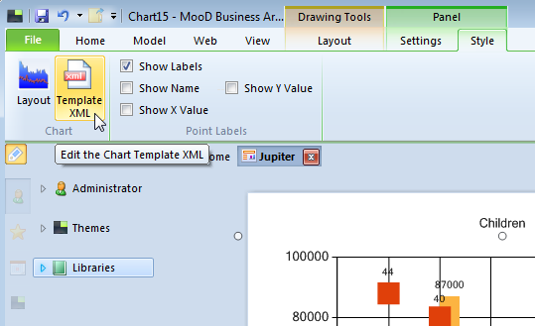
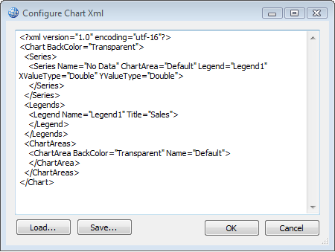
This displays the Configure Chart XML dialog box. For example:
Chart layout settings that change the defaults are stored and applied as XML. You can save and load different XML files, and thereby reuse particular configurations.
You can also directly edit this XML. You must exercise caution. If you edit the XML and break the syntax, you will get an error when you next flip the chart. If you edit the XML, click OK to save the changes. The Save button is for saving the XML to a file.
Note: If you edit series formatting, the XML includes identifiers to the fields used in those series. This affects how reusable such XML is.
Tip – Restoring a chart to its default formatting
A quick way to restore a chart to its default formatting is to delete the content of the Configure Chart XML dialog box.

46

Keywords
Each time a chart is displayed or refreshed, keywords are updated to show their current value in the MooD repository.
You can use keywords within:
- Manually created data point labels. This is the Label series property in the Series Collection Editor. See Manually creating data point labels on page 29 for details.
- Manually created data series legends. This is the Text cell property in the Legend Cell Column Collection Editor. See Manually creating a legend table on page 26 for details.
Note: If you use the Show Labels setting on the ribbon to implement data point labels, or use the chart’s default legends, you cannot use keywords. You can only use keywords when you manually create these items.

You can include formatting characters in keywords and combine them with standard text. The following tables list keywords and formatting respectively.

Table 1. Keywords

Keyword | Result | Applies To
#VALX | X value of a data point. | Data points
#VAL, #VALY,  #VALY2, #VALY3,  ... | Y value of the data point. | Data points
#SERIESNAME | Data series name. | Data points and Series
#LEGENDTEXT | Data series property LegendText if set. This property is used when you want the legend to use a name other than the data series name. | Data points and Series.
#LABEL | Data point label. | Data points
#AXISLABEL | Axis data point label. | Data points
#INDEX | Data point index. | Data points
#PERCENT | The percentage of the series total that a data point represents. This can be particularly helpful on pie charts to show the percentage each slice is. | Data points
#TOTAL | The total of all the Y values in a data series. | Series
#AVG | The average of all the Y values in a data series. | Series
#MIN | The minimum data point Y value in a data series. | Series
#MAX | The maximum data point Y value in a data series. | Series
#FIRST | First data point value of all Y values in the series. | Series
#LAST | Last data point value of all Y values in the series. | Series

47

Table 2. Keyword formatting

Formatting
\n | Inserts a new line into the text.
{Nx} | To the x number of decimal places. For example, #AVG{N2} will show an average to 2 decimal places.
{C} | As a currency. For example, #VAL{C} will show values as a currency, for example, £44.00. Use {C0} for just £44. The currency type is derived from the locale of your PC.  If you want to use a currency symbol that is not derived from your locale, include the currency symbol, for example, $#VAL

Examples
Here are some examples:
- #VAL\n#PERCENT
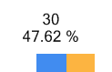
Gives the data point value, then on a new line, the percentage that that data value represents in the entire data series, for example:
- #AVG{N2}
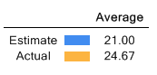
Gives the average value of a data series to 2 decimal places, for example, in a legend:
- #VAL{C0} million
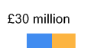
Gives the value as a whole number of £s (assuming a UK locale) but with the text million included in the label, for example:

Note: $#VAL{N0} million

Gives the value as a whole number of dollars (if you do not want to use the currency {C} format character).

48

