MooD 15
User Management and Permissions Guide

Document Number: MooD15UMP01

© MooD Enterprises Ltd., all rights reserved. 31/05/12

Notice of Copyright and Trademarks
MooD 15 User Management and Permissions Guide
® MooD, MooD Smarter Decisions, Performance Activation, Synchronization Activation Technology and Knowledge Map are registered trademarks of MooD Enterprises Ltd. in the United Kingdom and / or other countries.
Microsoft and Windows are trademarks of Microsoft Corporation in the USA and other countries.
Rights to all other referred trademarks or registered trademarks reside with their respective owners.
Aspects of the Enterprise Business Model, Model-Driven Data Aggregation and Business Solutions to Support Smarter Decisions are protected by International Patent and Patent Pending. These include the Meta-Architecture Framework, Panels Technologies, Auto- Explorer, Business Orchestration, the Activator mechanism, Process Driven System, Performance Activation, Model-Driven Enterprise Management, Dynamic Aggregation, Smart Columns, the Variant Mechanism, and other technologies and mechanisms implemented within MooD Business Architect and MooD Active Enterprise.
© MooD Enterprises Ltd., all rights reserved. No part of this document may be reproduced by any means, or transmitted, or translated into machine language without the written permission of the company.

2

Contents

Introduction 5
Changes in MooD 15 5
About users, user groups and permissions 6
Users and user groups 6
The Users and Groups themes 7
Types of permission 9
Element permissions 10
Element permission inheritance 11
Root element permissions 11
Element ownership 12
Library permissions 12
Inheritance of library permissions 14
Precedence of library permissions over element permissions 14
Field permissions 14
Precedence between element and field permissions 15
The Anonymous user 15
User management on the web 16
The Permissions tab in Business Architect 17
Displaying the Permissions tab 17
About the Permissions tab 18
Managing users and user groups 22
Creating user groups 22
Creating users 23
Adding users to a user group 25
Managing passwords and disabling accounts 27
Password settings 28
Managing permissions 29
3
Giving user groups library permissions 29
Assigning element permissions by user group 31

Tasks
Task 1 To create a user group: 22

Task 2 To create a user 23
Task 3 To add users to user groups 25
Task 4 To grant library permissions to a user group 29
Task 5 To assign element permissions by user group 32

Figures
Figure 1 Users, user groups and permissions 7

Tables
Table 1 Element permissions 10

Table 2 Library permissions 13

Table 3 Field permissions 14

Table 4 Permissions and what they can apply to 20

4

Introduction
This guide is for MooD administrators and users who have been granted permission to manage users, user groups, or permissions. It has the following sections:
- About users, user groups and permissions (page 6)
Explains MooD users, user groups and permissions, and how they function within Business Architect.
- The Permissions tab in Business Architect (page 17)
The Permissions tab is a single point for permissions management. This section outlines its functionality and behaviour.
- Managing users and user groups (page 22) and Managing permissions (page 29)
Instructions covering key tasks. These tasks assume knowledge of what is covered in the preceding sections.

Changes in MooD 15
Some changes relating to users and permissions have been introduced in MooD 15:
- Business Architect now has a single administrative point for permissions management – the Permissions tab.
- Library permissions have been introduced. These let you devolve management permissions that were previously restricted to members of the Administrators user group. Library permissions are available for: Users and Groups, Styles, Model Masters, Epochs, Queries, Smart Columns, Matrices, Threshold sets, Synchronizations and Publishing Schemes. Groups with permission to manage a library can edit, rename, delete, move and create within that library.
- You can set default root element permissions for a theme. All elements in that theme then inherit these permissions. Root elements are the first level of elements within a theme, and you can prevent users creating them.
- There is an Anonymous user.
- Action panels for web based user administration have been introduced. All are covered or introduced in this guide.
Note: MooD 15’s Getting Started Guide includes a list of new features covering all product areas. This is available as a PDF from Business Architect’s File tab.

5

About users, user groups and permissions
The relationship between users, user groups and permissions, together with the types of permission available and their application and inheritance, form a permission’s architecture that should provide your users with the facilities they need to achieve their goals, and at the same time provide the repository security you may require. To help you understand the permission’s model employed by MooD, this section includes the following:
- Users and user groups (page 6)
How users belong to user groups, and the default users and user groups created for you. We recommend that you use user groups as your primary means of controlling the allocation of permissions.
- Types of permission (page 9)
MooD has element permissions, library permissions and field permissions. This section introduces these types. Business Architect uses a single Permissions tab to manage all three types, so it is important to differentiate between them.
- Element permissions (page 10)
Information on the permissions that can be applied to elements. This includes sections on inheritance, on root element permissions, and on the ownership of elements (which does not affect permissions).
- Library permissions (page 12)
Library permissions let you to devolve specific management permissions without granting full Administrator user status. This includes a section on how a user’s library permissions take precedence over their element permissions.
- Field permissions (page 14)
Information on the permissions that can be applied to the fields that define each element within a theme. It includes a section on how element and field permissions interact (precedence).
- The Anonymous user (page 15)
Outlines this default user that lets you provide limited, login free access to a repository through the web.
- User management on the web (page 16)
Outlines the action panels for web based user administration.

Users and user groups
This diagram and the key points that follow cover how users, user groups and permissions interact.

6

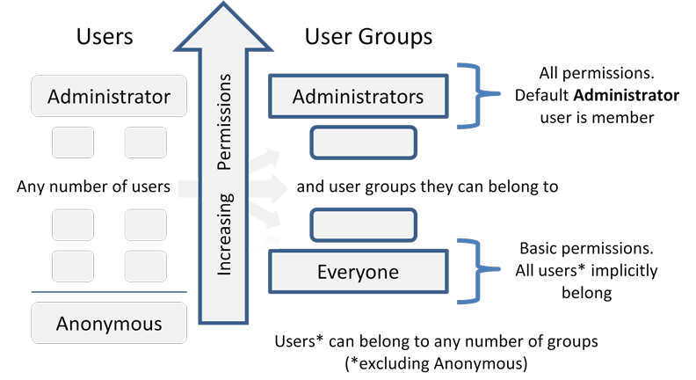

Figure 1. Users, user groups and permissions
Key points:
- Users and user groups are elements within the Users and Groups themes respectively.
- By default, there is a user called Administrator. This user is the repository administrator, has full privileges, and is responsible for creating any number of users and user groups required. You cannot delete the Administrator user, and you cannot restrict their permissions.
Note: The only other default user is the Anonymous user. This provides login free, but highly limited, access to a repository on the web. See The Anonymous user on page 15 for details.

- By default, there are two user groups: Administrators and Everyone.
  - The Administrator user implicitly belongs to the Administrators user group.
  - All users (excluding the Anonymous user) implicitly belong to the Everyone user group.
- Element and library permissions are assigned to user groups, but can also be assigned to individual users if required.
- Users can belong to more than one user group.
- Users inherit their permissions from the user groups they belong to, but individual users can have permissions that override their user group permissions. Permissions are cumulative.
We recommend that you use user groups to establish levels of access, and then assign users to an appropriate user group.

The Users and Groups themes
Users and user groups are elements belonging to the Users and Groups themes respectively. You create new ones just like any other element in MooD.
Users elements have the following default fields:

Description.

7

- Windows Login Name. The Active Directory domain and user login name for use within Active Publisher.
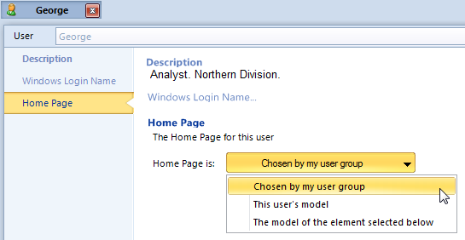
- Home Page. Each user and user group can have a Home Page. This is the model displayed when a user logs into a repository by means of Active Enterprise. The model can be the user’s model, a specific element’s model, or the model associated with the user group that the user is a member of. For example:
Groups elements have the following default fields:
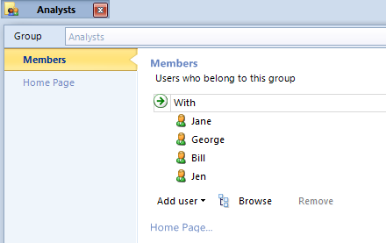
- Members. The users who are members of the user group, and therefore inherit its permissions. For example:
- Home Page. This functions the same for Users and Groups elements. See the previous Home Page description.

8

Types of permission
Before looking at the actual permissions, you should understand the three types of permission used in MooD, and how they interact.
  - Element permissions
Apply to each element in a theme either individually or collectively by means of inheritance. Element permissions can be set by user group. This means that the same elements can have different permissions for different user groups. If necessary, element permissions can be also be set for individual users. These override any permissions attained through user group membership, but are in turn overridden by any library permissions.
See Element permissions on page 10 for reference material on the actual permissions an element can have.
  - Library permissions
Grant management permissions previously exclusive to users in the Administrator user group to other user groups or users. Permissions are organized and granted by area (library), for example, Matrices, Queries, Synchronizations, and Users and Groups. This allows you to devolve management permissions without granting full Administrator user access. Again, if a user has specific library permissions, they take precedence over those attained by means of their user group membership.
Note: Individual Users elements cannot be given singular, across the board permission over an entire library. They can only have permissions for specific groups or items within a library. For example, queries can be organized into groups, with each group containing any number of individual queries. Users elements can be granted permission over individual queries or groups of queries, but not the entire Queries library itself. Only Groups elements can be given permission over an entire library category by means of a single permissions setting.

Library permissions also take precedence over any element permissions. For example, if a user belongs to one user group where editing of an element is denied, but also to one user group that has the power to manage matrices, then they will be able to edit that element’s matrices.
See Library permissions on page 12 for a list of areas that you can grant control over.
  - Field permissions
Apply to fields in themes (and consequently elements). Field permissions control whether fields are visible and editable in Business Architect, or when published on the web using Active Enterprise or Web Publisher. See Field permissions on page 14 for details.

Tip – Develop a ‘lean permissions’ architecture
As you learn about permissions and apply permissions to your repository, we recommend that you implement a lean permissions architecture. Fewer explicitly set permissions help performance and reduce maintenance. Achieve this by, wherever possible, applying high level group permissions and allowing inheritance to propagate permissions across your repository.

9

Element permissions
Business Architect’s Permissions tab lists five permissions (the last five columns in the next image):
Only three of the five apply to elements. These are:

Permission | Description
Edit | Grants permission to manage an element. This includes editing, creating child elements, renaming, moving and deleting.
View on Web | The element’s model can be viewed in a browser by means of Active Enterprise.  Note: This permission can also apply to fields. This controls what is presented to users, and what is output by Web Publisher (element permissions do not affect Web Publisher but field permissions can). See Field permissions on page 14 for details.
Manage Permissions | Users with this permission can edit the element’s permissions.

Table 1. Element permissions

Note: Although View in Architect applies to field permissions only, and Manage Root Elements only applies to themes, both affect what a user can do with elements. See Field permissions on page 14 and Root element permissions (page 11) for details.

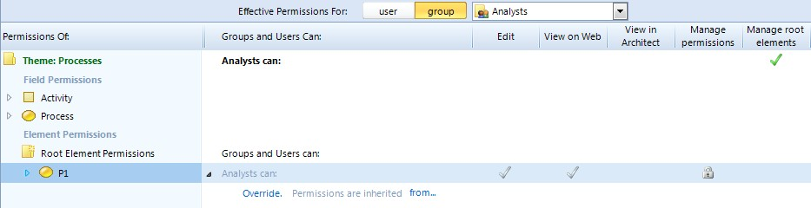
As shown here, permissions appear as columns on the Permissions tab:
A tick means permission is granted to that user or user group. A padlock means it is denied. A blank column means the permission is not applicable to that item.
There are two types of tick, and two types of padlock:
Greyed icons indicate that the element has inherited its permissions.
Coloured icons indicate that the element’s permissions have been explicitly set.

10

Element permission inheritance
By default, elements inherit their permissions from their parent. You can set an element’s permissions, and thereby override its inherited permissions. However, note that if you change the permissions for an element, its descendent elements will then inherit those permissions, unless they too have had their permissions overridden.
Business Architect’s Permissions tab includes a link to the element that an element inherits its permissions from. For example, in the following image you can see that E1 inherits its permissions from the root element.
Greyed ticks and padlocks (and the presence of the Override command and the inherited from link) indicate that the element inherits its permissions. If you click Override, you can set user group and user permissions for that element. The Override command will be removed, and the explicitly set permissions (with coloured icons) displayed instead, as shown here:
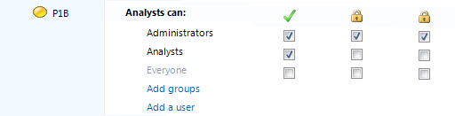
To help you manage element inheritance, the ribbon includes the following commands:
•
•
The ribbon also lets you Pickup and Apply element permissions.

Root element permissions
For each theme, there is a Manage Root Elements permission (ringed in the following image):
User groups or users granted this permission can create and edit root elements. Root elements are the first level of elements within a theme.
You can set the default Root Element Permissions (ringed in the following image) for users and user groups. Each root element created within a theme inherits the root element permissions.

11

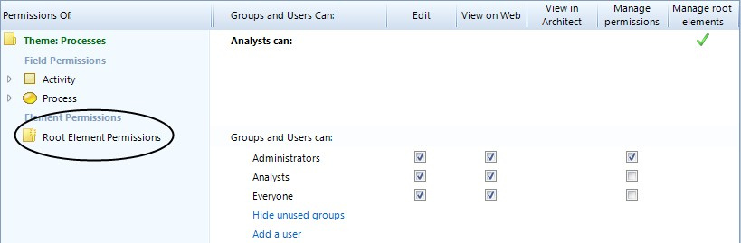
Due to inheritance, all elements in a theme will inherit the root element permissions unless they are specifically overridden.

Element ownership
MooD has the concept of element ownership. Typically, elements are owned by the user who created them. However, ownership can be changed (File tab, Manage Repository, Manage Ownership).
Element ownership does not affect permissions. Do not infer that because a user owns an element they have permissions for it. You can own an element but have no permissions over it.

Library permissions
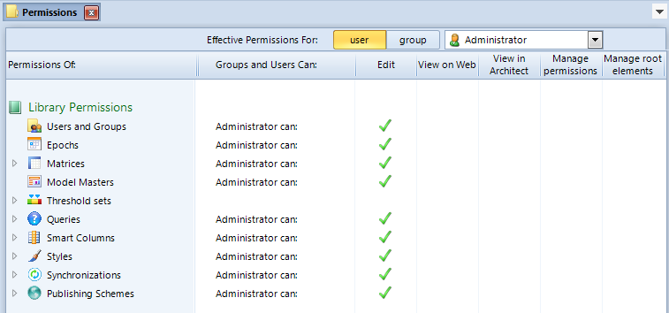
Library permissions grant management permission over specific, mostly reusable, features (libraries) to other user groups. If a user has Edit permission for a library, they can edit, rename, delete, move and create within that library. Such management powers were previously restricted to members of the Administrators group. Administrators continue to have all permissions, but can now devolve and control specific management responsibilities across the user base. The following image shows the library permissions. This is followed by a table describing them.

12

Library | Description
Users and Groups | Manage users and user groups. This includes adding, modifying or deleting users and user groups, but excludes managing Administrator users and assigning library permissions.
Epochs | Manage epochs. This is a universal permission covering all epochs in the repository. Primarily, this relates to custom epochs, as you cannot alter the start and end dates of calendar epochs.
Matrices | Manage matrices.
Model Masters | Manage model masters. This is a universal permission covering all model masters in the repository. You cannot set this permission for individual model masters or groups of model masters.
Threshold sets | Manage individual Thresholds. You cannot set permissions that cover all Thresholds (this is why there is no tick in the Threshold sets’ Edit column in the previous screenshot).
Queries | Manage queries.
Smart Columns | Manage Smart Columns.
Styles | Manage styles.
Synchronizations | Manage synchronizers (SAT).
Publishing Schemes | Manage Web Publishing schemes. Publishing schemes are listed individually. They cannot be organized into groups.

Table 2. Library permissions
Just like element permissions, you set library permissions in Business Architect’s Permissions
tab. Only two (Edit and Manage Permissions) apply to libraries.
Excluding Threshold sets, all library permissions let you set Edit permission across the entire library for user groups.
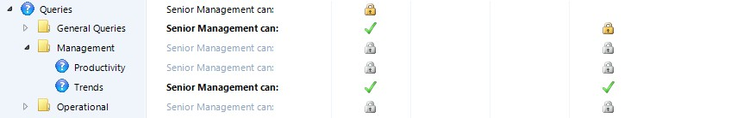
In the Explorer Bar, most libraries of reusable items can be organized into groups (in this context group means a group within a library and not a user group). You see the same hierarchy on the Permissions tab. For example, in the following screenshot, queries are organized in the groups General, Management and Operational. In such cases, for both user groups and users, you can set the Edit and Manage Permissions permissions for each group, and for each item in each group. Should you require it, this gives you a fine level of control over the management of your libraries.
The other permissions (the View on Web, View in Architect and Manage Root Elements
columns) do not apply to libraries.

13

Inheritance of library permissions
Library groups inherit permissions in the same way as elements. Hence, you can take a top down approach to setting permissions, and only override specific exceptions. Just like elements, coloured icons indicate explicitly set permissions, and greyed icons mean inherited permissions. See Element permissions inheritance on page 11 for details on the rules of permission inheritance (the contents of libraries are all elements in their own right).

Precedence of library permissions over element permissions
A user’s library permissions take precedence over their element permissions. For example, if a user does not have Edit permission for an element, but they do have the Matrices Edit library permission, they can manage that element’s matrices. However, they will not, for example, be able to manage the element’s queries, unless the Queries Edit library permission is also set.

Field permissions
Field permissions apply to the fields that define each element within a theme. Of the five permission columns on the Permissions tab, only the following three apply to fields.

Permission | Description
Edit | Grants permission to manage the field data.  Note: This means the right to manage the field instance within each element belonging to a theme. It does not confer management rights over the actual definition of that field within a theme.
View on Web | The field can be viewed in a web browser by means of Active Enterprise, or published through Web Publisher.  Note: In the previous release, the equivalent of the View in Architect permission within a theme governed what was included in Web Publisher’s output. This is now controlled by the View on Web field permission. Because of this, user group specific outputs can be created.
View in Architect | The field can be viewed in Business Architect.

Table 3. Field permissions
User groups and users can be applied to field permissions. Again, we recommend that you control field permissions by user group, and let individual users inherit from their user group membership.
The View on Web and View in Architect permissions let you control (restrict) what fields are presented to users. This helps you create ‘uncluttered’ solutions for your different user groups. By default, all fields are visible in Business Architect, Active Enterprise and Web Publisher, so you need to explicitly deny the relevant View permissions for your different user groups (clear the check boxes).

14

Precedence between element and field permissions
If a permission is denied in an element, it takes precedence over the corresponding field permission. Hence, if Edit permission is denied on an element, users cannot edit fields in that element regardless of any field permissions they might have for the theme concerned.
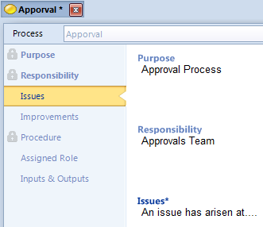
If a permission is granted in an element but denied in the theme’s field permissions, then the field permissions takes precedence over the element permissions. Hence, a user can have Edit permission on an element, but be denied Edit permission on certain fields within that element. This can be seen in the following image (the fields with the padlock icon are locked by the denial of the Edit field permission):

The Anonymous user
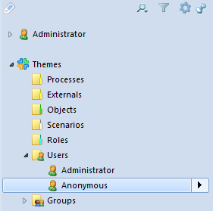
MooD now includes an Anonymous user by default.
The Anonymous user has strictly limited permissions and cannot belong to user groups. For repositories published to the web, the Anonymous user can allow restricted login-free access for browsing purposes only.

15

Use the Permissions tab to set permissions for the Anonymous user, for example, to specify what elements they can View on the Web, and what elements, if any, they can Edit (make sure you set the Permissions tab’s Effective Permissions For control to the Anonymous user).

User management on the web
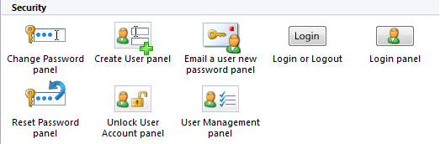
Action panels are available for web based user administration. On the ribbon, on the Home tab, in the Insert group, click Actions. In the gallery, the panels are in the Security group, as shown in the following image.

16

The Permissions tab in Business Architect
Business Architect’s Permissions tab is the single point for permissions management.

Displaying the Permissions tab
To display the Permissions tab, do one of the following:
- In the Explorer Bar, click an element, and then, on the ribbon, on the Home tab, click

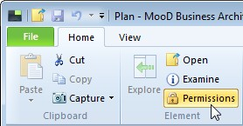
Permissions.
- In an element’s Examine pane, click the Padlock button.
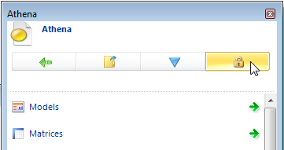
Both methods will open the Permissions tab for the chosen element.

17

About the Permissions tab
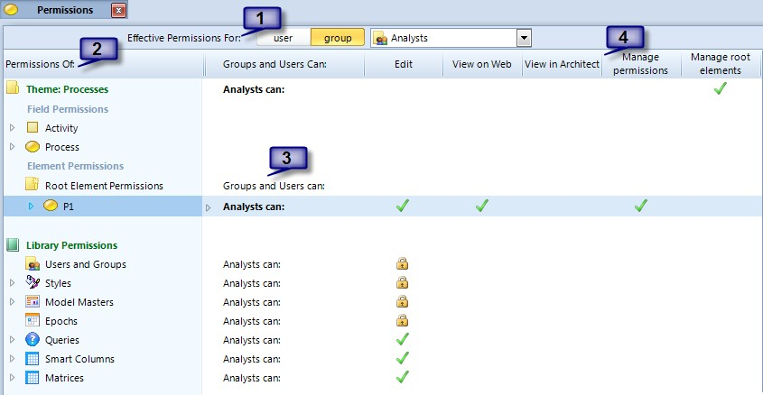
The Permissions tab has four main areas identified on the following image.
- The Effective Permissions For control. This sets the user or user group that the
Permissions tab displays and manages permissions for.
Click user or group to set a category, and then select the actual user or user group from the drop-down list on the right.

Note: Even with the Effective Permissions For control set to one user or user group, you can manage the permissions for others. The Groups and Users Can column (3) lets you do this. However, the Permissions tab’s main display is always for the user or user group selected in the Effective Permissions For control.
- The Permissions Of column. For the selected user or user group, this lists the repository items whose permissions you can view and set. The ribbon includes a Track Selected command. This synchronizes the Permissions tab with the Explorer Bar so that you can easily change what the Permissions tab is showing.
- The Groups and Users Can column. For each settable item listed in the Permissions Of column (2), this column lists the user or user group currently selected in the Effective Permissions For control (1). The settings for this user or user group are then shown in the Permissions columns (4).
The Groups and Users Can column includes several pieces of functionality. From here you can:
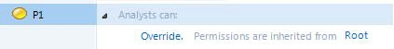
  - For the current user or user group, see where an element or field inherits its permissions from. For example:

18

Click the inherited from link (Root in the preceding image) to highlight the element referenced.
Note: If an element does not inherit its permissions, the user or user group name appears in bold, and it does not have an Override command and inherited from link. Instead it shows the explicitly set permissions. The Analysts group in the next image demonstrates this.

- Override inherited element and field permissions. The Override command is shown in the previous image, and an example of what you get when you use this option is shown in the next image. When user or user group permissions are explicitly set rather than inherited, that is, overridden, the user or user group name is displayed in bold. The Analysts user group in the next image demonstrates this.
When you click Override, the inherited permissions for that item are explicitly set. This gives you a valid set of permissions to start with.
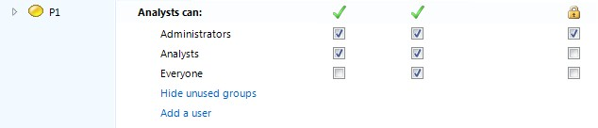
- See and explicitly set element, field and library permissions for the current user or user group, and for other user groups and users. For example, for an element:

Note: When you explicitly set permissions, you get commands to control what users and user groups are listed. For example, in the preceding image, there is an Add a user command. In the example, all of the groups are shown. However, if there were more groups, there would be an Add groups command.

- Change which users and user groups have the Manage Root Elements permission for the current theme, and set the actual root element permissions. Root elements are the first level of elements within a theme.
- Manage which user groups a user selected in the Effective Permissions For control
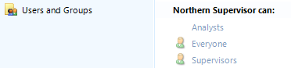
(1) is a member of. For example:
The icon means that the selected user is a member of that user group. You use the Add selected use to this group and Remove selected user from this group commands on the ribbon to control the current user’s user group membership.

Note: Although you can use this to manage a user’s user group membership, you cannot select a user group in the Effective Permissions For control (1) and use the Permissions tab to collectively manage its members. When creating user groups and users, we recommend that

19

you open a user group’s definition page, and then add users directly to its Members field. See Adding users to a user group on page 25 for instructions.

- The Permissions columns. These five columns are the permissions you can set. Each permission is only applicable to certain items in the Permissions Of column (2) — an empty column means it’s not applicable. The following table shows what permissions apply to what.

Permissions
 | Edit | View on Web | View in Architect | Manage Permissions | Manage Root Elements
Theme
Field
Element
Library

Table 4. Permissions and what they can apply to
Coloured and greyed ticks and padlocks indicate different settings, and whether those settings are explicitly applied or inherited.

Greyed icons indicate inherited permissions.
Coloured icons indicate that the permissions have been explicitly set.
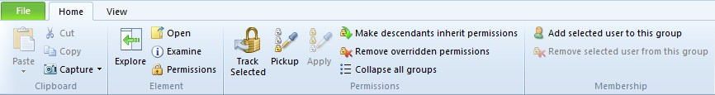
The Permissions tab also adds its own command groups to the Home tab on the ribbon, as shown here:
The ribbon commands relating to permissions and user group membership are:

Track Selected
When this button is selected (coloured as shown), the content of the Permissions tab keeps itself synchronized with the Explorer Bar. Each time you click an element in the Explorer Bar, the Permissions tab changes to show that element.

Note: If you split the Explorer Bar into two (drag the handle at the bottom), Track Selected synchronizes with the first Explorer Bar.

20

In the Explorer Bar, under Libraries, if you click Synchronize or Web Publish, their tabs open. Track Selected does not synchronize with these items.

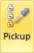
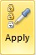
- Pickup and Apply
Use these buttons to pick up the permissions applied to one item, and then apply them to another.

Make descendants inherit permissions
Use this to apply the currently selected element’s permissions to its descendant elements. This effectively removes all descendant permissions and cleans up your permissions model from that point. It will also remove any explicitly set permissions on matrices and models.

Remove overridden permissions
If an element’s permissions are explicitly set as opposed to inherited, use this to restore its permission inheritance. This does not affect any descendant permissions.

Collapse all groups
Use this to restore the Permissions tab to its original view by collapsing any open groups.

Add selected user to this group and Remove selected user from this group

When a user is selected in the Effective Permissions For control (1), use this to quickly add and remove them from user groups. This excludes the Administrators user group which can only be managed directly.

21

Managing users and user groups
This section covers the key tasks you will perform when setting up users and user groups. It covers:
  - Creating user groups
  - Creating users
  - Adding users to a user group
  - Managing passwords and disabling accounts

Creating user groups
As covered in Users and user groups on page 6, Business Architect creates two default user groups: Administrators and Everyone. Typically, you create user groups for each role within your MooD solution.

Task 1 To create a user group:
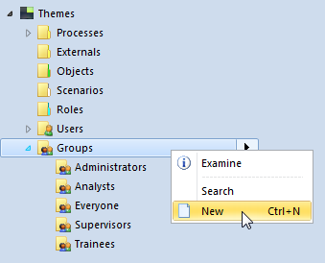
- In the Explorer Bar, under Themes, right-click Groups, and then click New.
This adds a user group called New Group, and selects its name.
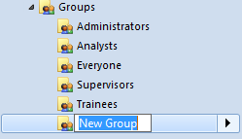

22

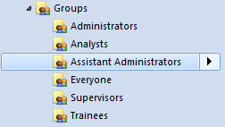
- Give the new group a descriptive name, for example, Assistant Administrators.
You can now:
  - Add users to the user group. See Adding users to a user group on page 25.
  - Assign library permissions to the user group. See Giving user groups library permissions on page 29.
  - Assign the user group to element permissions. See Assigning element permissions by user group on page 31.

Creating users
As covered in Users and user groups on page 6, Business Architect creates two default users: Administrator and Anonymous. You will need to create a user for each person wishing to log into the MooD solution.

Task 2 To create a user:
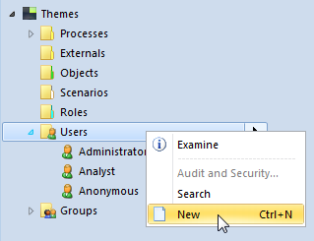
- In the Explorer Bar, under Themes, right-click Users, and then click New.
This displays the Create User dialog box.

23

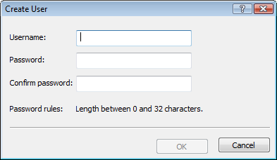
- Complete the Create User dialog box. To help you:
  - Username is the name that your user will type into Business Architect’s login dialog box when they try and open the repository in Business Architect.
  - Password will be valid until the user has successfully logged into the repository for the first time. Once logged in, the user will immediately be prompted to change their password.

Users without passwords
You may be able to omit the password, in which case, when you click OK, Business Architect displays the following:
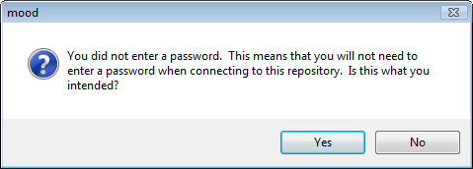
Click Yes to proceed, or No to return to the Create User dialog box where you can supply a password.
If you create a user without a password, that user will be prompted to create a password as soon as they open the repository in Business Architect. Again, the user can continue without supplying a password; in which case their username is unsecure. See Managing passwords on page 27 for more details.
- Click OK to create the user. The user is listed under Users.
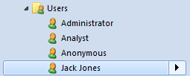

24

You can now add the user to the user group or groups that best match their required level of access. See Adding users to a user group on page 25 for details.

First time log in
When a user logs into Business Architect for the first time, they are presented with a dialog box like the following:
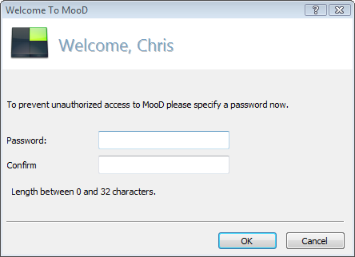
This prompts the user to change their Administrator assigned password. Should a user subsequently forget their password, it can be reset by the Adminstrator. See Managing passwords on page 27 for details.

Adding users to a user group
When you add users to a user group, they become members of that user group, and inherit their permissions from it. See About users, user groups and permissions on page 6 for more information.

Task 3 To add users to user groups:
- In the Explorer Bar, under Themes, under Groups, right-click the group, and then click

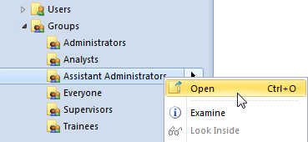
Open.
This displays the user group’s definition as a tab in the workspace. The Members field lists the users who are members of the user group.

25

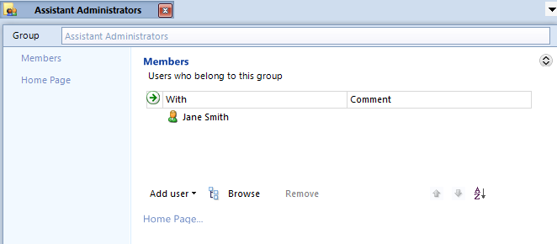
- Add additional users to the Members field. You can add users in the following ways:
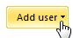
  - Click Add user, and then select a user from a drop-down list of all users.
You can filter this list, for example:
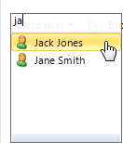
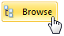
  - Click Browse to apply a filter to the Explorer Bar.
This applies the Elements allowed in Members filter to the Explorer Bar:
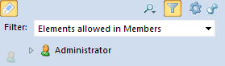
You can then see suitable elements, and drag them into the Members field.
  - Without using the Browse button to filter the Explorer Bar, drag a user element from the Explorer Bar into the Members field.

26

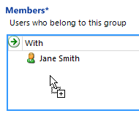
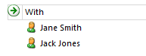
When you drop the user, they are added to the user group:

Note: Opening a Groups element’s definition tab and using its Member field is the recommended method of populating user groups with users. However, you can open a user’s Permissions tab and manage their user group membership. See the last bullet point (page 19) in the description of the Groups and Users Can column.

Managing passwords and disabling accounts
Members of the Administrators group can right-click a user, and then, from the shortcut menu (shown in the following image):
  - Reset users’ passwords.
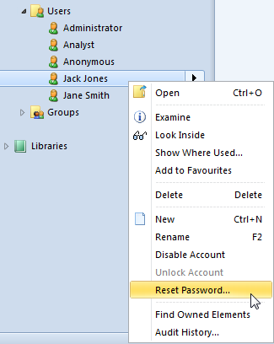
  - Disable users’ accounts to prevent access. Administrators can subsequently unlock disabled accounts.

27

Note: When someone attempts to log into Business Architect using a disabled account, they get a generic message saying that their login credentials are invalid. The message does not specifically state that the account has been disabled.

Password settings
Members of the Administrators user group can access the Audit and Security dialog box from the ribbon. Click File, point to Manage Repository, and then click Audit and Security Settings in the list of options that appears on the right.
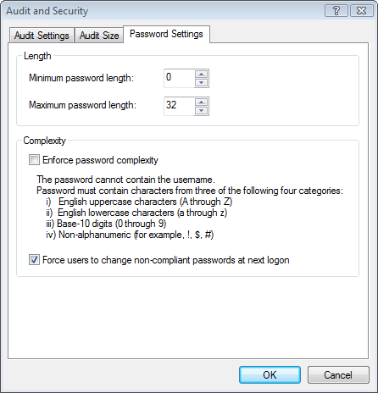
The Password Settings tab on this dialog box (shown next) lets you enforce passwords and their level of security. By default, passwords are not enforced.

28

Managing permissions
This section covers the key tasks you will perform when managing permissions:
  - Giving user groups library permissions
  - Assigning element permissions by user group (page 31)

Note: As we recommend that you control permissions by user group and allow users to inherit their permissions from their user group membership, the tasks here refer to user groups. However, both tasks are applicable to users ─ the only difference is what you set the Permissions tab’s Effective Permissions For control to.

Likewise, setting field permissions is the same basic process as setting element permissions (covered in this section’s second task).

Giving user groups library permissions
See the About users, user groups and permissions topics starting on page 6 for general details on permissions, and Library permissions (page 12) for a description of the specific administrative powers you can devolve to other user groups.

Task 4 To grant library permissions to a user group:
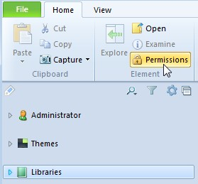
- In the Explorer Bar, click Libraries, and then, on the ribbon, click Permissions.
The Permissions tab is displayed.

Note: This task doesn’t fully describe the Permissions tab’s features and controls. See The Permissions tab in Business Architect on page 17 for full details on its user interface.

29

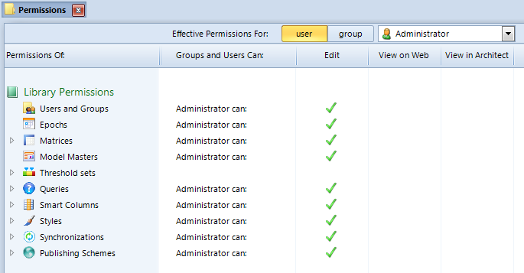
The Effective Permissions For control at the top of the tab is set to the current user (Administrator in the preceding image).
- In the Effective Permissions For control, click group, and then select a user group from the drop-down list.
This sets the user group that you will assign library permissions for. For example:
The Groups and Users Can column will show the selected user group and its Edit
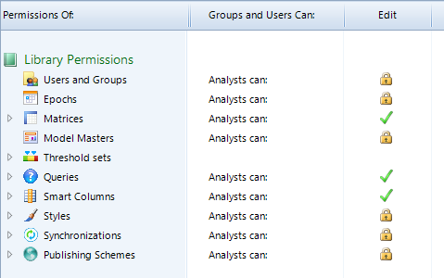
permission for each of the library permissions.

Note: You can set the Effective Permissions For control to a user, and then assign library permissions to that user for groups or items within a library (not the entire library). However, we recommend that you assign permissions by user group, and allow users to inherit their permissions from their user group membership.

30

- Click the library permission that you want to set. For example:
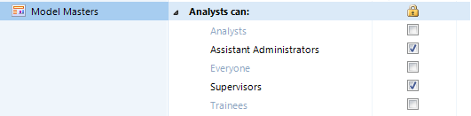
This expands to show its setting for all user groups. For example:
You can set library permissions for all user groups, not just for the user group selected in the Effective Permissions For control. However, the collapsed view always shows the setting for the currently selected user group.
- Click the check boxes to grant or remove a permission.
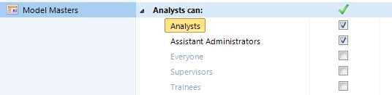
For example, when comparing the following image to the previous image, the permission has been removed from the Supervisors user group, but granted to the Analysts user group.
Permissions are saved as soon as they are applied. You do not need to explicitly save changes.

Note: Some libraries, for example Queries, can be further organized into groups, with each group inheriting from its parent group within the library. You can set the Edit permission for each grouping within such a library. In addition, the Manage permissions permission may be available. See Library permissions on page 12 for full details.

Assigning element permissions by user group
See the About users, user groups and permissions topics starting on page 6 for general details on permissions, and Element permissions (page 10) for details on the actual permissions you can assign to elements.
Note: The basic process in this task is also applicable to setting field permissions.
Indeed, when you set element permissions, the Permissions tab also lists the field permissions from the element’s theme, and the current user or user group’s library permissions. The Permissions tab lets you manage all of these at once.

31

Task 5 To assign element permissions by user group:
- In the Explorer Bar, click the element that you want to set permissions for.
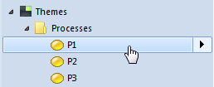
This selects (highlights) the element as shown in the following image. You will be able to set permissions for the selected element and its descendants.
- On the ribbon, on the Home tab, in the Element group, click Permissions.
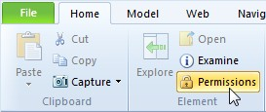
The Permissions tab is displayed.

Note: This task does not fully describe the Permissions tab’s features and controls. See The Permissions tab in Business Architect on page 17 for full details.

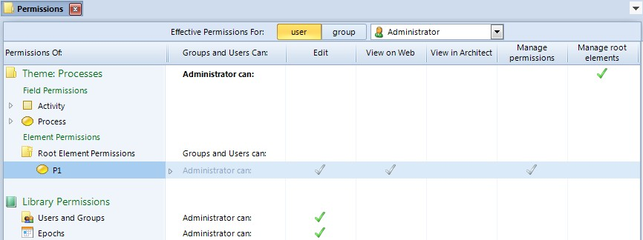
The Effective Permissions For control at the top of the tab is set to the current user (Administrator in the preceding image).
Note: You can also access the Permissions tab by clicking the Padlock icon on an element’s Examine pane. See Displaying the Permissions tab on page 17 for details.

- In the Effective Permissions For control, click group, and then select a user group from the drop-down list.
This sets the user group that you will set element permissions for. For example:
The Groups and Users Can column will show the selected user group and its element permissions for the current element and its descendants.

32

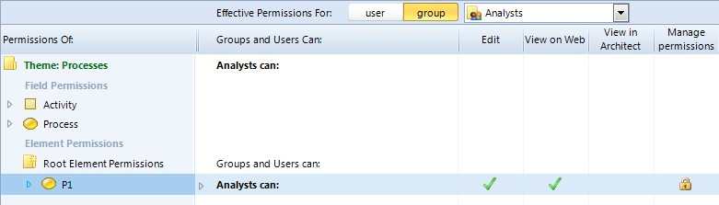

Note: You can set the Effective Permissions For control to a user, and then
assign element (or field) permissions to that user. However, we recommend that you assign permissions by user group and allow users to inherit their permissions from their group membership. Nevertheless, the process covered in this task is equally applicable to users.
- Click in the selected element’s Groups and Users Can column, or on one of its permissions.
What happens next depends on whether the element’s permissions are inherited or explicitly set:
  - If explicitly set (as indicated by the user group name being in a bold font), the section expands to show the permissions settings for a number of user groups. For example:
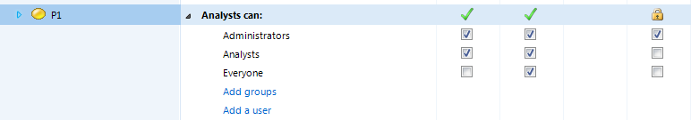
  - If inherited, the section expands to give you an Override command, and a link to where the element’s permissions are inherited from (Root in the image). For example:
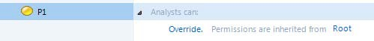
If you click Override, the section expands to show the permissions check boxes (in effect it will look like the image in the first bullet point).
You can set element permissions for all user groups (and users) and not just for the user group selected in the Effective Permissions For control. However, the collapsed view always shows the setting for the currently selected user group.

33

Note: If the selected element has descendants, you can click the element and see them. You can then select a descendant element and set its permissions.
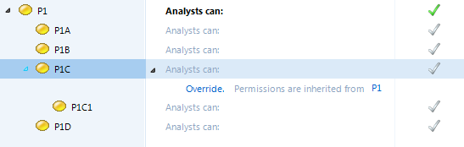

- Click the boxes to set or remove a permission.
Permissions are saved as soon as they are applied. You do not need to explicitly save changes.
Also, you can use the ribbon commands:
  - Make descendants inherit permissions and Remove overridden permissions to control inheritance.
  - Pickup and Apply to copy permissions from one element to another.
See The Permissions tab in Business Architect on page 17 if you need guidance on the user interface, and Element permissions (page 10) if you need information on the actual permissions and inheritance.

34

