MooD 15
Free Form Matrix

This document covers how to create a Free Form matrix in MooD Business Architect.

Document Number: MooD15FFM47

© MooD Enterprises Ltd, all rights reserved.

Notice of Copyright and Trademarks
MooD 15 Free Form Matrix
® MooD, MooD Smarter Decisions, Performance Activation, Synchronization Activation Technology and Knowledge Map are registered trademarks of MooD Enterprises Ltd. in the United Kingdom and / or other countries.
Microsoft and Windows are trademarks of Microsoft Corporation in the USA and other countries.
Rights to all other referred trademarks or registered trademarks reside with their respective owners.
Aspects of the Enterprise Business Model, Model-Driven Data Aggregation and Business Solutions to Support Smarter Decisions are protected by International Patent and Patent Pending. These include the Meta-Architecture Framework, Panels Technologies, Auto- Explorer, Business Orchestration, the Activator mechanism, Process Driven System, Performance Activation, Model-Driven Enterprise Management, Dynamic Aggregation, Smart Columns, the Variant Mechanism, and other technologies and mechanisms implemented within MooD Business Architect and MooD Active Enterprise.
© MooD Enterprises Ltd., all rights reserved. No part of this document may be reproduced by any means, or transmitted, or translated into machine language without the written permission of the company.

2

Contents
Introduction 4
About the Free Form matrix 4
Briefly, what is a Free Form matrix? 4
What sort of tables is it suitable for? 4
Key details 5
Three starting points (the three basic configurations available) 5
The Row query starting point 5
The Column query starting point 6
The Cell query starting point 7
Cell display (Controlling what appears in the cells) 8
Auto-generate columns and rows by default 8
Where is the Free Form matrix in Business Architect? 10
The Free Form matrix tab in Business Architect 11
How to create a Free Form matrix 13
Preparation 13
Developing a Row query Free Form matrix 13
Developing a Cell query Free Form matrix 15
Tasks
Task 1 To develop a Free Form matrix that starts with a Row query 13

3

Introduction
This document has two main sections:
- About the Free Form matrix
- How to create a Free Form matrix (page 13)

About the Free Form matrix
This section explains the Free Form matrix by answering:
- Briefly, what is it?
o What sort of tables is it suitable for?
- List the key details.
- Where is it in Business Architect?
- Explain how the Free Form matrix tab works.

Briefly, what is a Free Form matrix?
A Free Form matrix displays elements on both the X and Y axis. These elements are related by a query, and the cells can show information from those elements or from related elements. It is the most flexible matrix in MooD. This flexibility brings complexity. A Free Form matrix is constructed using queries. The key to using it is to understand clearly what you want to show in the matrix, and whether your repository has the data and relationships required to produce the queries needed. Knowing what you want to show in a table is central to successfully implementing any matrix, but this is particularly true of the Free Form matrix.

What sort of tables is it suitable for?
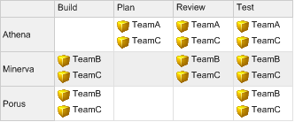
Because of its flexibility, any type of table. However, it is particularly suited to tables where you want to show the relationships between groups of elements and not just data values. This is best illustrated by two examples that show relationships between Task, Team and Project elements.
This first example has Projects as rows, and then shows the different Teams assigned to Tasks.

4

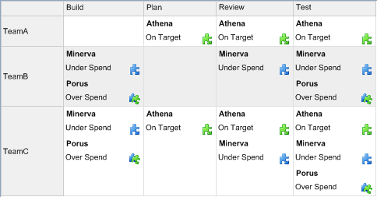
In this next example, the cells show Projects and the Pick list status for an applied measure.

Key details
An awareness of these key details will help you understand and construct Free Form matrices. The sections are:
- Three starting points – when you create a Free Form matrix, you choose between three starting points.
- Cell display (page 8) – how to control what is shown in the cells.
- Auto-generate columns and rows by default (page 8) – a brief overview of how you can extend the basic configurations by disabling some of the automatically generated content. This gives you finer control, but you have to write additional queries.

Three starting points (the three basic configurations available)
Free Form matrices all start with a query. However, you choose between three starting points: a Row query, a Column query, or a Cell query. The Free Form matrix tab has a Change button to cycle between them. Each starting point gives you a different type of table, and a different sequence of queries to construct it. The sections that follow outline each starting point.

The Row query starting point
This adds the rows first. After this you add a Cell to column query to add the columns and position elements against them. This second query starts from a row element.
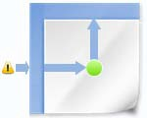
On the General tab for a Free Form matrix, this is the default starting point and it appears as:

(Query sequence: Row > Cell to column)

5

Note: For each query in the sequence, there is a sub tab within the main tab. For example, for a Free Form matrix that starts with a Row query, you have these tabs:
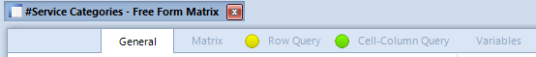

This type is ideal when you know what elements you want to show as rows. From this starting point, you then find the elements for your columns, and configure the cells to show some relationship between the two.
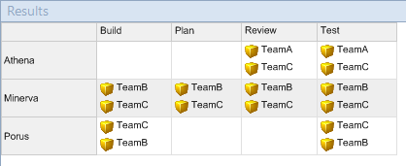
For example, as shown in the following image, show Projects as rows, then find Tasks as columns, and in the cells show what resources (if any) are allocated.

The Column query starting point
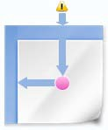
This adds the columns first. After this you add a Cell to row query to add the rows and position elements amongst them. This second query starts from a column element. The icon for this is:

(Query sequence: Column > Cell to row)
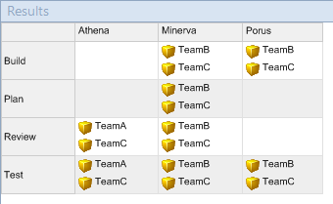
This starting point is the inverse of the Row query starting point. Choosing between them is a presentation choice, not a logical or content choice. For example, here is the previous example but with the Project elements added as columns:

6

The Cell query starting point
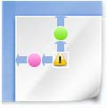
This is the most complex starting point. It lets you define a query that finds elements to use as cells, and then lets you define two queries (Cell to Column and Cell to Row) to add the columns and rows by which those elements are positioned within the table. Both these queries start from a cell element. The icon for this is:

(Query sequence: Cell >Cell to column > Cell to row)
This starting point is ideal for where you want cells to show elements and some information related to that element. For example, the following shows Project elements and a Measure status for different Teams and Tasks.
The Cell query starting point is also useful when you want one of the axes to show epochs. For example:
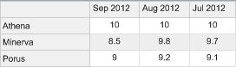
This second example:
- Starts with a Cell query that finds measure instances.
- Then has a Cell to column query that finds and orders their epochs (specifically a Find Instances Epoch block followed by an And finally block with an order by clause).
- Ends the query sequence with a Cell to row query that finds the Project elements that contain the measure instances (a Find Instances Container Element block).
- Finally, the Cell display setting is configured to show the value of the measure instance within each cell.

7

Cell display (Controlling what appears in the cells)
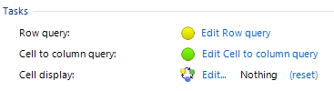
For all three types of Free Form matrix, once you have completed the queries to get the content, use the Cell display setting to control what is actually shown in the cells. This setting is the last setting under Tasks on the General tab. Click Edit to display a Select Content dialog box.
If the matrix starts from a Cell query, the cells can include or exclude the name of the elements they contain. This setting (Include element titles) is on the Matrix sub tab, within the Cells group, as shown in the next image:
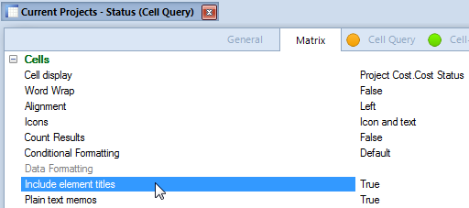

Auto-generate columns and rows by default
Once you add a Cell to query, the columns or rows included in the table are added automatically based on the content returned by that query. In many cases, MooD’s selection will be what you want. However, if it isn’t, you can switch off the auto generation and manually write another query to find exactly what you want. For example, if the auto generation includes too many columns, you can replace it with a query that finds just the required columns. As soon as you switch off auto generation, you get a new sub tab for the replacement query. How to do this for a Row query Free Form matrix is outlined next.
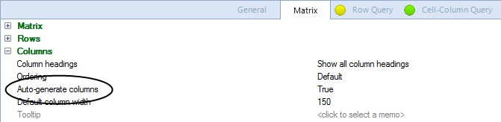
On the Matrix tab, in the Columns group, there is an Auto-generate columns setting that defaults to True.

8

When False, the query sequence for the Row query Free Form matrix changes from Row > Cell to column to Row > Column > Cell to column, and a Column Query sub tab is added to the main tab, as shown here:
The image that represents this configuration also changes to:
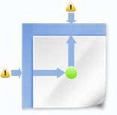
Use the new Column Query sub tab to replace the automatically generated columns. At the expense of an additional manual step, this gives you complete control over what columns appear in your matrix.
There are equivalent Auto-generate settings for the other two types of Free Form matrices. They function in the same manner. For example, for a Cell query (the third starting point), if you set both Auto-generate rows and Auto-generate columns to False:
  - The query sequence becomes: Row > Column > Cell > Cell to column > Cell to row.
  - You have five sub tabs:
  - The image that represents this particular configuration becomes:
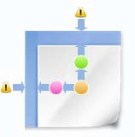

Note: This document does not elaborate further on these extended configurations. They add flexibility should you require it.

9

Where is the Free Form matrix in Business Architect?
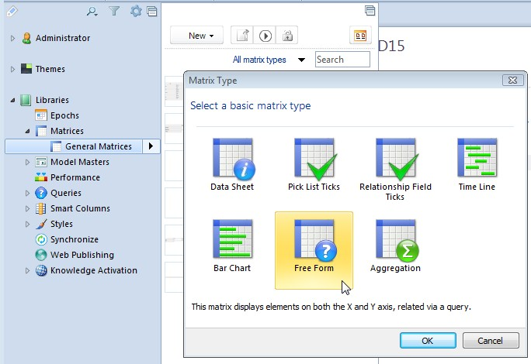
In the Explorer Bar, in the Matrices library, when you add a matrix, Free Form is one of the types you can select.
When you click OK, a matrix designer tab is displayed. The next section outlines this tab’s features in relation to Free Form matrices.

Note: You can see if your repository already contains Free Form matrices by filtering the Matrix library by that type. Click All matrix types (shown in the previous image just above the Matrix Type dialog box) and apply the Free Form filter to the Matrix pane.

10

The Free Form matrix tab in Business Architect
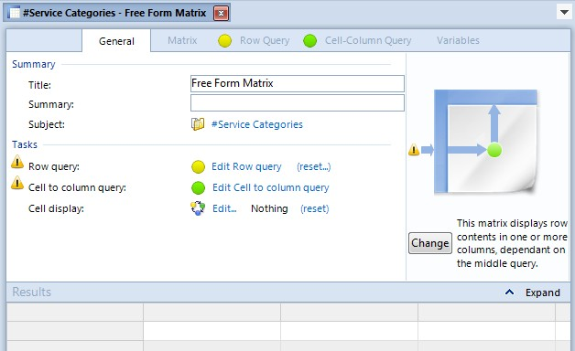

Figure 1. Image of Free Form matrix tab for Row query configuration
Key usage points:
  - Click the Change button to switch between the three basic configurations outlined on page 5.
    - The sub tabs, and what is included within the Tasks area, change as you move between the three configurations.
  - Under Tasks, if you click on any Edit query link, it takes you to the sub tab for that query (meaning there is a one to one relationship between the queries listed under Tasks and the sub tabs along the top of the main tab).
    - The image above the Change button is also clickable. Different points take you to the query they represent.
  - The Matrix sub tab includes a variety of standard configuration options, including the
Auto-generate settings outlined on page 8.
  - The reset link next to a query lets you reset that query to a standard query chosen from a list of basic, but frequently used, queries. This will replace any existing query, but if you are developing a new Free Form matrix, you can use reset to quickly select a query.
    - The reset link next to Cell display does reset that setting to nothing (after prompting for confirmation).
  - All Cell to queries start from an element found by the first query in its sequence. This will be a row element, a column element or a cell element. You cannot change this starting block.

11

If you want to test a Cell to query on its own tab, you must supply a relevant element on the Test sub tab.
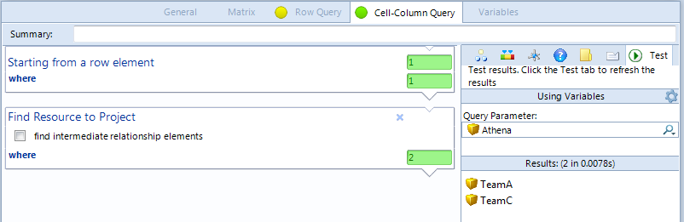
The next image shows all of this for a Cell to column query. The Starting from a row element block is fixed, and to test it, the Athena element has been added as the Query Parameter.

12

How to create a Free Form matrix
This section covers creating a Free Form matrix. It has the following sections:
  - Preparation – some guidance on what you should consider before you begin creating the matrix.
  - Developing a Row query Free Form matrix (page 13). A step by step task. The information here also applies to the Column query starting point (fundamentally the processes are the same).
  - Developing a Cell query Free Form matrix (page 15). This outlines the differences between this and the previous task.
These sections assume that you are familiar with the concepts and user interface covered in the About the Free Form matrix section starting on page 4.

Preparation
Preparation typically involves answering these questions:
- What do I want to show in this matrix?
- Does the repository include the information I need to show this?
o In particular, do the relationships exist?
- Could I use one of the simpler matrix types?
- If it involves calculations, is it more suited to an Aggregation matrix?
You can discover this by trial and error, but a little preparation, in particular having a clear understanding of what you want your matrix to show, is advisable.

Developing a Row query Free Form matrix
This section describes creating a Free Form matrix that uses at the default Row query starting point.

Task 1 To develop a Free Form matrix that starts with a Row query:
- In Business Architect, under Libraries, open the Matrices pane.
- In the Matrices pane, click New, and then select the element that the matrix will belong to.
- In the Matrix Type dialog box, click Free Form, and then click OK.
A tab for the new matrix is displayed. This defaults to the Row query format.
- Give the matrix a meaningful name.

13

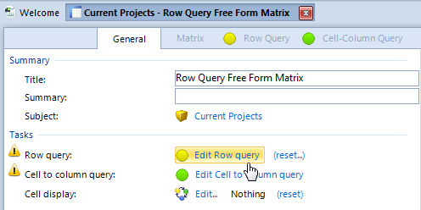
- Under Tasks, click Edit Row query.
The Row Query sub tab is displayed.
- Construct the query that finds the elements that you want to show as rows.
Use the Test tab (on the right side of the Row Query sub tab) to check that the query returns the elements you expect.
Note: At this point, if you click Execute, the Results area will show a table with these elements shown as both the rows and columns. This is because Auto-generate columns on the Matrix sub tab is set to True. This is the expected behaviour. The next step gives MooD the information it needs to find the actual columns required.

- Click the Cell-Column Query sub tab.
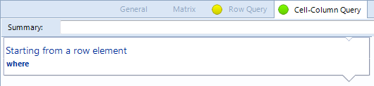
This is the query that finds the elements that you want to use as columns. As these elements are related to the row elements returned by the Row Query, this query already has row element as its starting point. You cannot change this.
- Construct the query.
Use the Test tab, or click Execute, to check that the query finds what you want and adds the desired columns to the table.
All that remains is to specify what will be displayed in the table’s cells.
- Click the General sub tab.
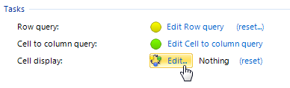
- Under Tasks, next to Cell display, click Edit.

14

The Select Content dialog box is displayed.
- Select what you want to show in the table’s cells.
- On the ribbon, click Execute to test the matrix.
The Results area will show the completed matrix. You can configure it further, or place it on a model. If it does not show what you want, you will have to revisit the queries and Cell display setting as appropriate.
Note: To create a Free Form matrix that starts with a Column query, you follow the same process but, before step 4, click the Change button to change the configuration. The image above the Change button will change, and the Row Query sub tab is replaced with the Column Query sub tab.

Developing a Cell query Free Form matrix
The process is the same as developing a Row query Free Form matrix except that the sequence of queries is:
  - Cell query – this finds the elements that will populate the cells.
  - Cell to column query – starting from a cell element, this query finds the columns.
  - Cell to row query – starting from a cell element, this query finds the rows.
Once you have defined these queries, use the Cell display setting on the General sub tab to select the content that will be shown within each cell. By default, the name of the element is included in the cell, but you can control this using the Include element titles setting in the Cells group of settings on the Matrix sub tab.
Another useful setting in the Cells group is Icons. Use this to include or exclude Pick list icons.

15

