MooD 15
Model Driven Documents

This document covers Model Driven Documents (MDD) (the Documents synchronizer).

If you want a reminder of how fragments, patterns and templates interact, see the diagram on page 8.

FAQ: What are the Save To filename tokens?

Answer:
$R Repository name
$D Date
$T The date and the time (separated by a full stop)
$N Start element name

Document Number: MooD15MDD42

© MooD Enterprises Ltd., all rights reserved.

Notice of Copyright and Trademarks
MooD 15 Model Driven Documents (MDD)
® MooD, MooD Smarter Decisions, Performance Activation, Synchronization Activation Technology and Knowledge Map are registered trademarks of MooD Enterprises Ltd. in the United Kingdom and / or other countries.
Microsoft and Windows are trademarks of Microsoft Corporation in the USA and other countries.
Rights to all other referred trademarks or registered trademarks reside with their respective owners.
Aspects of the Enterprise Business Model, Model-Driven Data Aggregation and Business Solutions to Support Smarter Decisions are protected by International Patent and Patent Pending. These include the Meta-Architecture Framework, Panels Technologies, Auto- Explorer, Business Orchestration, the Activator mechanism, Process Driven System, Performance Activation, Model-Driven Enterprise Management, Dynamic Aggregation, Smart Columns, the Variant Mechanism, and other technologies and mechanisms implemented within MooD Business Architect and MooD Active Enterprise.
© MooD Enterprises Ltd., all rights reserved. No part of this document may be reproduced by any means, or transmitted, or translated into machine language without the written permission of the company.

2

Contents
Introduction 7
Technical support and resources 7
About model driven documents 8
The template, fragments and patterns 8
About the Microsoft Word template 9
About fragments 9
About patterns 9
Exposing variables and parameters as pins 9
Templates within patterns 10
Creating a Documents synchronizer 11
About the Documents synchronizer tab 13
The Fragments pane 14
The Document Generator Properties pane 14
The Patterns tab 15
The Groups tab 15
The ribbon 16
The Home tab 16
The Settings tab 18
The Default Styles tab 19
Link settings 19
Developing documents 20
Workflow 20
Document properties 21
Setting a document’s properties including Use Template 23
Fragments 24
Dragging fragments into patterns 25
Element rules 26
3

Query rules 28
Patterns 31
The Fragment Auto-Creation dialog box 33
Using patterns 33
Name rules 34
Field rules (simple fields) 36
Formatted Text rules (HTML and rich text memo fields) 38
Pick List rules 41
Model rules 45
Matrix rules 48
Custom Text rules 51
Inserting lists 53
Inserting page and section breaks 54

Previewing documents and fragments 55

Executing Documents synchronizers 56
Viewing the Activation History 57

Advanced usage 58
Starting elements 58
Using starting elements 58
Parameterized queries 59
The <the rule subject> setting for Query, Model and Matrix rules 59
Example of using <the rule subject> - Generating multiple tables 60
Variables in Query, Model and Matrix rules 62
Document level variables and pinning 64
Pattern groups and Query rules 65
Repeating templates (templates within patterns) 67

4

Figures
Figure 1 Relationship between the template, fragments and patterns 8
Figure 2 Templates in patterns – repeating sections 68
Tasks
Task 1 To create a Documents synchronizer 11
Task 2 To open the Documents synchronizer tab for an MDD 13
Task 3 To set the basic properties including Use Template 23
Task 4 To add a fragment 24
Task 5 To insert an Element rule into a fragment (using the ribbon) 26
Task 6 To insert a Query rule into a fragment (using the ribbon) 29
Task 7 To create a pattern 32
Task 8 To insert a Name rule into a pattern: 35
Task 9 To insert a Field rule into a pattern: 37
Task 10 To insert a Formatted Text rule into a pattern: 39
Task 11 To insert a Pick List rule: 43
Task 12 To insert a Model rule into a pattern (using the ribbon) 47
Task 13 To insert a Matrix rule into a pattern (using the ribbon) 49
Task 14 To insert a Custom Text rule into a pattern: 51
Task 15 To preview a document or fragment 55
Task 16 To execute a Documents synchronizer 56
Tables

Table 1 The Home tab (on the ribbon) 16

Table 2 The Settings tab (on the ribbon) 18

Table 3 The Default Styles tab (on the ribbon) 19

Table 4 Properties in the Document Generator Properties pane 21

5

Table 5 Document properties on the Settings and Default Styles tabs on the ribbon 22
Table 6 Element rule properties 26
Table 7 Query rule properties 28
Table 8 Pattern properties 31
Table 9 Name rule properties 34
Table 10 Field rule properties 36
Table 11 Formatted Text rule properties 39
Table 12 Pick List rule properties 42
Table 13 Model rule properties 45
Table 14 Matrix rule properties 48
Table 15 Custom Text rule properties 51

6

Introduction
This guide is written for MooD Business Architect users who want to use Documents synchronizers to output documentation from a MooD repository. Such documents are called model driven documents (MDD).
This guide contains the following sections:
- About model driven documents (page 8)
This gives you an overview of Documents synchronizers and how to develop them. It introduces the key concepts of fragments and patterns, and how they interact with the underlying Microsoft Word template file that is the starting point for every MDD.
- Creating a Documents synchronizer (page 11)
MDDs are created from synchronizers of type Documents. Once you create one, you can access its Documents synchronizer tab.
- About the Documents synchronizer tab (page 13)
You use this tab to develop and preview MDDs. This section covers the user interface and all its components.
- Developing documents (page 20)
This covers all the standard tasks you can perform when developing MDDs using the Documents synchronizer tab. It includes reference material on each of the items (rules) you can insert into a document, and begins with an overview of the workflow.
- Executing Documents synchronizers (page 56)
This covers using Documents synchronizers to generate documents.
- Advanced usage (page 58)
This includes guidance on using:
  - Starting elements (page 58).
  - Parameterized queries (page 59).
  - The <the rule subject> setting for Query, Model and Matrix rules (page 59).
  - Variables in Query, Model and Matrix rules (page 62) – this includes material on exposing variables as pins by passing them up to the document level.
  - Pattern groups and Query rules (page 65).
  - Repeating templates (templates within patterns) (page 67).

Technical support and resources
MooD 15 is backed by a dedicated UK based technical support team. If you have a valid support contract, you have access to telephone and email support, and additional online resources.
We recommend that you refer to the MooD 15: Getting Started Guide. This covers the general use of MooD Business Architect and is available as a PDF from Business Architect’s File tab.

7

About model driven documents
A model driven document (MDD) is a Microsoft Word® document (.doc) generated from a MooD repository. Each MDD is a type of MooD synchronizer called Documents. This defines what is extracted from the repository and how it is structured and formatted. For example, you could create an MDD that generates a document detailing all projects with a particular status.
Once you have a Documents synchronizer, you use it like any other synchronization you have in Business Architect. Synchronizers are listed under Synchronize in the Explorer Bar’s Libraries section, and you can schedule or execute them as required.

The template, fragments and patterns
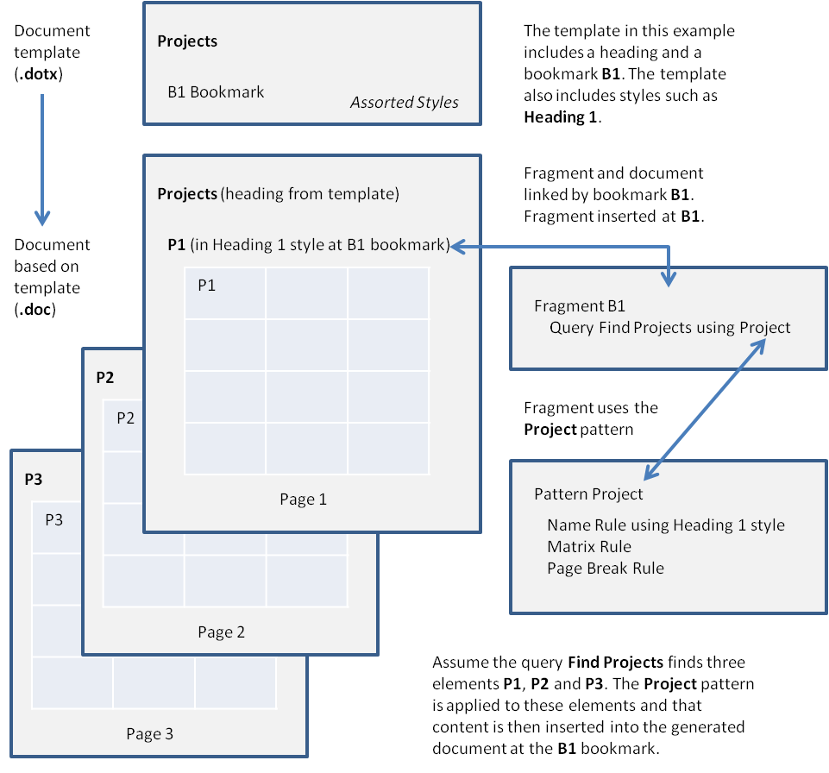

Figure 1. Relationship between the template, fragments and patterns
Each MDD is based on a Microsoft Word template. A document based on this template is created and fragments are inserted into it. Patterns are used within fragments. Put simply, fragments are the elements you want to include in the document, and patterns are the content you want to include for each element. The sections that follow elaborate this basic description.

8

About the Microsoft Word template
All generated documents (.doc files) are based on a Microsoft Word template file (.dot or .dotx files). The template defines the basic properties of the document such as page size, margins, headers and footers etc. and any fixed text required, such as corporate logos, titles, or standard content. The template also defines the Microsoft Word styles that you will use in patterns.
The template can include bookmarks and you can insert content from the MooD repository directly into a bookmark location. Bookmarks can be included in the body of the template and in its headers and footers. One use of bookmarks is to have an entire document as the underlying template and only insert specific pieces of information from the MooD repository at bookmarked points. This is in contrast to generating all of a document’s content from the repository. You can, of course, have any combination of fixed and generated content.
When you generate a document, Business Architect creates a new document based on this template file. It will not alter the template file itself. This means you can use the same template file as the basis for many generated documents. You can create a Microsoft Word template file in a variety of ways, including saving an existing Word document as a template file. See your Microsoft Word documentation for more information on templates.

About fragments
Fragments define structure and are inserted into the document.
Fragments reference elements in the MooD repository. Elements can be explicitly inserted or inserted as the result of a query. Fragments and their elements are inserted into the generated document. Fragments provide the structure for the content that will be extracted from the MooD repository. You can have multiple fragments. Each fragment can reference as many individual or sets of elements as required.
The order of fragments is the order they will be inserted into the document unless you use bookmarks in your template file. Fragments can be inserted at a bookmark location. If you use bookmarked fragments, any fragments that are not bookmarked are inserted at the end of the document.

About patterns
Patterns define content and format. Patterns are used within fragments.
Each element is given a pattern. As elements are inserted into the generated document their patterns are applied. The pattern defines what content from the element will be added to the document, and how that content will be ordered and formatted (using styles from the underlying template). For example, a pattern can include the element’s name formatted as a heading, field values formatted as a list, and then an image of the element’s model. Business Architect gives you a variety of repository building blocks (rules) to construct your patterns, such as, Name, Field and Matrix. Patterns are reusable and ensure consistent content and presentation within the generated document.

Exposing variables and parameters as pins
If you include content from your repository that requires variables, you can either set these at the rule level, or you can pass them upwards to the document level. At the document level they

9

become exposed for pinning. See Variables in Query, Model and Matrix rules on page 62 for more on this feature.

Templates within patterns
In the preceding overview, a pattern gets its styles from the underlying Microsoft Word template. However, patterns can have their own Microsoft Word template.
Content from any elements that such a pattern is applied to is inserted into the generated Word document within a section based on the pattern’s template and using styles from that template. This means that within a document based on the underlying Microsoft Word template, you can have any number of repeating sections based on other Microsoft Word templates. Each template has its own bookmarks, formatting and structure.
This feature simplifies the development of documents with many repeating sections. Rather than maintain one mammoth template, you can design, use, maintain, and more importantly reuse, component templates. The Documents synchronizer’s underlying template can become simpler and act as a wrapper for your various repeating templates.
See Repeating templates on page 67 for more on this feature. However, two key points to note are:
- Because each template can have its own bookmarks, patterns that use a template must define their rules within fragments. A pattern’s fragments are then inserted into the pattern’s template at their bookmarked location. Business Architect will not let you break this rule.
  - Headers and footers in the generated document are taken from the underlying template. Any headers and footers in pattern templates are ignored.

10

Creating a Documents synchronizer
Each model driven document (MDD) is a MooD synchronization of type Documents.

Task 1 To create a Documents synchronizer:
- In the Explorer Bar, under Libraries, click Synchronize.
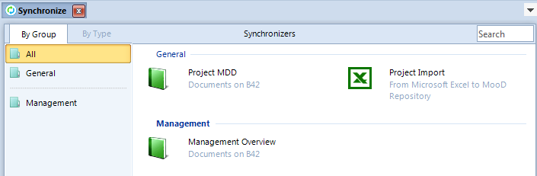
The Synchronize tab opens. This lists your synchronization groups.
- Click the group that you want to add the Documents synchronizer to.

Adding groups
To add a group, on the ribbon, on the Home tab, in the Groups group, click New.

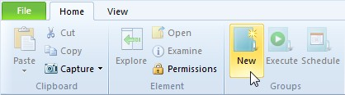
In this task, a Documents group already exists. The new Documents synchronizer is added to this group.
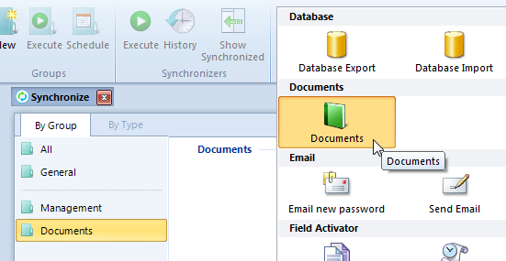
- On the Home tab, in the Insert group, in the gallery of synchronizers, click Documents.

11

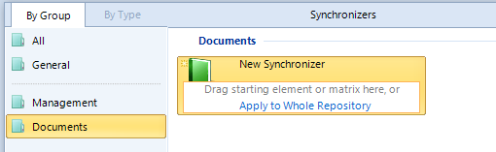
A synchronizer called New Synchronizer appears in the selected group (you can’t rename this until you have completed the next step).
- Do one of the following:
  - Drag an element into the Drag starting element here area.
This type of Documents synchronizer lets you generate the same basic document many times but base it on a different element each time. See the Starting elements section (page 58) for details.
Note: Although it is possible to start from a matrix, and this can be of limited use with respect to the Name rule, this isn’t generally done. Matrices are catered for by the Matrix rule.

  - Click Apply to Whole Repository if you do not want to use a starting element.
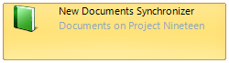
In either case, the synchronizer will then appear as follows with either the repository or starting element included in the detail.
- Right click the synchronizer, click Rename, and then give the synchronizer a meaningful name.
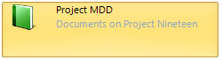
You can now double-click the synchronizer and construct your document model. See About the Documents synchronizer tab on page 13 for general details on the working environment, and Developing documents on page 20 for guidance on the actual tasks.

12

About the Documents synchronizer tab
You use a Documents synchronizer tab to construct your model driven document (MDD).

Note: You must have a Documents synchronizer before you can access this tab. See
Creating a Documents synchronizer on page 11 for how to create one.

The tab’s name will be the name of your synchronizer. However, this guide always refers to it as the Documents synchronizer tab.

Task 2 To open the Documents synchronizer tab for an MDD:
- In the Explorer Bar, under Libraries, click Synchronize.
The Synchronize tab opens. This lists your synchronization groups and the synchronizers within.
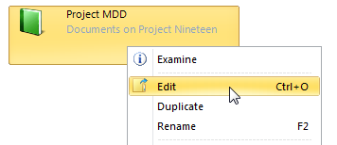
- Right click the Documents synchronizer you want to configure, and then click Edit.
The Documents synchronizer tab for that MDD is displayed. It will look similar to this:
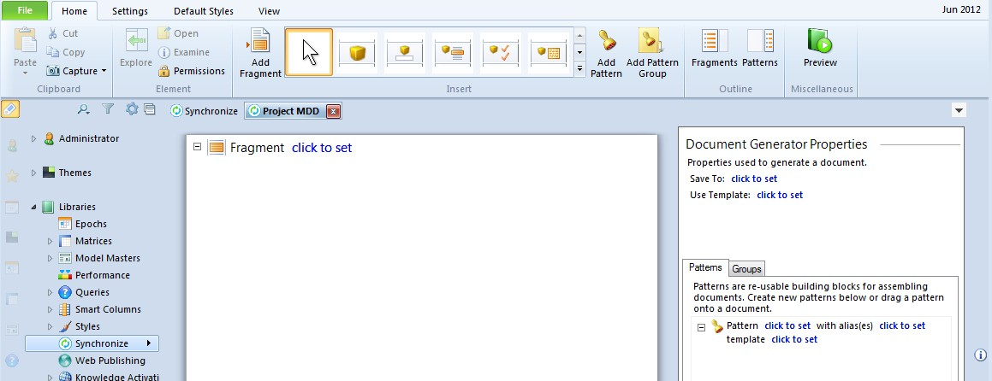
The Documents synchronizer tab has three areas:
- The Fragments pane.
- The Document Generator Properties pane. This includes two tabs: Patterns and Groups.
- The ribbon.
The purpose and features of these three areas are outlined in the following sections.

13

The Fragments pane
This holds fragments. Fragments define structure.
Fragments contain elements from the repository. You can insert individual elements into a fragment, or you can insert a query that will find and insert elements. Documents can include one or more fragments. Combined together, these fragments, and the elements they hold, define the structure of your generated document. You can consider fragments as analogous to sections in a finished document.
Note: While fragments will typically reference elements, they can also include rules more commonly used in patterns, for example, Custom Text and Matrix rules.

If you create a Documents synchronizer that uses a starting element, you can construct fragments that do not include element references. Such fragments get their element reference from the starting element. See Starting elements on page 58 for details.
The order of fragments in the pane is the order they will appear in the generated document, unless they have the same name as a bookmark in the Microsoft Word template file being used, in which case the fragment is inserted into the generated document at its bookmark. If you use bookmarked fragments, any fragments that are not bookmarked are inserted at the end of the document.
You can reorder fragments, and preview individual fragments. You can reorder the items within a fragment, move items between fragments, and duplicate items (Ctrl drag).

The Document Generator Properties pane
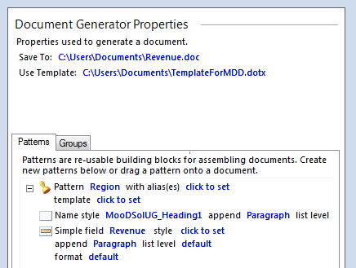
This area lists basic settings, such as the Microsoft Word template file to use, and where to save generated documents (you can include tokens in this filename (see page 21)). When you create a document model, you should set these before you build your document structure. It also holds the Patterns and Groups tabs described next.

14

The Patterns tab
This holds patterns. Patterns define content and format.
Each element must have a pattern. Patterns are reusable. When a document is generated, each element has its pattern applied. The pattern uses rules to specify what content from the element will be included in the generated document, and how that content will be ordered and formatted. For example, you could have a pattern that includes the element’s name formatted as a heading, followed by an image of its model. The same pattern can be applied to any number of individual elements, or to all of the elements returned by a query.
Patterns can include any number and combination of the following rules:
- Name – the element’s name.
- Field – values taken from the element’s simple fields.
- Formatted Text – content taken from the element’s HTML and rich text memo fields.
- Pick List – content taken from Pick lists associated with the element.
- Model – the element’s model, a selected element’s model, or a Model Master applied to an element.
- Matrix – a matrix associated with the element, a matrix generated against an element, or a selected matrix (ignoring the current element).
- Custom Text – pieces of fixed text that you type yourself when you construct a pattern, that is, it is not drawn from the element.
- Break – assorted page and section breaks.
- Lists – there are two rules (Start List and End List) that you can use to insert formatted lists without using styles from the underlying Microsoft Word template.
- Element and Query – more complex patterns can include elements and queries to provide a degree of nesting.
o Parameterized queries are useful within patterns as they get their parameter (an element) from the element to which the pattern is applied. See Parameterized queries on page 59 for details.
The Fragments pane and Patterns tab synchronize with each other. If you click an item in either pane, the fragments or patterns that use the selected item are highlighted in the other pane.
When you select an item in either pane, a Delete button appears.
Note: If you delete a pattern that is used elsewhere, a warning icon is inserted beside the affected rules. Your document will still generate, but the affected elements will be excluded.
Patterns can also include fragments when the pattern is using its own Microsoft Word template to insert specially formatted or repeating sections into the generated document. See Repeating templates on page 67 for details.
To duplicate a pattern, use Ctrl drag.

The Groups tab
This holds pattern groups. Pattern groups include multiple patterns and are used with queries. As a query can return multiple elements, you use a pattern group to apply different patterns to

15

the different types of elements returned by the query. See Pattern groups and Query rules on page 65 for details.

The ribbon
When a Documents synchronizer tab is displayed, on the ribbon, the Home, Settings and
Default Styles tabs include commands specifically for MDD. These are described next.

The Home tab
This tab includes commands that let you build and test your document model.

Table 1. The Home tab (on the ribbon)

Insert group
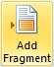 | Click this to add a new fragment to the Fragments pane (or the Patterns tab if that has focus).  Once a fragment has been added, you can drag it to another position, or Ctrl drag it to create a copy.
Insert group – Rules gallery
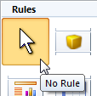 | The first item in the Rules gallery (No Rule) cancels the insertion point cursor:  When you click any other rule in the gallery, the cursor changes to an insertion point when it is over the Fragments pane or Patterns tab.  The Esc key also returns the cursor to normal.
 | Insert rule | Fragments | Patterns
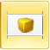 | Element. Once an Element rule is inserted and set to an actual element, you can double-click its icon to display a dialog box showing its memos and strings.
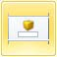 | Name. | Start
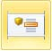 | Field (Simple). | Start
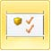 | Pick List. | Start

16

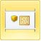 | Formatted Text (HTML and rich text memo fields). | Start
 | Model.
 | Matrix.
 | Query.
 | Custom Text.
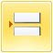 | Break. A Microsoft Word page or section break.
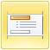 | Start List.
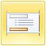 | End List.
Start indicates that these are only really useful in fragments when you are using a starting element. See Starting elements on page 58 for details.
Insert group
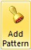 | Add a new pattern to the Patterns tab.
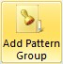 | Add a new pattern group to the Groups tab.
Outline group
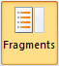 | Click this to expand or contract the fragments in the Fragments pane.

17

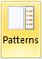 | Click this to expand or contract the patterns in the Patterns tab.
When contracted, only the fragment and pattern headings are displayed. Their content is hidden.
Miscellaneous group
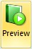 | Click this to generate and test your output. This generates the entire document.  You can also preview individual fragments. When you select a fragment heading, a Preview button is added to its line:

The Settings tab
This tab includes general settings for your document model and epoch settings.

Table 2. The Settings tab (on the ribbon)

Epoch group
Epoch. The epoch that the MDD will be generated against. Rules will source their data from this epoch. You can click and select from:
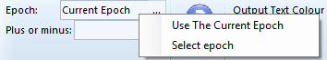
This property defaults to Current Epoch which by default is the current month. The current epoch is shown in Business Architect’s upper right corner.
Plus or minus. An epoch modifier. A number plus or minus the selected epoch. This is plus or minus the unit of the selected epoch. For example, if epoch is set to the current month, setting it to:
- 1 will generate the MDD against the next month.
- -12 will generate against the same month one year earlier.
For custom epochs, the modifier is relative to the epoch’s position in its epoch group.
Variables group
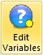 | Use this to set defaults for any variables that have been passed to the document level. Document level variables are exposed for pinning.  See Variables in Query, Model and Matrix rules on page 62 for details on how to pass variables from the rule level to the document level, but note that if there are no document level variables, the Select Query Variables dialog box that this command opens will be empty.
Form group
Output Text Colour. Provided the underlying document does not use grey, setting

18

Output Text Colour to Grey allows you to quickly see what text in a generated document has been inserted using an MDD. The other setting, Default, uses the colours in the style that is applied to the text.
Caption Position. The default position of matrix and model captions. Choose between Top and Bottom. The Model and Matrix rules let you set the actual caption used and its style (the rules have caption and caption style properties).

The Default Styles tab
This tab sets default styles for text and tables.

Table 3. The Default Styles tab (on the ribbon)

Default Text Style gallery
A style to apply to items (excluding matrices) that do not have their style property set. You select a style from a gallery of styles available in the associated Microsoft Word template. If the Use Template property is not set, the gallery includes styles from the Microsoft Word Normal template.
Default Table Style gallery
A style to apply to matrices that do not have their style property set. It behaves in the same way as Default Text Style.

Link settings
Links are used to both display and set the various settings. Initially many are set to Click to set
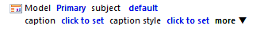
while others show a default setting. For example:
When you click a link, it lets you set that property. This might be using a dialog box, a drop- down list of possible values, or by just typing the setting. Once set, the link changes to show the new setting.
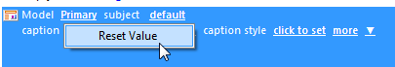
If you right click a link, you can choose between Clear value and Reset value (which depends on whether the setting requires a value). For example:

Note: If a rule has additional settings that are still set to their defaults, the more link gives you a Show Extra Settings command to display them. Once any of these settings have been changed from their default, they remain visible and the Show Extra Settings command changes to Clear Extra Settings. This returns the additional settings to their defaults. It does not just hide them.

19

Developing documents
This section covers the tasks involved in developing Documents synchronizers. It begins with an overview of the typical workflow.

Workflow
The suggested workflow for developing a Documents synchronizer is:
- Make sure you have a suitable Microsoft Word template file (.dot or .dotx) for your document. In particular, if you want to insert content (fragments) at specific points in the document, make sure that the template file includes bookmarks at those locations. See About model driven documents on page 8 for general details of how Documents synchronizers work.
- Create a synchronizer of type Documents. See Creating a Documents synchronizer on page 11.
At this point you can access the Documents synchronizer tab and undertake the remaining tasks outlined below. These tasks assume you have read About the Documents synchronizer tab on page 13 and are aware of its general purpose and features.
- Set the document’s properties. The properties are divided between:
  - The Document Generator Properties pane to the right of the Documents synchronizer tab. This includes the Use Template property. One of the first things you must do is set this to the Microsoft Word template file your document will use. Also note that Save To can include tokens that are replaced with their value when the document is generated, for example, $R for the name of the repository, and $D for the date.
  - The Settings tab on the ribbon. This includes some defaults that you can set once Use Template is set.
See Document properties on page 21 for details on both groups of settings and for instructions on the key ones to set including Use Template.
- Construct your document’s model. This means defining its structure, content and formatting by developing fragments, and the patterns to use in your fragments:
  - Fragments (page 24)
  - Patterns (page 31)
When you develop fragments and patterns you insert any number and combination of the rules listed below (a rule defines how that item is included in the generated document).
Typically fragments use the first two rules to include content (elements) from your repository.
  - Elements (page 26)
  - Queries (page 28) to include multiple elements
Typically patterns use the remaining rules to define the actual content that is extracted and inserted for each element included in your fragments.
  - Names (page 34)

20

  - Fields (simple) (page 36)
  - Formatted Text (HTML and Rich Text memo fields) (page 38)
  - Pick Lists (page 41)
  - Models (page 45)
  - Matrices (page 48)
  - Custom Text (page 51)
  - Lists (page 53)
There are two rules (Start List and End List) that you can use to insert formatted lists without using styles from the underlying Microsoft Word template. You may find this an easier way to generate formatted (bulleted, numbered etc.) lists.
  - Page and Section Breaks (page 54)

Note: The division of the rules between fragments and patterns above is a simplification. Each rule can be used anywhere. However, for the purpose of explaining the basics of Documents synchronizers, it is a useful division. More complex scenarios are noted in the text and covered in the Advanced usage section starting on page 58.

- Test your Documents synchronizer. You can test individual fragments or preview the entire document. See Previewing documents and fragments on page 55 for details.
Note: In common with all synchronizers, on the Synchronize tab, on the ribbon, on the Home tab, in the Synchronizers group, click History to see the Activation History dialog box for the selected synchronizer. Alternatively, right click a synchronizer and then click View History. The Activation History dialog box includes information that can help you investigate errors and warnings in your synchronizer.

Document properties
Each Documents synchronizer has properties divided between the Document Generator Properties pane and the Settings tab on the ribbon. The key property to set is the Use Template setting on the Document Generator Properties pane. Many other settings rely on this being set.

Table 4. Properties in the Document Generator Properties pane

Property | Description
Save To | The filename and location where the generated document will be saved. The link displays a Save As dialog box and you can choose between a Microsoft Word document and a PDF document.  You can include the following filename tokens that will be replaced with their current value when the document is saved:  $R Repository name  $D Date  $T The date and the time (separated by a full stop)

21

$N Start element name
For example, C:\Documents\$RReport$D.doc.
You can preview documents without having this set. Preview only generates temporary documents.
Use Template | The Microsoft Word template file that the document gets its page setup, default content, and styles and bookmarks from. When you generate a document, Business Architect creates a new document based on this template file. It will not alter the template file itself. This means you can use the same template file for many generated documents.  Styles define how items tagged with that style are formatted in a Microsoft Word document. For example, styles typically exist for headings, lists and normal text. The Name, Field, Formatted Text, Pick List, Matrix and Custom Text rules have a style property that is set to a style from the underlying Microsoft Word template. This controls how they appear in the generated document.  If you do not specify a valid template file, you will not be able to set styles or select bookmarks. You can still preview and generate your document, but it will use the Microsoft Word Normal style throughout.  Fragments given the same name as bookmarks in the template file are inserted at that bookmark. This includes bookmarks in the template’s headers and footers.

Table 5. Document properties on the Settings and Default Styles tabs on the ribbon

Property | Description
Settings tab
Epoch | The epoch that the MDD will be generated against. Any measures, matrices, queries, etc. that use epochs will source their data from this epoch. You can click and select from:  This property defaults to the Current Epoch which by default is the current month. The current epoch is shown in Business Architect’s upper right corner.
Plus or minus | An epoch modifier. A number plus or minus the selected epoch. This is plus or minus the unit of the selected epoch. For example, if epoch is set to the current month, setting it to:  - 1 will generate the MDD against the next month.  - -12 will generate against the same month one year earlier.  For custom epochs, the modifier is relative to the epoch’s position in its epoch group.
Edit Variables | Use this to set defaults for any variables that have been passed to the

22

 | document level. Document level variables are exposed for pinning. See Variables in Query, Model and Matrix rules on page 62 for details on how to pass variables from the rule level to the document level, but note that if there are no document level variables, the Select Query Variables dialog box that this command opens will be empty.
Output Text Colour | Use this to set a colour for generated text. This means that repository content added to a template can have a different colour to the content already in the template document.
Caption Position | The default position of matrix and model captions.
Default Styles tab
Default Text Style | A style to apply to items (excluding matrices) that do not have their style property set. You select a style from a gallery of styles available in the associated Microsoft Word template. If the Use Template property is not set, the gallery includes styles from the Microsoft Word Normal template.
Default Table Style | A style to apply to matrices that do not have their style property set. It behaves in the same way as Default Text Style.

Setting a document’s properties including Use Template
Before you can construct a Documents synchronizer, you need to set some basic properties.

Task 3 To set the basic properties including Use Template:
- Open the Documents synchronizer tab (page 13).
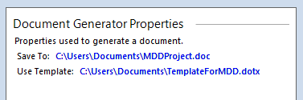
The properties you should set are listed under Document Generator Properties.
- Next to Save To, click the click to set link. The Save As dialog box is displayed.

Note: If a property is set, the link will be its setting and not click to set (as is the case in the preceding image). You can right click a setting, and then choose to clear or reset its value. This works for all settings that do not need a setting, or have a default setting.
- Use the Save As dialog box to select a location and name for the generated document.

Note: You can include tokens in the filename that will be replaced with their current value when the document is generated. The tokens are: $R repository name, $D date, $T date and time, and $N start element name.

The Save To property will show the selected path as a link.

23

- Next to Use Template, click the click to set link. The Open dialog box is displayed.
- Use the Open dialog box to select the Microsoft Word template file that you want to base the generated document on.
The Use Template property will show the selected file as a link.
- If required, use the Settings and Default Styles tabs on the ribbon to set the epoch and the various default styles. You can return and edit these settings later if required.
Once these basic properties are set, you can begin constructing your document’s model by adding fragments, and developing patterns to use within those fragments.

Fragments
Fragments define structure by referencing the elements that will be included in the generated document.
Fragments are named. This can be anything, but is more likely to be the name of a bookmark in the underlying Microsoft Word template. When you set the name, you can type a name, or select a bookmark from a drop-down list. If you use a bookmark, the fragment is inserted into the generated document at that bookmarked location. If you use bookmarked fragments, any fragments that are not bookmarked are inserted at the end of the document.
Note: You can name your fragments and then subsequently add corresponding bookmarks to your Microsoft Word template. You can rename fragments at any time.

Task 4 To add a fragment:
- Open the Documents synchronizer tab (page 13).
- On the Home tab, in the Insert group, click Add Fragment.
This adds a new fragment to the bottom of the Fragments pane.

Note: If this is a new Documents synchronizer, the Fragments pane will already include a default fragment. You should start with this.

You can drag fragments up and down the Fragments pane. Their position in the Fragments pane is only relevant if you are not using bookmarks.

When you click Add Fragment, if a pattern is currently selected in the Patterns tab and that pattern is empty or it includes fragments, then the new fragment will be added to that pattern. See Repeating templates on page 67 for information on when you might want to include fragments in patterns. See also Dragging fragments into patterns next.
- Click the click to set link and do one of the following:

24

  - Type a name for the fragment.
  - Select a bookmark from the drop-down list. The bookmark name will act as the fragment’s name, and the fragment will be inserted into the generated document at that bookmark’s location.
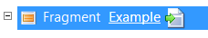
The click to set link will be replaced with the name.
As outlined in Workflow on page 20, you can now add rules to the fragment. Typically, you will add Element and Query rules, and thereby populate your fragment with the elements that it will draw content from. Once fragments include rules, you can test them. See Previewing documents and fragments on page 55 for details.

Note: The fragment’s name will not appear in the generated document. If, for instance, you want a section heading, you can either include it in the Microsoft Word template at the fragment’s bookmarked location, or add a Custom Text rule as the first rule in the fragment.

Dragging fragments into patterns
You can drag fragments from the Fragments pane (or from other patterns) and drop them into patterns in the Patterns tab. This functions as follows:
- If the pattern is empty or already contains fragments, the dragged fragment is moved into the pattern.
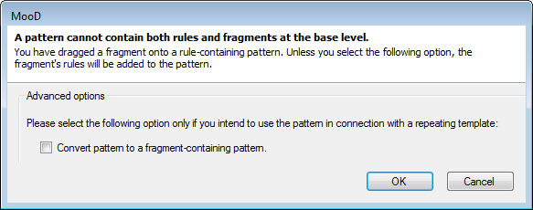
- If the pattern already contains rules (not held within a fragment), the following dialog box is displayed.
If you proceed, you have two possible outcomes:
  - If you just click OK, the fragment’s rules are extracted and added to the pattern.
  - If you select Convert pattern to a fragment-containing pattern and then click OK, the dragged fragment is added to the pattern, and the pattern’s existing rules are moved into a new fragment created for them within the pattern. See Repeating templates on page 67 for details on fragments within patterns and their use with repeating templates.

25

Element rules
Inserting an Element rule into a fragment means that content from the element referenced by the rule will be inserted into the generated document. What content is inserted and how it is formatted is determined by the pattern used by the Element rule.
Note: You can also insert Element rules into patterns. This allows you to construct more complex structures as it allows for a degree of nesting.

Table 6. Element rule properties

Property | Description
<element> | The element to use. The link for this will initially be click to set. Once set, the element’s name becomes the link.
using | The pattern to use. The pattern defines what content from the element will be inserted into the document and how it will be formatted once generated. Patterns are reusable blocks configured in the Patterns tab.  If you drag a pattern from the Patterns tab into the Fragments pane, this creates an Element rule with using set to that pattern.

Task 5 To insert an Element rule into a fragment (using the ribbon):
- Open the Documents synchronizer tab (page 13).
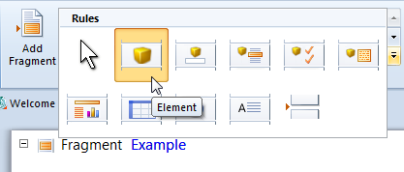
- On the Home tab, in the Insert group, in the Rules gallery, click Element.
When the cursor is over the Fragments pane (or the Patterns tab) it changes to:
This is where the rule will be inserted.

Note: To cancel this, use the Esc key, or, in the Rules gallery, click No Rule:
- Click to insert a new Element rule at the cursor’s location.

26

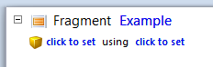
- Click the first click to set link.
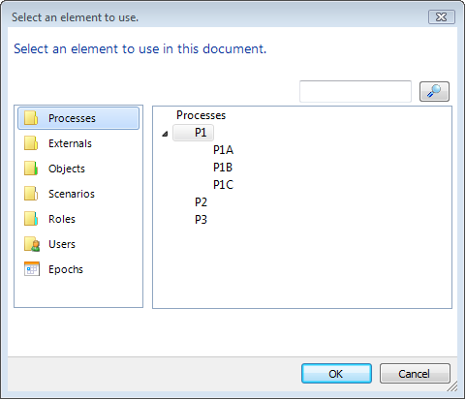
The Select an element to use dialog box is displayed.
- Select the element you want to insert, and then click OK.
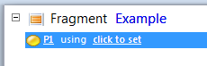
The Element rule is updated to show the selected element as the first link.

Note: Once an Element rule is inserted and set to an actual element, you can double-click the element’s icon to display a dialog box showing its memos and strings.

- Click the remaining click to set link and select a pattern from the drop-down list.
- You can now test your generated output. See Previewing documents and fragments on page 55 for details.
The preceding task describes using the ribbon to add Element rules. You can also add them as follows:
- Drag an element from the Explorer Bar (or any element’s Examine pane) and drop it at the required location. An Element rule set to the dragged element is created.

27

  - Drag a pattern from the Patterns tab to the Fragments pane. This method inserts an Element rule already set to that pattern.

Query rules
A Query rule finds matching elements and includes them in a fragment one after another. Iteratively, each element has a pattern applied and its content added. For example, you could have a Query rule that finds all known risks and applies a pattern that adds a heading and description for each into the generated document.
Note: You can also insert Query rules into patterns. This allows you to construct more complex structures as it allows for a degree of nesting. This is especially useful if you want to use a parameterized query. See Parameterized queries on page 59 for details.

Table 7. Query rule properties

Property | Description
Query | The query to use.
using | The pattern to apply to each element returned by the query. The pattern defines what content from the element will be inserted into the document and how it will be formatted once generated. Patterns are reusable blocks configured in the Patterns tab.  If you want to apply the same pattern to each element, click the click to set link to select a pattern from a drop-down list (do not change the using setting).  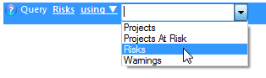  If you want each element to be assigned a pattern based on its type, click the using link, and then select group.  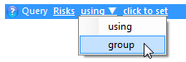  Now click the click to set link and select a pattern group (provided you have changed using to group, the drop-down list will now list your pattern groups).  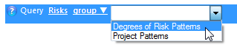  See Pattern groups and Query rules on page 65 for details on using pattern groups. The task that follows sets the Query rule to a single pattern.

28

Note: If you use a Query rule in a pattern, do not set its using
property to that pattern. This would form a recursive loop.
edit variables | If you include a query that takes variables, this property is added to the Query rule. Use it to set rule level values for each variable, or pass them up to the document level where they become exposed for pinning (you can also set document level defaults). See Variables in Query, Model and Matrix rules on page 62 for more details. You could also make use of the  <the rule subject> setting as described on page 59.

Task 6 To insert a Query rule into a fragment (using the ribbon):
- Open the Documents synchronizer tab.
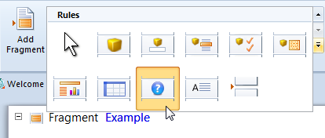
- On the Home tab, in the Insert group, in the Rules gallery, click Query.
When the cursor is over the Fragments pane (or the Patterns tab) it changes to:
This is where the rule will be inserted.

Note: To cancel this, use the Esc key, or, in the Rules gallery, click No Rule:
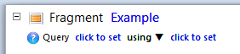
- Click to insert the new Query rule at the cursor’s location.
- Click the first click to set link.
This displays the Select a query dialog box. You can use this to find a query, or select from some standard queries such as Children.

29

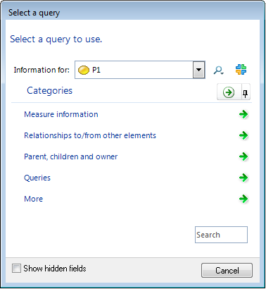
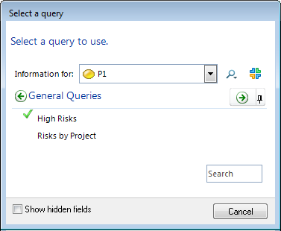
- Find and select the query you want to use.
The click to set link is replaced by the name of the selected query.
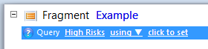
- Click the remaining click to set link and select a pattern from the drop-down list.

Note: In Query rules you can use a pattern group instead of a pattern. Pattern groups let you apply a pattern based on the type of each element

30

returned by a query. This involves clicking the using link and changing it to group. See Pattern groups and Query rules on page 65 for details on using pattern groups.

- If you selected a query that takes variables, click the edit variables link and use the Select Query Variables dialog box to specify the variables or pass them to the document level.
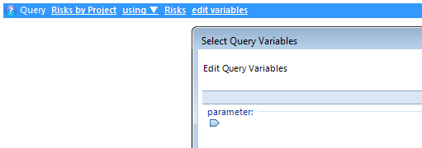
The edit variables link is only added to the Query rule when you select a query that takes variables, for example:
- You can now test your generated output. See Previewing documents and fragments on page 55 for details.
The preceding task describes using the ribbon to add Query rules. You can also use the Explorer Bar’s Libraries section to open a Queries pane, and then drag a query to the required location in a fragment or pattern. If dropped at a valid location, a Query rule set to the dragged query is created.

Patterns
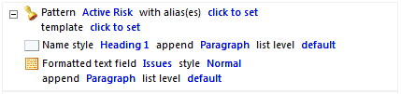
Patterns define content and format. Patterns are applied to elements. A pattern uses rules to define what content from the element will be added to the document and how it is formatted (using styles from the underlying template). For example, a pattern could include the element’s name formatted as a heading, followed by the contents of a memo field formatted as normal text (that is, a Name rule followed by a Formatted Text rule) as shown here:
Patterns themselves have the properties listed below. This is followed by instructions on how to create a pattern and add rules to it.

Table 8. Pattern properties

Property | Description
Pattern | The pattern’s name. When you apply patterns to Element and Query rules (their using property), you select from a drop-down list of these names.  You should make your pattern names unique and descriptive.

31

with alias(es) | A Query rule can use a pattern group. Pattern groups let you apply a pattern based on the type of each element returned by the Query rule. If this pattern is to be included in a pattern group, set with alias(es) to the type(s) of element that it will apply to.  The link for this setting displays the Select Aliases dialog box. Use this to select one or more types that the pattern can be used with. It also includes an Any setting.  See Pattern groups and Query rules on page 65 for details on using pattern groups.
template | A Microsoft Word template file to be used each time the pattern is applied to an element. This means you can insert repeating sections based on a different Microsoft Word template. See Repeating templates on page 67 for more details.  If you have a pattern that contains rules, and you subsequently set template, you will be prompted to create a fragment to contain those rules. See the next section on the Fragment Auto-Creation dialog box for more details.

Task 7 To create a pattern:
- Open the Documents synchronizer tab (page 13).
- On the Home tab, in the Insert group, click Add Pattern.
A new pattern is added to the Patterns tab.
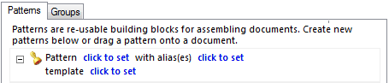

Note: If nothing is selected on the Patterns tab, the new pattern appears at the top. If something is selected on the tab, the new pattern is added after that selection.

- Click the first click to set link and name the pattern.
- You can now use the Rules gallery to add content to the pattern. With the exception of Custom Text and Break rules, this will be content taken from each of the elements the pattern is applied to. You can insert the following rules:
  - Name (page 34)
  - Field (simple) (page 36)
  - Formatted Text (HTML and rich text memo fields) (page 38)

32

  - Pick List (page 41)
  - Model (page 45)
  - Matrix (page 48)
  - Custom Text (page 51)
  - Lists (created using the Start List and End List rules) (page 53)
  - Page and Section Break (page 54) For example:
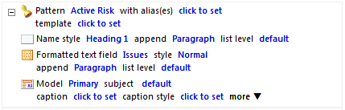
As you insert rules, you can specify how they will be formatted in the generated document. See the individual rules sections for details on inserting each.
You can drag rules and reorder them within a pattern. If you select a rule within a pattern, you can use the button at the end of its line to delete it.
The Fragment Auto-Creation dialog box
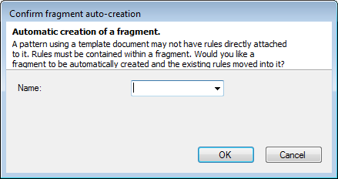
When you click to insert a rule, if you get the dialog shown here:
It means that the pattern has its template property set. If you want to proceed, you must accept the automatic insertion of a fragment. If required, use Name to set a bookmark for the new fragment. This is a bookmark in the pattern’s template, not the document’s template.
See Repeating templates on page 67 for more details.

Using patterns
Once you have created patterns, you can apply them to Element and Query rules in your fragments. You can do this in two ways:
- Set the using property for Element and Query rules.

33

- Drag a pattern from the Patterns tab onto the Fragments pane. This inserts an Element rule with its using property already set to the pattern.
Once a pattern is used in a fragment, you can use the Preview features to see how it will appear in the generated document. See Previewing documents and fragments on page 55 for details.
You can also include your patterns within patterns groups for use with Query rules. If you have a query that returns different element types, you might want to apply a pattern to each element based on its type. You use a pattern group to do this. See Pattern groups and Query rules on page 65 for details on this.

Name rules
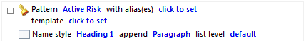
Use a Name rule to include an element’s name in a pattern.

Note: You can also insert Name rules into fragments. This is useful if you create an MDD that uses a starting element (see Starting elements on page 58 for details), or if you use templates within patterns (see Repeating templates on page 67 for details).

Table 9. Name rule properties

Property | Description
style | The Microsoft Word style to apply to the content when it is inserted into the generated document.  Styles come from a Microsoft Word template file. This will be the template set in the Use Template setting under Document Generator Properties, unless the pattern has its template property set in which case the style comes from that template. If a Microsoft Word template file is not set, styles from Normal.dot will appear in the drop-down list.  If style is unset, it uses the Default Text Style (on the ribbon), or if that is unset, the Microsoft Word Normal style. This means you can always generate and preview your document.
append | What formatting character to append to the Element’s name when it is inserted into the generated document. Choose between:  - Paragraph. This is the default.  - Nothing  - Space  - Tab  - Line Break
list level | If the element’s name is being inserted into a style that supports multi- level lists, the level at which to insert it. You can set levels 1 to 9 or leave  this set to default for no list. If the style is not a list style, any number set

34

here is ignored. list level also applies when the rule sits within a Start List and End List construct.

Task 8 To insert a Name rule into a pattern:
- Open the Documents synchronizer tab (page 13).
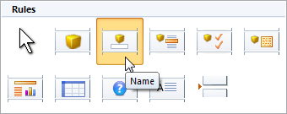
- On the Home tab, in the Insert group, in the Rules gallery, click Name.
When the cursor is over the Patterns tab (or the Fragments pane) it changes to:
This is where the rule will be inserted.

Note: To cancel this, use the Esc key, or, in the Rules gallery, click No Rule:
- Click to insert the Name rule at the cursor’s location.

Note: If instead of an insertion you get the Fragment Auto-Creation dialog box, it means that the pattern has its template property set and the rule must be placed within a fragment. This dialog box does this for you. If required, use the dialog box’s Name setting to set a bookmark for the new fragment. See The Fragment Auto-Creation dialog box on page 33 for more details.

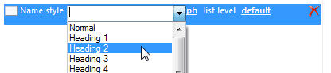
- Click the first click to set link and select a style from the drop-down list.

Note: If you have not set Use Template (under Document Generator Properties) to a Microsoft Word template file, the drop-down list includes styles from Normal.dot. You can leave style unset and still preview and generate your document, but it will use the Microsoft Word Normal style throughout. You can also type the names of styles that don’t currently

35

exist. If they are not found when the document is generated, again the default style is used.
- If required, use the remaining links to change the default append and list level settings.
- You can now preview your generated output. To preview a pattern you must use it within a fragment. See Previewing documents and fragments on page 55 for details.

Field rules (simple fields)
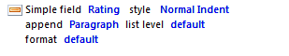
Use a Field rule to include content from an element’s simple fields in a pattern. Simple fields are defined in the theme to which the element belongs.

Note: You can also insert Field rules into fragments. This is useful if you create an MDD that uses a starting element (see Starting elements on page 58 for details), or if you include fragments within patterns either to achieve a degree of fragment nesting or to make use of templates with patterns (see Repeating templates on page 67 for details on both).

Table 10. Field rule properties

Property | Description
Simple field | The name of the simple field whose content is to be inserted. The link displays the Select the Simple Field dialog box. Use this to find and select the field.  If the element to which the pattern is being applied does not have this simple field, or it is not set, nothing is inserted into the generated document.
style | The Microsoft Word style to apply to the simple field’s content when it is inserted into the generated document.  Styles come from a Microsoft Word template file. This will be the template set in the Use Template setting under Document Generator Properties, unless the pattern has its template property set in which case the style comes from that template. If a Microsoft Word template file is not set, styles from Normal.dot will appear in the drop-down list.  If style is unset, it uses the Default Text Style (on the ribbon), or if that is unset, the Microsoft Word Normal style. This means you can always generate and preview your document.
append | A formatting character to append to the simple field’s content when it is inserted into the generated document. Choose from:  - Paragraph. This is the default.  - Nothing  - Space

36

- Tab
- Line Break
list level | If the simple field’s content is being inserted into a style that supports multi-level lists, the level at which to insert it. You can set levels 1 to 9, or leave this set to default for no list. If the style is not a list style, any number set here is ignored. list level also applies when the rule sits within a Start List and End List construct.
format | If the simple field is a date or number, this extra property lets you set its formatting. The link displays the Number Formatting or Date Format dialog box as appropriate.

Task 9 To insert a Field rule into a pattern:
- Open the Documents synchronizer tab (page 13).
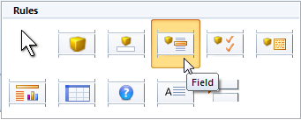
- On the Home tab, in the Insert group, in the Rules gallery, click Field.
When the cursor is over the Patterns tab (or the Fragments pane) it changes to:
This is where the rule will be inserted.

Note: To cancel this, use the Esc key, or, in the Rules gallery, click No Rule:
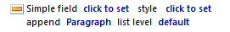
- Click to insert a Field rule at the cursor’s location.

Note: If instead of an insertion you get the Fragment Auto-Creation dialog box, it means that the pattern has its template property set and the rule must be placed within a fragment. This dialog box does this for you. If required, use the Name setting (on the dialog box) to set a bookmark for the new fragment. See The Fragment Auto-Creation dialog box on page 33 for more details.

- Click the first click to set link.

37

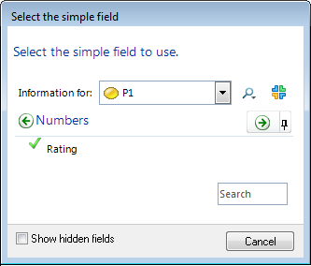
This displays the Select the simple field dialog box.
- Use the Select the simple field dialog box to find and select the simple field you want.
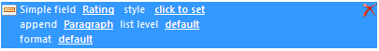
The click to set link is replaced by the name of the simple field. If the simple field is a date or number, a format link is added.
- Click the style setting’s click to set link and choose a Microsoft Word style from the drop-down list.

Note: If you have not set Use Template (under Document Generator Properties) to a Microsoft Word template file, the drop-down list includes styles from Normal.dot. You can leave style unset and still preview and generate your document, but it will use the Microsoft Word Normal style throughout. You can also type the names of styles that don’t currently exist. If they are not found when the document is generated, again the default style is used.

- If required, use the remaining links to change the default append and list level settings, and, if available, the format.
- You can now preview your generated output. To preview a pattern, you must use it within a fragment. See Previewing documents and fragments on page 55 for details.

Formatted Text rules (HTML and rich text memo fields)
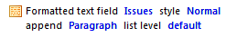
Use a Formatted Text rule to insert content from an element’s memo fields into a pattern. This can be HTML or rich text.

38

Note: You can also insert Formatted Text rules into fragments. This is useful if you create an MDD that uses a starting element (see Starting elements on page 58 for details), or if you include fragments within patterns either to achieve a degree of fragment nesting or to make use of templates with patterns (see Repeating templates on page 67 for details on both).

Table 11. Formatted Text rule properties

Property | Description
Formatted text field | The name of the memo field whose content is to be inserted. The link displays the Select the formatted text field dialog box. Use this to find and select the field.  If the element to which the pattern is being applied does not have this memo field, or it is not set, nothing is inserted into the generated document.
style | The Microsoft Word style to apply to the content when it is inserted into the generated document.  Styles come from a Microsoft Word template file. This will be the template set in the Use Template setting under Document Generator Properties, unless the pattern has its template property set in which case the style comes from that template. If a Microsoft Word template file is not set, no styles will appear in the drop-down list.  If style is unset, it uses the Default Text Style (on the ribbon), or, if that is unset, the Microsoft Word Normal style. This means you can always generate and preview your document.
append | What formatting character to append to the content when it is inserted into the generated document. Choose between:  - Paragraph. This is the default.  - Nothing.  - Space.  - Tab.  - Line Break.
list level | If the content is being inserted into a Microsoft Word style that supports multi-level lists, the level at which to insert it. You can set levels 1 to 9, or leave this set to default for no list. If the style is not a list style, any number set here is ignored. list level also applies when the rule sits within a Start List and End List construct.

Task 10 To insert a Formatted Text rule into a pattern:
- Open the Documents synchronizer tab (page 13).
- On the Home tab, in the Insert group, in the Rules gallery, click Formatted Text.

39

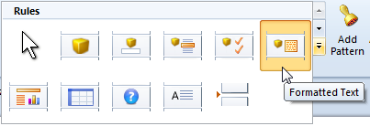
When the cursor is over the Patterns tab (or the Fragments pane) it changes to:
This is where the rule will be inserted.

Note: To cancel this, use the Esc key, or, in the Rules gallery, click No Rule:
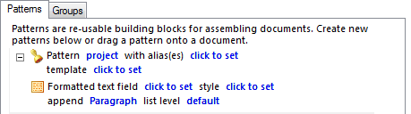
- Click to insert a Formatted Text rule at the cursor’s location.

Note: If instead of an insertion you get the Fragment Auto-Creation dialog box, it means that the pattern has its template property set and the rule must be placed within a fragment. This dialog box does this for you. If required, use the Name setting (on the dialog box) to set a bookmark for the new fragment. See The Fragment Auto-Creation dialog box on page 33 for more details.

- Click the first click to set link.
The Select the formatted text field dialog box is displayed.

40

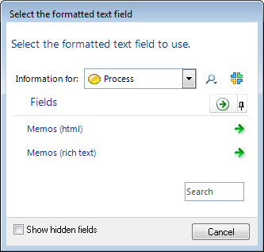
- Find and click the field you want to use.
The click to set link is replaced by the name of the field.
- If required, do any of the following:
  - Use the style property to apply a specific Microsoft Word style. Leave this unset to accept the default style.
Note: If a Microsoft Word template file is not set, no styles will appear in the drop-down.

  - Use the append property to insert formatting after the content.
  - If style is set to a multi-level list, use the list level property to control its position. See the properties table that precedes this task for more details on these settings.
- You can now preview your generated output. To preview a pattern you must use it within a fragment. See Previewing documents and fragments on page 55 for details.

Pick List rules
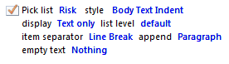
Use the Pick List rule to insert content from a Pick list into a pattern.

Note: You can also insert Pick List rules into fragments. This is useful if you create an MDD that uses a starting element (see Starting elements on page 58 for details), or if you include fragments within patterns either to achieve a degree of fragment nesting or to make use of templates with patterns (see Repeating templates on page 67 for details on both).

41

Table 12. Pick List rule properties

Property | Description
Pick list | The Pick list whose content is to be inserted. The link displays the Select the pick list dialog box.
style | The Microsoft Word style to apply to the content when it is inserted into the generated document.  Styles come from a Microsoft Word template file. This will be the template set in the Use Template setting under Document Generator Properties, unless the pattern has its template property set in which case the style comes from that template. If a Microsoft Word template file is not set, no styles will appear in the drop-down list.  If style is unset, it uses the Default Text Style (on the ribbon), or, if that is unset, the Microsoft Word Normal style. This means you can always generate and preview your document.
display | Use this to set what parts of the Pick list are displayed and their order. Choose from:  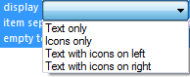
list level | If the content is being inserted into a Microsoft Word style that supports multi-level lists, the level at which to insert it. You can set levels 1 to 9, or leave this set to default for no list. If the style is not a list style, any number set here is ignored. list level also applies when the rule sits within a Start List and End List construct.
item separator | A formatting character to place between items in the list. Choose from the drop-down list or type the character you require:  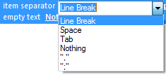
append | A formatting character to append to the list when it is inserted into the generated document. Choose from:  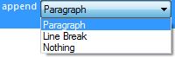
empty text | What to include when the Pick list is not set for an element. Choose between Nothing to insert no text at all, or <Unknown> to include the text <Unknown> in the actual document.

42

Task 11 To insert a Pick List rule:
- Open the Documents synchronizer tab (page 13).
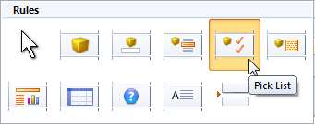
- On the Home tab, in the Rules gallery, click Pick List.
When the cursor is over the Fragments pane (or the Patterns tab) it changes to:
This is where the rule will be inserted.

Note: To cancel this, use the Esc key, or, in the Rules gallery, click No Rule:
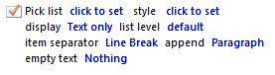
- Click to insert the Pick List rule at the curser’s location.

Note: If instead of an insertion you get the Fragment Auto-Creation dialog box, it means that the pattern has its template property set and the rule must be placed within a fragment. This dialog box does this for you. If required, use the Name setting (on the dialog box) to set a bookmark for the new fragment. See The Fragment Auto-Creation dialog box on page 33 for more details.

- Click the first click to set link.
This displays the Select the pick list dialog box.

43

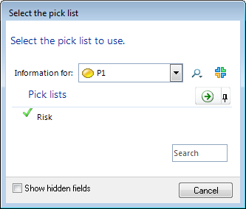
- Find and select the Pick list.
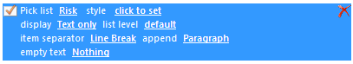
The click to set link is replaced by the name of the Pick list.
- Click the style setting and choose a Microsoft Word style from the drop-down list.

Note: If you have not set Use Template (under Document Generator Properties) to a Microsoft Word template file, styles from Normal.dot will appear in the drop-down list. You can leave style unset and still preview and generate your document, but it will use the Microsoft Word Normal style throughout.

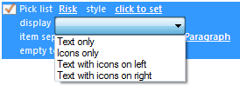
- If required, use the display setting to change how the Pick list is represented in the generated document. This defaults to Text only, but you can choose from:
- If required, use the remaining links to control how the Pick list is formatted. See the Pick List rule properties table for details on the remaining settings.
- You can now preview your generated output. To preview a pattern you must use it within a fragment. See Previewing documents and fragments on page 55 for details.

44

Model rules
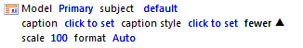
Use a Model rule to insert an element’s model into a pattern, or to apply a Model Master to an element and insert the resultant model. Element user permissions do not affect their models in an MDD.
and with the Model property set to Model Master:
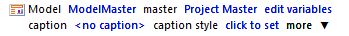

Note: You can also insert Model rules into fragments. This is useful if you set the Model rule’s subject property to a specific element, or if you create an MDD that uses a starting element. See Starting elements on page 58 for details.

Table 13. Model rule properties

Property | Description
Model | What model to insert. Choose between these three settings:  - Primary. This is the default and behaves as follows:  - For an Object element the primary model is the context model.  - For a Process element it is the capability, activity or object association model depending on the sub-type.  - Secondary. Typically, elements do not have a secondary model. However, if it does, it behaves as follows:  - For an Object element it is the state model.  - For a Process element it is the insight model.  - Model Master. Use this to insert a Model Master populated with an element. When this is set you get two additional links: master and edit variables. Use master to select the Model Master, and then use edit variables to set what element is shown in that Model Master. The edit variables link displays the Select Query Variables dialog box. This exposes the Model Master Subject parameter, as shown here:  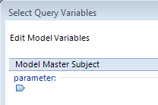  In addition to explicitly setting this to an element, setting Model to  Model Master also allows you to:

45

- Make use of the <the rule subject> setting. This sets the Model Master Subject parameter to the element that the rule is being applied to. See The <the rule subject> setting for Query, Model and Matrix rules on page 59 for details.
- Pass the Model Master Subject parameter (and any variables the Model Master might have) up to the document level where it becomes exposed for pinning. See Variables in Query, Model and Matrix rules on page 62 for more details.
subject | Only present when Model is set to Primary or Secondary.  The element whose model is to be inserted. Leave this set to default to use the element to which the pattern is applied (or the starting element if applicable). Alternatively, click the link to display the Select subject dialog box and choose a specific element.
caption | Click this to display the Caption Settings dialog box. Use this to configure the caption text. You can type specific text or use the <element name> token, and type your own Label. You can also stop a caption from being inserted by clearing the Show Caption check box.  Note: The position of the caption is determined by the Caption Position setting on the ribbon (the Settings tab).
caption style | The Microsoft Word style to apply to the caption if shown.  Styles come from a Microsoft Word template file. This will be the template set in the Use Template setting under Document Generator Properties, unless the pattern has its template property set in which case the style comes from that template.  If caption style is unset, it uses the Default Text Style (on the ribbon) or if that is unset, the Microsoft Word Normal style. This means you can always generate and preview your document.
And if you click:

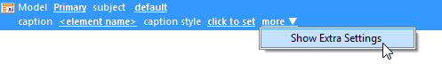
Note that once you have shown extra settings, the command changes to Clear Extra Settings. This returns the extra settings to their defaults. It does not just hide them.
scale | How to scale the inserted model relative to its size in the MooD repository. Choose between 100 (the default), 75, 50 and 25 percent or enter a percentage. However, note that if the image will not fit in the generated document, it will be scaled to fit automatically.
format | The format of the image. Leave this set to Auto, or select from:  - Emf (Microsoft Windows Enhanced Metafile)

46

- Jpg
- Png
When set to Auto, MooD will generate an Emf file. If this is above a certain size, a Png is also generated and the smaller of the two is used.

Task 12 To insert a Model rule into a pattern (using the ribbon):
- Open the Documents synchronizer tab (page 13).
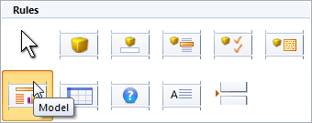
- On the Home tab, in the Insert group, in the Rules gallery, click Model.
When the cursor is over the Patterns tab (or the Fragments pane) it changes to:
This is where the rule will be inserted.

Note: To cancel this, use the Esc key, or, in the Rules gallery, click No Rule:
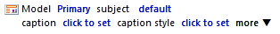
- Click to insert a Model rule at the cursor’s location.

Note: If instead of an insertion you get the Fragment Auto-Creation dialog box, it means that the pattern has its template property set and the rule must be placed within a fragment. This dialog box does this for you. If required, use the Name setting (on the dialog box) to set a bookmark for the new fragment. See The Fragment Auto-Creation dialog box on page 33 for more details.

- If required, use the links to change the rule’s default settings. See the table of properties that precedes this task for details.
- You can now preview your generated output. To preview a pattern, you must use it within a fragment. See Previewing documents and fragments on page 55 for details.
The preceding task describes using the ribbon to add Model rules. You can also drag a Model from an element’s Examine pane (right-click an element, and then click Examine) to the required location in a fragment or pattern. If dropped at a valid location, a Model rule set to the dragged model is created.

47

Matrix rules
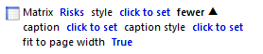
Use a Matrix rule to insert a matrix into a pattern or fragment. For matrices, you select the specific matrix that you want to include. In MDD, element user permissions do not affect the matrices associated with them.

Introducing <the rule subject>
You can use this feature to insert the same table multiple times for different elements. Provided your matrix includes a variable for its Row Query, you can, in the Matrix rule within a pattern, set this variable to <the rule subject>. When the pattern is then used in a fragment, a matrix is generated and inserted for each element in the fragment. See The <the rule subject> setting for Query, Model and Matrix rules on page 59 for more details on this usage (the remainder of this topic outlines the basic rule properties and how to insert a standard Matrix rule).

Table 14. Matrix rule properties

Property | Description
Matrix | The matrix to insert. Click the link to display the Select a Matrix dialog box.
style | The Microsoft Word table style to use when the matrix is inserted into the generated document. The first style in the drop-down list is a special style called MooD matrix style. This attempts to replicate the formatting within Business Architect as far as possible. You must test the output and note that setting fit page to width to False is likely to improve the accuracy.  If style is unset, it uses the Default Table Style setting on the ribbon.
If the matrix requires a subject element, the rule will include the use as matrix subject
property, as shown here:
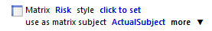
This defaults to ActualSubject (the subject element of the matrix itself), but you can click the link and change it to Parameter. As shown next, this adds an edit variables link to the rule. Click this to open the Select Query Variables dialog box. Use this to set the parameter that will supply the subject for the matrix when the MDD is generated. If the parameter is not set, the rule subject is used.

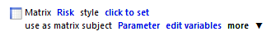
If the matrix requires a variable, for example, if its Row Query uses one, the rule will include the edit variables property, as shown here:
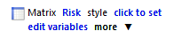
Click edit variables to open the Select Query Variables dialog box. Use it to set rule level

48

values for each variable, or pass them up to the document level where they become exposed for pinning (you can also set document level defaults). See Variables in Query, Model and Matrix rules on page 62 for more details.
You may also want to make use of the <the rule subject> setting. This sets the variable to the element that the rule is being applied to. See The <the rule subject> setting for Query, Model and Matrix rules on page 59 for more details on this.
If you click more, and then click Show Extra Settings, you get the remaining properties listed in this table.
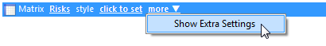
Note that once you have shown extra settings, the command changes to Clear Extra Settings. This returns the extra settings to their defaults. It does not just hide them.
caption | Click this to display the Caption Settings dialog box. Use this to configure the caption text. You can type specific text or use the <element name> token, and type your own Label. You can also stop a caption from being inserted by clearing the Show Caption check box.  Note: The position of the caption is determined by the Caption Position setting on the ribbon (the Settings tab).
caption style | The Microsoft Word style to apply to the caption if shown.  Styles come from a Microsoft Word template file. This will be the template set in the Use Template setting under Document Generator Properties, unless the pattern has its template property set in which case the style comes from that template.  If caption style is unset, it uses the Default Text Style setting on the ribbon, or, if that is unset, the Microsoft Word Normal style. This means you can always generate and preview your document.
fit to page width | Set this to True or False. If style is set to MooD matrix style, setting this to False is likely to improve the accuracy of the replication.

Task 13 To insert a Matrix rule into a pattern (using the ribbon):
- Open the Documents synchronizer tab.
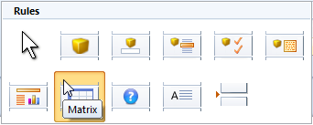
- On the Home tab, in the Insert group, in the Rules gallery, click Matrix.
When the cursor is over the Patterns tab (or the Fragments pane) it changes to:

49

This is where the rule will be inserted.

Note: To cancel this use the Esc key, or in the Rules gallery click No Rule:
- Click to insert a Matrix rule at the cursor’s location.

Note: If instead of an insertion you get the Fragment Auto-Creation dialog box, it means that the pattern has its template property set and the rule must be placed within a fragment. This dialog box does this for you. If required, use the Name setting (on the dialog box) to set a bookmark for the new fragment. See The Fragment Auto-Creation dialog box on page 33 for more details.

- Click the first click to set link.
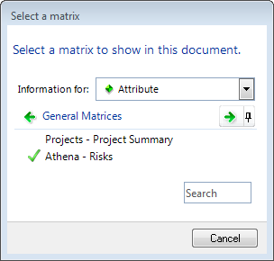
This displays the Select a matrix dialog box.
- Find and select the matrix.
The click to set link is replaced by the name of the matrix.
- If required, use the remaining links to set the various optional properties.
- You can now preview your generated output. To preview a pattern, you must use it within a fragment. See Previewing documents and fragments on page 55 for details.
The preceding task describes using the ribbon to add Matrix rules. You can also add them as follows:

50

- Use the Explorer Bar’s Libraries section to open a Matrices pane, and then drag a matrix to the required location in a fragment or pattern. If dropped at a valid location, a Matrix rule set to the dragged matrix is created.
Drag a matrix from an element’s Examine pane (right-click an element and click
Examine (or press F12)) to the required location.

Custom Text rules
Inserting a Custom Text rule includes a piece of text in the fragment or pattern that will then be inserted into the generated document. This piece of text is not derived from the repository. It is a piece of text that you supply when you insert a Custom Text rule. For example, you might want to include “This information is for internal use only.” in certain sections of your generated document.

Table 15. Custom Text rule properties

Property | Description
Custom text | The piece of text to insert.
style | The Microsoft Word style to apply to the text when it is inserted into the generated document.
append | What formatting character to append to the content when it is inserted into the generated document. Choose between:  - Paragraph. This is the default.  - Nothing.  - Space.  - Tab.  - Line Break.
list level | If the Custom Text is being inserted into a multi-level list, the level at which to insert it. You can set levels 1 to 9 or leave this set to default for no list. If the style is not a list style, any number set here is ignored. list level also applies when the rule sits within a Start List and End List construct.

Task 14 To insert a Custom Text rule into a pattern:
- Open the Documents synchronizer tab (page 13).
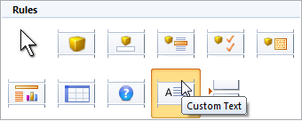
- On the Home tab, in the Insert group, in the Rules gallery, click Custom Text.
When the cursor is over the Patterns tab (or the Fragments pane) it changes to:

51

This is where the rule will be inserted.

Note: To cancel this, use the Esc key, or, in the Rules gallery, click No Rule:
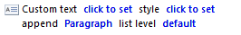
- Click to insert the Custom Text rule at the cursor’s location.

Note: If instead of an insertion you get the Fragment Auto-Creation dialog box, it means that the pattern has its template property set and the rule must be placed within a fragment. This dialog box does this for you. If required, use the Name setting (on the dialog box) to set a bookmark for the new fragment. See The Fragment Auto-Creation dialog box on page 33 for more details.

- Click the first click to set link.
This displays the Edit custom text dialog box.
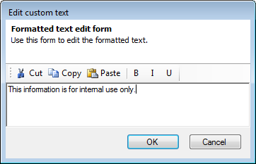
- Type the text you want to use and then click OK.

Note: Bold, italic and underline will only be preserved if used sparingly within the text. Microsoft Word may remove such formatting when it applies the style. For example, if you make the entire piece of custom text bold, but apply a style that doesn’t set the text to bold, Microsoft Word will remove the bold formatting. However, if you only make one or two words bold, that formatting should be preserved. If you want to make entire Custom Text items bold, italic or underlined, you should use a style that applies that formatting.

You can also paste formatted text from another application, such as

52

WordPad, into this dialog box. This is one way to increase the font size or include more complex formatting without using Word styles.
The click to set link is replaced by the piece of text.
- If required, use the remaining links to set the optional properties.
- You can now preview your generated output. To preview a pattern, you must use it within a fragment. See Previewing documents and fragments on page 55 for details.

Inserting lists
You can use the Start List and End List rules to include simple lists. On the ribbon, in the Rules
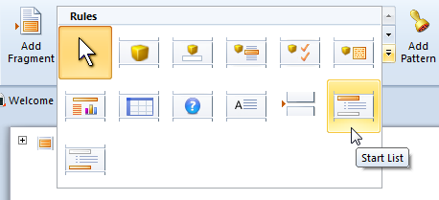
gallery, click Start List.
This inserts a Start List rule with a single of type property. Click the link to select a type of list formatting from a drop-down:
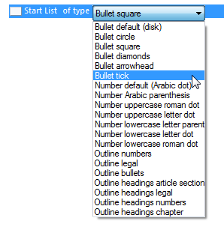
You can then insert other rules into the list before closing the list by inserting an End List rule (in the Rules gallery, this follows the Start List rule). Everything that you include between these two rules will be formatted in a list.

53

Inserting page and section breaks
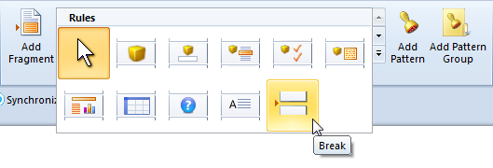
You can include any kind of Microsoft Word break in your document model. On the ribbon, in the Rules gallery, click Break.
This inserts a Document break rule with a single property that is, by default, set to Page Break. Click the link to select the type of break required.
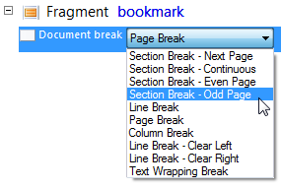
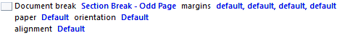
Depending on the type of break inserted, other settings will appear, for example:
These settings relate directly to their settings in Microsoft Word.

54

Previewing documents and fragments
You can preview your document as you develop it. You can preview the entire document or individual fragments. If you want to test a pattern, you must use it in a fragment and preview that.

Task 15 To preview a document or fragment:
- Open the Documents synchronizer tab (page 13).
- Do one of the following:
  - To preview the entire document, on the ribbon, on the Home tab, in the
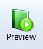
Miscellaneous group, click Preview.
  - To preview a fragment, click the fragment, and then click the Preview button at the end of its line.
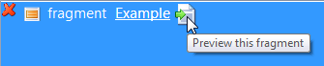
A temporary Microsoft Word document is generated and displayed.

Note: You will see some progress dialog boxes as the preview is generated. If there is a problem, the progress dialog boxes will include the error encountered, for example, if the template file cannot be found, or if a fragment uses a pattern that no longer exists. You still get a preview of your document, but items may be missing or the formatting might default to the Microsoft Word Normal style.

In common with all synchronizers, on the Synchronize tab, on the ribbon, on the Home tab, in the Synchronizers group, click History to see the Activation History dialog box for the selected synchronizer. Alternatively, right click a synchronizer and then click View History. The Activation History dialog box includes information that can help you investigate errors and warnings in your synchronizer.

55

Executing Documents synchronizers
When you execute a Documents synchronizer, the document is generated and saved. It is not opened in Microsoft Word, and you will not be prompted to confirm any file overwrites.

Note: Include the $T token (substitute with date.time) in the synchronizer’s Save To filename to guarantee uniquely named files. See the Save To property on page 21 for details on all the tokens that you can include in the filename.

Task 16 To execute a Documents synchronizer:
- In the Explorer Bar, under Libraries, click Synchronize.
The Synchronize tab is displayed. This lists your synchronization groups and the synchronizers within.
- Right click the Documents synchronizer you want to execute, and then click Execute
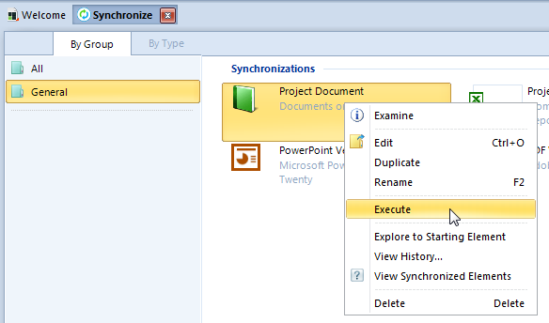
(the ribbon also has an Execute command).
The document is generated and saved to the filename and location specified in the Documents synchronizer’s Save To property (see Document properties on page 21). The generated document is not opened in Microsoft Word, and, if the filename already exists, it will be overwritten without warning.

Note: You will see some progress dialog boxes as the document is generated.
If there is an issue, these will include the problem encountered, for example, if the template file cannot be found, or if a fragment uses a pattern that no longer exists. Provided the Save To property is set, the document is created and saved, but its content will reflect the problems encountered. If Save To is not set, the synchronizer will execute, but you are warned that no document will be saved.
If you have developed Documents synchronizers that use starting elements, see Starting elements (page 58) for instructions on executing them.

56

Viewing the Activation History
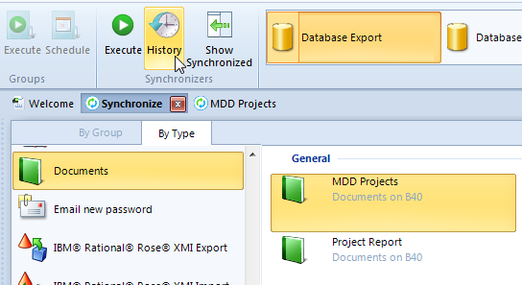
In common with all synchronizers, on the Synchronize tab, on the ribbon, on the Home tab, in the Synchronizers group, click History (shown next) to see the Activation History dialog box for the selected synchronizer.
Alternatively, right click a synchronizer and then click View History.
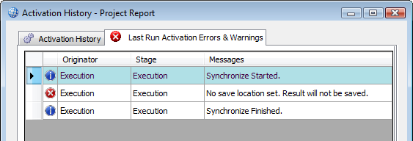
The Activation History dialog box includes information that can help you investigate errors and warnings in your synchronizer, for example, the following image shows the error when no Save To location is set.

57

Advanced usage
The remaining topics cover these more advanced aspects of MDD:
  - Starting elements
  - Parameterized queries (page 59)
  - The <the rule subject> setting for Query, Model and Matrix rules (page 59)
  - Variables in Query, Model and Matrix rules (page 62) – this includes material on exposing variables as pins
  - Pattern groups and Query rules (page 65)
  - Repeating templates (templates within patterns) (page 67)

Starting elements
Documents synchronizers can use a starting element. This gives you more flexibility and lets you reuse your MDDs more widely.
Starting elements let you generate the same document many times but using a different starting point each time. You pass the starting element to the synchronizer each time you want to generate the model driven document. If you use Active Enterprise, you could collect the starting element from the user.
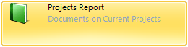
In Business Architect’s Synchronize tab, the synchronizer’s description includes the last starting element used. For example, the following shows a synchronizer that was last run (or configured to run) on the Current Projects element:
If you drag another element, for example Future Projects, onto the synchronizer, the description changes to show the new starting element that the document will be generated against.
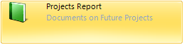

Using starting elements
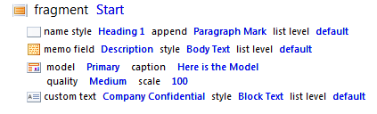
Using a starting element means that you can insert Names, Fields, Memos, Models and parameterized Query rules into fragments and build document models like the following:

58

Normally such rules are included in patterns which are applied to elements within fragments. However, as you are passing the MDD a starting element each time, the rules will know which element to extract their content from.
You can mix fragments that make use of the starting element with fragments that use Element or Query rules to specify the elements to include. Individual fragments can incorporate both approaches.

Parameterized queries
Parameterized queries are queries that take an element as a parameter. You can include parameterized queries:
- In patterns, in which case the element used as the parameter is the element that the pattern is applied to when it is used within a fragment.
- In fragments, provided your synchronizer uses a starting element. See Starting elements on page 58 for more details.
Parameterized queries allow you to build more complex content into your model driven documents. For example, you could include a query in a pattern that returns all the risks associated with a project. This pattern would then be applied to a query within a fragment that returns all current projects. Used together you would obtain content showing all the risks associated with each of your current projects. Each time the document is generated, it would execute the queries and generate up to date content.

The <the rule subject> setting for Query, Model and Matrix rules
Queries, matrices and models can require variables (and or parameters). Hence, when you include their corresponding rules in a pattern or fragment, those rules include an edit variables setting. This gives you the Select Query Variable dialog box complete with fields for all the variables required.
For example, if you include a Model rule and set its Model setting to Model Master, and its master setting to a Model Master, an edit variables setting is added to the rule. Click this to get a Select Query Variables dialog box with Model Master Subject exposed as a parameter:
Whilst you can explicitly set variables to elements, for MDD there is a special setting called
<the rule subject>. This sets the variable to the element that the rule is being applied to.
To access this setting, on the Select Query Variables dialog box, click the + button, as shown in the next image (this example is for a Matrix rule where the matrix Row Query uses a variable called FromMDD):

59

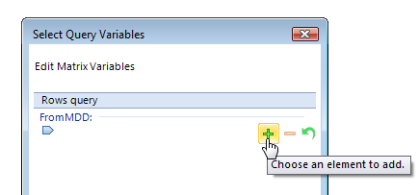
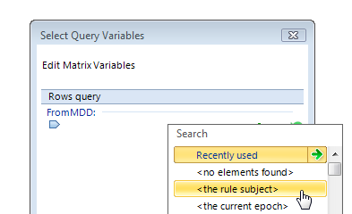
In the list that appears, <the rule subject> appears near the top:

Example of using <the rule subject> - Generating multiple tables
The power of <the rule subject> is illustrated by this example scenario:
You want to construct a Projects Report MDD that, for each project returned by a query, inserts a table of details for that project.
To achieve this you:
  - Create a matrix for the table that you want to insert multiple times into the Word document. This matrix acts as a template for the table that will be populated and inserted by the MDD.
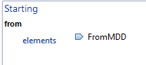
In the matrix, the key point is to set the Row Query to a variable. When the matrix is included in a Matrix rule, this is the variable that you will set to <the rule subject>. For example, the following image shows this in a Data Sheet matrix.

60

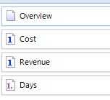
You can then create columns in the matrix that will be populated with content from the element passed to it using this variable (FromMDD in this example). For example, here the Data Sheet matrix has four columns set to:
Giving you a table like:
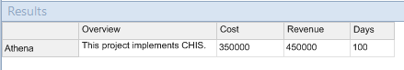
This is the table structure that will be inserted into the generated document when the Data Sheet matrix is used in a Matrix rule. For the purposes of this example, this matrix is called Projects Table for MDD.
  - Create a Documents synchronizer that uses the matrix in a Matrix rule, ensuring that you set the matrix variable to <the rule subject>.
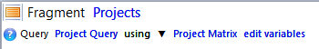
For example, the following structure would work:

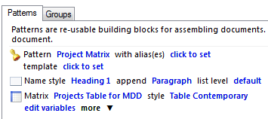
Here you have:
    - A fragment with a Query rule that finds projects and applies the pattern Project Matrix to the elements found.
    - The pattern Project Matrix that includes a Matrix rule set to the Data Sheet matrix called Projects Table for MDD.
The edit variable link for this Matrix rule sets the matrix’s FromMDD variable to
<the rule subject> as shown here:

61

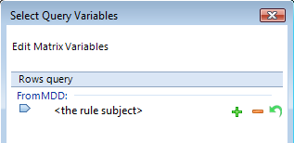
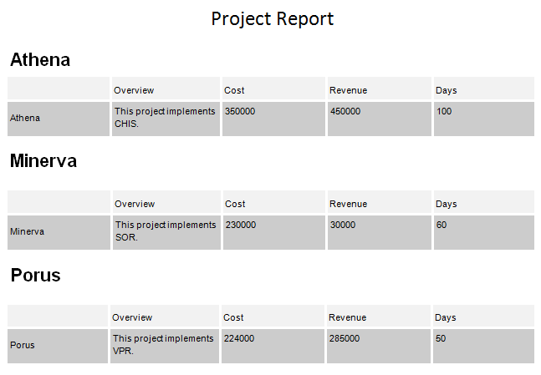
Together the Data Sheet matrix and Documents synchronizer outlined in this example would generate a document like:
This assumes that the Project Query query used in the fragment found three elements: Athena, Minerva and Porus. These elements became the <the rule subject> and were iteratively passed to the matrix and inserted into the generated document.

Variables in Query, Model and Matrix rules
Queries, models, model masters and matrices can all use variables. When a corresponding rule requires variables, it includes an edit variables link. This opens the Select Query Variables dialog box where you can set the variable, or pass it upwards to the document level where it becomes exposed for pinning (you can set defaults on the ribbon (the Edit Variables command on the Settings tab)).

62

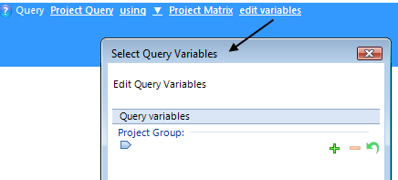
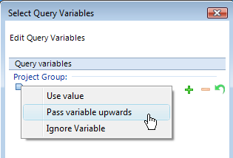
If you click on the symbol for a variable, you get a choice of settings:
Choose between:
  - Use value. This is the default and means use the value that is set here at the rule level.
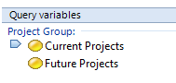
Use the plus and minus group of buttons to set the variable. Variables can have more than one setting. For example, the following would run the same query for Current Projects and then Future Projects, and all matching elements would then be included in the rule (ordered as one group of elements, not as two sets).
  - Pass variable upwards. Select this to set the variable at the document level. This exposes the variable for pinning, although you can use the Edit Variable command on the Settings tab on the ribbon to set defaults. This changes the Select Query Variable dialog box to:
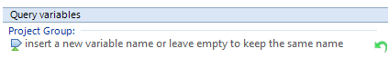
When you pass variables to the document level you can keep the same name or rename them. Provided variables are of the same data type, you can rename them all to the same single document level variable. MDD will automatically rename conflicting variables so that you cannot end up with two document level variables of the same name.

63

See Document level variables and pinning next for more details.
  - Ignore variable. Select this to ignore this variable. If this is selected, MDD will include a warning that it has done so.

Document level variables and pinning
Variables passed upwards (see the previous section) to the document level are exposed for pinning. This lets you gather their value from a user. For example, you could allow a user to select the group of projects that they want to generate a report for.
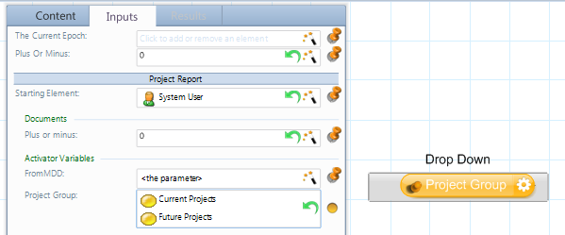
When you add an Action panel that executes a Documents synchronizer, any document level variables are listed on the panel’s Inputs tab. For example, the following shows such a panel with the document level variable Project Group pinned to a Drop Down Action panel.
On the ribbon for a Documents synchronizer, there is an Edit Variables command on the
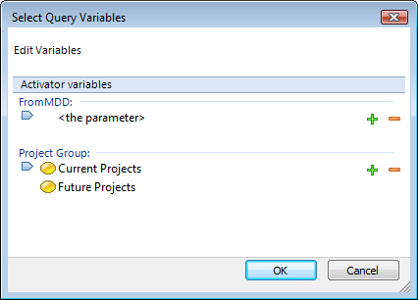
Settings tab. Use this to set defaults for any document level variables. For example:
These defaults can be seen on the Action panel in the preceding image, and they are the settings used when the MDD is run directly.

64

Note: The <the parameter> setting at the document level means the element to which the rule is currently being applied. This has the same effect as the <the subject rule> setting covered on page 59.
If you click Edit Variables and get an empty dialog box, it means that no variables have been passed upwards. This either means that the MDD doesn’t use anything with a variable, or all the variables have been set at the rule level.

Pattern groups and Query rules
If you have a query that returns different element types, you might want to apply a pattern to each element based on its type. You use a pattern group to do this.
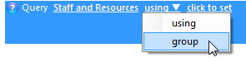
Query rules include a using setting that you can change to group, as shown here:
When this is set to group, the click to set link lets you select a pattern group from a list of those available on the Groups tab, for example:
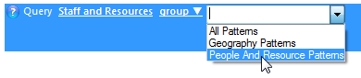
Each element returned by the query will then be assigned a pattern from the selected pattern group.
The decision as to which pattern is applied to each element is determined by each pattern’s
with alias(es) setting. This setting lists what element types that pattern can be applied to. For example, if a pattern group included the following two patterns:
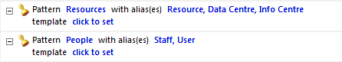
a query using that pattern group would assign the pattern:
  - Resources to any Resource, Data Centre and Info Centre elements.
  - People to any Staff and User elements.
When you click the with alias(es) link, you get the Select Aliases dialog box. Use this to select the element types that you want the pattern to be used with, for example:

65

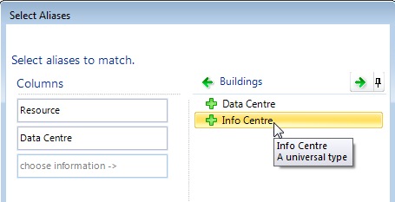
There is a special setting Any that can be uses as a catch all (it is at the bottom of the first list shown in the Select Aliases dialog box).
Note: The with alias(es) setting only affects a pattern’s use when it applied by means of a pattern group. If the pattern is applied directly to an element, the with alias(es) setting is ignored.

Patterns are tested by alias in the order they appear in the pattern group.
Pattern groups are listed on the Groups tab. For example:
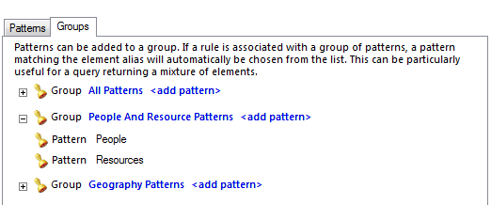
On the ribbon, on the Home tab, in the Insert group, there is an Add Pattern Group
command:
Use each group’s <add pattern> link to add its patterns:

66

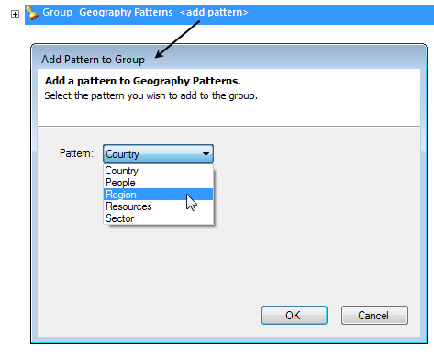
See Query rules on page 28 for more information on using queries to find and include elements in your document and Patterns on page 31 for more information on creating and using patterns.

Repeating templates (templates within patterns)
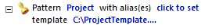
Each document always has a single underlying Microsoft Word template. In many cases this will be sufficient. However, patterns can use a different template. For example:
Content from elements that such a pattern is applied to is inserted into the generated document within a section based on the pattern’s template, and thereby uses styles, structure, content and bookmarks from the pattern’s template instead of the document’s underlying template. The underlying template still provides the overriding structure and the document’s headers and footers.

Note: The type of Microsoft Word section break used is Continuous.
The following diagram illustrates this behavior for a fragment that uses such a pattern.

67

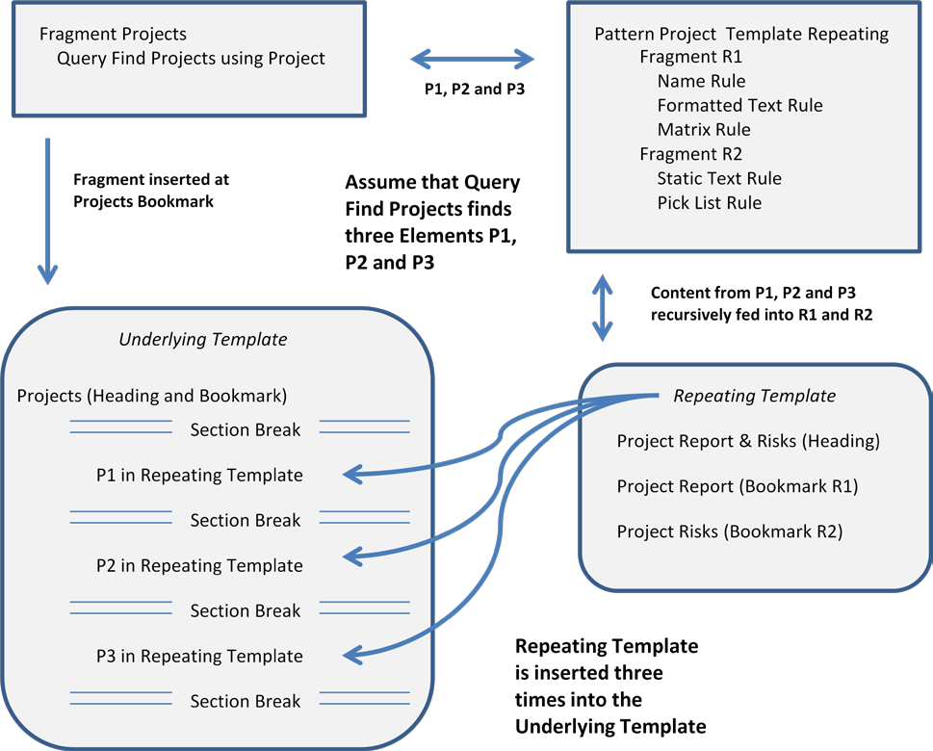

Figure 2. Templates in patterns – repeating sections
This feature helps in the development of documents with many repeating sections. Rather than maintaining one mammoth template, you can design, use, maintain, and more importantly, reuse, several component templates. The underlying template can become simpler and act as a wrapper for your various repeating templates.
Because you use bookmarks from the pattern’s template, the pattern’s rules must be held within fragments (this is because fragments include the bookmark setting). The pattern can include any number of fragments. As a result of this, you may encounter the two dialogs detailed next.

68

When you set the template property for a pattern that already includes rules, Business Architect displays the dialog shown above. If you click OK, the template will be set to the selected template and a fragment created containing the existing rules. Name lets you select a bookmark from the pattern’s template.
For the same reason, if you drag a fragment and drop it into a pattern that already contains rules (not held in a fragment and hence with template unset), you get the following dialog box:
If you proceed, you have two possible outcomes:
  - If you select Convert pattern to a fragment containing pattern and then click OK, the dragged fragment is added to the pattern, and the pattern’s existing rules are put into another fragment.
  - If you just click OK, the fragment’s rules are extracted and added to the pattern.

69

