MooD 15
Radial Chart Guide

Document Number: MooD15RADC44

© MooD Enterprises Ltd., all rights reserved.

Notice of Copyright and Trademarks
MooD 15 Radial Chart Guide
® MooD, MooD Smarter Decisions, Performance Activation, Synchronization Activation Technology and Knowledge Map are registered trademarks of MooD Enterprises Ltd. in the United Kingdom and / or other countries.
Microsoft and Windows are trademarks of Microsoft Corporation in the USA and other countries.
Rights to all other referred trademarks or registered trademarks reside with their respective owners.
Aspects of the Enterprise Business Model, Model-Driven Data Aggregation and Business Solutions to Support Smarter Decisions are protected by International Patent and Patent Pending. These include the Meta-Architecture Framework, Panels Technologies, Auto- Explorer, Business Orchestration, the Activator mechanism, Process Driven System, Performance Activation, Model-Driven Enterprise Management, Dynamic Aggregation, Smart Columns, the Variant Mechanism, and other technologies and mechanisms implemented within MooD Business Architect and MooD Active Enterprise.
© MooD Enterprises Ltd., all rights reserved. No part of this document may be reproduced by any means, or transmitted, or translated into machine language without the written permission of the company.

2

Contents
Radial Chart Guide 1
Introduction 4
Related documentation 4
About Radial charts 5
General features 6
Active Enterprise features 6
Configuration features 7
Adding a Radial chart to a model 9
Testing Radial charts – web preview 14
Features 15
The ribbon 15
Conditional formatting 18
Link highlighting 19
Depth settings 20
Duplicate nodes 21
Query variables 22
Green pinning – using Radial charts to drive content 23
Tasks
Task 1 To add a Radial chart to a model 9
Tables
Table 1 Ribbon reference (the Style tab) 15

3

Introduction
A Radial chart shows a series of related rings radiating from a starting ring. Elements appear as nodes on each ring, and the links between nodes show the relationships.
Radial charts have extra features in Active Enterprise making them a highly effective means of conveying interactions and dependencies. In particular, the element that a Radial chart is centred on is exposed for green pinning, and can therefore be used to drive other panels.
This guide contains the following sections:
- About Radial charts (page 5)
An introduction to what Radial charts are, and when you might want to use one. It goes on to explain how Radial charts are constructed, their features and configuration, and how they behave when viewed in a browser.
- Adding a Radial chart to a model (page 9)
This covers adding a Radial chart and building the chain of relationships that forms its rings. It also covers testing Radial charts (Active Enterprise features, such as node centring, can only be tested in web preview).
- Features (page 15)
This section covers key features in greater detail. It includes reference material on the ribbon, and sections on how to implement:
  - Conditional formatting (page 18)
  - Link highlighting (page 19)
  - Depth settings (page 20)
  - Duplicate nodes (page 21)
  - Query variables (page 22)
  - Green pinning (page 23)

Related documentation
The MooD 15: Getting Started Guide covers the general use of MooD Business Architect. It is available from Business Architect’s File tab.

4

About Radial charts
A Radial chart is a number of rings emanating in one direction from a central ring. Each ring contains one or more elements shown as nodes on the ring. Each ring is related to the previous ring by a single relationship. This relationship forms the links between nodes. For example:
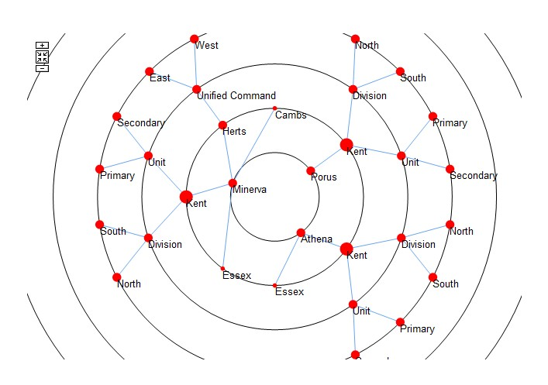
Radial charts can provide a simple overview of how elements are connected, and they can be configured in a variety of ways to help convey the complexity of interactions between elements. For example, in the image above, nodes are sized according to their number of links.
In practice, Radial charts can help you judge the complex interactions between a set of related elements. For example, the varying degree to which a business object acts as a common resource supporting the achievement of a set of business processes can be clearly represented by a Radial chart. You can quickly see how significant an object is to your processes.
Consequently, the impact of removing or investing in an object would be apparent. You create and design Radial charts in Business Architect. When deployed in Active
Enterprise, Radial charts provide additional interactivity to the user. The remainder of this
section covers:
- General features of Radial charts including rings, nodes and links.
- Active Enterprise features such as animation and depth formatting that enrich Radial charts when they are deployed in browsers. Node centring is particularly powerful, as the element that a Radial chart is centred on is exposed for green pinning, and can therefore drive the content of other panels.
- Configuration features.

5

General features
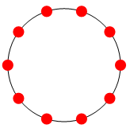
Radial charts are composed of rings. Each ring is a group of elements. Each element appears as a node on the ring, for example:
The first ring forms the centre of the chart. All other rings radiate from this first ring. When you add a Radial chart to a model, you specify the subject element and the information shown from it. This creates the first ring. In the previous image, the ring could represent the children of a subject element. You cannot delete the first ring.

Note: If the first ring is a single element, it appears as a node on its own in the centre.
It is still considered the chart’s first ring. For example, the following chart has three rings:
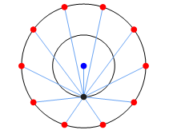
As you add rings to a chart, you specify how the elements in the new ring relate to the elements in the preceding ring. The chart then shows the relationships between the nodes on each ring as links.
You can emphasize the importance of particular relationships in the following ways:
- Nodes can be sized relative to an element or measure field, or to the number of links coming from the node.
- Nodes and links can be coloured based on a Pick list.

Active Enterprise features
In a browser, you can:
- Click a node’s label to go to that node or to centre the chart on that node. On the ribbon these are the Allow Node Navigation and Allow Centring settings. If only one is enabled, it is done immediately. As shown next, if both are enabled, you choose which one you want from a menu.

6

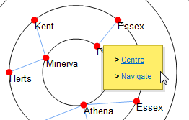
Centring can be animated (the Animate setting on the ribbon).
See The ribbon on page 15 for reference material on all of the settings.

Node centring – A powerful way to drive solutions
The element that a Radial chart is centred on is exposed for green pinning. Centring a Radial chart on a node (element) updates any pinned panels accordingly. This is a particularly powerful feature for solution development, as Radial charts can drive surrounding content. As a user centres a Radial chart on an element, they’ll see the pinned panels (Info panels, matrices, and charts) update to show content for that element. See Green pinning on page 23 for more information on implementing this.
- Zoom. Use the mouse wheel or Zoom buttons to explore a chart’s rings. The ribbon includes a Reset/Zoom Button check box. The Reset button re-centres the chart on its original point.
- Pan. Click and hold on whitespace (the chart’s background colour) to then drag (pan) the chart. You can use the left or right mouse buttons.
For browsers, you can also configure:
- Link highlighting. Choose between:
  - Upstream — highlight links from the selected element to the first ring. This shows the chain of relationships that placed the node on the chart.
  - Downstream — highlight links from the selected element outwards to related nodes further down the relationship chain.
Highlighting is applied when the mouse pointer is over a node’s label. See Link highlighting on page 19 for more details.
- Depth settings. From the node or ring that the chart is currently centred on, you can make rings beyond a certain depth appear differently. Typically, you use this to make distant rings less prominent and help users focus on closer relationships. See Depth settings on page 20 for more details.

Configuration features
Radial charts have additional configuration options to those outlined in the previous two sections.
From the ribbon you can:
- Set a background colour (fill), the gap between rings, the colour of rings, whether the line of the ring itself should appear, and the font properties of any text. See The ribbon on page 15 for reference material on all of these settings.

7

- Display duplicates. If set, elements that are linked to several times can have duplicate nodes on a ring. This can make the chart’s hierarchy easier to understand. The Radial chart uses its own algorithm to manage duplicate nodes. See Duplicate nodes on page 21 for more details.
Using the Edit Rings dialog box, you can also configure nodes and links on a per ring basis. You can:
- Set the appearance (style) of links and nodes. You can use different colours, shapes, line widths, and label formats. See step 12 in the Add a Radial chart task for information on these basic settings (page 13).
- Conditionally size and colour nodes and links based on element fields. For example, you could conditionally make links red and in a thicker line. See Conditional formatting on page 18 for details.

8

Adding a Radial chart to a model
Adding a Radial chart is like adding any other panel. You place it onto a model, and then use its flip side and the ribbon to configure it.
Task 1 To add a Radial chart to a model:
- Open the model.
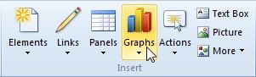
- On the Home tab, in the Insert group, click Graphs.
A gallery opens.
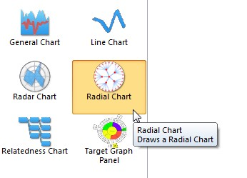
- In the gallery, in the Graphs section, click Radial Chart.
As you move the cursor over the model, Business Architect shows you that a Radial chart will be added.
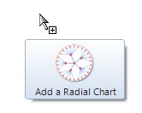
- Click to add the Radial chart to the model. A Radial chart is added on its flip side.

9

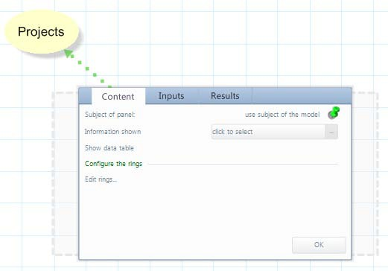
By default, the Radial chart is pinned to the model’s subject element.
- If you want to use a different subject element, pin the panel to that element. The subject element must be on the same model as the chart.
- Next to Information shown, click click to select.
A Select Content dialog box for the subject element is displayed.
- Select the content from the subject element that will form the nodes on the chart’s first ring.
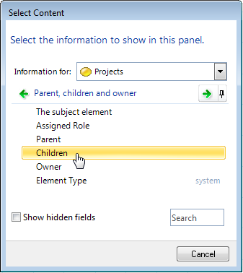
For example:

10

Setting Information shown to a query
If you set Information shown to a query, an Edit this query link is added to the
Content tab, and the Inputs tab will include fields for any query variables required.
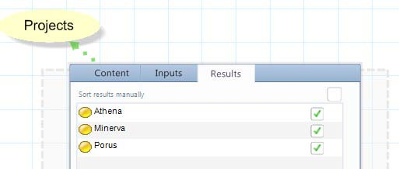
The Results tab lists the elements that will form nodes on the chart’s first ring, as shown next:
You can change the sequence of nodes on the first ring, or omit individual elements from the chart.

Note: If there is only a single element, it will appear as a node in the centre of the chart. As hiding and reordering don’t apply, single nodes are not listed on the Results tab. Instead, it appears dimmed and shows the message This tab is not supported for this panel configuration.
Manually adding elements
This task automatically adds elements. However, you can add elements manually by selecting I want to add elements manually in the Select Content dialog box. When this is selected, the Results tab changes to include an Add button.
Once you have content for your Radial chart’s first ring, you can add additional rings.

11

- On the Content tab, under Configure the rings, click Edit rings. The Edit Rings dialog box is displayed.
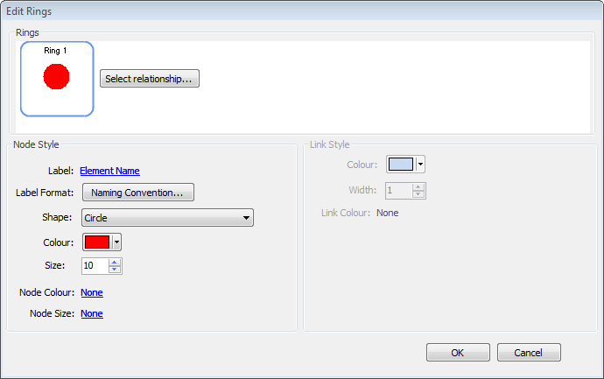
- Under Rings, click the Select Relationship button. The Select Relationship dialog box is displayed.
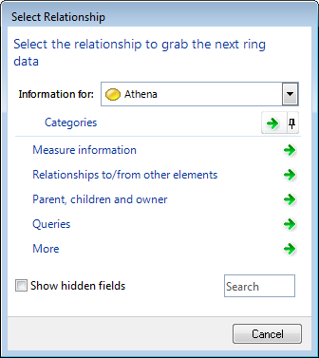

12

- Select the relationship between the first ring and the second ring.
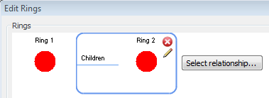
The Rings group in the Edit Rings dialog box will show the new ring and its relationship to the first ring.
- If required, repeat steps 9 and 10 to add more rings.
As Radial charts are a sequence of related rings, you can only delete the last ring in the chain, and you can only add new rings to the end of the sequence. You can use the button to access the Select Relationship dialog box for each ring. However, if you change an interim relationship, you should check for consequences later in the chain.
- For each ring, format the nodes and links as required.
The Edit Rings dialog box has format settings for individual rings. Under Rings, rings are numbered. The ring shown with a border indicates that the current Node Style and Link Style settings apply to that ring. Link formatting applies to links to that ring from the preceding ring (this is why the Link Style group is unavailable for the first ring.)
Individual ring settings override any corresponding chart wide settings (settings on the ribbon).

The Label setting and its importance for Active Enterprise
Label defaults to Element Name, but you can click the link and change this to another field or measure, or to None. However, note that node navigation, chart centring, and link highlighting rely on labels being visible.
See Conditional formatting on page 18 for details on using this feature with the Node Colour, Node Size and Link Colour fields.
- Once you have the rings you need, click OK to close the Edit Rings dialog box and return to the Content tab.

13

- On the Content tab, click OK.
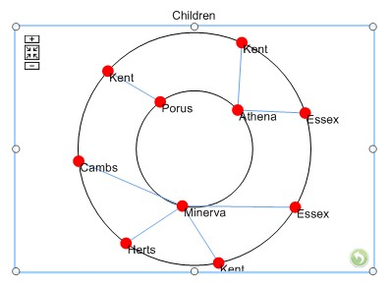
The panel flips to display the Radial chart on the model.
Once you have a Radial chart, you can:
  - Use the ribbon to configure chart wide settings that apply to all rings.
  - Use the Edit Rings dialog box to configure individual rings. Individual ring settings override any chart wide settings.
  - Pin Info panels, matrices, and Graph panels to the Radial chart so that, under Active Enterprise, they show content derived from the node that the Radial chart is currently centred on.
See the Features section (page 15) for details of the various configuration possibilities.

Testing Radial charts – web preview
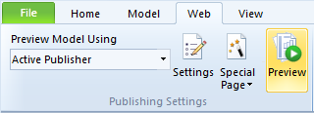
Because many Radial chart features are Active Enterprise only, they are not apparent on a model displayed in Business Architect. To fully test Radial charts, on the ribbon, on the Web tab, click Preview.
This displays the model in a browser where you can test features such as depth settings, node centring, and green pinning.

14

Features
This section covers aspects of Radial charts in more depth. It covers:
- The ribbon – this is reference material for everything on the Style tab.
- Conditional formatting (page 18)
- Link highlighting (page 19)
- Depth settings (page 20)
- Duplicate nodes (page 21)
- Query variables (page 22)
- Green pinning (page 23)
This material assumes you are familiar with the more general aspects of Radial charts covered in About Radial charts on page 5.

The ribbon
The following table lists all the commands on the ribbon for a Radial chart. These are under the
Panel tab group, on the Style tab.

Table 1. Ribbon reference (the Style tab)

The Chart group
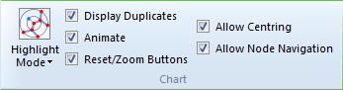
Highlight Mode
Use this to highlight the links to or from a node and thereby show the relationship chain. See
Link highlighting on page 19 for more on this feature.
Display Duplicates
If selected, display duplicate nodes for elements that are linked to several times. See Duplicate nodes on page 21 for more on this feature.
Animate
In Active Enterprise, use animation. For example, if Allow Centring is selected, animate the transition from one node to another. This can help users understand what is happening, but it does have a slight impact on performance.
Reset/Zoom Buttons
Add the buttons shown next to the chart. These will be shown in Business Architect, but are only useable in Active Enterprise.
Reset will return to the initial view (node or ring). It does not reset any zoom or panning

15

settings.
If not selected, you can still use the mouse to zoom and pan a chart (in Active Enterprise).
Allow Centring and Allow Node Navigation
In Active Enterprise, Allow Centring lets users click on a node’s label and re-centre the chart on that node. Any green pinned panels will be updated accordingly. Allow Node Navigation lets users navigate to a node. If only one of these check boxes is selected, a mouse click does that action immediately. If both are selected, the user chooses from a menu, as shown here:
Centring can be animated (the Animate check box).
The Font group
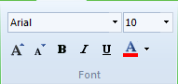
These font settings apply to the text in the chart’s labels.
The Highlighting group
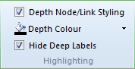
Depth Node/Link Styling
In Active Enterprise, select this to make nodes beyond a certain depth appear differently. The chart’s Inputs tab (on its flip side) has a Depth field that you can set or pin to an Action panel. See Depth settings on page 20 for more on this feature.
Depth Colour
The colour used once depth settings take effect.
Hide Deep Labels
Use this to hide labels on nodes that appear beyond the depth threshold.

16

The Palette group
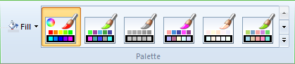
Use Fill to set the chart’s background colour. The options include a Transparency control.
In the gallery, select from the available colour palettes. Each applies different colours to each ring in the chart. Alternatively, click the first palette (highlighted in preceding image) to open the Edit Rings dialog box where you can manually set the colours used.
The Rings group
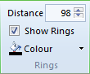
Distance
Use this to adjust the distance between rings. The range is 10 to 500.
Show Rings
Use this to show or hide the line that links nodes and forms the ring itself.
Colour
If Show Rings is selected, the colour of those rings.

17

Conditional formatting
The Edit Rings dialog box supports conditional formatting for Node Colour, Node Size, and

Link Colour.
Conditional colours can be based on a measure or Pick list.
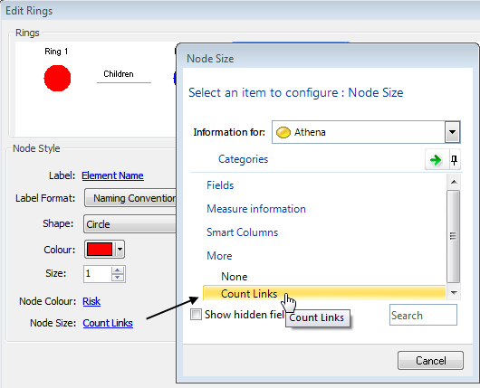
Conditional sizing can be based on a number field, on a measure, or, as shown in the following image, on the number of links coming from the node (Count Links in the More group).
Conditional sizing takes place within a range of plus or minus half the Size setting. Hence, if Size is set to 10, the range used is 5 to 15. Note that if you use a number field with the range 1 to 3 where 1 signifies greater priority, conditional sizing may have the opposite effect to that desired.
If the condition cannot be found for an element, the default colour or size is used.

18

Link highlighting
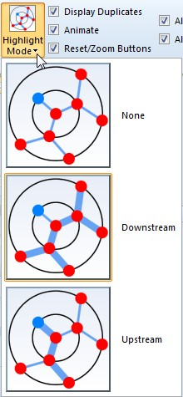
The ribbon has a Highlight Mode setting:
In Active Enterprise, when the mouse pointer is over a node’s label, this highlights the links to and from that node. In addition to None, you can set Highlight Mode to Downstream and Upstream.

Downstream | Upstream
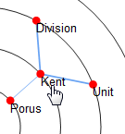 | 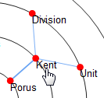
Outwards, away from the centre. Highlight links from a node to related nodes further down the relationship chain. | Inwards, towards the centre. Highlight back to the first ring. This traces the relationship back up the chain and is only available when Display Duplicates is selected.

19

Depth settings
In Active Enterprise, from the node or ring that the chart is currently centred on, you can make rings beyond a certain depth appear differently. Typically, you use this to make distant rings less prominent and help the user focus on closer relationships. For rings beyond the depth setting, you can:
- Use a different colour for nodes and links. On the ribbon, on the Style tab, select the Depth Node/Link Styling check box, and then set Depth Colour to the desired colour and transparency.
- Hide node labels. On the Style tab, select Hide Deep Labels.
- Completely hide nodes and links. Select the Depth Node/ Link Styling check box, and then set Depth Colour to No Fill.
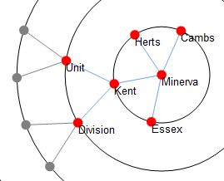
For example, here is a section of a Radial chart with a depth setting of 2, after which labels are hidden, and nodes and links are grey:
Each time you centre the chart on another element, the depth styling is reapplied. For example, here is the same chart centred on the Unit node:
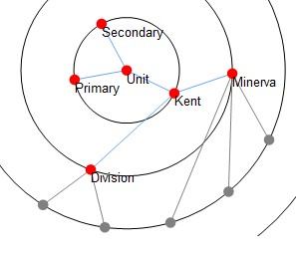
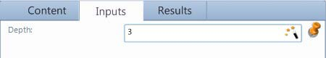
Use the Depth setting on the chart’s Inputs tab (on the flip side) to set the depth threshold.

20

You can set this to a number, or pin the setting to an Action panel and allow the Active Enterprise user to control the setting. To use an Action panel:
- Click the Wand icon to add a new Action panel that has Depth pinned to it.
- Manually pin Depth to a suitable Action panel.

Note: Setting Depth to zero or to no value turns off depth styling.

Duplicate nodes
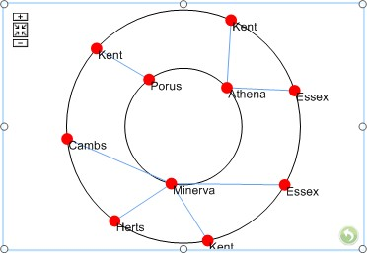
The ribbon has a Display Duplicates setting. If selected, the Radial chart will display duplicate nodes for elements that are linked to several times. This can make the chart’s hierarchy easier to understand as it avoids links that cross rings. For example, the following images show the same content. The first has Display Duplicates selected.
And with Display Duplicates cleared:
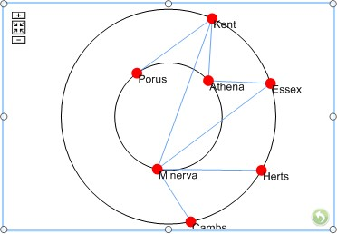

Active Enterprise – Display Duplicates and Allow Centring
Centring a chart on a duplicate node centres the display on that duplicate node only. You will not see the links from the other instances of the node. If you implement a solution where this might have an impact, educate your users accordingly. The Reset button (enabled on the Style tab) lets users return to the chart’s initial view with all nodes and links visible.

21

Query variables
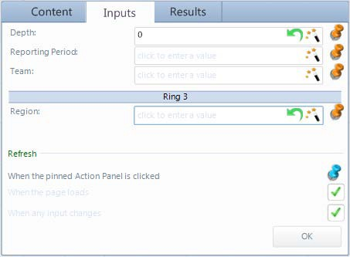
If a ring in your Radial chart is based on a query that uses variables, the Inputs tab adjusts to gather those variables. You can enter them directly, or configure Action panels to collect values from the user. For example, the following image shows an Inputs tab with three query variable fields. Two are required by the first ring, and one by the third ring.
The Inputs tab will have as many query variable input fields as required, and labels will show you what ring they relate to (if not the first ring). To set a field, drag elements into it, or type directly into the box.
Each query variable input field also lets you:
- Click the Reset icon to reset the variable to its value when the query was last saved.
- Click the Wand icon to add a new Action panel that will allow users to set this query variable.
You can choose from a list of suitable Action panel types. If you add an Action panel this way, the query variable is automatically pinned to it.
- Manually pin the query variable to a suitable Action panel.

22

Green pinning – using Radial charts to drive content
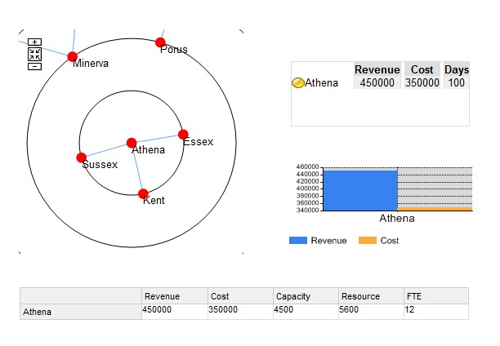
The element that a Radial chart is centred on is exposed for green pinning. In Active Enterprise, centring a Radial chart on a node (element) updates any pinned panels accordingly. This means that you can pin matrices, Info panels and charts to a Radial chart so that they all show content for the element that the Radial chart is centred on. If the user centres the Radial chart on another element, all the pinned content updates. For example, the next image shows a Radial chart with an Info panel, a Column chart, and a Data Sheet matrix pinned to it.
To pin panels to a Radial chart, drop the panel’s Subject of panel green pin onto the Radial chart.
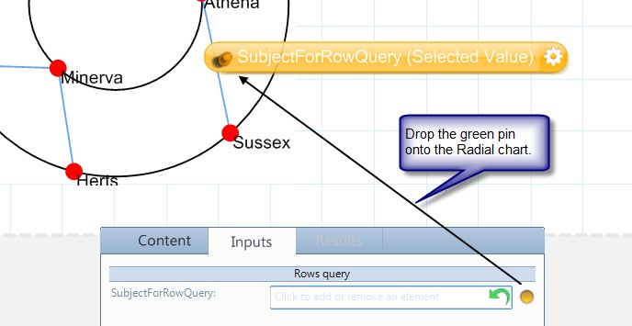
For matrices, make the matrix Row Query a variable, and then pin that variable to the Radial chart. For example, the next image shows the Inputs tab for a Data Sheet matrix configured in this way.

23

