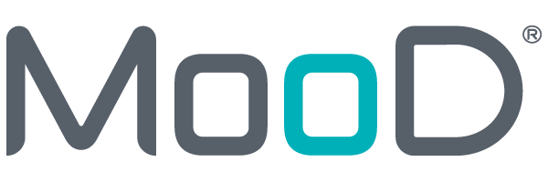

MooD 15
Clock Face chart

This guide outlines the Clock Face chart. From a central subject element, this chart positions related content on a ‘clock face’ partitioned equally between the chart’s series (one segment per series). Segments extend clockwise with the first segment centred on 12 o’clock. You can choose to show or hide the subject element(s) in the centre of the clock face, and you have control over how content is positioned, sized and coloured within each segment.

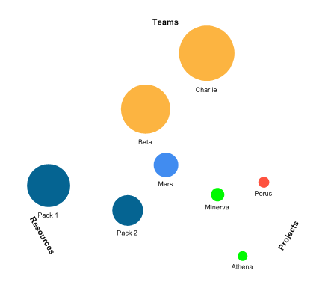

Document Number: 15CF8610

© MooD International Limited, all rights reserved.

Contents
- Introduction 3
- Configuring a Clock Face chart 5
  - Flipside options – Content setup 5
    - Using Smart Columns for series settings 7
  - Ribbon options – Refining appearance 9
    - Settings tab 9
    - Labels tab 9
    - Labels (Callout) tab 10
    - Style tab 11
    - X Axis and Y Axis tabs 11

2

Introduction
MooD 15 Build 86 includes the Clock Face chart. From a subject element, this chart plots related content on a pseudo clock face divided into any number of segments. Each segment is a series in the chart. Here is how it is represented when first dropped on a model (i.e. before any configuration).
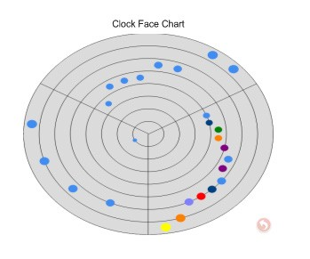
The chart is termed Clock Face as this best describes how elements are positioned (there are no hour numbers). The ‘clock face’ is partitioned into equal segments going clockwise, but the first segment centres on 12 o’clock. Hence:
  - As you can see from the image above, a three series chart goes 10 to 2, 2 to 6 and 6 to 10.
  - If the chart has two series, the first series is positioned from 9 to 3, and the second series is positioned between from 3 to 9 i.e. the top half and bottom half of the chart.
  - If the chart has five series, the clock face is divided into five ‘2hr 24min’ segments with the first spanning 10:48 to 1:12, the second 1:12 to 3:36 and so forth.

3

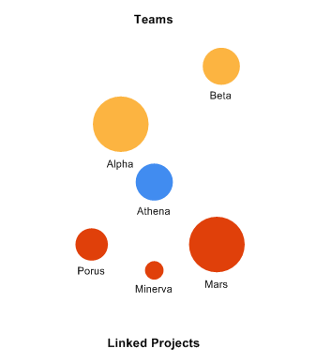
Below is an example. This two series chart shows the Team and Project elements associated with the central Athena Project element. Elements are positioned and sized by different criteria to convey their relative significance to Athena.
To illustrate what you can do with the Clock Face chart, here are some points about this one:
  - This chart has two series (Teams and Linked Projects). These form the two segments 9 to 3 and 3 to 9 (top and bottom half). The elements found by each series are placed within their segment.
  - The subject element Athena is shown, but you can hide it.
  - The relative sizing of the Project elements is determined by a numeric field on those Project elements.
  - The distance from the centre and size of the Team elements are determined by Smart Columns. Using Smart Columns means you can utilize fields in the Team elements. (This example is detailed later.)
  - The colours in the example are just defaults, but you can set the colour palette for the chart, and set the colours used by each series.
  - The markers are the default shape. Other shapes are available. However, you cannot specify a shape per series. It is one shape for everything.
You may also be interested in the Project Performance and Risk Performance charts. These let you chart specific performance and direction of performance respectively. In particular, the Project Performance chart has many similarities to the Clock Face chart.

4

Configuring a Clock Face chart
As with all charts, the Clock Face chart is available from the Graphs gallery on a model’s ribbon (the Home tab), and configuration has two stages:
  - Use the panel’s flipside to specify the chart’s content and some aspects of its appearance.
  - Use the ribbon to refine the chart’s appearance and behaviour.

Flipside options – Content setup
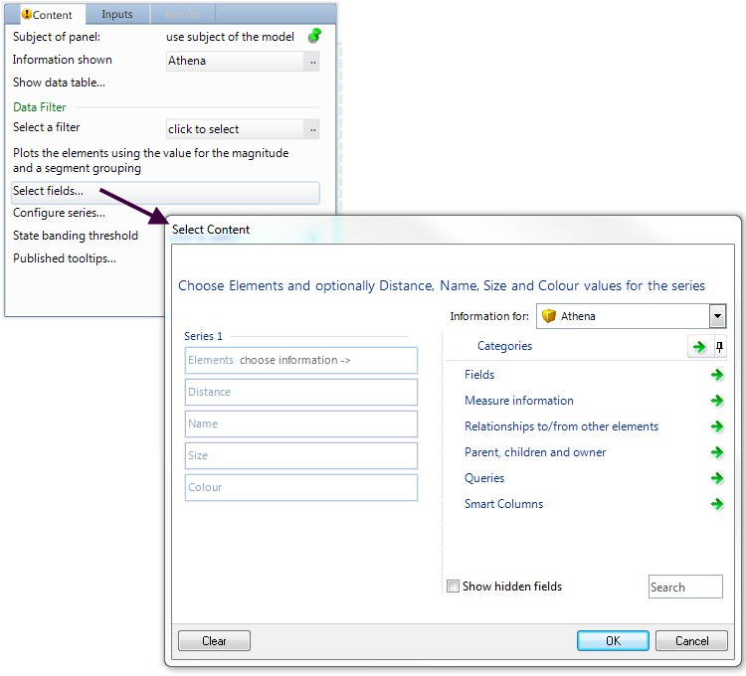
After placing a Clock Face chart on a model, flip its panel to configure the content it will display. Set Information Shown, and then click Select Fields.

Key Points about content configuration:
    - Known Issue: The Select Content dialog box you get for Information Shown lets you select an Aggregation matrix. You cannot use an Aggregation matrix to drive a Clock Face chart.

5

    - By default, the element(s) returned by the Information Shown setting are displayed at the centre of the chart. This is the Include Elements setting on the ribbon (Style tab).
    - Select Fields displays the Select Content dialog box. From the starting point of the subject element(s), this is where you find the related content to show in the chart.
      - You can also open the Select Content dialog box from the chart’s ribbon. The Style tab includes a Select Fields command (only enabled when the Conditional check box is selected).
    - Each series is a segment on the chart. Series 1 is centres on 12 o’clock. Subsequent series extend clockwise. The clock face is divided equally between the series. So if you have three series, you’ll have three segments – series 1 from 10 to 2, series 2 from 2 to 6 and series 3 from 6 to 10. To change the series order, you need to define them again. You cannot move series up and down the order.
      - By default, the segments are not visually partitioned. However, if you want to do this, use the Grid settings on the ribbon’s X Axis tab.
    - For each series:
      - Elements finds the elements that will be included in that series. As in the example, typically this will be a relationship to other elements.
        - Elements is the only mandatory setting required for a series.
        - Once Elements is set, a new set of Series fields is added to the Select Content dialog box.
        - If Elements returns no elements (for example, it is set to a query that finds nothing), an empty segment is still added to the chart. You might want to use this behaviour to adjust your chart’s appearance. However, note that the empty series is still labelled.
      - Distance. By default (i.e. when this is unset), all of the elements in a series are the same distance from the centre. This setting introduces relative distancing. For example, you might want to base the distance on a numeric field value (higher equals further). You could also use a Smart Column for this.
        - If you find that the positioning is not in the order you require, there is an Invert distances setting on the Configure Series dialog box (see below).
      - Name. The label to use for each element on the chart. For example, a field or a Smart Column with a string fact. If unset, the element name is used.
        - The text labels around the edge are the series’ titles. You use the Configure Series option (see below) to change this, and the Font settings on the X Axis tab to hide them.
      - Size. This behaves the same as Distance and the ribbon includes several sizing settings.
      - Colour. You only get this option when the Conditional check box on the chart’s ribbon (Style tab) is selected. This lets you override the default colours derived from the palette. You can set this to a Pick list field and thereby use the colour associated with an element’s Pick item. You could also use a Smart Column that uses a Threshold or Aggregated Pick State fact to return a Pick item and hence its colour.

6

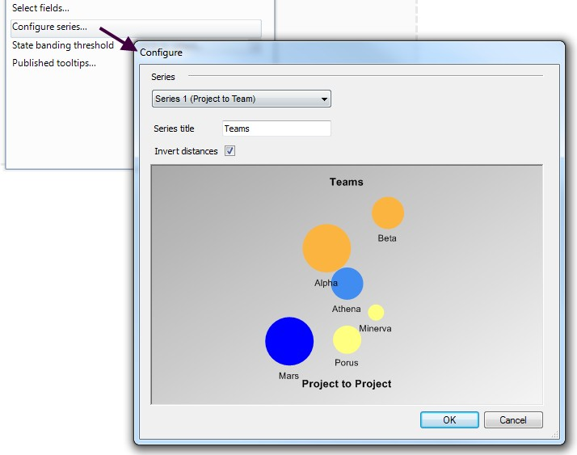
    - Once you have added series, you can use the Configure Series option to make some changes.
You can:
      - Change the label used for each series. For example, in the example, the default label would be the relationship Project to Team, but this has been changed to just Teams.
        - You must have a label. You cannot set it to ‘space’. However, if you want to hide the label, use the Font settings on the X Axis tab.
        - The ribbon’s Style tab includes a Label Style setting. Use this to control the label’s orientation.
      - Invert the distance positioning. See the Distance setting above.

2.1.1. Using Smart Columns for series settings
In the Select Content dialog box, the Distance, Name, Size and Colour fields in each series can use Smart Columns. The benefit of this is that you can incorporate calculations based on content from elements at the end of relationships and not just the subject element type.
This is best illustrated with an example. Consider this scenario. Your chart has a Project element as its subject element. Project elements can have a relationship to Team elements and you want to base the sizing on a field in the Team element. The effect you want to achieve looks like this:

7

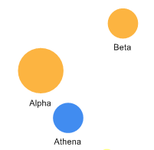

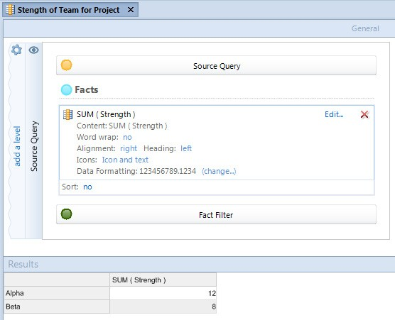
Because Team and Projects are different element types, you cannot just select the field via the Select Content dialog box. Instead you need to create a Smart Column that includes the Team elements and does a SUM fact on the field that you want to use. For example:
For the series that uses the Project to Team relationship as its Element setting, you can then set the Size field to the Smart Column. This will base your sizing on the values returned by the Smart Column. For example:

8

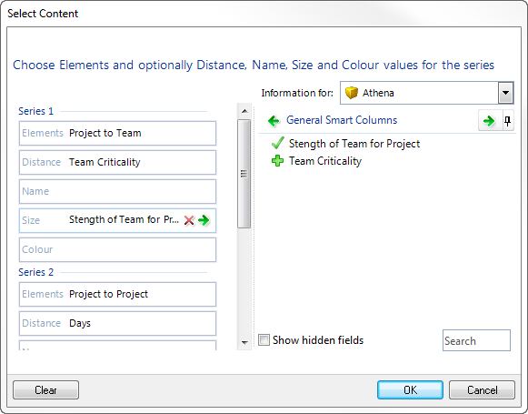
In the example shown here, Distance is also determined by a Smart Column.

Ribbon options – Refining appearance
Once you have a Clock Face chart populated with content, use the ribbon to refine its appearance and behaviour in your solution. The tabs include many options that have different value when used with different charts and data sets. You may have to use a degree of trial and error. However, the following sections detail some of the settings that have particular relevance to the Clock Face chart.

Settings tab
This tab includes general naming convention settings and an option that lets you access the chart’s XML. Note that XML includes content that is specific to the data in your chart, so it is not completely reusable. However, examining the XML can let you see what non default options have been set in a particular chart.

Labels tab
This tab controls the labels attached to nodes. Its settings are not specific to the Clock Face chart. Settings you might want to use include:
      - The Value 1, Value 2 etc. settings let you add additional values to the label. These add additional fields to each series in the Select Content dialog box. Use these fields to set the source of the additional values, for example, a Smart Column.

9

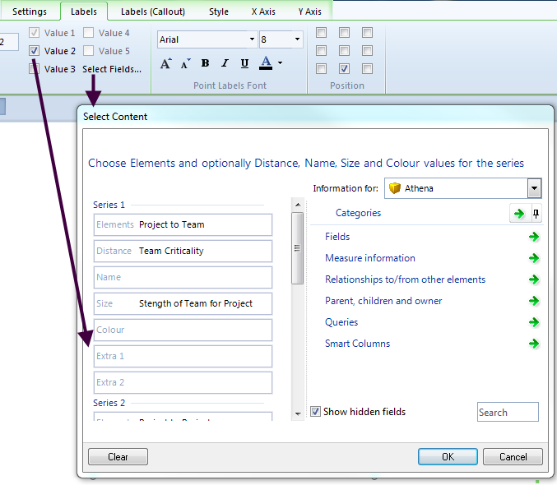
Click Select Fields… on the ribbon or on the panel’s flip side to display the Select Content dialog box.

Labels (Callout) tab
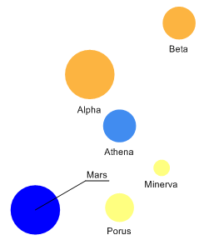
By default, callout labels are disabled. This tab lets you enable callout labels and then configure their behaviour. In this next image, the label for Mars is a callout label:

10

In this chart, the callout algorithm has only had to apply a callout to Mars (i.e. enabling callouts does not mean everything gets one). Typically you need to experiment with the settings to get the best appearance for your data. Callout labels are not specific to the Clock Face chart.

Style tab
The Style tab sets general style and behaviour characteristics for the Clock Face chart. Hence, whilst many of the settings are common to charts, some are specific to charts like the Clock Face chart. Notable settings are:
      - Include Elements (Chart group). This refers to the elements returned by the chart’s Information Shown setting (on the flip side). Clear this check box to exclude their symbols from the centre of the chart.
      - Slider (Chart group). This slider is only enabled when a State Banding Threshold is set on the chart’s flip side. It lets you control the transparency of the banding colours.
      - Default, Maximum and Minimum (Distance group). These settings control the offset from the centre used when the Distance setting for a series does not return a value.
      - Marker Size and Marker Scaling (Markers group). Marker Size sets the central marker’s size (provided Include Elements is selected), and the size of markers for any series where Size is not set. If a series does have Size set, then the Marker Scaling check box means take the Marker Size setting into account when scaling.
      - Conditional (Palette group). When this is selected, a Colour field is added to each series.
Note: The series that the last three bullets refer to are the chart series configured in the chart’s Select Content dialog box. Click Select Fields… on the ribbon (next to Conditional) or on the panel’s flip side to display the Select Content dialog box.

X Axis and Y Axis tabs
These tabs control the chart axes:
      - The X axis is the outside of the clock face.
        - In terms of the grid settings, the X axis controls the lines from the centre out that partition the clock face into segments.
      - The Y axis is from the centre out.
        - The Y axis grid settings relate to rings emanating from the centre.
The settings are not specific to the Clock Face chart. However, the following may be useful:
      - If you have more than one series with the same name, Equate (X Axis tab Display group) will map their elements into a single clock face segment. This is based on the series titles set using the Configure Series option on the chart’s flip side.
      - If you want to hide the series titles (around the outside), use the Font settings on the X Axis tab.
        - If you want to change the size of these labels, set Auto Fit to None. If not, any font size you set will be overridden by the Auto Fit.
      - If you want to show lines between series, use the Grid settings on the X Axis tab.

11

