MooD International Support Portal Support Solution

Query Variables Report
Build 58+

When you generate a report from the cog icon on the Queries pane, the Verbose option now adds a
Variables in Queries section to the report. See image QVR1 for an image that explains this better.

Readers Comments (if any) Images (if any)

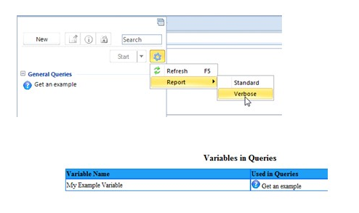

Figure 1 QVR1 Query Variables Report

© MooD Enterprises Ltd, all rights reserved.

