MooD 15 Measures
This document covers how to setup measures in theme administration, and then apply them to elements. This is a seven stage process.

Quick Reference:

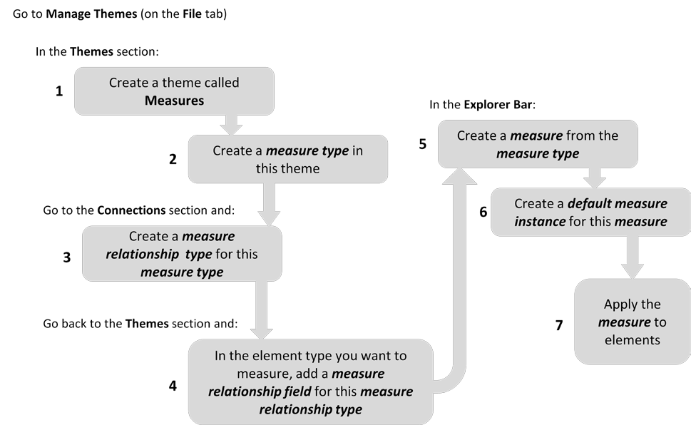

Document Number: MooD15MEAS44

© MooD Enterprises Ltd, all rights reserved.

Notice of Copyright and Trademarks
MooD 15 Measures
® MooD, MooD Smarter Decisions, Performance Activation, Synchronization Activation Technology and Knowledge Map are registered trademarks of MooD Enterprises Ltd. in the United Kingdom and / or other countries.
Microsoft and Windows are trademarks of Microsoft Corporation in the USA and other countries.
Rights to all other referred trademarks or registered trademarks reside with their respective owners.
Aspects of the Enterprise Business Model, Model-Driven Data Aggregation and Business Solutions to Support Smarter Decisions are protected by International Patent and Patent Pending. These include the Meta-Architecture Framework, Panels Technologies, Auto- Explorer, Business Orchestration, the Activator mechanism, Process Driven System, Performance Activation, Model-Driven Enterprise Management, Dynamic Aggregation, Smart Columns, the Variant Mechanism, and other technologies and mechanisms implemented within MooD Business Architect and MooD Active Enterprise.
© MooD Enterprises Ltd., all rights reserved. No part of this document may be reproduced by any means, or transmitted, or translated into machine language without the written permission of the company.

2

Contents
Introducing measures 4
Glossary 4
Setting up measures – the seven stages 6
Stage 1 ─ Create a Measures theme 8
Stage 2 ─ Create measure types 9
Using the measure type’s “Can be applied to” tab 13
Stage 3 ─ Create measure relationships 15
Stage 4 ─ Add measure relationship fields to element type definitions 16
Stage 5 ─ Creating measures from measure types 18
Stage 6 ─ Create defaults for measures (optional) 19
Activators 21
Thresholds 23
Stage 7 ─ Applying measures to elements 25
Introducing Epoch measures 28
Tasks
Task 1 To create a theme called Measures 8
Task 2 To add a Cost measure type to the Measures theme: 9
Task 3 To add a Financial Metrics measure relationship: 15
Task 4 To add a Financial Metrics measure field to the Project element type: 16
Task 5 To create a Project Cost measure from the Cost measure type: 18
Task 6 To add defaults to a measure called Project Cost 20
Task 7 To apply the Project Cost measure to an element 25
Tables
Table 1 Measures glossary 4
Figures
Figure 1 Setting up measures 6
3

Introducing measures
A measure quantifies some aspect of performance. Measures are applied to elements and have a value for that element. Each measure compares its value against a threshold to produce a state. This state is a value from a Pick list. For example, a Cost measure compared against some financial thresholds to produce a RAG (red amber green) status. This could then be used in models to quickly and effectively convey performance.

Glossary
This glossary should help you differentiate the various terms used in this document and within Business Architect.

Table 1. Measures glossary

measure | A measure is created from a measure type. A measure is what is actually applied to elements.  Measures are elements and are listed in two places in Business Architect:  - The Explorer Bar, under Themes, within your Measures (or equivalent) theme.  - The Performance library.  Measure can also be used as a general term for the whole process of gauging performance within MooD.
measure type | The structural and behavioural definition of a measure. Measure types are created in theme administration.
measure relationship type  or  measure relationship | Collections of one or more measure types. Within a theme, when you define a type (element) that you want to apply measures to, you add a Measure field to its type definition. This field is set to a measure relationship type and thereby defines what measures can be applied to elements of that type. This means that a single field on an element can hold measure instances based on all the measure types referenced by that measure relationship.  A measure type can be used in more than one measure relationship.
measure instance | The application of a measure on an element. The measure instance holds the measure for that element. It holds an Actual value, a threshold, and a Pick list state produced by comparing the Actual against the threshold (the Pick list used is defined in the measure type).
default measure instance | A set of defaults that can be applied to measure instances. When there is a default measure instance, any measure instances created on an element inherit these defaults. You can set defaults for the Actual value and the threshold.

4

threshold | A set of criteria that determine the status of a measure instance. The measure instance’s Actual value is compared against the thresholds to produce a Pick list state for that measure instance. The Pick list used is set in the measure type, but the applicable threshold is set at the measure instance level. Usually this is by inheritance from the default measure instance, but thresholds can also be set at the individual measure instance level. This gives you a fine level of control over the thresholds used to determine the Pick list state on a measure instance.
activator | An activator lets you derive the measure instance Actual value from a calculation or an external source. You can choose from a selection of Activators, for example, Aggregation Activator, Excel Activator and SQL Server Activator.

5

Setting up measures – the seven stages
This section assumes you are familiar with the various definitions in the glossary on page 4. The diagram is followed by a description of the overall process, and then specific sections for each stage.

Figure 1. Setting up measures
Before anyone can apply measures to elements, you (as repository administrator) must configure measure types and make sure your themes (elements) can use them. This is the first four stages in the seven listed here. For this, you will use the Manage themes of elements and connections between them dialog box (on the ribbon, click File, and then click Manage Themes).
The seven stages to setup measures are:
- Create a Measures theme.
- Create a measure type within the Measures theme.
- Create a measure relationship type for the measure type (or add the measure type to an existing measure relationship type).
- In the theme that you want to measure, add a measure relationship field to the element type definition.
This field is set to a measure relationship type (and will have the same name). This is the field that will hold the element’s measure instances once a measure has been applied to the element.

6

A quick way to complete stages 3 and 4
There is a quick way to accomplish stages 3 and 4 at the end of stage 2. However, it has the consequence that it always creates measure relationship types called Measures, and always adds fields called Measures to the element type definitions. Unless you rename everything, this is a maintenance issue. However, this quick method is described in the Using the measure type’s “Can be applied to” tab section on page 13 (at the end of the second task).
At this point you leave the Manage themes of elements and connections between them dialog box and return to the main Business Architect interface to complete the three remaining stages.
- In the Explorer Bar, create a measure from your measure type.
- Create a default measure instance for the measure. This is optional, but recommended. This section includes subsections on activators and thresholds.
- Apply the measure to an element to create measure instances on that element.
Seven corresponding sections and tasks follow. The example used throughout creates a Measures theme, a Cost measure type from which a Project Cost measure will be created, and a Financial Metrics measure relationship type. It configures a Project theme so that its elements can use Cost measures by means of a field called Financial Metrics. The sixth task adds the optional defaults, and the final task applies the Project Cost measure to an element. This assumes that you are the repository administrator, and that you have a theme called Projects. Any other prerequisites are defined before the task concerned.

The benefit of measure relationships
Users sometimes ask why, when you add a measure field to an element’s type definition, you don’t just select the measure type, and instead have to set up and then add the field as a measure relationship. The basic reason for this is structural flexibility. This is twofold:
- Measure relationships can include multiple measure types.
- Each measure type can be included in multiple measure relationships.
This makes measure types reusable, and lets you hold different measure types within a single measures field on an element. For example, you could have the following measure relationships:
- Financial Metrics that can hold Cost, Fixed Cost and Revenue measure instances.
- Costs that can hold Cost and Fixed Cost measure instances.
- Revenue measure relationship that can only hold Revenue measure instances.

7

Stage 1 ─ Create a Measures theme
You must have at least one theme to create your measure types in. This theme can be called anything, but typically it is called Measures.

Task 1 To create a theme called Measures:
- In Business Architect, click File, and then click Manage Repository.
This displays the Manage themes of elements and connections between them dialog box. This is the dialog box for all theme administration (your repository’s Meta model). It opens at the Themes section and all the themes in your repository are listed on the left side.
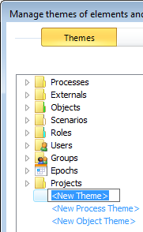
- Click <New Theme>.
It becomes editable.
- Type Measures.
- Click white space (anywhere outside the renaming box but inside the dialog box). This creates the Measures theme.
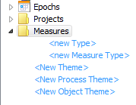
You can now add some measure types to the Measures theme.

Note: You can create measure types within any theme. For example, if you have a Project theme that defines project related element types, you could create all the project related measure types within it. However, in practice, measures are frequently located together under one universal theme. This guide follows this principle with its Measures theme.

8

Stage 2 ─ Create measure types
Within the Measures theme, you need to create measure types for each of the measures that you want to apply to elements in your repository.
This task creates a measure type called Cost. You will need:
- A simple numeric field type called Cost. This is the field that the measure will use to store its value. If you don’t have this, you can create it during the task, although this is not described.
- A Pick list called Cost Status with three states: Overspend, On Target and Underspend. This is the Pick list that will be used to determine the status of the measure when it is applied to an element. Again, if you don’t have this, you can create it during the task (again not described).

Task 2 To add a Cost measure type to the Measures theme:
- In Business Architect, click File, and then click Manage Repository.
This displays the Manage themes of elements and connections between them
dialog box.
- Expand the Measures theme:
(This is the end point of Task 1.)
- Click <new Measure Type>.
It becomes editable. In this example, we will create a measure type called Cost.
- Type Cost.
- Click white space (anywhere outside the renaming box but inside the dialog box). The New component: Instance of Measure dialog box is displayed.

9

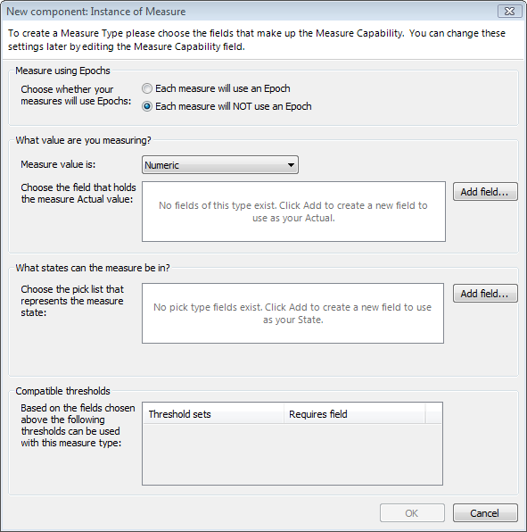
You use this to configure the measure instance format that will ultimately be created for the measure type. The remainder of this task covers this. It includes some information boxes that elaborate on this process; however, you can skip these and just follow the actual steps to complete the task.
Note: This example will not use epochs. See Introducing epoch measures on page 28 for more.
About measure instances
A measure instance is the application of a measure on a specific element (the instance of a measure on an element). They always have the naming structure elementName.measureName. For example, Athena.Project Cost would uniquely identify a Project Cost measure on the element Athena.
Measure instances always have:
- a value held in a named field
- a status against a Pick list
- a threshold for the status (an existing threshold or a direct threshold against that measure instance)
The first two are what you are setting up in the New component: Instance of Measure dialog box using the Add field buttons.
The third (the threshold) is set in a measure instance itself, either individually, or by inheritance from a default measure instance. The New component: Instance of

10

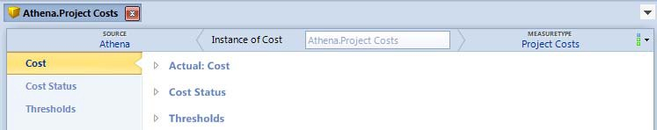
Measure dialog box displays what thresholds are compatible based on your Add field settings. However, as you can always add thresholds later or define a threshold from within a measure instance, this is just general information, and, if empty, not a cause for concern at this stage in the task here. (Thresholds are covered in the Creating defaults for measures section on page 19.)
All this means that, when you open a measure instance, you see a structure like this:

The first two are the field and Pick list you select here using the Add fields buttons, and Thresholds is where you control the threshold that is used to compare the value against the Pick list.
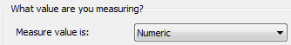
- Make sure Measure value is is set to Numeric (it defaults to this).

About measure data types
Measure value is can be set to one of three data types: Numeric, Date or String. Each measure type can only store one type of data, and MooD will enforce this. If you need to store two types of measure data, create two measure types. You can apply multiple measures to an element.
- Click the first Add field button.
The Choose a field for the Actual dialog box is displayed. You will use this to select (or create) the field that holds the measure instance value (the Actual). In this example task, this is the Cost field.

About “Actual” within measure instances, and introducing Activators
The Actual holds the value that is compared against the threshold to produce a Pick list state for the measure instance. In a measure instance, the name of this field is preceded by the word Actual. For example:
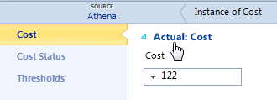
The Actual can be evaluated from another source by means of an Activator. For example, an Activator could be used to calculate the value from a number of other fields. Like thresholds, you can configure this individually or set it in a default measure instance. The Creating defaults for measures section on page 19 includes an Activators subsection (page 21).
- Select the Cost field, and then click OK.

11

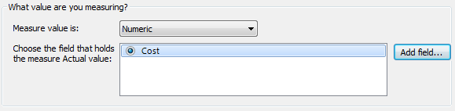
The Cost field is shown on the New component: Instance of Measure dialog box.

Multiple measure value fields
A measure instance can have multiple values of the same type. Only the Actual is compared against the threshold to produce a Pick list state for the measure instance. You could use an Activator on the Actual to calculate its value from the other measure value fields.
- Click the second Add field button.
The Choose a field for the State dialog box is displayed. You will use this to select (or create) the Pick list that determines the measure instance state when it is compared against a threshold. In this example task, this is the Cost Status Pick list.
- Select the Cost Status Pick list, and then click OK.
The Cost Status Pick list is shown on the New component: Instance of Measure
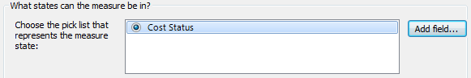
dialog box.
- Click OK.
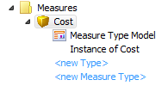
The New component: Instance of Measure dialog box closes and you have a measure type (Cost) that includes a measure instance definition (Instance of Cost).

Note: If you want to save your measure type at this point, you have to click OK to close the Manage themes of elements and connections between them dialog box. If you want to continue setting up measures, you can, and the dialog box will eventually save your changes or warn you if you are about to abandon without saving.

When your measure type has been saved, its Definition tab will include the field Elements to which this measure type is applied. When you open measures created from the measure type, this field lists all the elements that the measure is applied to. You will not see this field until the measure type has been saved (which can mean clicking OK and then reopening).

12

The next two stages (3 and 4) make your measure type usable by creating a measure relationship that references it, and then adding that measure relationship to a type definition so that elements of that type can use the measure types referenced by the measure relationship.
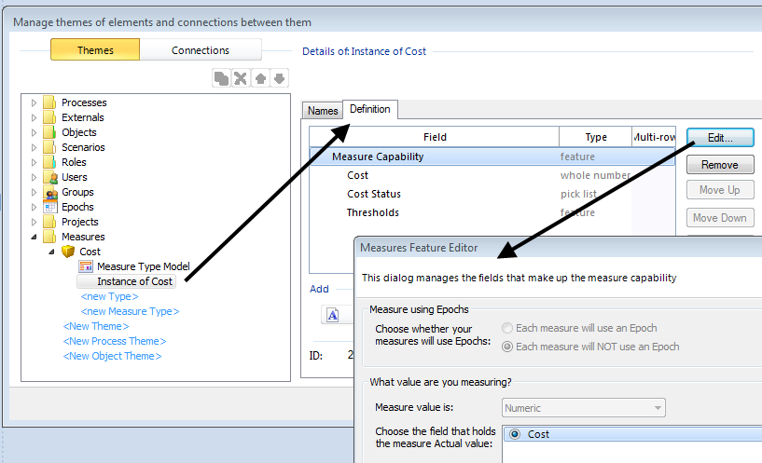The section that immediately follows this task describes a quick way of completing these two stages, but it brings maintenance issues. Either approach is available for you. For a fuller understanding of measures, we recommend that you follow the tasks, and then read about the quicker method.
Editing the measure instance definition
Once you have created a measure type, if you want to edit the measure instance (get back to the New component: Instance of Measure dialog box), you need to select the measure instance (under Themes), and then, on its Definition tab, click Edit. This displays the Measures Feature Editor dialog box (which is the same dialog box renamed for editing).

Using the measure type’s “Can be applied to” tab
This a quick way to create a measure relationship and add a measure relationship field to an element type definition. Whilst this completes stages 3 and 4 (the next two sections), it has the following drawback: every time you do it this way, it names the measure relationship Measures. Unless you rename them all, this makes maintenance difficult, as whenever you come to select from a list of measure relationships, they will all be called Measures. It is good practice to create meaningfully named measure relationships, so for this reason, and to help you more fully understand measures, we recommend that you get into the habit of following stages 3 and 4 fully.
However, if you don’t have many measures, or just want to get a working measure as quickly as possible, you can make use of the measure type’s Can be applied to tab.
As soon as you click OK on the New component: Instance of Measure dialog box (the end of the preceding task), you return to the Manage themes of elements and connections

13

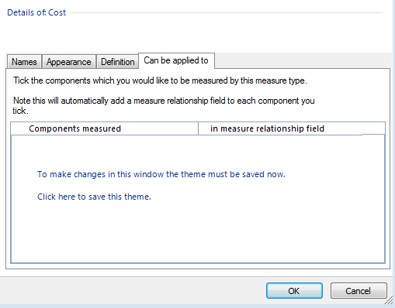
between them dialog box. You can now click the Can be applied to tab. Provided you have not saved already, this gives you:
Click where instructed to save the theme. The Components measured list will now show everything that can have a measure applied.
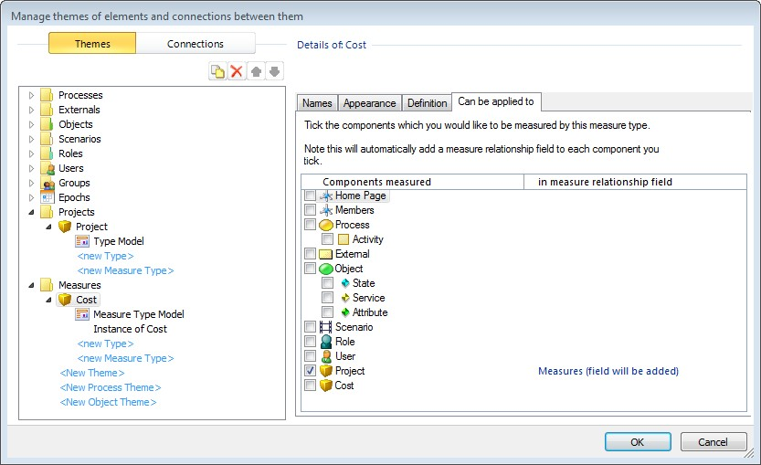

14

Select the component that you want to apply the measure to. This adds:
- a measure relationship called Measures that uses the measure type (effectively completing stage 3).
- a corresponding measure relationship field called Measures to the selected component (effectively completing stage 4).
You could now proceed to stage 5 and create an actual measure from your measure type.

Stage 3 ─ Create measure relationships
You need to create a measure relationship that uses your measure type (or add the measure type to an existing measure relationship). In an element type definition, when you add a measures field to the definition, what you add is a measure relationship field. Essentially, the measure relationship defines what measure types can be applied to the element.
Continuing with the example, the following task creates a measure relationship type called
Financial Metrics that can use the measure type Cost.

Task 3 To add a Financial Metrics measure relationship:
- In Business Architect, click File, and then click Manage Repository.
This displays the Manage themes of elements and connections between them
dialog box. Themes will be selected (coloured).
- Click Connections.
- Expand Measure Relationships.

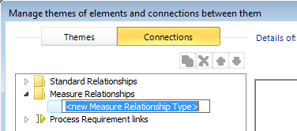
Click <new Measure Relationship Type>.
It becomes editable. In this example, we will create a measure relationship called

Financial Metrics.
- Type Financial Metrics.
- Click white space (anywhere outside the renaming box but inside the dialog box). Three tabs are added to the right side of the dialog box.
- Click Can use measures.
This tab lists your measure types. If you have been following the example, it will include the Cost measure type.
- Select Cost.

15

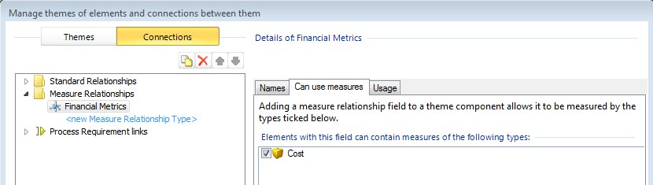
- Save this change by doing one of the following:
  - Click OK to close the Manage themes of elements and connections between them dialog box.
  - Click Themes. A dialog box will prompt you and allow you to save the change without closing the Manage themes of elements and connections between them dialog box.
Now you have a measure relationship that you can add to an element’s type definition to create a measure relationship field in that element.
Note: As mentioned, if you already have a suitable measure relationship type, you can add new measure types to the list of measure types it can use. On the measure relationship’s Can use measures tab, just select the check box for the measure type that you want to include. For example, the following image shows Revenue being included in the Financial Metrics measure relationship.
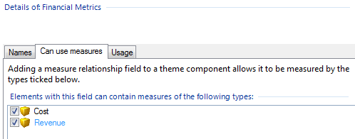

Stage 4 ─ Add measure relationship fields to element type definitions
Once you have a measure relationship that includes one or more measure types, you can add it to an element type’s list of fields. This means that any elements of that type will have a field that can accept the measures allowed by the measure relationship. The name of this field will be the name of the measure relationship.
Once you have done this, the measure is ready to be used (or have defaults applied (optional stage 6)).

Task 4 To add a Financial Metrics measure field to the Project element type:
- In Business Architect, click File, and then click Manage Repository.

16

This displays the Manage themes of elements and connections between them
dialog box.
- Expand the Projects theme.
- Click Project.
The Details of section on the right of the dialog box should now display three tabs (Names, Appearance and Definition) that define the Project element type.
- Click the Definition tab.
- Under Add, click the Measure button.
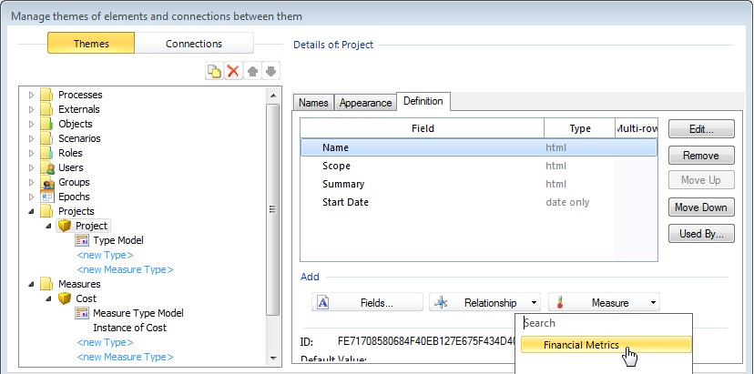
This displays a list of your measure relationships.
- Click Financial Metrics.
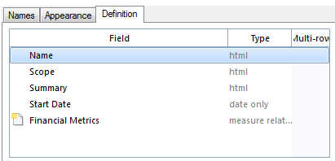
The Financial Metrics measure relationship is listed in the Field list.
The icon beside it indicates that this addition to the definition has not been saved yet.
- Click OK.
This saves the change. In the Explorer Bar, if you click a Project element, and then right-click and click Open, you will be able to see the Financial Metrics field in the element’s definition.

17

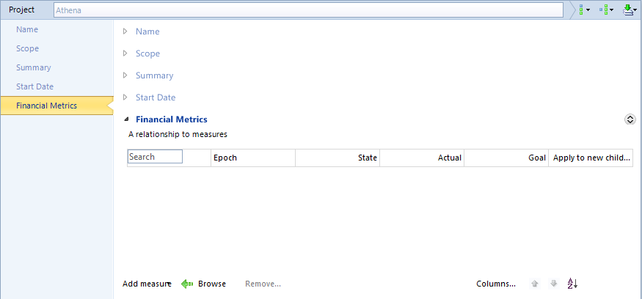
If you are following the example, although you have now completed the basic configuration of a measure, if you were to click the Add measure link in your example (shown at the bottom of the preceding image), it would not contain the Cost measure. This is because you have not yet created a Cost measure from the Cost measure type. You do this in the Explorer Bar, not in the Manage themes of elements and connections between them dialog box.

Stage 5 ─ Create measures from measure types
Once you have configured a measure type, you need to create a measure from it. This measure is what is ultimately applied to elements to create measure instances.
Note: You can create multiple measures from a measure type. For example, from the Cost measure type you could create measures called Project Cost and Fixed Cost. This aspect is not demonstrated by this example.

Task 5 To create a Project Cost measure from the Cost measure type:
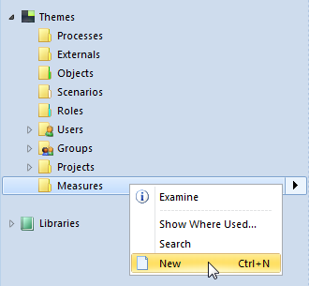
- In the Explorer Bar, under Themes, right-click Measures, and then click New.

18

One of the following will happen:
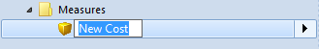
  - If your repository only has one measure type, a measure based on that type is created and its name is made available for editing. This is the case if you are creating this example in a new repository. The rest of this task assumes this, and that you see the following:
  - If you have more than one measure type, you select the one you want from a list before getting to the renaming point. If this is the case, select the Cost measure type.
- Type Project Cost, and then press the Tab key (or click white space) to save the renaming.
You will now have a measure called Project Cost.
If you right-click Project Cost, and then click Open, you can see the measure’s definition. It will include the Elements to which this measure type is applied field. As this is a new measure, this field will be empty.
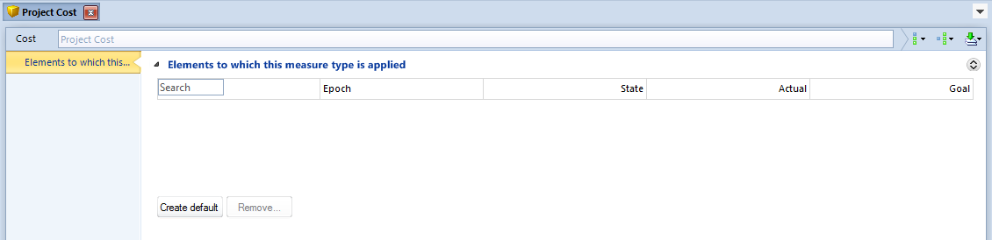
Although you can now apply this measure to elements, it is usual to set up defaults. This is the next stage and uses the Create default button that you can see in the preceding image.

Stage 6 ─ Create defaults for measures (optional)
This is an optional (but recommended) step that falls between repository administration and normal usage.
You may want to set up measure defaults. When you apply a measure to an element, the element’s measure instance gets these defaults automatically. These defaults can include:
- Values for the measure instance fields.
- A threshold for the measure. The threshold assigns a Pick list state depending on how the measure instance compares against the threshold.
The defaults are held in a default measure instance.
Defaults apply to the measures created from a measure type. Not to the actual measure types. So to do this, you need to have created measures from your measure types (stage 5). The task that follows adds defaults to the Project Cost measure created from the example Cost measure type (task 5).

19

Task 6 To add defaults to a measure called Project Cost:
- In the Explorer Bar, expand Themes, and then expand Measures.
If you have been following the example, you should get to a point where you can see:
- Right-click Project Cost, and then click Open.
The Project Cost measure’s definition is displayed. It will include the Elements to which this measure type is applied field. As this is a new measure, this field will be empty, but it will have a Create default button.
- Click Create default.
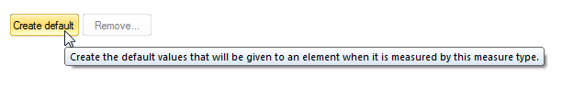
A default measure instance is added to the Elements to which this measure type is applied field. It has the same name as the measure – in this example Project Cost.
This looks like a measure instance and has the same structure. You need to open it and set its fields to the required defaults. Then, whenever the measure is applied to an element, its measure instance will inherit these defaults. This is what the remainder of this task demonstrates.
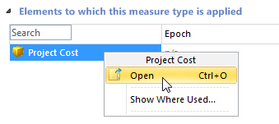
- In the Elements to which this measure type is applied field, right-click Project Cost, and then click Open.
This opens the default measure instance.

20

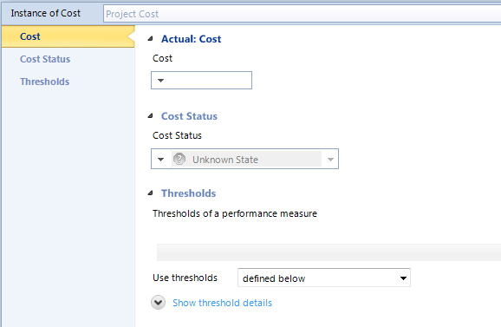
- Set the defaults. To help you:
  - Every measure instance has an Actual field. You can set this to a value, or you can use an Activator. See the Activators section next for information on this.
  - Every measure instance has a Pick list associated with it. In this example, this is the Cost Status Pick list. This gets its state from how the Actual compares against the Thresholds setting. See the Thresholds section (page 23) for details on setting up thresholds and applying them to measures.
- Save the Project Cost default measure instance.
Now, when you apply the measure to an element, it will get these defaults, although you can change them for specific instances. See Stage 7 – Applying measures to elements on page 25 for details.

Activators
An activator lets you derive the Actual value from a calculation or an external source.
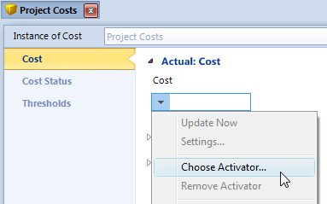
To set up an Activator, click the down arrow next to the Actual’s field, and then click Choose Activator.
The Activate dialog box is displayed.

21

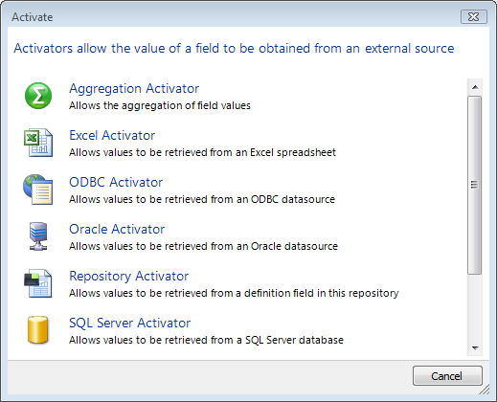
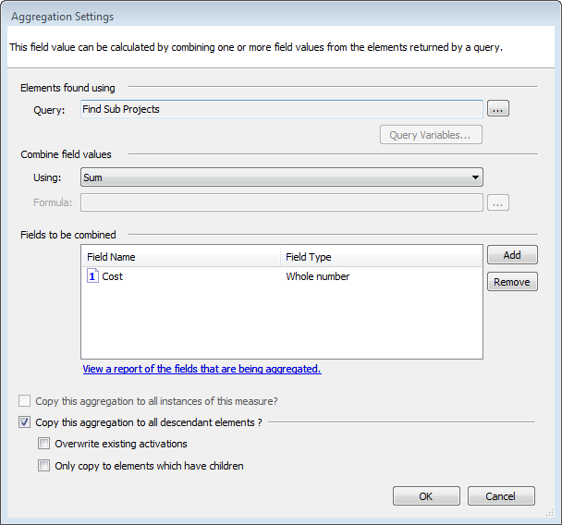
This gives you a choice of Activators that you can configure. For example, the Aggregation Activator shown next lets you calculate the Actual from the field values in elements returned by a query.

Note: The query that you want to use in an Aggregation Activator must already exist.
You cannot create it from within the Aggregation Settings dialog box.

22

Measures and Synchronization Activation Technology (SAT)
SAT is frequently used to import measures data into a repository. For example:
- Measures can be exposed in record descriptions and mapped, as shown here:
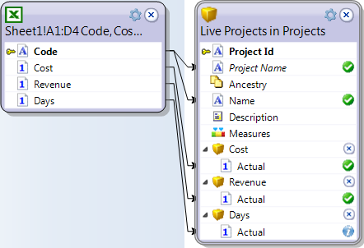
- You can map to a Measure Instances target, as shown here:

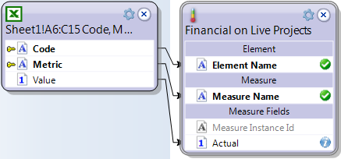
When available as a mapping option, the Mapping tab includes the Measure Instances target, as shown here:
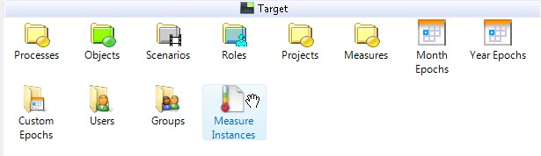
- The Excel Import SAT wizard includes a MooD Measure Instances layout.
The best approach for you will depend on how your source data is formatted and on how your themes are configured.

Thresholds
A threshold is a set of criteria that determine the status of a measure instance. The measure instance’s Actual value is compared against the thresholds to produce a Pick list state for that measure instance. The Pick list used is set in the measure type, but the applicable threshold is set at the measure instance level. Usually this is by inheritance from the default measure instance, but thresholds can also be set at the individual measure instance level. This gives you a fine level of control over the thresholds used to determine the Pick list state on a measure instance.

23

The images that follow show the process of setting a threshold in the Project Cost default measure instance. The process is essentially the same for all thresholds.
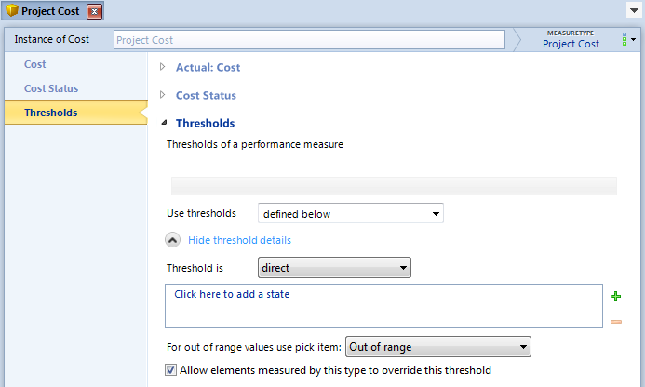
In the Project Cost default measure instance, expand the Thresholds field and show its details, for example:
When you click the Click here to add a state link, you select from the states in the measure type’s Pick list. For example, in the Cost Status Pick list you choose from:
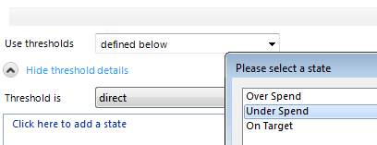
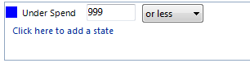
Once you have selected a state, you set values for that state. When the Actual value (Cost) matches these values, the measure instance’s state (Cost Status) will attain that Pick list state. For example, as shown in the following image, when Cost is less that 1000, the Cost Status is set to Under Spend.
Use Click here to add a state until you have set values for the Pick list states you want to use (you don’t have to set thresholds for all of them although this example does).

24

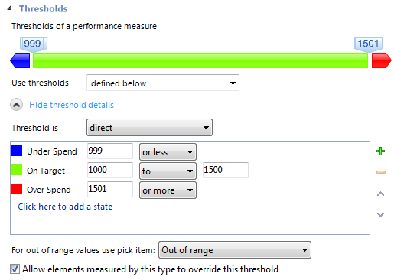
As shown in the preceding image, you get a visual representation of the threshold. The images also show some additional features including:
- The Use thresholds setting. You can create thresholds in the Performance library (in the Explorer Bar) and use them instead of defining them here.
- The Threshold is setting. Some thresholds can be percentage comparisons rather than
direct value comparisons. If the threshold supports this, you can set it here.
- The For out of range values use pick item setting. If the Actual value does not fall within a defined threshold, you can set the assigned state here. This can be any Pick list state or a default Out of range state.
- In default measure instances, the Allow elements measured by this type to override this threshold check box. You can use this to control how rigid the threshold settings are when they are inherited.

Stage 7 ─ Applying measures to elements
Applying measures is a drag and drop operation.

Task 7 To apply the Project Cost measure to an element:
- In the Explorer Bar, do one of the following:
  - Open the element definition and drag the Project Cost measure from the Explorer Bar into its Financial Metrics field. For example, the following image shows this for an element called Porus.

25

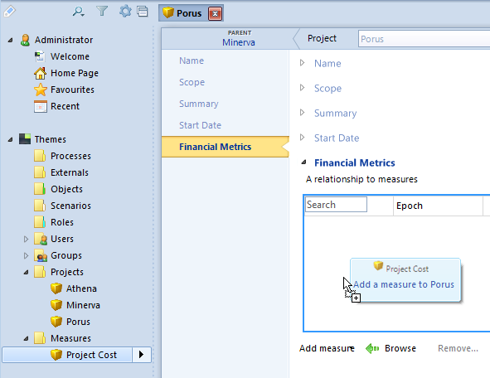

Note: Below the Financial Metrics field, you can also click Add measure to
select from a list of measures, or Browse to filter the Explorer Bar by applicable measures.

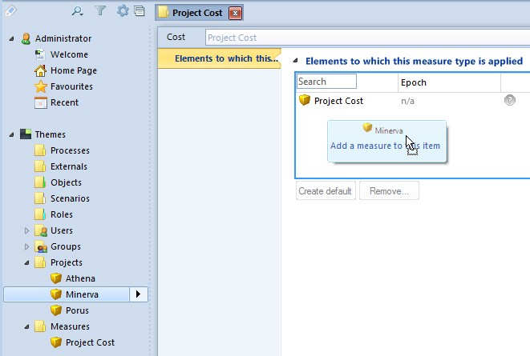
  - Open the measure definition and drag the element from the Explorer Bar into its Elements to which this measure type is applied field. For example, the following image shows this for an element called Minerva.
When you drop either, you get the Add Measure dialog box prompting you to confirm whether the measure will be inherited by descendant elements.

26

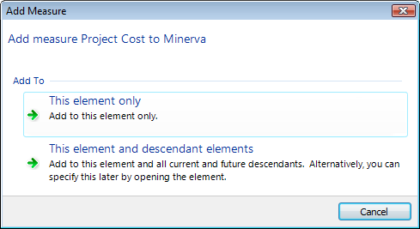
- Click the required level of inheritance.
Regardless of which way you applied the measure:
  - A measure instance is created in the element’s Financial Metrics field.
  - The element is listed in the Project Cost measure’s Elements to which this measure type is applied field.
Business Architect will only allow you to apply measures to elements where that measure is valid. If you try to apply a measure and it isn’t allowed, you must check how that measure is configured against stages two to four in the process.

27

Introducing Epoch measures
When you create a measure type (stage 2 on page 9) you state whether it will or will not use epochs.

Important: You cannot change a non epoch measure type into an epoch enabled measure type. You can only create a new epoch enabled measure type.

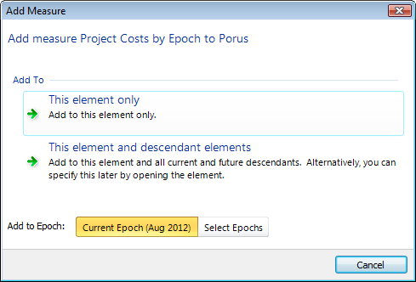
If you create a measure type that can use epochs, the process is the same until you apply the epoch enabled measure to an element (stage 7 on page 25). At this point, you get an Add Measure dialog box like the one shown in this image:
This shows a measure called Project Costs by Epochs. Because this measure supports epochs, you have the Add to Epoch setting. This defaults to the Current Epoch. However, if you click Select Epochs, the Add Measure dialog box expands as shown here:

28

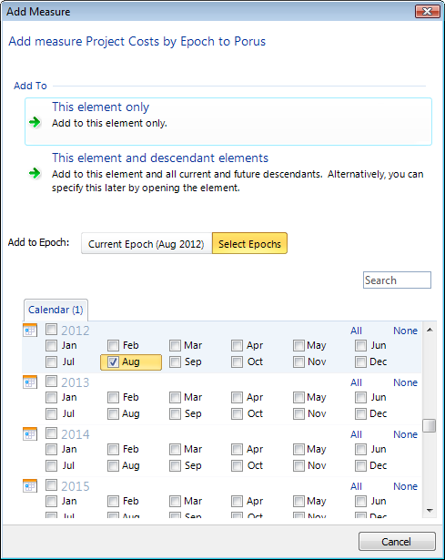
Here you select the epochs you want.
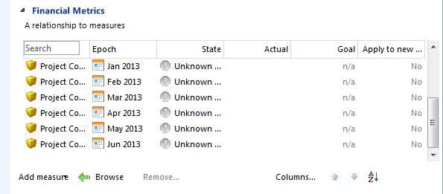
Measure instances will be created for the selected epochs and applied to the element, as shown here:

29

