MooD International Support Portal Support Solution

Permissions Resolution Report
Build 59+

Prior to this build, Active Enterprise pages were cached on an individual user basis. From this build forward, they are cached by user group and only cached individually when required. This means that if several users belong to the same user group and have the same permissions, they will share the same cached pages. This is more efficient.
The Permissions Resolution Report is an option on the Active Publishing Configuration dialog box (click Settings on the Web Publishing ribbon). This lets you see the results of caching by user group on an Active Enterprise site. It shows you what users resolve to what user groups.
To utilize the information in this report, look for individual users in the Permissions Grouping column and check whether they actually need to have their permissions set individually. It is more efficient to control permissions by group membership.
You can also generate this report from the Permissions tab. There is a Resolution Report command on its ribbon.
The image PRR1 shows both access points.

MooD International Support Portal Support Solution

Readers Comments (if any) Images (if any)

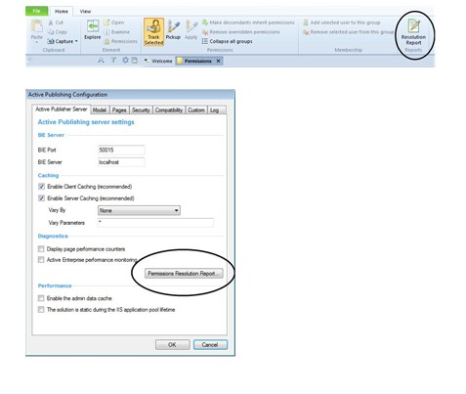

Figure 1 PRR1 Permissions Resolution Report

