MooD 15
World Map panel

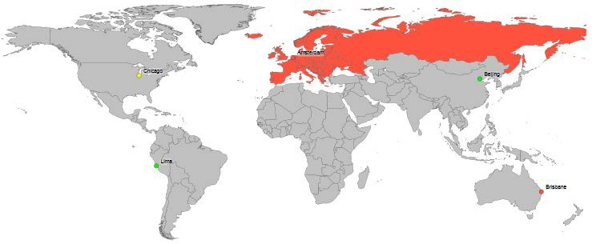

Document Number: 15WMP8610

© MooD International Limited, all rights reserved.

Contents
- Introduction 3
- Configuring a World Map panel 4
  - Data Requirements for Markers and Regions 4
    - Region Latitude/Longitude and Region Cycling 5
  - Flipside Options – Content setup 5
    - Useful Region strings 6
  - Ribbon Options – Refining appearance 6
    - The Labels tab 6
    - The Style tab 7
    - Custom map support 7

2

Introduction
The World Map panel lets you define regions, for example Europe, and markers, for example, Chicago and Lima. As well as having fixed settings, regions can be conditionally coloured, and markers can be conditionally shaped, coloured and sized. Markers can be labelled.
Markers and regions are defined using fields in the elements returned by the panel’s Information Shown setting. You can also use Smart Columns to drive any conditional settings or to provide labels.
The World Map panel is often used alongside the Ticker action panel. Frequently, the ticker shows live incidents scrolling across the top of a map showing their impact.
You can also define a number of regions and get the World Map panel to cycle through them.

3

Configuring a World Map panel
The World Map panel is available from the Graphs gallery on a model’s ribbon (the Home
tab). Configuration has two stages:
  - Use the panel’s flipside to specify content and some aspects of its appearance. From the flip side you access the Select Content dialog box where you specify markers and or regions.
o The World Map panel has more complex data requirements than some graph panels. To use it effectively you will need to use Manage Themes to add specific fields to your element types. The first section below gives details.
  - Use the ribbon to refine the panel’s appearance and behaviour.

Data Requirements for Markers and Regions
The World Map panel can show two things:
  - Markers – Points on the map that may or may not be within a defined region. You have a range of marker shapes and, like regions, markers can be coloured by some criteria. Markers can have labels.
  - Regions – Areas made up of individual countries, for example, Europe. MooD uses a string of country codes to define a region. A region can be an individual country. Countries do not have to share borders. Typically, the World Map panel will use colour to show a region’s status.
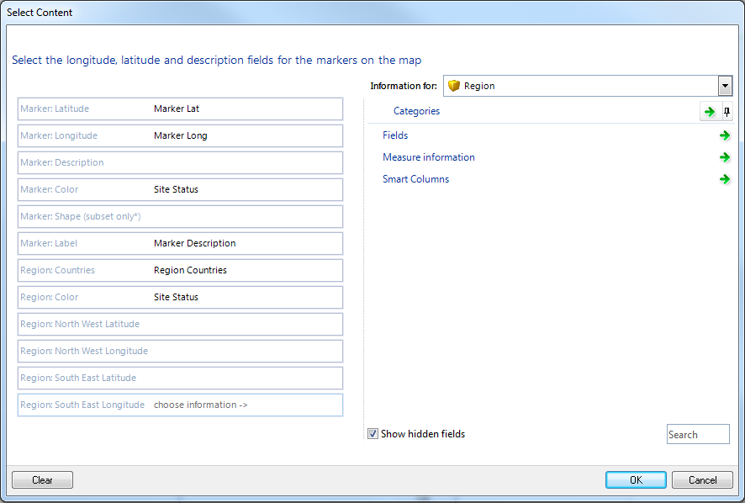
As shown next, the Select Content dialog box that you access from the panel’s flipside includes fields for regions and markers:

4

These fields can get their content from element fields, measures or Smart Columns. So you may have to use Manage Themes to add suitable fields to your element types. For example, if you have Site elements that you want to display as markers on a map, you will probably need to add Latitude and Longitude fields to the Site element type, and then populate the Site elements with the relevant data.
If you want to include markers and regions on a World Map panel, you may need to use a joined query to find different element types. For example, you may define a specific element type for your regions and incorporate marker fields into another element type. Information Shown (on the panel’s flipside) will need to find both element types. Then, when you set the different fields in the Select Content dialog box, use Information For to switch between the two element types. For example, in the image above, the Marker fields have been set to fields in a Site element type, and the Region fields have been set to fields from a Region element type (as shown). Both elements types make use of the Site Status Pick List field.

Region Latitude/Longitude and Region Cycling
The four Region Latitude/Longitude fields are used when you want the World Map panel to display a specific region and not the entire world. The region is defined by giving the four geographic corners. If you define multiple regions in this way, you can select the Cycle Regions check box on the ribbon’s Style tab to make MooD cycle between them on the web. You can also set a Cycle Timeout to control the timing.
Important: If you want to define regions this way, for each one make sure Region:Countries is also set to a string field. The value is irrelevant and ignored, but the field must be set.

Flipside Options – Content setup
After placing a World Map panel on a model, flip its panel to configure the content it will display. Set Information Shown to the elements required (for example, a joined query that returns active Sites (markers) and regions), and then click Select fields for markers and regions. This displays a Select Content dialog box (there is an image on the preceding page). Use the:
- Marker fields to specify where the markers get their configuration from. For example, if you are showing Site elements, these could be fields in the Site element type.
  - The default marker shape is a circle. As mentioned in the dialog, only certain shapes are supported. These are: rectangle, rounded rectangle, ellipse, circle, donut, triangle, diamond, pentagon, right and left chevron, star and square. If the Pick List returns an unsupported shape, a circle is used.
  - Marker Color and Marker Shape should be set to a Pick List, or to a Smart Column that returns a Pick List state.
- Region Countries and Region Color fields to define different regions in your panel, and the colour they should be shown in.
o Set Region Countries to a string field that holds a comma separated list of ISO country codes that together define the region. For example, ca,us,pm.gl,bm for North America. See the section below for continent strings that you can use.

5

- Region Latitude and Longitude fields if you want to display a specific part of the map or do region cycling. See the previous section for details.

Useful Region strings
Here is a table of frequently used regions:

To represent: | Use:
Europe | by,bg,cz,hu,md,pl,ro,ru,sk,ua,dk,ee,fo,fi,gg,is,ie,je,lv,lt,im,no,se,gb,al,ad,  ba,hr,gi,gr,va,it,mk,mt,me,pt,sm,rs,si,es,at,be,fx,de,li,lu,mc,nl,ch
Asia | kz,kg,tj,tm,uz,cn,jp,kp,kr,mn,tw,af,bd,bt,in,ir,mv,np,pk,lk,bn,kh,id,la,my,m  m,ph,sg,th,tl,vn,am,az,bh,cy,ge,iq,il,jo,kw,lb,ps,om,qa,sa,sy,tr,ae,ye
Africa | bi,km,dj,er,et,ke,mg,mw,mu,yt,mz,re,rw,sc,so,tz,ug,zm,zw,ao,cm,cf,td,cg  ,cd,gq,ga,st,dz,eg,ly,ma,sd,tn,eh,bw,ls,na,za,sz,bj,bf,cv,vi,gm,gh,gn,gw,l r,ml,mr,ne,ng,sh,sn,sl,tg,ci
Oceania | au,nz,fj,nc,pg,sb,vu,gu,ki,mh,fm,nr,mp,pw,as,ck,pf,nu,pn,ws,to,tv,wf
North America | ca,us,pm,gl,bm
Central America | bz,cr,sv,gt,hn,mx,ni,pa,cu,pr,do,ht
South America | ar,bo,br,cl,co,ec,fk,gf,gy,py,pe,sr,uy,ve

Ribbon Options – Refining appearance
Once you have a World Map panel populated with content, use the ribbon to refine its appearance and behaviour in your solution. There are two tabs:
- Labels – Format marker labels.
- Style – Basic settings, region cycling and custom maps. The following sections explain the key settings.

The Labels tab
Key points about the Labels tab and configuring labels:
      - Labels apply to markers only. In the Select Content dialog box, the Marker: Label field must be set. See Flipside Options – Content setup (page 5) for details.
        - You could of course use a marker to label a region. The point is that regions do not have their own labels.
      - The Position setting is the label’s position relative to the marker.
      - If your panel has closely positioned markers, use the Collisions and Movement Directions settings to influence how MooD attempts to position labels.
        - Iterations is the number of times MooD will run its positioning algorithms. This will affect performance.
        - Marker Overlap includes markers in the collision avoidance.
        - Hide Overlap will hide labels where collision avoidance cannot resolve the collision. This helps ensure that some labels are visible.

6

        - Movement Directions gives the directions that collision avoidance can use.
      - The Transparency settings affect the labels’ text boxes and the connecting lines between markers and labels.
      - The Font settings are for the label text.

The Style tab
Key points about the Style tab:
      - See Region Latitude/Longitude and Region Cycling (page 5) for details on the Cycle Regions and Cycle Timeout settings.
      - The Map setting lets you choose between High and Low resolution, and the Custom setting. Choose Low if you have a slow network connection. Choose Custom, to enable the Map Custom group of settings and see the next section for details.
      - Marker Radius is the radius in pixels. If you change the marker shape from the default circle, radius translates to the box dimensions within which the marker shape is drawn.
      - Land and Borders let you set the map’s fill and line colour respectively. These apply to the whole map. Conditional colouring only applies to regions and markers (see Flipside Options – Content setup (page 5) for details).

Custom map support
Since MooD 15 Build 86, the World Map panel can make use of custom maps. This means you are no longer restricted to the default world map or to defining a geographic region using four corner coordinates. For example, it could be a city map, or the map of a single country or continent.
MooD international will generate and make available some custom maps for demonstration purposes. If you have any specific custom map requirements, please submit a request to MooD International Support. You will need to submit an image (in Scalable Vector Graphic (SVG) format) that you have the rights to use. By submitting an image you confirm that you have the rights to use that image. MooD International will attempt to produce the necessary data from this image.
To use a custom map, on the ribbon’s Style tab, in the Map group, set Map to Custom, and then use the Map Data… command to open the Custom Map Data dialog box. Here you can paste custom map data.
Technical Note: Map data is a JSON (JavaScript Object Notation) object comprising area named properties and path values. For example:
{
'AREA1':'M 100,100 L100,200 L200,200 L200,100 Z’, 'AREA2':'M 200,200 L200,300 L300,300 L300,200 Z’,
}
These are generated from SVG files. If you have the resources and technical knowledge, you may be able to generate map data yourself. If you search online for SVG and JSON, you will find some assistance.

7

