MooD and the C4 model.
The C4 Model is a set of architecture viewpoints designed by Simon Brown to address common needs in software architecture:
“The C4 model was created as a way to help software development teams describe and communicate software architecture, both during up-front design sessions and when retrospectively documenting an existing codebase. It’s a way to create maps of your code, at various levels of detail, in the same way you would use something like Google Maps to zoom in and out of an area you are interested in.
The C4 model consists of a hierarchical set of software architecture diagrams for context, containers, components, and code.”
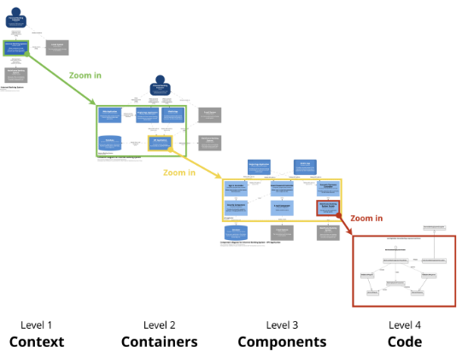

The C4 model is based on modelling four layers of abstraction of a software system, but with several complementary diagrams.
MooD now has two blueprints compatible with modelling using C4.
- An ArchiMate blueprint, supporting sufficient concepts to model using the mapping described here.
- Additionally, a C4 specific blueprint containing constructs suitable for modelling in C4 is also available, containing the following constructs, and relationships between them:
- Software System
- Containers
  - Database
  - Mobile
  - Web Browser
- Components
- Code
- Existing Systems
- People
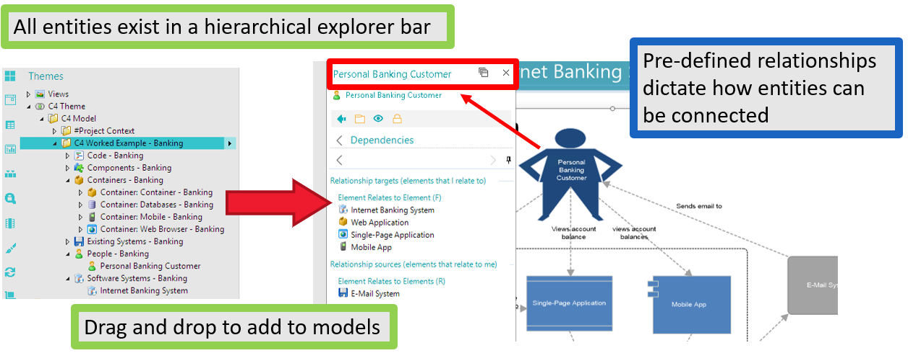

Using these constructs, it is possible to model using C4:
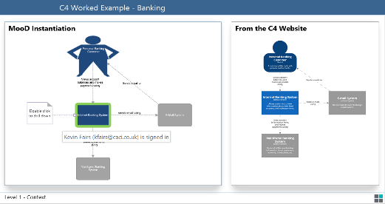

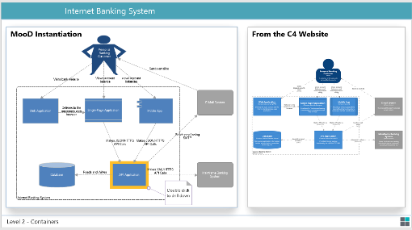

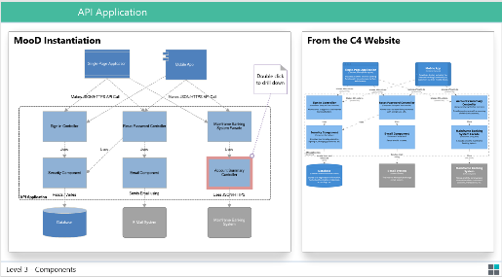

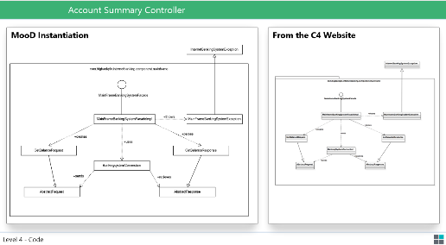

For more information on the C4 model see the C4 website.
For access to the C4 MooD blueprint, please email moodonline@caci.co.uk

